SERVICES TO YOUTH (September 2025)
Celebrating Excellence: STY Honors Scholars with Awards, Achievements & Summer Socials
STY proudly celebrated our Scholars and their outstanding accomplishments through a series of inspiring and joy-filled events. From scholarship presentations to milestone graduations and creative summer socials, each gathering highlighted the brilliance, resilience, and promise of our young leaders.

AACR Scholarship Award Presentation: On Thursday, June 5, STY had the honor of participating in the inaugural African American Community Roundtable of Howard County Senior Scholarship & Awards Ceremony at St. John Baptist Church in Columbia, MD. The event, created in response to recent HCPSS policy changes limiting race-based scholarship presentations, provided a powerful platform to recognize the excellence of Howard County’s African American graduating seniors. One of our Scholars, Isaiah Thomas, attended this ceremony and MP Diana Coleman and Scholarship Committee Chair Greta Carey Peoples were on-hand to present him with our White Rose Award and recognize his outstanding accomplishments.

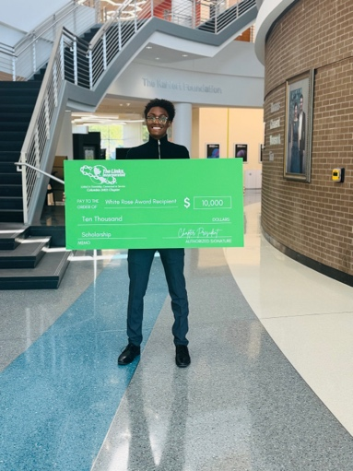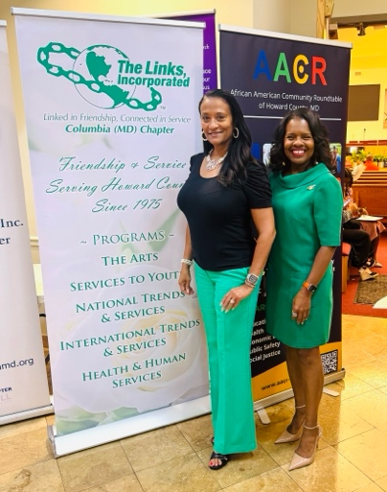

Link Scholars End Of Year Reception: On Friday, June 6, STY hosted its annual Links Scholars End-of-Year Reception in Fulton, MD, bringing together Scholars, families, and chapter members for an evening of joy, reflection, and celebration. We warmly welcomed our newest 2025 Links Scholars, Isaiah Thomas and Jason Young, while celebrating the accomplishments of all Scholars throughout the year. The highlight of the evening was honoring our graduating seniors:
- Camille Young, who graduated summa cum laude in Political Science from Spelman College. Camille, one of three Co-Valedictorians in her class, will begin law school at Georgetown University this fall.
- Ella Harris, inducted into Phi Beta Kappa last year, graduated summa cum laude from Princeton University with a degree in African American Studies and a certificate in Gender and Sexuality Studies. Ella plans to pursue a career in museums, libraries, or archives to ensure the art, history, and culture of African-descended people and underrepresented communities are preserved and celebrated.

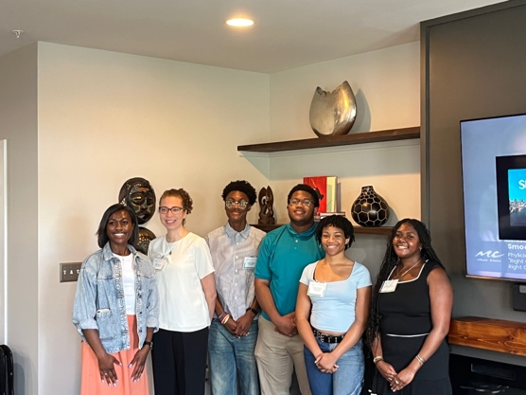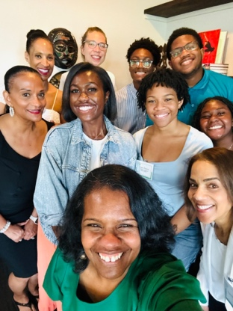
Link Scholars Summer Send-Off: STY hosted a warm and memorable Scholars Summer Send-Off on Wednesday, August 13, at Candles by Candy, an African American–owned candle-making studio at Savage Mill. Owner Candace Randall-Bell shared her inspiring journey as an entrepreneur and encouraged Scholars to embrace resilience and creativity as they navigate college and beyond. After hearing words of wisdom from MP Diana, the Scholars designed and poured their own custom candles, sparking not only fragrance-filled fun and fellowship, but also meaningful conversations. The evening gave our seasoned Scholars the chance to share their personal insights and advice with newcomers Isaiah and Jason and engage in an authentic exchange of encouragement, wisdom, and community that perfectly captured the heart of our facet’s mission.

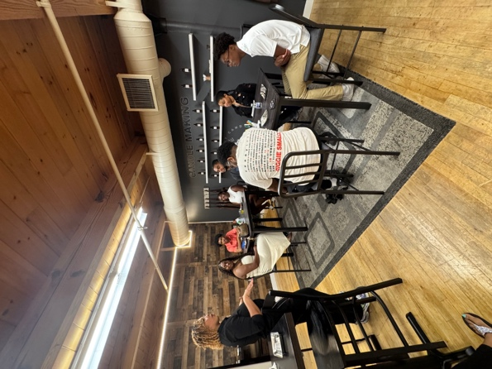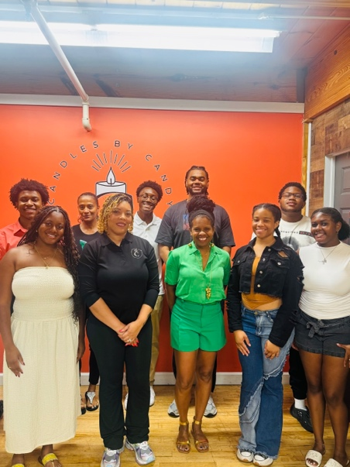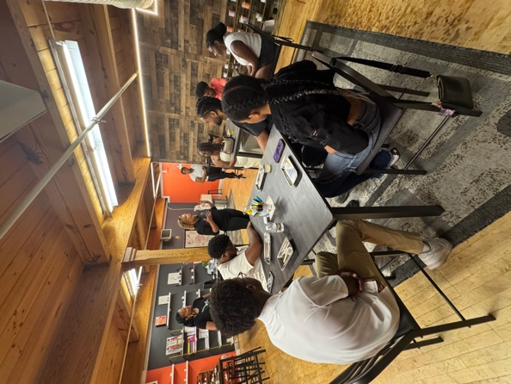

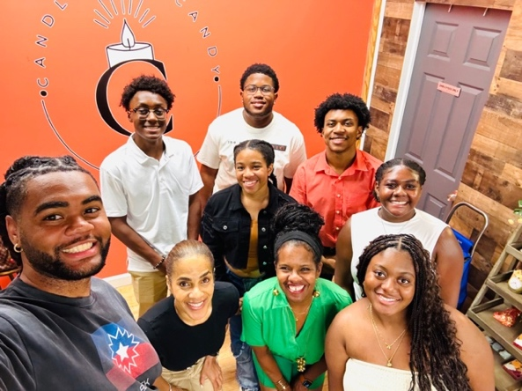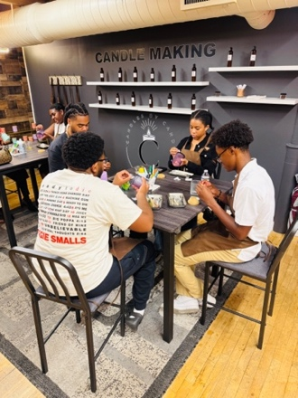

Introducing The Columbia (MD) Chapter Links Scholars
