SERVICES TO YOUTH

Links Love HBCUs: The Eastern Area HBCU Capital Campaign “Finish-Line Funding” continues through the month of October! These funds will directly support HBCU students, including any of our Scholars, in clearing the final financial hurdle needed to cross the finish line to graduation. The Chapter goal is to raise at least $5,000 and we are almost there! Please consider donating to this effort. You have the option to donate on behalf of the chapter or make an individual contribution. We are encouraging members to click on this link to make your donation and select Chapter Donation under Donation Type as you complete your donation: https://fundraise.givesmart.com/form/iE1_0w?vid=1lr38j.

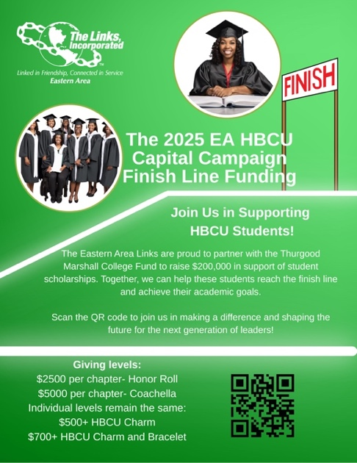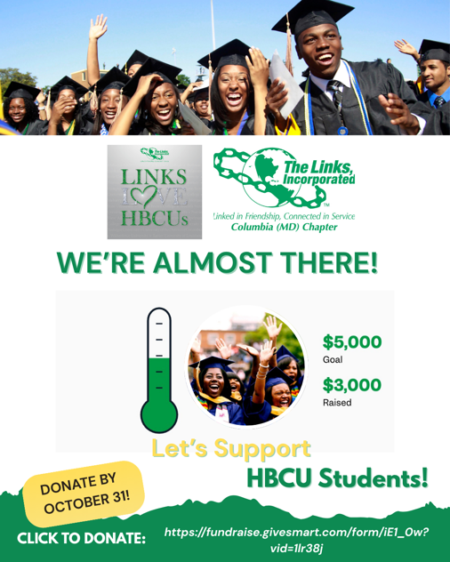

“Linked To Wellness” Mental Wellness Virtual Series Kick-off Session: Balancing coursework, relationships, finances, and future goals can make college life feel like a never-ending juggling act. That’s why the recent virtual session, “Mind Over Major: Mental Wellness for College Students,” provided such a timely and refreshing space for students to pause, reflect, and recharge. This session brought together 20 participants, including about 15 students from colleges and HBCUs across the country for an open and honest conversation about what it really means to care for your mental health during the college years. Students shared their own experiences of managing stress, navigating uncertainty, and finding balance in demanding academic and personal environments.

Led by Dr. Nicole Cutts, the discussion focused on practical strategies for managing stress and strengthening your mindset. Students left feeling encouraged, supported, and more equipped with tangible tools to help them thrive in their academic journeys. The session reinforced an important message: your mind deserves as much care as your major — and taking time to prioritize mental wellness isn’t just beneficial, it’s essential.

