SERVICES TO YOUTH
“Linked To Wellness” Mental Wellness Virtual Series
Your Personal Invitation Can Make the Difference!

The next virtual Mental Wellness session, "Using Social Media & AI for Purpose, Not Pressure," will be held on Sunday, March 22 at 3PM EST / 2PM CST. This conversation is designed specifically for college students navigating the pressures of the digital world. The conversation explores how to use these powerful tools in a way that protects their mental wellness, builds their personal brand authentically, and opens doors for them without losing their voice or values.

But the success of this series depends on you Link sisters.
We know from experience the most effective way to reach students is through personal invitations. When a trusted adult shares an opportunity directly, students are far more likely to participate.

Please take a moment to personally invite a college student(s) or share this opportunity with parents of college students in your network. A quick text, email, or conversation could make the difference in helping them engage in this important topic. The flyer, registration link, and speaker bios for this session is below. Please note, for the March LTW session only, the first 30 students to register AND attend will receive a $10 e-gift card from Subway!

Let’s work together to ensure this important conversation reaches as many students as possible! Registration Link: https://LinkedToWellnessMarSession.eventbrite.com

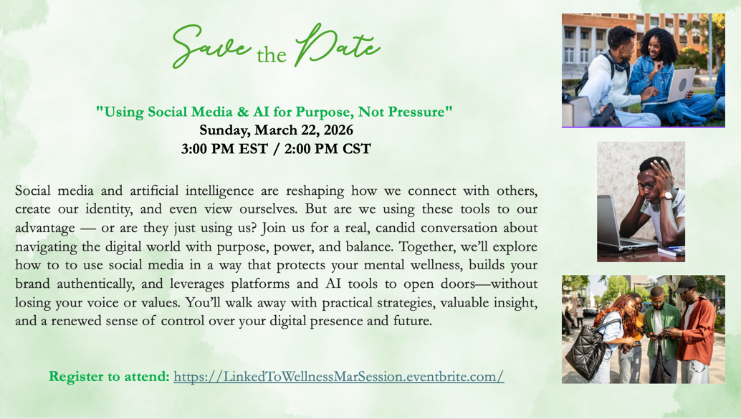

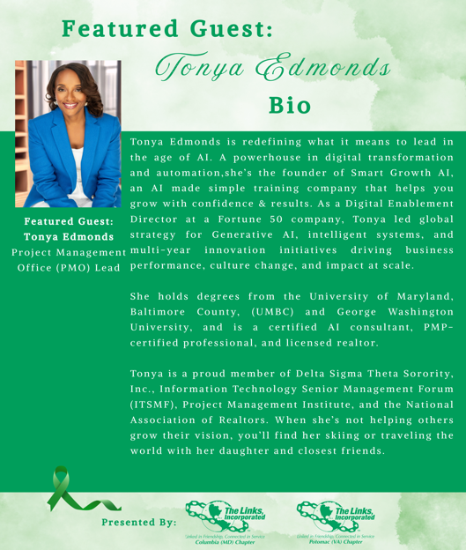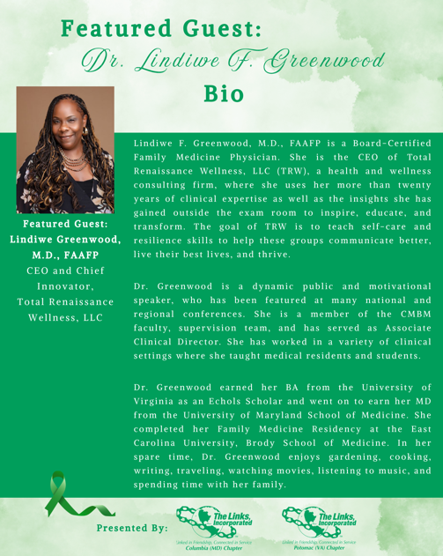

Scholarship Applications: The 2026 Chapter Scholarship application is now available on the chapter website, and we need your help to ensure that eligible students across Howard County are aware of this opportunity. The link to the application on the chapter website can be found here: https://www.columbiamdlinks.org/scholarship. Please note, this year, given the recent budget reductions, the chapter will award four (4) scholarships of $2,500 each (distributed over two years) to students enrolling full-time at Howard Community College.

The application deadline is April 3, so timely outreach is critical.

We encourage you to share this information widely with:
• High school seniors
• Guidance counselors
• School administrators
• Youth organizations
• Churches and community groups
• Any families you know with graduating seniors

Applicants must:
• Be a resident of Howard County, Maryland
• Be a high school senior graduating by June 2026
• Be enrolled full-time at Howard Community College in the Fall 2026

Your outreach can make a meaningful difference in helping deserving Howard County students access higher education. Thank you in advance for helping us spread the word.

Links Love HBCUs: DevCon: DevCon is a three-day immersive experience sponsored by the Thurgood Marshall College Fund (TMCF) and designed to equip 400 freshman and sophomore HBCU students that attend with the tools, resources and insights needed to explore career pathways, develop essential professional skills and engage with top industry leaders. TMCF has now engaged The Eastern Area Links as a strategic partner to deliver high-impact professional development experiences centered on civic responsibility, professional readiness, and executive presence. This engagement provided intentional, structured learning focused on voter education and civic responsibility, alongside professional attire, personal grooming, workplace hygiene, and professional dining etiquette, core competencies that directly influence student confidence, credibility, and long-term career mobility. Links Greta and Carol Ann represented the Columbia (MD) Chapter in this highly impactful and successful event by volunteering ‘in various capacities. We will follow-up with the Programming Committee to offer potential opportunities for our chapter to engage in this program in the future.

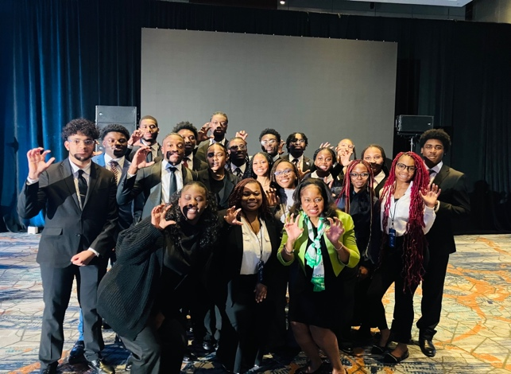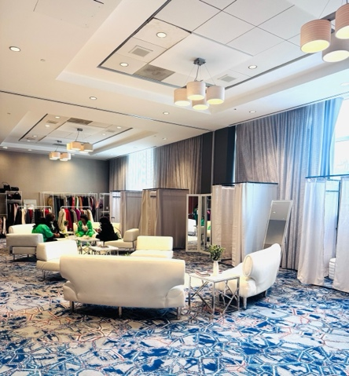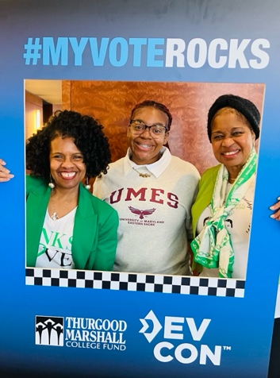
Links Love HBCUs: HCPSS HBCU Fair: HCPSS hosted its second annual Historically Black Colleges and Universities (HBCU) College and Career Fair on Saturday, March 7 from 9 a.m.- 2 p.m. at Guilford Park High School, 8500 Ridgely’s Run Road, Jessup. HBCU representatives were onsite to provide students and families with information on admissions, scholarships, and pathways to higher education as well as applications to apply. Representatives from several businesses and organizations were on hand to discuss employment opportunities. Thank you to Link Raven, Link Audra, and Link Carol Ann for visiting this Fair to assess its potential for all facets to integrate this community program into our future programming plans.

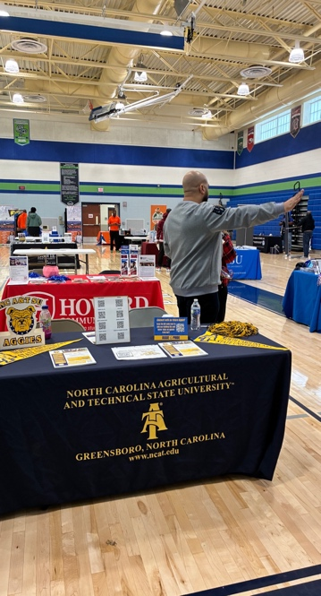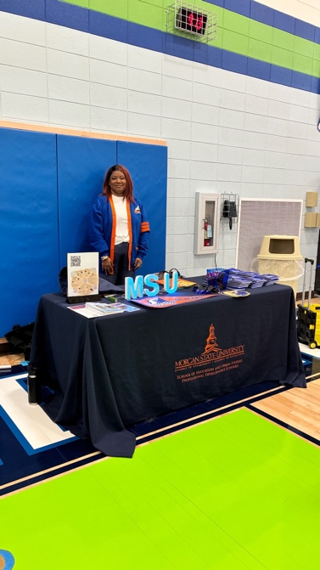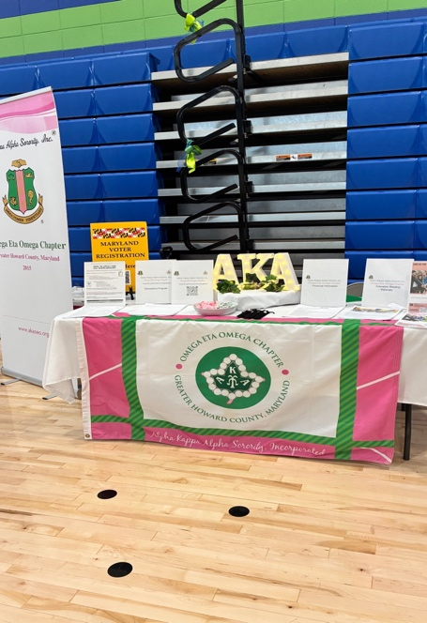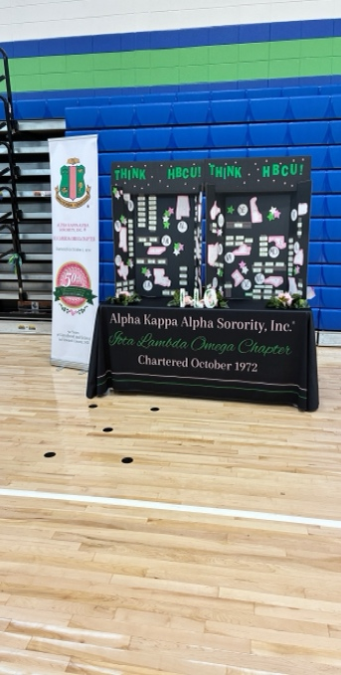

Scholar Spotlight: https://youtu.be/Oh10Pis43jg
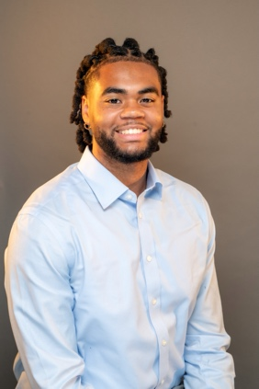
Evan Spann, Class of 2026
Morehouse College, Psychology Major

