SERVICES TO YOUTH
Links Love HBCUs: The Eastern Area HBCU “Finish Line Funding” Capital Campaign kicked off in the month of October and the Columbia (MD) Chapter did its part in finishing strong! The Chapter goal was to raise at least $5,000 and we contributed well over that! These ‘much needed’ funds will directly support HBCU students in clearing the final financial hurdle needed to cross the finish line to graduation, so our contribution was very important in helping to achieve this goal. Thank you to the entire Chapter, and to those 18 members who contributed beyond our Chapter donation, for helping to make this campaign such a success!
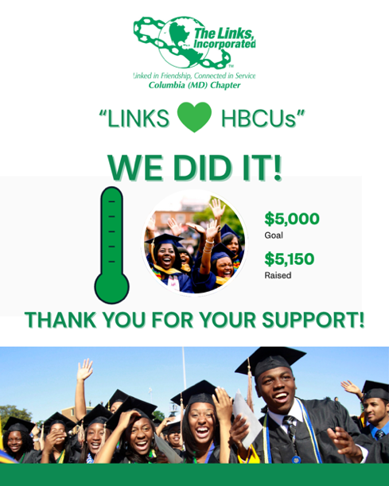

“Linked To Wellness” Mental Wellness Virtual Series Kick-off Session (October): “Mind Over Major:” Balancing coursework, relationships, finances, and future goals can make college life feel like a never-ending juggling act. That’s why the recent virtual session, “Mind Over Major: Mental Wellness for College Students,” provided such a timely and refreshing space for students to pause, reflect, and recharge. This session, hosted by the Columbia (MD) and Potomac (VA) Chapters, brought together 20 participants, including about 15 students from colleges and HBCUs across the country for an open and honest conversation about what it really means to care for your mental health during the college years. Students shared their own experiences of managing stress, navigating uncertainty, and finding balance in demanding academic and personal environments.

Led by Dr. Nicole Cutts, the discussion focused on practical strategies for managing stress and strengthening your mindset. Students left feeling encouraged, supported, and more equipped with tangible tools to help them thrive in their academic journeys. The session reinforced an important message: your mind deserves as much care as your major — and taking time to prioritize mental wellness isn’t just beneficial, it’s essential.

Here is some of the feedback received from the students:

“The ‘Mind Over Major: Mental Wellness For College Students’ session came at a perfect time for me. The discussion helped me recognize new ways to care for my mental well-being just as intentionally as I care for my physical health. With the ongoing pressures of school and personal life, I’m reminded how important it is to maintain a healthy, balanced routine. Thank you for inviting us to such a meaningful and timely conversation.”

“The session was genuinely amazing. We started off by introducing ourselves and then describing how we felt about midterms in one sentence. I said “stressed,” and other students shared similar feelings of worry. The timing of the session was perfect and aligned with how we were all feeling. We also discussed things we can do when feeling stressed, learned about different resources available on and off campus, and took turns giving our peers ideas. We concluded the session with a meaningful takeaway. Thank you for giving me the opportunity to have been a part!”

“The session went well and was super insightful. Thanks so much for sharing it with us!”

“The session was very helpful and informative. Thank you for referring us to it!”

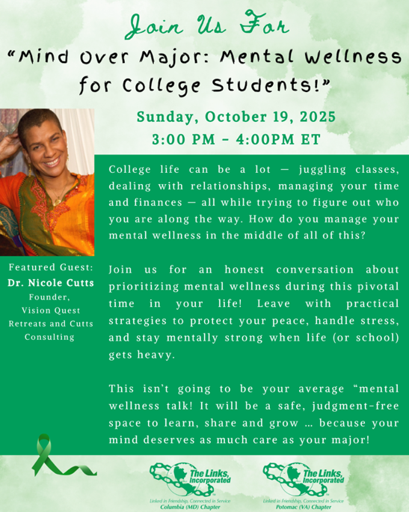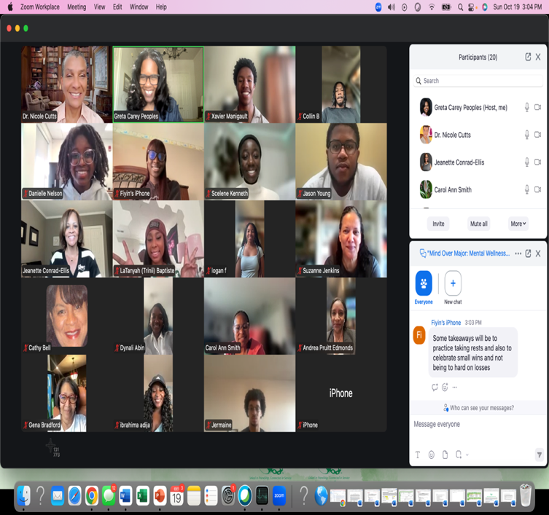

“Linked To Wellness” Virtual Series (November): “Know Your Body, Protect Your Power:” The next “Linked To Wellness” Virtual Series session, “Know Your Body, Protect Your Power,” will be held on Sunday, November 16 at 3:00 PM EST / 2:00PM CST. Too often, when it comes to our own health, we aren’t always taught what questions to ask, what numbers matter, or how to navigate the medical system with confidence and self-advocacy. This session, led by Dr. Marcia LoBrano, an Emergency Medicine Physician, will engage students in a real conversation about their bodies, their health, and their future—because being informed is being empowered. Here is the link to register: https://LinkedToWellnessNovSession.eventbrite.com. Please share this information with any college students you know that might benefit from this discussion and encourage them to invite their friends to register.
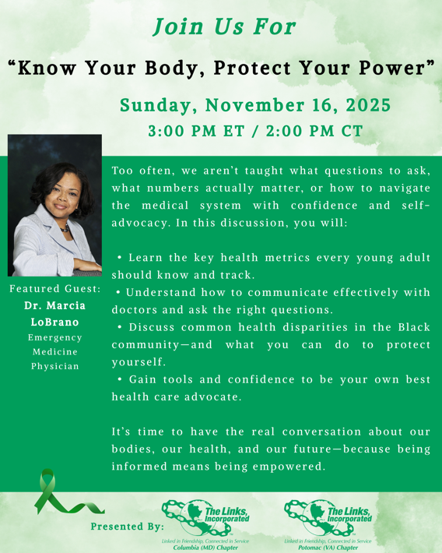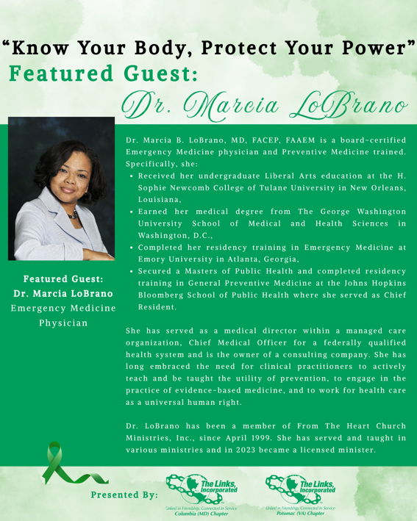

Links Scholars Holiday Celebration (December): STY will be hosting our Links Scholars and Masonville Cove interns to see the world premiere of “Santa Claus Is Comin’” on Sunday, December 21 at 3:00PM at Baltimore Center Stage (BCS) (700 North Calvert Street, Baltimore). This spirited musical performance will feature holiday classics reimagined with a Motown soulful sound! If you are interested in joining us for this event, visit the BCS website to purchase your ticket: https://secure.centerstage.org/overview/5096. Once you click on this link, enter the promo code BLACKSANTA in the top right box, click Submit, choose the performance date of Sunday, December 21, then select your seat(s) and checkout. Note, the promo code only applies to Full Admission tickets and cannot be used with other already discounted seats. If you have any questions about this event, please email Link Greta Carey Peoples at gretapeoples@gmail.com.

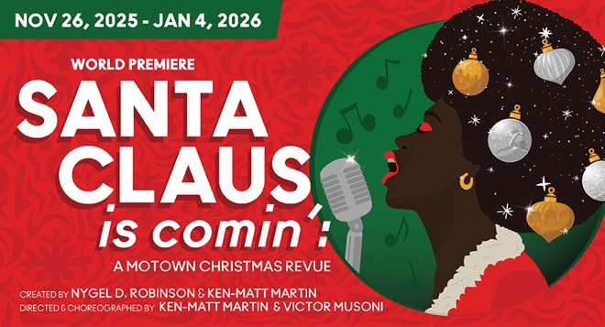

Scholar Spotlight: https://youtu.be/32-rVPqbzB4
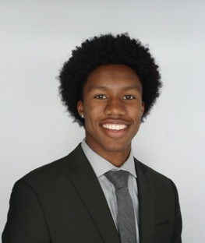
Xavier Manigault, Class of 2027
Georgia Institute of Technology, Chemical & Biomolecular Engineering

