SERVICES TO YOUTH

Scholar Spotlight: Danielle Nelson: https://youtu.be/5leW_ZrA998
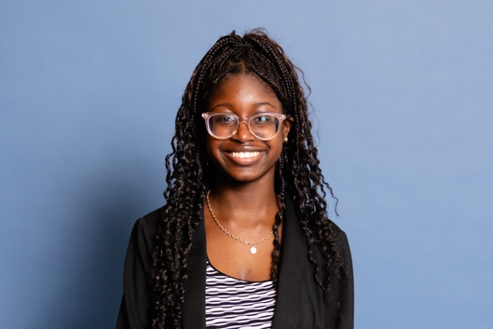
Danielle Nelson, Class of 2028
Stony Brook University, Computer Science

“Linked To Wellness” Virtual Series Session (January): The next “Linked to Wellness” Virtual Series session, “Looking for Real Love: Building Healthy Relationships That Last,” will be held on Sunday, January 25 at 3:00 PM EST / 2:00PM CST. More information about this session is below. Here is the link to register: https://LinkedToWellnessJanSession.eventbrite.com. Please share this information with any college students you know that might benefit from this discussion and encourage them to invite their friends to register.

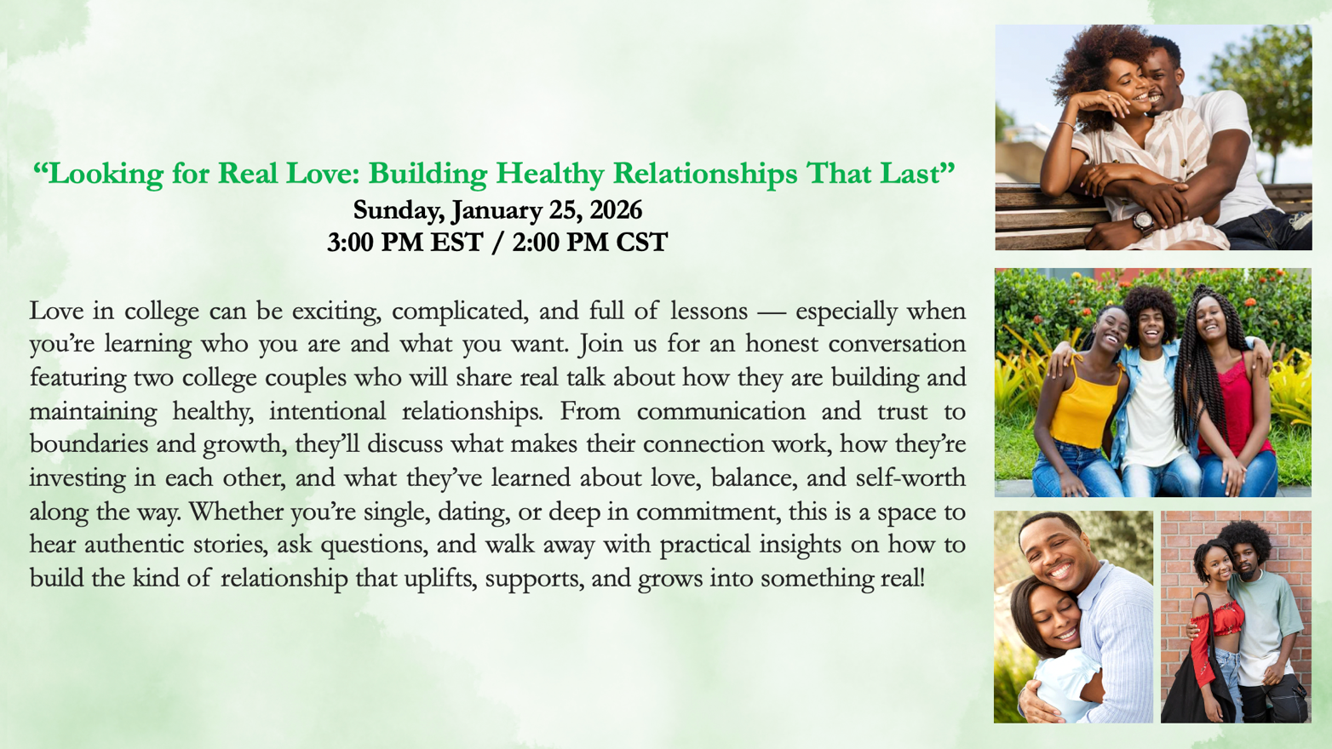

Links Scholars Holiday Celebration (December):
STY had the pleasure of hosting our Links Scholars at the world premiere of Santa Claus Is Comin’ on Sunday, December 21, at Baltimore Center Stage. This vibrant musical production reimagined beloved holiday classics with a distinctly Motown soul and delivered an unforgettable evening of music and artistry. The performances were engaging, and the talent on stage was truly exceptional.

For many of our Scholars, this marked their first experience at a regional theatre, making the evening especially meaningful. We were honored to share this extraordinary cultural experience and introduce them to the richness of live theatrical performance.

To commemorate the occasion, each Scholar received an elegantly wrapped Christmas gift from the chapter—a mini watercolor paint palette set—thoughtfully chosen to encourage creativity, reflection, and moments of peace. It is our hope that this gift will inspire them to focus on self-expression and the joy of artistic exploration.
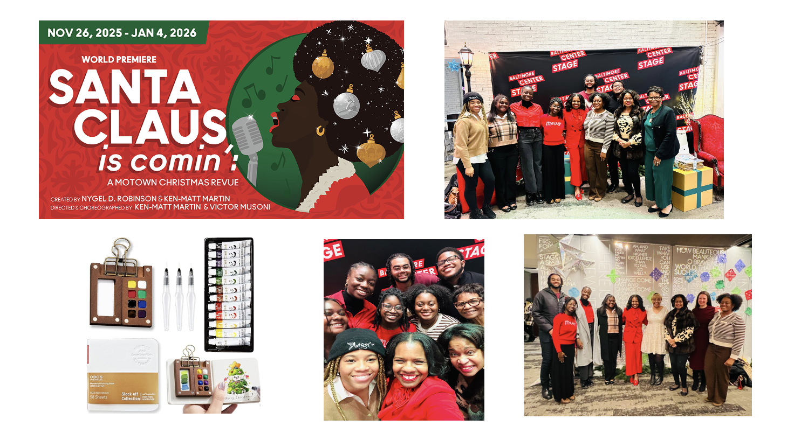
Links Love HBCUs: DevCon: The Eastern Area is looking for chapter members to volunteer to assist with this year’s DevCon. DevCon is a dynamic three-day immersive experience sponsored by the Thurgood Marshall College Fund (TMCF) and designed to equip freshman and sophomore students from historically Black colleges and universities with the tools, resources and insights needed to explore career pathways, develop essential professional skills and engage with top industry leaders. This year, this event will be held at the Baltimore Hilton Inner Harbor on February 18 – 21, 2026. The theme is “Fearless Futures.”

To strengthen DevCon’s holistic development model, TMCF is engaging The Eastern Area of The Links, Incorporated as a strategic partner to deliver high-impact professional development experiences centered on civic responsibility, professional readiness, and executive presence. This engagement will provide intentional, structured learning to 400 freshman and sophomore HBCU students that will be focused on voter education and civic responsibility, alongside professional attire, personal grooming, workplace hygiene, and professional dining etiquette, core competencies that directly influence student confidence, credibility, and long-term career mobility. Specifically, here are the areas in which volunteer assistance is needed:

- Wednesday, 2/18, Noon-5:00PM: Voter Registration and Civic Engagement Sessions
Expected Attendance: 400 Students (rolling arrivals)

Scope: Serving at the welcoming and registration checkpoint, The Eastern Area Links will facilitate a structured 15–20 minutes engagement session designed to verify student voter registration and deliver targeted education on voter awareness, civic participation, and associated responsibilities. This activation will provide a high-touch, mission-aligned entry point that reinforces civic readiness as a core component of the DevCon experience. All 400 students will move through this checkpoint in staggered arrival waves between 12:00 PM and 5:00 PM ET, ensuring an efficient flow while maintaining a meaningful, educational interaction for each participant.

- Wednesday, 2/18: - Friday, 2/20: “Linked N Style” Clothing Boutique
Expected Attendance: 200 - 400 Students (rolling arrivals)

Scope: LINKS ’N Style is a high-touch professional development clothing closet designed to enhance student confidence and career readiness through access to professional attire, personalized guidance, and hygiene resources. In partnership with The Eastern Area Links, students will participate in appointment-based, one-on-one shopping experiences supported by private shopping assistants. Need professional and business clothing, shoes, and accessories donations for men and women and travel size hygiene products. Also need volunteers to (i) be personal brand coaches for the students assisting them with appropriate body type clothing, (ii) facilitate personal branding workshops every 20 minutes on Wednesday, and (iii) sign up students for the clothing closet and work the closet daily. The hours of operation are as follows: 2/18 (12:00 PM - 4:00 PM), 2/19 (7:00 AM - 8:30 AM, 11:00 AM - 12:00 PM, 6:30 PM - 8:30 PM), and 2/20 (7:00 AM - 8:30 AM, 11:00 AM - 12:00 PM, 6:30 PM - 8:30 PM).

- Thursday, 2/19, 5:00-7:00PM: Professional Etiquette Dinner (“Dine Like a Diplomat”).
Expected Attendance: 400 Students

Scope: In partnership with TMCF certified etiquette training coach Marky Yarbrough, The Eastern Area Links will support a curated workplace dining and professional etiquette dinner experience. This activation will deliver structured etiquette training and real-time coaching to students during an active meal service, reinforcing professional standards through applied, experiential learning. A minimum of 30 Link sisters are needed to volunteer to sit at student tables, dine with students, and assist them with proper etiquette.

If you are interested in volunteering for this program, please contact Link Chin at columbiamdlinks.recsecretary@gmail.com or Link Greta at gretapeoples@gmail.com so you can be connected with the respective EA contacts for your area(s) of interest.

For more information about DevCon, visit https://tmcf.org/programs/devcon/.

