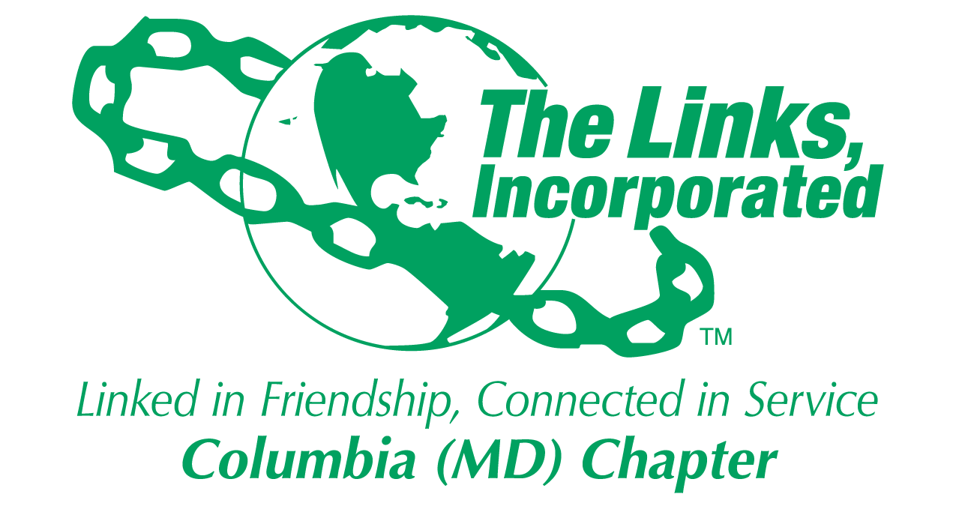
Facet/Committee Reporting Form
Name of Facet/Committee: National Trends and Services Facet
Date/ Time/Location of Meeting: Tuesday, April 21, 2026, 7:00 PM - Via Zoom
Members Present:
- April 21, 2026
  - Jewell Debnam, Paulette Scott, Judy Smith, Donna Staton, Rochelle Michaux-Conway

Summary of Meeting (Dot Points):
- NTS Facet will support the Umbrella Program "Linked to Wellness Initiative" by promoting healthy food choices and nutrition education for better lifestyles. We completed our third sponsorship event with Howard Community College’s Fueling Dragons Food Pantry on April 21st from 3:00 – 5:00 pm. Year to date, our Chapter has donated 625 pounds of food and impacted on 456 students. In addition, we provided food and beverage nutritional education.
- Grassroots Intervention Crisis Center – 1) We delivered our final meals on April 21st. The four events impacted 352 residents’ year to date. 2) The Positive Interaction – We completed our last Bingo Game night on April 21st. In total there were three activities, impacting 73 3) Spreading Love Through Warmth Program by providing blankets during Code Blue. We delivered 88 in November.
- “Link Up the Vote - We are partnering with St. John Baptist Church to do voter registration on May 3rd, 17th and 31st. First Baptist Church of Gilford and Celebration Church are participating. We will continue to integrate voter information at events and expand our partnerships with other community organizations.
-
- HCPPS Apprenticeship Maryland Program – We provided scholarship application information and invited the students to attend the STY- “Money Tips They Didn’t Teach You in School.” The Fundraising Committee is reviewing opportunities to raise money for FY27.
NEXT MEETING: TBD (New Program Year)
- Focus - FY2027
  - Linked to Wellness Umbrella Program – Partnerships: HCC and Grassroots
  - “Link Up the Vote” – Continue and solicit additional partners.
  - HCPSS Apprenticeship Maryland – Secure funds to continue program.

2025-2026 Program Year
Activity Objective(s) | Total # of Attendees | Resources Utilized | Outcomes
LINKED to Wellness Umbrella Program  Provide Healthy food and health education to improve healthy lifestyle | Howard Community College Goal – 200 students  Achieved – 456 students  Grassroots Goal – 70 residents  Achieved – 352 residents | Fresh fruit, educational materials  Hot meal | -FY26: Donated 625 lbs. of food and served 456 students  -FY26: Provided four meals impacting 352 residents
Improve mental anxiety through “Positive Interaction Programs.”  Grassroots | Program from January – April 2025  Goal - Total interactions – 75  Achieved – 73 Only 3 of 4 events | Games/Arts & Crafts  Gift cards | -FY26: Three Social interaction events impacting 73 residents
Spreading Love Through Warmth Program  Grassroots | Goal – 70 blankets  Achieved - 88 | In-kind donation of supplies | -FY 26: Delivered 88 blankets in November during Code Blue
“Link Up the Vote” | Goals – TBD |  | FY 27- Kick-off in May in partnership with St. John Baptist Church

Signature of Facet/Committee Chair: Rochelle Michaux-Conway
Date: May 7, 2026
Please Email to Chapter President, Chapter Vice President, Chapter Recording Secretary and Chapter Program Coordinator prior to Chapter Executive Committee Meeting

