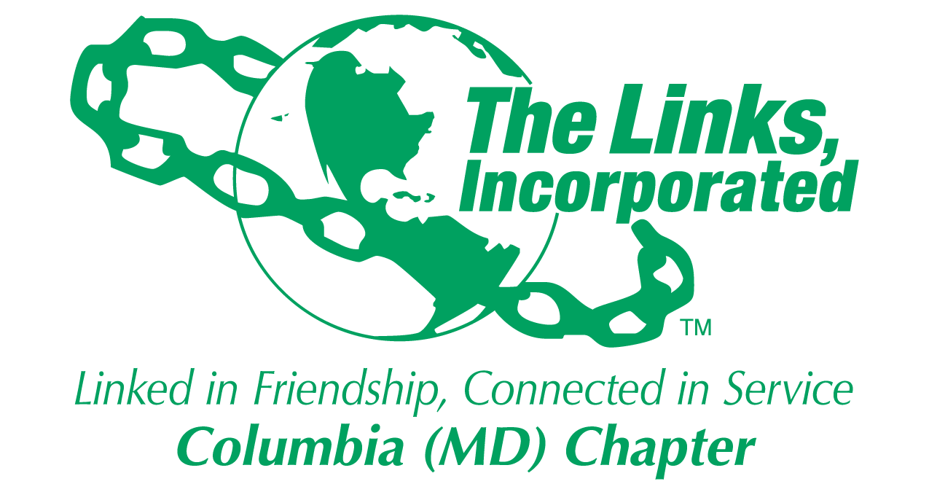
Facet/Committee Reporting Form
Name of Facet/Committee: National Trends and Services Facet
Date/ Time/Location of Meeting: Tuesday, October 21, 7:00 PM - Via Zoom
Members Present:
- October 21, 2025
  - Jewell Debnam, Rhonda Ricks, Paulette Scott, Myra Smith, Donna Staton, Rochelle Michaux-Conway

Summary of Meeting (Dot Points):
- Link Paulette provided the Linkspiration – “My Sister, My Brother
- Discussed Umbrella Program “Linked to Wellness Initiative”. NTS Facet will focus on providing healthy food and health education/nutrition to improve healthy lifestyle. We plan to sponsor an event at Howard Community College’s Fueling Dragons Food Pantry on November 18th from 3:00 – 6:00 pm.
- “Link Up The Vote “is a National initiative. The three pillars will be voter registration/identification, voter information and voter activation. Our goal will be to integrate voter information at events which we host and expand our partnerships with other community organizations.
- Grassroots Intervention Crisis Center – 1) We will continue our Positive Interaction Game Night from January – April on the second Tuesday from 6:30 – 8:00 pm. 2) Spreading Love Through Warmth Program by providing blankets. The shelter will have 88 beds by the end of the year. The Amazon link for donations is posted in the Chapter newsletter. Donations will be accepted at the Chapter meeting on November 8th. The blankets will be delivered to Grassroots on Monday, November 10th at 4:00 pm. 3) Meals – The first hot meal will be delivered on November 6th. Additional meals are planned for February and/or April. 4) Housewarming Kits will be reviewed in January 2026.
- NEXT MEETING: November 18, 2025
- Focus November - January
  - Complete HCC Fueling Dragon Event as part of Umbrella Program
  - Solidify plans for “Link Up The Vote” and potential partners
  - Complete Grassroots Intervention Crisis Center events that are within this timeframe
  - Begin “Workforce Development Initiative” project planning

2025-2026 Program Year
Activity Objective(s) | Total # of Attendees | Resources Utilized | Outcomes
LINKED to Wellness Umbrella Program  Provide Healthy food and health education to improve healthy lifestyle | Howard Community College Goal – 200 people  Grassroots Goal – 70 people | Fresh fruit, educational materials  Hot meal
Improve mental anxiety through “Positive Interaction Programs”  Grassroots | Program from January – April 2025  Goal - Total interactions – 75 | Games/Arts & Crafts  Gift cards
Spreading Love Through Warmth Program  Grassroots | Goal – 88 blankets | In-kind donation of supplies
Supporting Transition From Homelessness to Housing | Goal – 5 | In-kind donation of supplies
“Link Up The Vote” | Goals - TBD | Educational materials

Signature of Facet/Committee Chair: Rochelle Michaux-Conway
Date: October 29, 2025
Please Email to Chapter President, Chapter Vice President, Chapter Recording Secretary and Chapter Program Coordinator prior to Chapter Executive Committee Meeting

