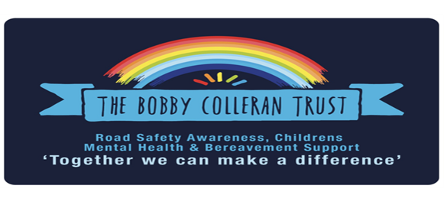

‘Slow Down’
Road Safety
Strategy
2026

Slow Down: Road Safety Programme
The Bobby Colleran Trust

Overview
Slow Down is a regional road safety programme delivered across the Liverpool City Region, designed to reduce speeding and improve driver awareness through education, behaviour change, and community action.
The programme is built on a powerful real-life story, helping children, families, and drivers understand that slowing down saves lives.

The Need
Speeding remains a leading factor in serious road collisions, particularly affecting children in residential areas and around schools.
There is a clear need for:
- Early education on road safety
- Increased driver awareness of consequences
- Stronger community-led safety culture

Our Approach
We deliver a structured, four-stage programme:
1. Awareness
- High-impact school assemblies
- Emotional storytelling to influence behaviour
- Core message: “Slow down. You never know who is around the corner.”
2. Education
- Classroom workshops covering:
  - Speed and stopping distances
  - Driver reaction times
  - Real-life consequences
3. Advocacy
- Pupils create campaigns and pledges
- Young people act as Road Safety Ambassadors
- Influence extends to families and communities
4. Community Action
- Local campaigns around schools
- Parent pledges and visible signage
- Collaboration with councils and police

Who We Reach
- Primary and secondary school pupils (KS1–KS4)
- Parents, carers, and local communities
- Drivers within high-risk areas
Delivered across:
Liverpool, Knowsley, Sefton, St Helens, Wirral, and Halton
Long-term goal: to roll out nationally

Impact
We measure success through:
- Number of schools and pupils engaged
- Increased knowledge and awareness
- Behaviour change (pre/post evaluation)
- Community engagement levels
Long-term goal: reduce risky driving behaviours and improve child road safety.

Strategic Alignment
The programme supports priorities set by the Department for Transport, including:
- Safer speeds
- Education and prevention
- Community engagement
- Evidence-based approaches

Partnerships
We work with:
- Local authorities
- Police and road safety teams
- Schools and academy trusts
- Community organisations
- Corporate partners

Why This Matters
Slow Down is more than education—it is a behaviour change campaign that:
- Uses real-life impact to influence drivers
- Empowers children as advocates for safety
- Creates lasting cultural change in communities

Funding Opportunity
Investment will enable us to:
- Expand delivery across more schools
- Increase community campaigns in high-risk areas
- Strengthen evaluation and long-term impact measurement
- Grow Slow Down into a flagship regional safety campaign

Approval and Review
Approved By | Approval Date | Review Date
Trustee Board | 01/04/2026 | 01/04/2027

