ParishSOFT Giver Guide Article: A quick reference to managing gifts and giving online.

Welcome!
As part of our upgrade from Faith Direct to ParishSOFT Giving, we’ve created this guide to help you manage your gifts with confidence. Below you’ll find simple steps and helpful contact information to ensure your giving experience remains seamless, secure, and flexible.

In This Article
Click to explore detailed instructions and FAQs:
- Common Giver Questions
- Creating and Editing Recurring Gifts
- Managing My Giving Account
- Managing Refunds (for parishes)
- Merging Donor Profiles
- How to Manage and Modify Recurring Gifts
- How to Generate Email Contribution Statements
- How to Give Online or by Text (Duplicate link as it includes both methods)

Here are some of the most common issues we receive from givers and donors—maybe yours too!

Logging In to Your Giver Account
- Use the login link provided by your parish.
- Sign in with your Faith Direct email and password.
- Forgot your password? Click “Forgot Password” to reset it.
- Still having trouble? Contact our donor support team at donorsupport@parishsoft.com
Once logged in, you can:
- View giving and payment history
- Manage recurring gifts
- Update personal info and payment methods
- Connect to multiple locations or churches

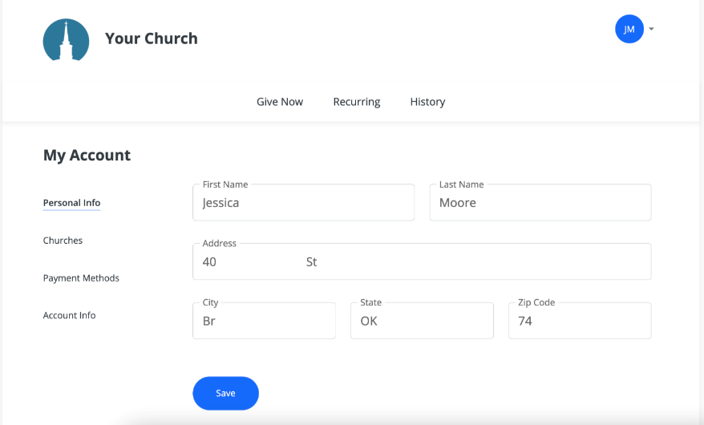
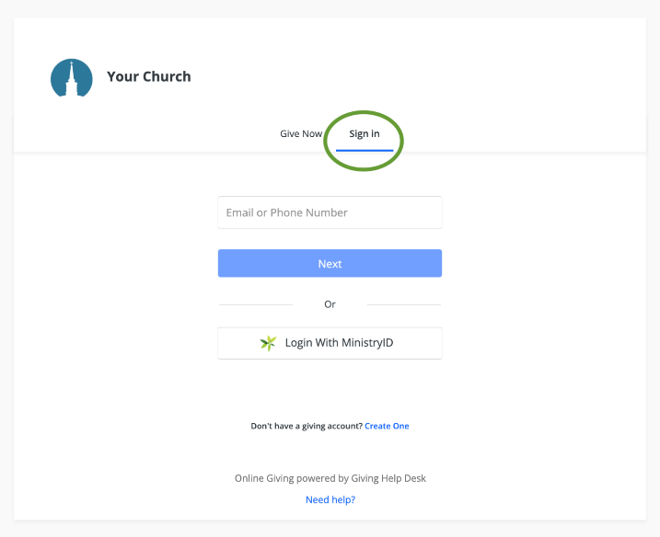

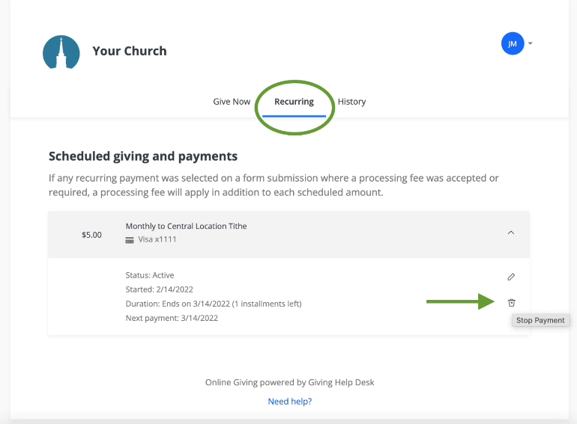
Managing Recurring Gifts
To cancel or adjust a recurring gift:
- Log into your account
- Click the Recurring tab
- Use the trashcan icon to cancel a gift
Want to make changes? You can edit frequency, amount, or payment date at any time.

Refund Requests
- Refunds can be requested through your parish directly or by contacting Donor Support at donorsupport@parishsoft.com.

Giving Options
Online Giving:
Log in to your ParishSOFT Giver Account to give online anytime.

Text Giving:
- Text GIVE to your parish’s Text Giving Number
- Follow the secure prompts
- Save the number in your contacts for easy future gifts

Need Help?
Our Donor Support Team is here for you:
Monday–Friday | 8 AM–5 PM CST
donorsupport@parishsoft.com
866-507-8757

