Service name: | 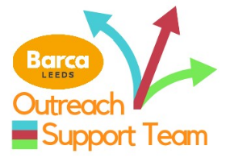  Barca Outreach Support Team
Date of Privacy Notice: | 23/11/2023
What service is being provided? | Intensive community support through A&E and Yorkshire ambulance service referral channels.  Longer term holistic support around people’s psychosocial needs.
What personal data do we need from you? | Name, DOB, Address, NHS Number, contact number
What 'special types' of personal data do we need from you? | Other information that may help us to provide accessible person-centred support. This may include any services that someone is involved with, benefit information, housing information, next of kin, medical information, criminal history.
What is our lawful basis for processing your data? | You, or your legal representative, have given consent.  It is necessary to deliver health or social care services.
Who will be using your personal data?  The Data Controller is ..  The Data Processor is/are … | The data Controller is Barca-Leeds. The data Processor is Barca-Leeds.  Barca Outreach Support Team Navigators will process the data within Barca and this is stored on the Barca database system. Consent forms will be completed with all people working with the service who have data processed for them.  The data presented to the NHS for reporting is always anonymised.
What will it be used for and what gives us the right to ask for it and use it? | It will be used to shape the support that the team provides. It will allow us to advocate for someone and gain an understanding of the person and their needs.
Who else might we share your data with? | NHS, NHS High Intensity Use meeting,  Commissioners (although this information will be anonymised)  We will discuss with you if we feel that your information needs to be shared with other services.
How long will your data be kept? | Your information will be kept for 5 years following the end of support.
Our use of your data will be subject to the following legal rights: | You can request access to your information at any point. You can change your mind on the information sharing agreement at any point.

