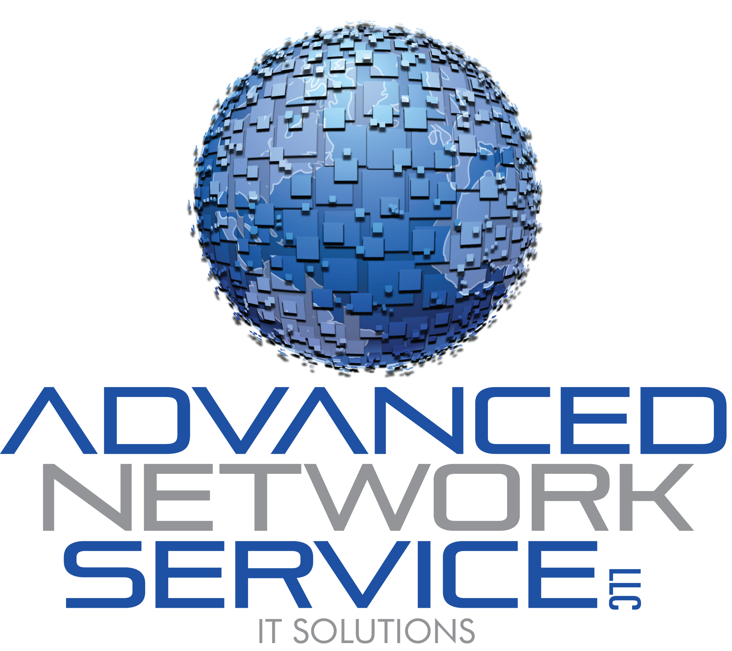
How to contact or connect to the support team
There are three ways to contact support depending on your issue. For technical issues, the first, best, method is to connect to our help desk support team at
www.startmysession.com
The website is pictured below.
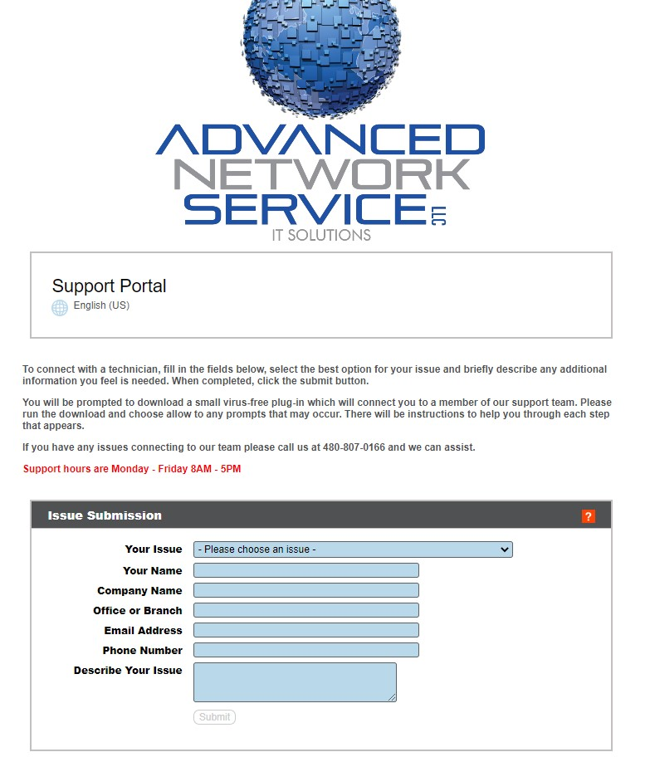
Chose the issue that best fits what you are needing support for from the drop down. Fill in all fields in the Issue Submission boxes including a brief description of your issue and click the Submit button which will light up orange when ready.
Please run any applications that you are prompted for. You will be provided help steps as you go through the process.
In Chrome, the application will appear in the top right download icon (arrow pointing downward) of your browser. Simply double click to run the remote application as pictured below.
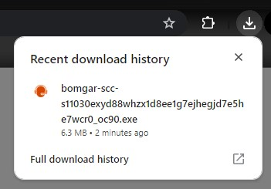
In Firefox, the application will appear in the top right download icon (arrow pointing downward) of your browser. Simply double click to run the remote application as pictured below.
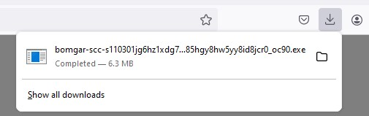

In Edge the application will download to you, you can open the download location with the down arrow at the top of your browser as pictured below if not already opened. Simply click Open file shown below to run. (if for any reason the download does not appear click the orange click here option)
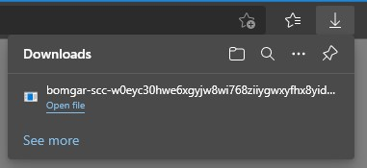

You may be prompted to allow the application to run, simply click the Yes button as pictured below.
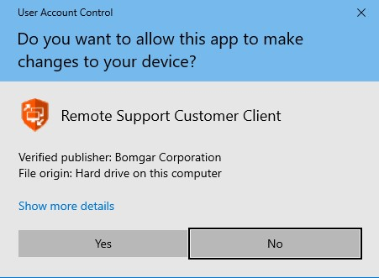
Once your connection completes you will have a small connection window left on your screen, this window will remain until an available technician connects to your computer.
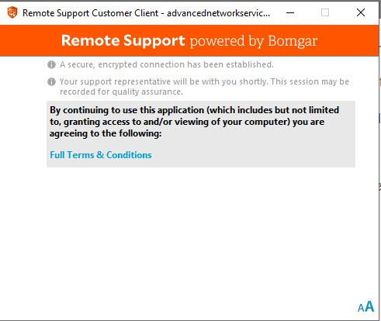
Once a technician has arrived and is connected the chat option will open in the window and a technician will beginning working directly with you as in the example below.
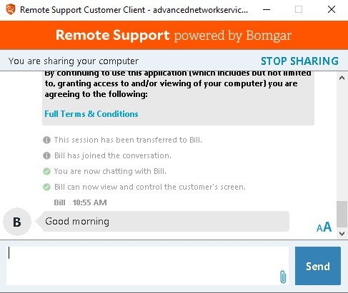
Once the connection is ended and your issue is resolved a website will open with the option to complete a survey as pictured below, along with I pop up letting you know the technician is no longer connected. Click OK on the small pop up to close it. Then simply close the browser tab/window when finished or if you do not wish to participate.
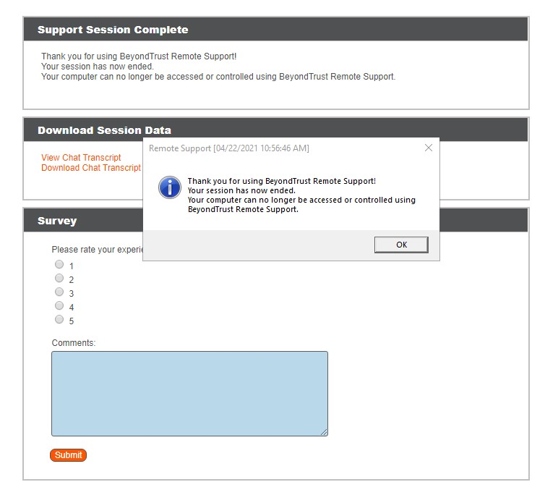


If your issue or request does not require you to connect to the support team directly for a technical issue, or you have a request such as new user creations, terminations, etc you can email your request into our ticketing system at:
support@advnetservice.com
Our support team will respond when the request is received and provide you updates to the progress of your request or ask for any additional information or assistance they may need from you.


If you cannot reach our team through connection or email due to network or connection issues you can call the support team directly at
480-807-0166 and choose option 1
This will ring all available support member’s desk phones. If our technicians are all assisting others please leave a voicemail message detailing your issue. The next available technician will respond back to you as quickly as possible

