**Join the SPIRITUAL FOOD CSA Community!**

Your Neighborhood Community Supported Agriculture Program

4209 East West Hwy

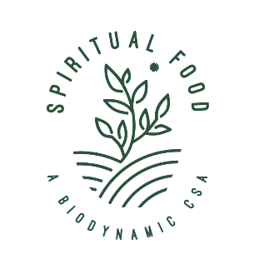

* **Farm Fresh Vegetables**
* **Add-on options: eggs, fresh baked sourdough bread; yogurt; cheese; ferments etc.**
* **Biodynamic & TRULY Organic Regenerative Agriculture**
* **Support Small Family Farmers & Artisans**
* **Choice of 5 locations in the DMV area (w/ some home delivery)**
* **Choose 4, 13, or 25 week subscription**
* **Weekly or Bi-weekly**
* **Flexibility with pauses and holds for vacations or urgent needs**
* **25+ Year Tradition of Education and Service**
* **Volunteer Opportunities! Experience the Joy of Community**

WHY CSA? Not all organic food is the same. It’s important to know who grows your food and how, to support small local farmers and be part of a community with a shared purpose: to heal the earth and ensure health and security for all. CSA members pre-pay for a farmer’s harvests. It’s a win-win arrangement that pioneers a new society where giving & receiving become one. And because SFCSA provides Biodynamic food, we are nourished at a level deeper than the physical.

To learn more, please visit: www.spiritualfoodcsa.org Or call: 301 654 4899