Attn: Police Officers


3520 Commercial Ave
Northbrook, IL 60804
LICENSE # 122-001324
Phone: (224) 235 4347
info@gammateamcorp.com
www.gammateamcorp.com

GAMMA TEAM SECURITY, Inc. is a premium company in the Security Services sect offering clients flexible, customized security solutions and superior customer services by putting forward outstanding safety measures 24/7.

We are hiring active and retired police officers from all departments for security assignments around the Chicagoland area.

If you are interested, please call 224-235-4347 or e-mail at info@gammateamcorp.com

Job Types: Full-time, Part-time, Contract
Pay: starting at $27.00 per hour

COVID-19 considerations:
wearing Mask, social distancing

We know that you are committed to your work, and we appreciate and respect everything you do.

Sincerely,

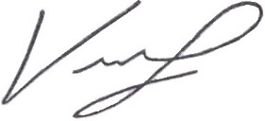
President
Gamma Team Security, Inc.
Wolf Iklov

