

Worksheet: Map and Prioritize Places, Values, and Attributes

Use this first table to identify key values already known for the heritage place. The broad value categories are provided as guidance; however, it is likely that other broad groupings will exist at many sites. We encourage you to use your language if more appropriate than English in describing your values. For explanations of broad value categories look at Appendix 1.

If you have done Stage A of Heritage Adapts you should have already completed part one and part two - therefore move onto part three - the Prioritisation section

Part One - Understanding Values and Attributes
Broad Value Category | Attribute (What is important?) | Value (Why is it important?)
EXAMPLE: Koutammakou  Ecological and Cultural | Sacred groves, forests, sanctuaries, cemeteries, ritual, initiation and funeral practices, dances and songs. | The sacred groves and forests are reservoirs for flora and fauna and contribute to the balance of the ecosystem. The Takienta would not exist without the sacred groves, forests and sanctuary. These are the places where rituals, initiations, funerals, dances and songs are performed.

This table is compiled from a range of sources including:

Court, Sarah, Jo, Eugene, Mackay, Richard, Murai, Mizuki and Therivel, Riki (2022) Guidance and toolkit for impact assessments in a World Heritage Context. Manual. UNESCO, ICCROM, ICOMOS and IUCN, Paris, France; Rome, Italy; Charenton-le-Pont, France; Gland, Switzerland. https://openarchive.icomos.org/id/eprint/2707/
Lin, B, Melbourne-Thomas, J, Hopkins, M, Hill, R, Sheppard, M, Meyers, J, Thomas, L, Visschers, L, Dunlop, M, McNeair, B, Syme, L, Grant, C, Pedrocchi, N, Oakley, P, Stevens, A, Rose, D, Rose, E, Gould, J, Locke, J, & Maybanks, L. 2022, Climate change toolkit for World Heritage properties in Australia: handbook for property managers, Department of Climate Change, Energy, the Environment and Water, Canberra. https://www.dcceew.gov.au/parks-heritage/heritage/publications/climate-change-toolkit-world-properties
Heron, Scott F., Day, Jon D., Mbogelah, Mercy, Bugumba, Revocatus, Abraham, Evarest, Sadi, Mohamed Bakari, Noah, Pauline, Khamis, Mzee Said, Madenge, Stephen and Megarry, William (2022) Application of the Climate Vulnerability Index for the Ruins of Kilwa Kisiwani and the Ruins of Songo Mnara, Tanzania. Project Report. CVI Africa Project, Dar es Salaam, Tanzania. https://openarchive.icomos.org/id/eprint/2658/

Part Two - Understanding their Relationship

Now that you have mapped your values and attributes, it is important to consider the relationship they have with one another - whether there are multiple attributes to a single value, or attribute with multiple values. Refer to Appendix 2 for examples.

Associated Value(s) | Associated Attribute(s) | Relationship

Appendix 1: Examples of Broad Value Categories

- Biological diversity (e.g., other flora, fauna, or habitats of significance not in the SOUV)
- Aesthetic values or phenomena (e.g., any special scenic qualities or phenomena that are significant)
- Economic values (e.g., provide income or employment opportunities through tourism, fishing, or other commercial activities, etc.)
- Recreational values (e.g., provide for recreational activities like hiking, camping, wildlife viewing, etc.)
- Historic/cultural values (e.g., features or locations that represent history or enable traditions or ways of life to continue, etc.)
- Learning/ Scientific values (e.g., opportunities for scientific research, nature interpretation, etc.)
- Spiritual/ Philosophical fulfillment (e.g., areas that are sacred, religious, or spiritually significant, etc.)
- Health/ therapeutic values (e.g., areas that enable people to feel better physically or mentally, etc.)

Examples from Sites

Site: Ruins of Kilwa Kisiwani and Ruins of Songo Mnara, People’s Republic of Tanzania
SoOUV(Excerpt): Located on two islands close to each other just off the Tanzanian coast about 300km south of Dar es Salaam are the remains of two port cities, Kilwa Kisiwani and Songo Mnara. The larger, Kilwa Kisiwani, was occupied from the 9th to the 19th century and reached its peak of prosperity in the 13th and 14th centuries. In 1331-1332, the great traveler, Ibn Battouta made a stop here and described Kilwa as one of the most beautiful cities of the world.
Kilwa Kisiwani and Songo Mnara were Swahili trading cities and their prosperity was based on control of Indian Ocean trade with Arabia, India and China, particularly between the 13th and 16th centuries, when gold and ivory from the hinterland was traded for silver, carnelians, perfumes, Persian faience and Chinese porcelain. Kilwa Kisiwani minted its own currency in the 11th to 14th centuries. In the 16th century, the Portuguese established a fort on Kilwa Kisiwani and the decline of the two islands began.
The remains of Kilwa Kisiwani cover much of the island with many parts of the city still unexcavated. The substantial standing ruins, built of coral and lime mortar, include the Great Mosque constructed in the 11th century and considerably enlarged in the 13th century, and roofed entirely with domes and vaults, some decorated with embedded Chinese porcelain; the palace Husuni Kubwa built between c1310 and 1333 with its large octagonal bathing pool; Husuni Ndogo, numerous mosques, the Gereza (prison) constructed on the ruins of the Portuguese fort and an entire urban complex with houses, public squares, burial grounds, etc.

Broad Value Category | Attribute (What is important?) | Value (Why is it important?)
Historic Values | Objects and artefacts, Trading routes, Exchange processes | Site of Swahili Trading History - Kilwa Kisiwani, was occupied from the 9th to the 19th century and reached its peak of prosperity in the 13th and 14th centuries…when gold and ivory from the hinterland was traded for silver, carnelians, perfumes, Persian faience and Chinese porcelain.
Archaeological | Standing archaeological remains, building knowledge and construction techniques | The remains of Kilwa Kisiwani cover much of the island with many parts of the city still unexcavated. The substantial standing ruins, built of coral and lime mortar show specific built material and building techniques.

Appendix 2: Examples of Broad Value Categories

Examples of visually exploring the relationship between value and attributes using the Heritopolis example.

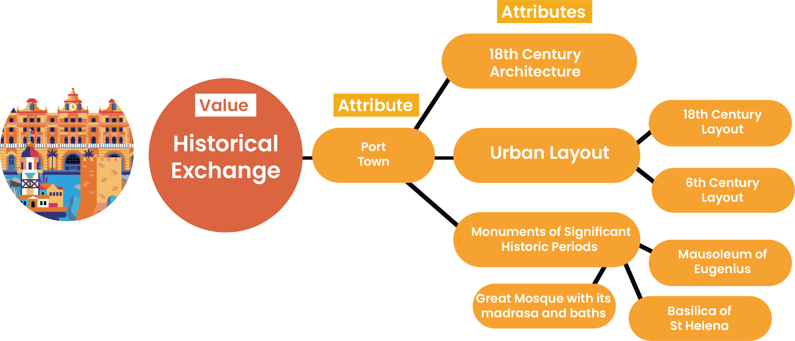
Located on the Blue Sea coast, the historic port town of Heritopolis has played a role throughout history as a place of interchange between historic cultures over time. While much of the architecture reflects the city’s golden age of wealth as a trading port in the 18th century, the buildings respect the much older urban layout that dates back to the 6th century. The 18th-century urban plan placed equal emphasis on the built fabric as on public green spaces within the city centre. In addition, within the urban fabric are a range of significant monuments from each stage of the city’s history: the Mausoleum of Eugenius, the Basilica of St Helena and the Great Mosque with its madrasa and baths, are all important architectural masterpieces of different periods. The eclectic mix of vernacular and monumental architecture reflects the diverse communities who have lived in the city for one and a half millennia and who continue to follow traditional practices today.

Part Three - Prioritising Values

Use this last table to now think about how you are going to prioritise your values and attributes for the sake of the risk assessment. Make sure to have clear rationale for prioritisation, ensuring the involvement and validation of key stakeholders and associated communities.

Key Value | Attributes (What is important?) | Prioritisation | Rationale
EXAMPLE: Ecological and Cultural  The sacred groves and forests are reservoirs for flora and fauna and contribute to the balance of the ecosystem. The Takienta would not exist without the sacred groves, forests and sanctuary. These are the places where rituals, initiations, funerals, dances and songs are performed. | Sacred groves, forests, sanctuaries, cemeteries, ritual, initiation and funeral practices, dances and songs. | 1 | These particular values were reflected most strongly as a priority with the local community, and the core components that hold up the spiritual components of the cultural landscape.  It was also felt that these were currently most obviously being impacted by climate impacts as well as other environmental changes.

