Climate Data Toolkit
This toolkit provides a flexible framework for assessing past climate trends, current conditions and future projections for any cultural or natural heritage site. It is designed to help site managers, researchers and communities document climate indicators and hazards from multiple knowledge systems, identify past events and potential future scenarios, and organise data for use in management planning.

Heritage place or practice details
- Heritage place:
- Geographic reference used for climate data (e.g. site boundary, buffer area, nearest town/city, watershed, coastal zone):
- Climate focal point(s)(e.g. steward, site staff, community representatives, local technicians):
- External partners supporting climate data (e.g. universities, research institutes, meteorological agencies, consultants, …):
- Role of partners (if applicable) (e.g. data access, analysis, interpretation, facilitation, validation,...)
- Climate data approach (e.g. led by stewards, co-developed with partners, supported by external organisations,...):
- Primary climate data platform(s)(e.g. Regional Data Hubs, national platform,...)
- Additional western scientific climate data sources (e.g. national meteorological service, hydrological service, satellite products, academic studies)
- Local or on-site climate data (none, informal observations, local records, sensors/gauges, …)
- Historical baseline used (e.g. 1970–2000):
- Future scenarios used (e.g. SSP2-4.5, SSP5-8.5, other):
- Future time windows explored (e.g. 2040–2060, 2080–2100):

1. Climate Hazards and Climate Context – Introduction
This section supports the identification and documentation of climate-related hazards and climate conditions that have affected, or could affect, the heritage place. Its purpose is to help custodians and partners develop a clear, shared understanding of local climate risks and trends, grounded in both lived experience and climate data, and to set the foundation for interpretation and future planning.
The assessment should be conducted using a plural knowledge-system approach. This means that climate hazards and indicators are identified and characterised by integrating information from multiple data sources, rather than relying on a single dataset or perspective. Experience shows that adaptation planning is more effective when Indigenous, local, and traditional knowledge are considered alongside scientific evidence, and when diverse interests, contexts, and ways of knowing are recognised.

Identifying climate hazards
Begin by identifying climate-related hazards that have occurred in the past, are currently affecting the place, or are expected to intensify in the future. These hazards should be identified through:
- Engagement with communities and knowledge holders, including elders, community leaders, practitioners, resource users, and other stakeholders, to understand which hazards have been experienced, how they are remembered, and what changes are being noticed over time;
- Review of historical records and archives, such as photographs, written accounts, oral histories, and heritage documentation;
- Review of climate and hazard data, including:
  - National meteorological and hydrological services,
  - Regional climate centres and platforms such as the Regional Data Hubs,
  - Global hazard screening tools that classify hazards (for example, high, medium, low, or very low likelihood of damaging events).
When compiling the hazard list, consider both:
- Sudden hazards, such as floods, storms, cyclones, heatwaves, landslides, or wildfires; and
- Slow-onset hazards, such as sea-level rise, increasing temperatures, changes in rainfall patterns, salinisation, or seasonal water scarcity.

Describing the climate context
In parallel, this section supports a general description of the climate and weather context of the heritage place. This description should be based on an assessment of key climate indicators, including temperature, humidity, rainfall, sea-level rise, extreme weather events, and site-specific hazards.
To build a holistic picture, these indicators should be evaluated using diverse sources of information, including:
- Scientific data and research, such as peer-reviewed studies, national climate summaries, and meteorological or hydrological records;
- Indigenous Knowledge and local knowledge, including observations of seasonal change, water availability, phenology, and hazard frequency shared through community consultations;
- Local community experiences and observations, gathered through interviews, focus groups, or participatory mapping;
- Historical records and archives, including photographs, diaries, early measurements, and oral histories;
- Interdisciplinary studies, combining insights from archaeology, ecology, social sciences, and climate science;
- Modern technology and climate modelling, such as downscaled climate models, satellite observations, hazard maps, and web-based climate tools;
- On-site monitoring and measurements, where available (e.g. microclimate sensors, rain gauges, water-level gauges, tide gauges, or remote cameras).
For each climate element described, users are encouraged to briefly note which sources were used, how different knowledge systems contribute to the understanding, and whether they complement or differ from one another.

2. Using Regional Climate Data Hubs in this Toolkit
This toolkit partially draws on bioclimatic variables available through the Regional Data Hubs to help heritage, culture, arts and creative industries stewards, communities, and partners understand past climate conditions, current trends, and possible future changes. The aim is not to analyse all available data, but to use a small, relevant selection of indicators to support meaningful interpretation, dialogue, and planning.

2.1 What climate data are available in the Regional Data Hubs?
The Regional Data Hubs provide bioclimatic variables for both historical and future periods:
- Historical baseline:1970–2000
- Future climate projections (CMIP6):
  - Medium-emission scenario (SSP2-4.5):
2020–2040 · 2040–2060 · 2060–2080 · 2080–2100
  - High-emission scenario (SSP5-8.5):
2040–2060 · 2060–2080 · 2080–2100
These scenarios reflect different global development and emissions pathways and are used to explore possible futures, not to make exact predictions.

2.2 Which future scenarios to focus on?
For most heritage contexts, it is recommended to work with two future time windows:
- Medium-emission scenario (SSP2-4.5, 2040–2060): this scenario is useful for near- to mid-term, practical adaptation planning, where changes are significant but still within a range where incremental actions can reduce impacts.
- High-emission scenario (SSP5-8.5, 2080–2100: This scenario helps explore long-term, high-end risks and supports thinking about transformational adaptation, limits to coping, and long-term continuity of heritage practices and places.
Together, these scenarios support a preparedness approach that balances realism and ambition, allowing participants to engage with both plausible and more extreme futures.

2.3 How many indicators to use
The data hub includes 19 bioclimatic variables. To keep discussions clear, inclusive, and accessible—especially for communities, rights holders, and non-specialists—it is strongly recommended to focus on:
- 2–3 temperature-related indicators, and
- 2–3 precipitation-related indicators.
Using too many datasets at once can quickly become overwhelming and make interpretation harder rather than clearer. The indicators below are provided as a reference list, from which a small, relevant subset can be selected depending on the heritage place and the questions being explored.

2.4 Bioclimatic Climate Indicators Available in the Regional Data Hubs

Table 1 - Temperature Indicators
Code | Climate indicator | What does it measure? | Why does it matter?
BIO1 | Annual Mean Temperature (°C) | Average temperature across all months of the year | Provides a general baseline of local climate conditions and long-term warming trends
BIO2 | Mean Diurnal Range (°C) | Average difference between daily maximum and minimum temperatures | Indicates daily temperature swings, relevant for material stress (expansion and contraction)
BIO3 | Isothermality (%) | Ratio of day–night temperature variation to annual temperature variation | High values indicate strong daily temperature changes, affecting sensitive materials and ecosystems
BIO4 | Temperature Seasonality (°C ×100) | Variability of monthly mean temperatures over a year | Shows strength of seasonal contrasts (e.g. hot summers, cold winters)
BIO5 | Max Temperature of Warmest Month (°C) | Highest monthly mean maximum temperature | Key indicator for extreme heat, heat stress on people, vegetation, and heritage materials
BIO6 | Min Temperature of Coldest Month (°C) | Lowest monthly mean minimum temperature | Captures extreme cold risks affecting frost-sensitive heritage or ecosystems
BIO7 | Temperature Annual Range (°C) | Difference between BIO5 and BIO6 | Measures how extreme temperature contrasts are over the year
BIO8 | Mean Temperature of Wettest Quarter (°C) | Average temperature during the wettest 3-month period | Important for understanding combined heat and humidity risks (mold, fungi, decay)
BIO9 | Mean Temperature of Driest Quarter (°C) | Average temperature during the driest 3-month period | Highlights combined heat and drought stress
BIO10 | Mean Temperature of Warmest Quarter (°C) | Average temperature of the 3 warmest consecutive months | Indicates prolonged seasonal heat exposure
BIO11 | Mean Temperature of Coldest Quarter (°C) | Average temperature of the 3 coldest consecutive months | Indicates prolonged seasonal cold exposure

Table 2 - Precipitation Indicators
Code | Climate indicator | What does it measure? | Why does it matter?
BIO12 | Annual Precipitation (mm) | Total rainfall in a year | Basic measure of water availability and flood or drought potential
BIO13 | Precipitation of Wettest Month (mm) | Rainfall in the single wettest month | Useful for assessing peak storm, flooding, and erosion risks
BIO14 | Precipitation of Driest Month (mm) | Rainfall in the driest month | Indicates severity of seasonal drought and water scarcity
BIO15 | Precipitation Seasonality | Variability of rainfall across months | Higher values indicate uneven rainfall distribution and stronger dry/wet season contrasts
BIO16 | Precipitation of Wettest Quarter (mm) | Total rainfall during the 3 wettest consecutive months | Captures seasonal flooding potential
BIO17 | Precipitation of Driest Quarter (mm) | Total rainfall during the 3 driest consecutive months | Highlights vulnerability to prolonged dry periods
BIO18 | Precipitation of Warmest Quarter (mm) | Total rainfall during the warmest 3 months | Important for understanding combined heat and rainfall stress (e.g. tropical storms)
BIO19 | Precipitation of Coldest Quarter (mm) | Total rainfall during the coldest 3 months | Helps interpret winter rain or snow dynamics

3. List of Climate Hazards and Indicators

Table 3 – Historical and Present Climate Hazards and Indicators
Use this table to record hazards that have occurred at the heritage place in the past and at present. Keep descriptions concise. Longer explanations should go in the sections below.
Hazards | Evidence base | Climate‑indicator data | Source: Regional Data Hubs, other sources | Climate hazard data | Source: Regional Data Hubs, other source
(Example: river/urban flooding) | Local accounts of major floods in 1987 and 2019; regional rainfall and river‑level records; documentation of damage to heritage structures | Annual precipitation, extreme rainfall days, and river discharge data |  | Flood hazard maps for the district showing high flood risk; ThinkHazard! Classification of flood hazard

Table 4 – Future Climate Hazards and Indicators
Record hazards are expected to become more severe or frequent in the future. Use projections from regional climate models, national climate reports and community perspectives.
Hazards | Climate‑indicator projections | Source: Regional Data Hubs, other sources | Climate-hazard projections | Source: Regional Data Hubs, other sources
(Example: heatwaves) | Projected increase in annual mean temperature of 2–4 °C by 2060; more days above 35 °C | Regional Data Hub | ThinkHazard! projects medium to high extreme‑heat hazard; regional heatwave indices | Regional Data Hub

3. Historical and Present Climate Indicators
This section summarises historical climate variables and introduces maps and graphs for selected indicators. Unless otherwise specified, use a baseline period such as 1970–2000 or another 30‑year interval appropriate to your region.

3.1 Climate Indicators Summary (historical baseline)
Populate the table below with numerical values derived from the Regional Data Hubs or similar high‑resolution datasets. Leave cells blank until data are collected. Units are given in parentheses. Use separate rows if multiple sources provide different estimates.

Table 5 - Historical Climate Indicators Summary
Climate Indicators (1970–2000) | Code | Value | Notes
Annual mean temperature (°C) | BIO 1
Maximum temperature of warmest month (°C)
Minimum temperature of coldest month (°C)
Mean temperature of wettest quarter (°C)
Mean temperature of driest quarter (°C)
Mean temperature of warmest quarter (°C)
Mean temperature of coldest quarter (°C)
Annual precipitation (mm)
Precipitation of the wettest month (mm)
Precipitation of driest month (mm)
Precipitation of the wettest quarter (mm)
Precipitation of driest quarter (mm)
Precipitation of the warmest quarter (mm)
Precipitation of coldest quarter (mm)

3.2 Temperature maps from Regional Data Hubs
Select key temperature indicators (e.g., annual mean temperature, mean temperature of warmest quarter) and create 1–2 maps illustrating downscaled historical climate data for your heritage place. The high‑resolution data (e.g., 1 km² at the equator) available through the Regional Data Hubs can reveal spatial variations across the site. Maps should include a legend, scale bar, and descriptive caption (e.g., “Annual mean temperature in [heritage place] between 1970 and 2000”).
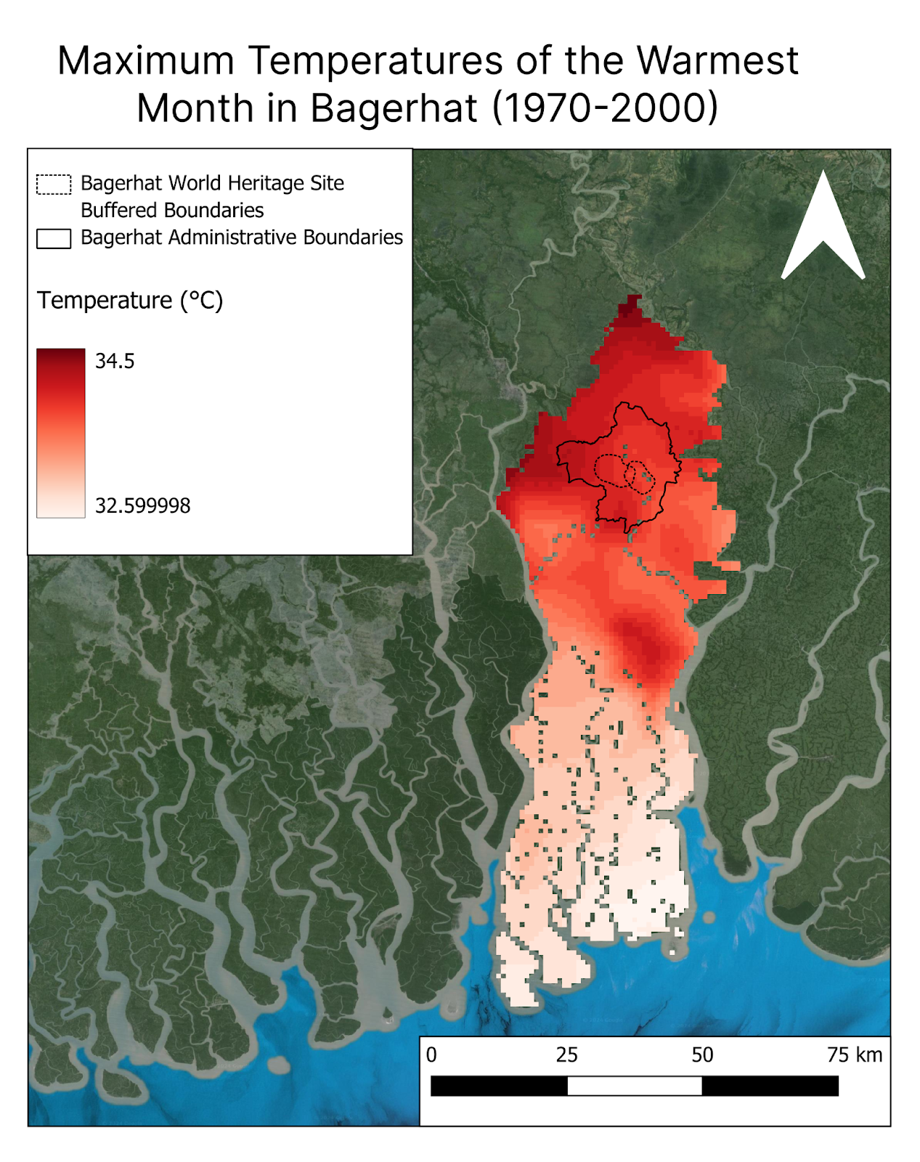 | 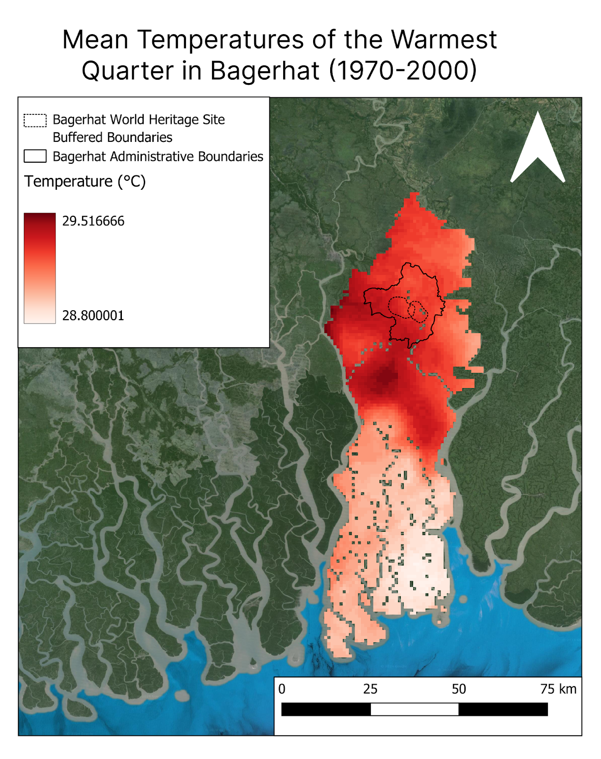

3.3 Mean yearly temperature from Meteoblue
Websites like meteoblue.com provide interactive graphs of historical and current mean yearly temperature for towns and cities worldwide. Search for the closest settlement to your heritage place and extract the mean annual temperature data. Use this information to generate a graph similar to the example below:
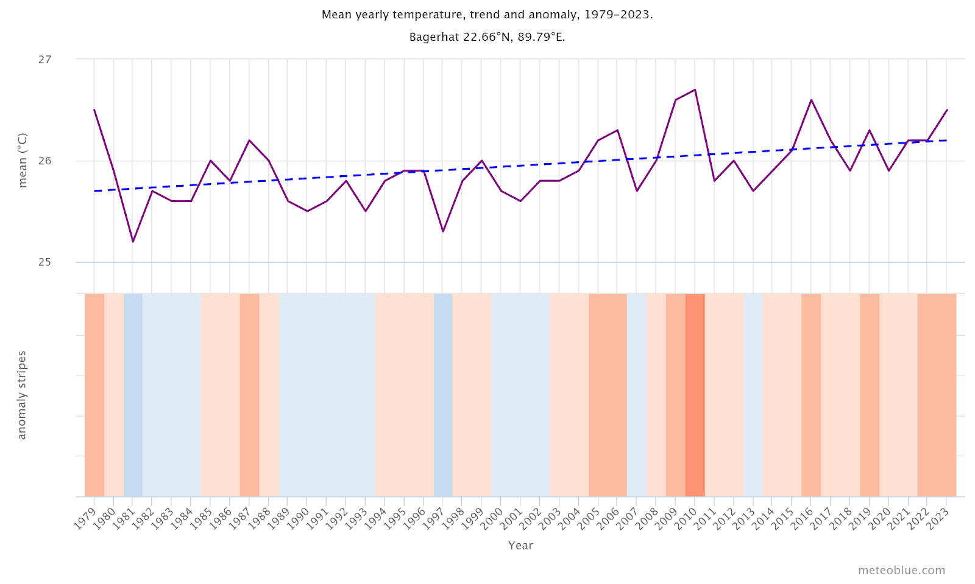
Figure: Example of Yearly temperature change in Bagerhat between 1979 and 2023. The top graph shows an estimate of the mean annual temperature for the larger region of Bagerhat. The dashed blue line is the linear climate change trend. If the trend line is going up from left to right, the temperature trend is positive and it is getting warmer in Bagerhat due to climate change. If it is horizontal, no clear trend is seen, and if it is going down, conditions in Bagerhat are becoming colder over time. In the lower part the graph shows the so-called warming stripes. Each coloured stripe represents the average temperature for a year - blue for colder and red for warmer years. Interactive graph available here.

3.4 Precipitation from Regional Data Hubs
Select key precipitation indicators (e.g., annual precipitation, precipitation of the wettest month, or precipitation of the driest quarter) and create 1–3 maps illustrating downscaled historical climate data for your heritage place. The high‑resolution data (e.g., 1 km² at the equator) available through the Regional Data Hubs can reveal spatial variations across the site. Maps should include a legend, scale bar, and descriptive caption (e.g., “Mean annual precipitation in [heritage place] between 1970 and 2000”).
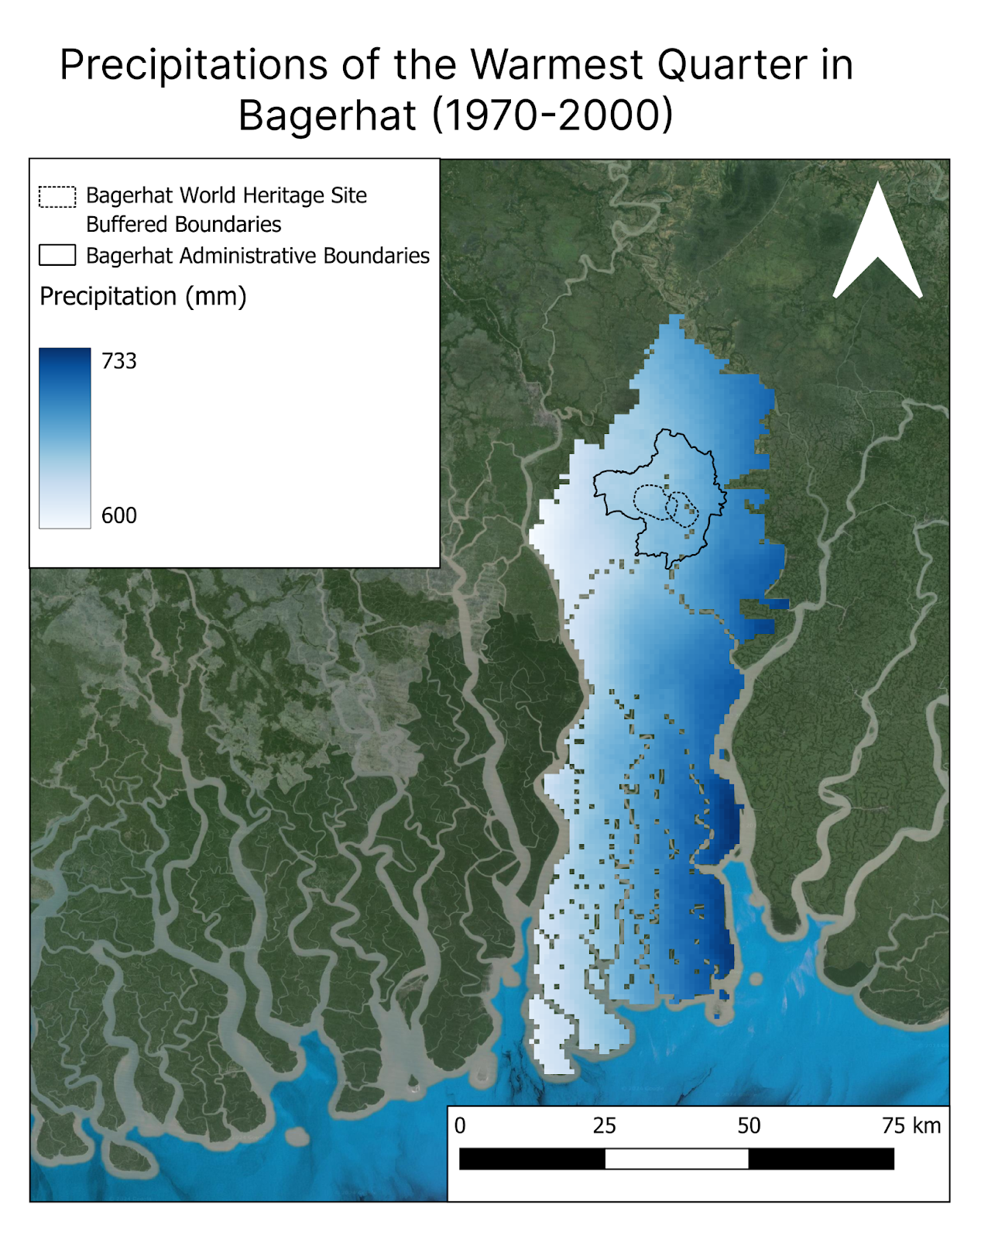

3.5 Mean yearly precipitation from Meteoblue
Websites like meteoblue.com provide interactive graphs of historical and current mean yearly precipitations for towns and cities worldwide. Search for the closest settlement to your heritage place and extract the mean annual temperature data. Use this information to generate a graph similar to the example below:
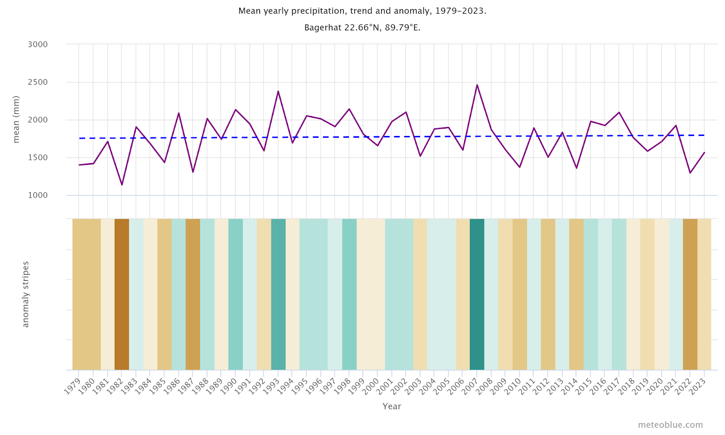
Figure: Yearly precipitation change in Bagerhat between 1979 and 2023. The top graph shows an estimate of mean total precipitation for the larger region of Cartagena. The dashed blue line is the linear climate change trend. If the trend line is going up from left to right, the precipitation trend is positive and it is getting wetter in Cartagena due to climate change. If it is horizontal, no clear trend is seen and if it is going down conditions are becoming drier in Cartagena over time. In the lower part the graph shows the so-called precipitation stripes. Each coloured stripe represents the total precipitation of a year - green for wetter and brown for drier years. Interactive graph available here.

4 Future Climate Projections of Climate Indicators
Climate projections help heritage managers anticipate future conditions and develop adaptation strategies. Fill in the table below using data from regional climate models (e.g., SSP2‑RCP4.5 for a “middle of the road” scenario and SSP5‑RCP8.5 for a high‑emissions scenario). Provide minimum and maximum values for each indicator and note the source of the projection. Additional scenarios may be added as columns if needed.

Table 6 - Future Climate Indicators Summary
Climate indicator | Baseline (e.g., 1970–2000) | Current (year) | Scenario (e.g., SSP2‑RCP4.5) – 2060 | Scenario (e.g., SSP2‑RCP4.5) – 2100 | Scenario (e.g., SSP5‑RCP8.5) – 2060 | Scenario (e.g., SSP5‑RCP8.5) – 2100
Annual mean temperature (°C)
Maximum temperature of warmest month (°C)
Minimum temperature of coldest month (°C)
Mean temperature of wettest quarter (°C)
Mean temperature of driest quarter (°C)
Mean temperature of warmest quarter (°C)
Mean temperature of coldest quarter (°C)
Annual precipitation (mm)
Precipitation of wettest month (mm)
Precipitation of driest month (mm)
Precipitation of wettest quarter (mm)
Precipitation of driest quarter (mm)
Precipitation of warmest quarter (mm)
Precipitation of coldest quarter (mm)

4.1 Discuss uncertainties
When interpreting projections, clearly describe the uncertainties associated with climate models and emission scenarios. Uncertainties may arise from:
- Model differences – different climate models may yield different results for the same scenario.
- Emission pathways – future greenhouse gas emissions depend on socio‑economic developments. Compare multiple scenarios to capture a range of possibilities.
- Downscaling methods – regional downscaling introduces additional uncertainties related to resolution and local factors.
- Natural variability – decadal climate variability can modulate trends.

4.2 Interpretation of future climate indicators into climate hazards

Step 1: Pick a few indicators (don’t use all 19)
Choose only:
- 2–3 temperature indicators, and
- 2–3 precipitation indicators.
This keeps the discussion clear for stewards, communities, and rights holders.
Good indicator options
- Temperature: BIO1, BIO5, BIO6, BIO8, BIO9
- Precipitation: BIO12, BIO13, BIO14, BIO18

Step 2: Compare “past” and “future”
For each indicator, compare:
- Historical baseline (1970–2000)
with
- Future scenario values (e.g., SSP2-4.5 and SSP5-8.5 in your chosen time windows)
You are looking for the direction of change: hotter / wetter / drier / more variable.

Step 3: Translate indicator changes into hazards
Convert the change into a simple hazard message:
- BIO5: Maximum temperature of the warmest month - if BIO5 increases, the hottest month of the year becomes hotter. This signals more extreme heat, increasing heat stress for people, vegetation, and heritage materials.
- BIO6: Minimum temperature of the coldest month - if BIO6 increases, the coldest period becomes warmer. This means less cooling at night or during cooler seasons, which can increase discomfort and reduce natural relief from heat.
- BIO8: Mean temperature of the wettest quarter - if BIO8 increases, the wettest season becomes warmer. This points to hotter and more humid conditions, increasing risks of mold, fungi, insects, and biological growth on materials and structures.
- BIO9: Mean temperature of the driest quarter - if BIO9 increases, the dry season becomes hotter. This indicates combined heat and drought stress, affecting soils, vegetation, water availability, and materials.
- BIO13: Precipitation of the wettest month - if BIO13 increases, more rain falls in the wettest month. This suggests more intense rainfall events, increasing the risk of flooding, runoff, and erosion.
- BIO14: Precipitation of the driest month - if BIO14 decreases, the driest month receives even less rainfall. This signals greater water scarcity and longer or harsher dry periods.
- BIO18 – Precipitation of the warmest quarter - changes in BIO18 show how rainfall behaves during the hottest part of the year. Increases or greater variability can indicate rain falling during extreme heat, leading to storms, erosion, flooding, and thermal discomfort.

Step 4: Ask 3 simple interpretation questions
For each indicator (or set of indicators), answer:
- What is changing? (hotter, wetter, drier, more variable)
- When is it changing? (wet season, dry season, hottest month, etc.)
- So what hazard does that create? (heat stress, drought, flooding, erosion, humid heat)

Step 5: Identify “combined hazards”
Some hazards come from two changes happening together. Look for key pairs:
- Heat + humidity (BIO5 or BIO1 + BIO8) → thermal stress + mold/biological growth
- Heat + drought (BIO9 + BIO14) → water scarcity + vegetation stress + soil cracking
- Heavy rain + heat (BIO13 + BIO18) → flash flooding + erosion + faster material damage
Write these as short “compound hazard” statements.

Step 6: Link hazards to heritage impacts
For each hazard or combined hazard, write:
- What could it damage or disrupt, for example:
  - materials and structures (wood, earth, stone, metal, plaster)
  - landscapes and ecosystems (sacred plants, soils, water sources)
  - cultural practices (timing of rituals, access, maintenance)
  - people (comfort, health, safety)
That’s it: indicators → changes → hazards → combined hazards → heritage impacts.

5. Examples of climate data presentations (Preserving Legacies Activation Cohort 2025-2026)
- Bahia (Portuguese): Climate Data Presentation - Bahia Workshop November 2025
- Kerkennah (French):Climate Data Kerkennah - Future - 2025
- Kherlen River Basin (English then translated to Mongolian):Climate Data Presentation - Kherlen River Workshop September 2025
- Himalayas (English) Bhutan - Climate Data - Regional Data Hub - 2025.pptx

