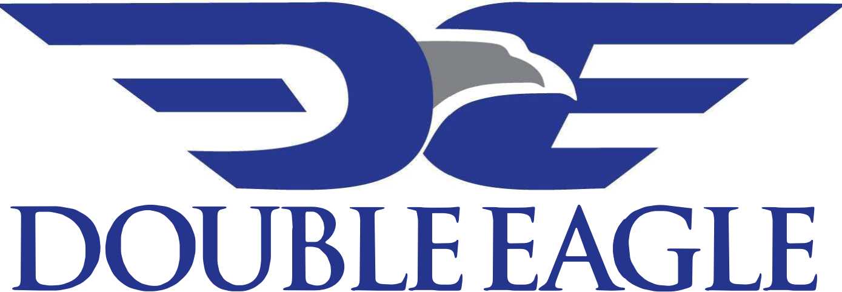
Change of Address Request Form
Owner Relations
Please return the completed form by email to revenue@depermian.com
or mail to:
Double Eagle
Attn: Revenue Dept
3724 Hulen Street, Fort Worth, TX 76107
Account Information
Owner Number
Name on Account
Tax ID or SSN
Telephone No.
Email Address

Address Change
Previous Address | Current Address

Authorization
Signature of Owner / Agent |  | Date
Print Owner Name

