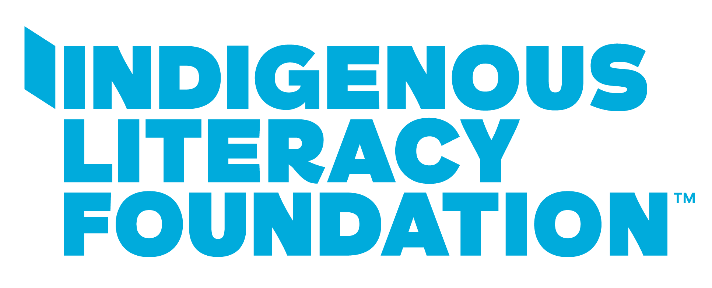

**KEY MESSAGES - INDIGENOUS LITERACY DAY**

**Copy for EDM’s/Newsletters/Webpages**

* [School Name/Organisation Name] is celebrating Indigenous Literacy Day with the Indigenous Literacy Foundation on Wednesday 3 September! It’s a national celebration of First Nations stories, cultures and languages. This years theme is ***Strength In Our Stories: For Now & Future Generations***. Celebrate with us by registering for the free FILM and LIVESTREAM event via [ilf.org.au/ILD](http://ilf.org.au/ILD)
* On Wednesday 3 September, [school name/organisation name] will be celebrating Indigenous Literacy Day - a celebration of First Nations stories, cultures and languages. Join us by registering for the free FILM and LIVESTREAM event celebrating the theme ***Strength In Our Stories: For Now & Future Generations***. Register now and learn more! ilf.org.au/ild
* The Indigenous Literacy Foundation is celebrating Indigenous Literacy Day on Wednesday 3 September, a celebration of First Nations stories, cultures and languages. This year's theme ***Strength In Our Stories: For Now & Future Generations*** will take you on an adventure through 3 remote Aboriginal Communities to learn about the diverse ways storytelling makes their Communities strong. Register for the free FILM and LIVESTREAM event at [ilf.org.au/ILD](http://ilf.org.au/ILD)

**Indigenous Literacy Foundation Social Media Handles**   
@IndigenousLiteracyFoundation - Facebook, Instagram, Linkedin

**Hashtags**

#IndigenousLiteracyDay #ILD2025

#ReadingOpensDoors #IndigenousLiteracyFoundation