Jubilee Year 2025
Pilgrims of Hope
It is funny that this past Christmas in the Church we celebrated the greatest gift of all – the arrival of Jesus. As many, like me, spent so much time in preparation and thanksgiving with others during the Christmas season there may have been something unnoticed or put aside when we attended our Christmas Eve Masses. That evening Pope Francis opened the ‘Holy Door’ in St Peter’s Basilica and at that moment our Jubilee Year of Hope began. Maybe for many of us we might have feared Christmas coming to an end, knowing that our loved ones had to depart home, and that time of celebration would take another year to come back round again.
It seems that the Church wanted to give us an extra gift this year, a year’s offer of special graces and blessings, a year of forgiveness, reconciliation, renewal and most importantly hope. It gives me, and hopefully you, great comfort in knowing that when we thought about our own new year resolutions, this year, with the graces given from the Jubilee, can be a year of resolution between us, the world and God.
One of the main factors of this Jubilee Year in the Church is hope and it made me think about what hope means in my own life? It seems the older I have got the more negative that word has become in my own life and perhaps in the lives of others. We may now hope for something better or different. I know in my own life I can be a bit selfish with how I express hope – I hope that the meeting is called off, so I don’t have to do it. I hope that someone thanks me for doing this or I am not doing it again. I hope someone else volunteers and I don’t have to do it. Maybe this Jubilee can give me another way to express hope, to use the word beyond my own needs but for the needs of others. As a youth centre this is something which we have had to think about in preparation for the Jubilee Year. What does it mean in the Church to have hope?

Year 5 and 6
Being a Pilgrim of Hope: The start of my pilgrimage journey
A retreat day for those in primary school. For the first time, in this Jubilee Year, we are opening the offer to work with those in year 5 as well as year 6. The retreat offers a chance for those in primary school to think how they can begin their journey to be Pilgrims of Hope. The young people will be challenged to think of what it means to not just walk on our own in this world but beside others. Caring for our world, protecting it and making sure it is a better place for those who will become the new generation of pilgrims of hope in the future. With the understanding that in everything we do, if done correctly can make the journey for others a lot easier.
Please contact us to book your group.
Year 7
Being a Pilgrim of Hope: In my new community
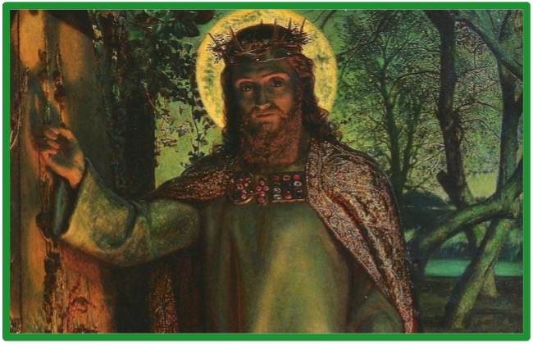
‘Knock and the door will be opened’. Matthew 7:7-8.
A door can symbolise many different things in the world, for us in the Church the door can be a sign of invitation. There are many opportunities set before us to allow us to get to the next point in life, but the question remains in all of us, will we accept the invitation? Whether we decide to open that door is up to us but when we take the initial step through the door a change of renewal begins. This retreat day is specifically aimed at those in year 7 allowing them to reflect on how they have opened a new door which has lead them to a new school with new opportunities and most importantly a new community. As well, another doorway of faith has been offered to them.
‘Ask and it will be given to you; seek and you will find; knock and the door will be opened to you’.
Please contact us to book your group.
Year 8
Being a Pilgrim of Hope: Transformed by the Spirit
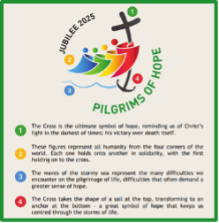
The logo for the 2025 Jubilee Year features an anchor in the shape of the bottom of a cross, with rough waves underneath. The anchor symbolises hope, and the waves represent the challenges of life's pilgrimage. The motto for the year, "Pilgrims in Hope", is written in green letters at the bottom of the logo.
This retreat day is aimed specifically at those in year 8 to allow them to think about how the sacrament of Confirmation transforms us to be fuller members of the Christian community.
This day will help young people focus on the waves they may face in their own lives but remembering the stability that the anchor provides for us all.
Please note: The whole day will not focus on the Sacrament of Confirmation, but it will be mentioned and young people will be challenged to think about what this Sacrament could offer them in their own lives. This day is suitable for those not receiving the Sacrament this year.
Please contact us to book your group.
Year 9 and 10
Being a Pilgrim of Hope: Servant Leadership

In 2023 Pope Francis led a rosary prayer for young people for World Youth Day. When he spoke to the young leaders he said: Dream big, God does too!
This is a day for those who have already received the Sacrament of Confirmation and would like to continue their pilgrim journey by focusing on what it means to be a leader in the Church and in the world.
Pope Francis also said at that meeting, ‘Follow Jesus with confidence, thinking of your growth not as a way of raising yourself above others, but as a way of lowering yourself to serve them’. Need I say more!
The date for these free days is Tuesday, 10th June 2025 or Tuesday, 25th November 2025. Max 8 per school. First come first served.
Year 11 and 6th Form
Being a Pilgrim of Hope: Where do I go from here?

Within a society radically anchored to life within the present moment, it is difficult for us to imagine what life will be like in the future. We sometimes find ourselves trapped within the anxieties of what may have happened in our past and fear what is to come. It is in remembering that we have all been chosen and called by the Lord we are able to see beyond our own hopes and fears. This day is a chance for all young people to reminded of their own value and worth in the world and the Church.
Young people are invited to a morning or afternoon to allow time to think about the next stage of their journey and how we all can be pilgrims of hope in those next steps away from school or college.
The date is Wednesday, 1st October 2025.
There is a choice of a morning or afternoon session on that day.
The day is free to attend.
Please contact us to book young people onto your preferred time. First come first served.
Special Groups and Resources
Being a Pilgrim of Hope: Music Ministry
This Jubilee Year we are hoping to create something that will have a lasting effect for the future of our Diocese and young people. We have a great cohort of people who are currently working in the background to create a Music Ministry programme to allow young people to have more involvement in our liturgies and masses – in Schools, Parishes, Confirmation, Lourdes and Faith in Action.
We are hoping to know more this month and be able to share opportunities for all young people who want to be part of this. Keep your eyes peeled and please think of any young people who may be interested in being a part of this.
Contact us for more details.
Jack Traynor: A Pilgrim of Hope - Faith in Action Jubilee 2025 Reflection Point
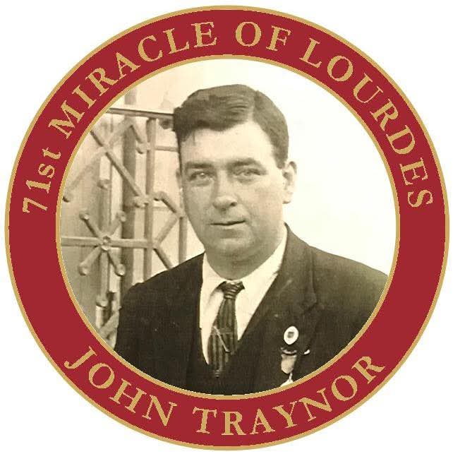
A new FIA resource that can be used in our schools and parishes that marries the theme of the Jubilee Year with our own miraculous Lourdes cure of Jack Traynor.
Being a Pilgrim of Hope: Mission Accepted - Lourdes 2025
Resources for those who will travel to Lourdes on the youth pilgrimage to allow them to think about how their pilgrimage to Lourdes is a fulfilment of the call to be Pilgrims of Hope.
Being a Pilgrim of Hope: Faith in Action Partners
A meeting for those adults who might like to be a Pilgrim of Hope but are not sure what they can do. We will offer a reminder of the opportunities an adult has to be involved in the FIA award scheme and how you have an opportunity to offer hope to many young people in our archdiocese by being one of our FIA partners.

