

The Demise of Smartphone Mirroring?

Chris Schreiner

July 2025

The Demise of Smartphone Mirroring?

For over ten years, smartphone mirroring has dominated in-vehicle infotainment. Apple CarPlay and Android Auto enabled users to bring in their own contacts and content in a manner that was all-too-often much more usable than embedded systems. It did not take long for users to utilize mirroring systems more often than embedded infotainment and consider them a must-have in their next vehicle.

Smartphone mirroring became so dominant that there were questions as to whether economy or mid-tier vehicles, or even entire smaller OEMs, should abandon any internal connected infotainment development and rely solely on mirroring for anything beyond radio.

## Have the Tables Turned?

The development of Android Automotive with Google Automotive Services (GAS) enabled automakers to more seamlessly provide those same apps straight into an embedded infotainment system, with the caveat that users still needed to have an account and sign into it to access them. Given the lack of time consumers spend setting up all the extra features in their vehicle, requiring a sign-in process for each and every service provided is a major barrier. Dealers do not want to sit and handhold their new customers through a tedious sign-in process for anything beyond a Google account.

So for the past few years, Android Automotive with GAS has arguably provided comparable functionality as smartphone mirroring, with the exception of conquering the sign-in process.

Meanwhile, more and more vehicles provide wireless smartphone mirroring, making that experience even better, since connectivity had become the top complaint for CarPlay and Android Auto.

The infotainment connectivity paradigm has traditionally been focused on “bringing your own device” (BYOD), and we still see many within the industry view this kind of connectivity as device-centric. However, that paradigm no longer corresponds with reality. App developers have long been focused on cross-platform experiences and now even mobile-first services such as WhatsApp are providing laptop- and tablet-based options creating a dominant app-centric environment.

## Cross-Platform Authorization

As part of this evolution, apps have made it easier to sign in across multiple platforms, using techniques like QR codes or text message authentication.

### QR Codes

QR codes provide the simplest way and are the most promising solution for the car. When launched on the in-car screen, the app provides a QR code that the user can scan with their smartphone camera which takes them to a webpage to confirm login. Android Automotive already provides this to allow for easier login to the main driver’s Google account. WhatsApp also provides cross-platform login via QR code.

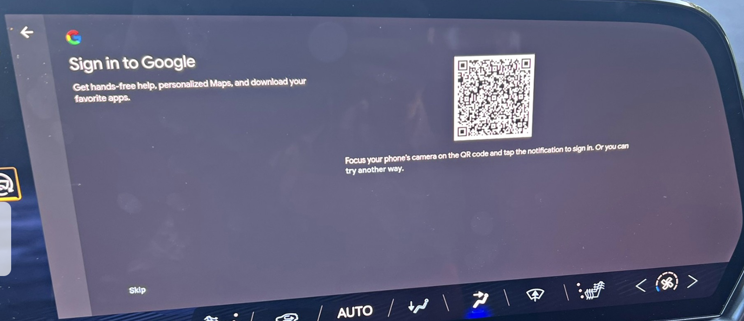

QR code login link on Android Automotive

This is a one-time setup that only takes a few steps: 1) launch app, 2) scan code, 3) confirm account access.

The barrier comes from the app developers themselves. Currently, very few apps offer QR code authentication, as QR code familiarity has spread faster in Asia and Europe than it has in the US. They have been more widely adopted by apps that would have heavy TV usage, but other apps have yet to justify the benefit of implementing QR codes for their automotive version.

However, if they did, then that final barrier would be removed, and the embedded unit would have an overall UX advantage over smartphone mirroring.

### OAuth + SSO

OAuth (Open Authorization) + SSO (Single Sign On) for cross-platform authentication has been on a much more rapid rise. This method gives users the option to sign into a third party app by authorizing access from an account they are already logged into (e.g. Google, Facebook).

For Android Automotive, this method could work very well, as users are already logged into the car with their Google account. The barrier for this method is that they will also have to have used their Google account for the third-party app, which is not a given. So this method only solves the issue for a subset of users compared to QR codes.

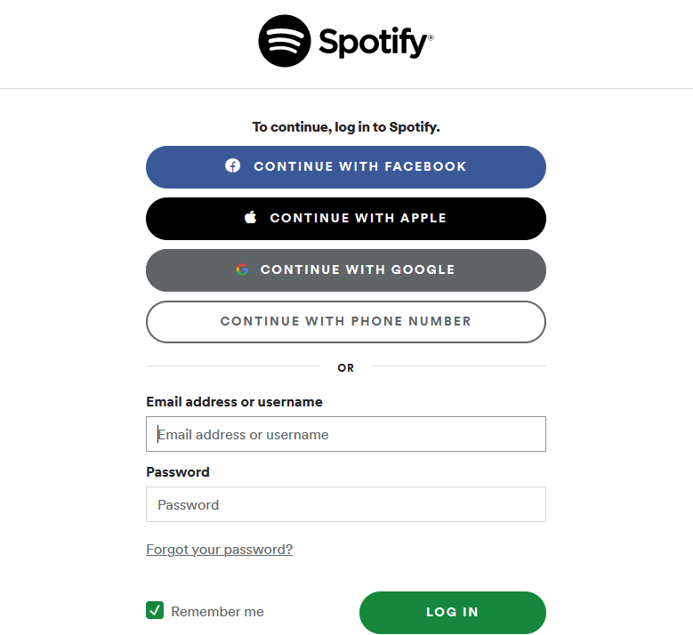

OAuth + SSO on Spotify

### Passkeys

A passkey method could allow the vehicle to send a signal to the paired smartphone and request access to an app. The phone could then detect the request and ask the user to confirm login via FaceID or fingerprint on their smartphone. This would also be a seamless method, but the infrastructure in the car is not there yet to support this.

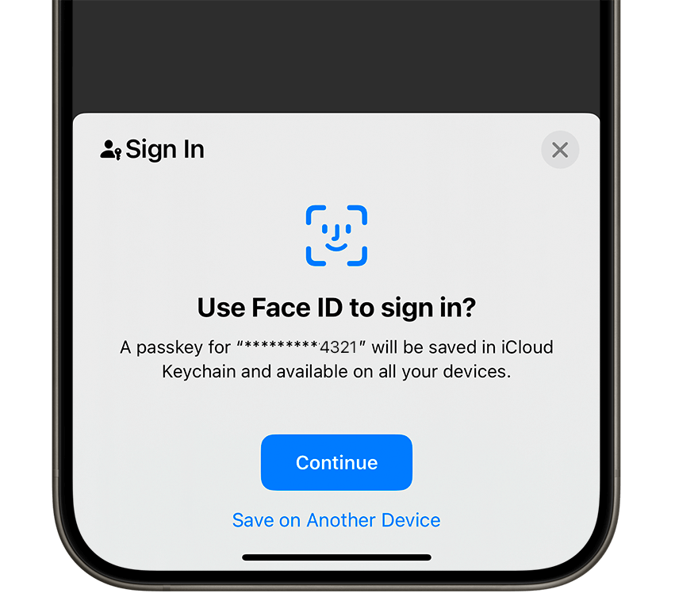

Passkey with Face ID Authorisation

### Pairing Code

Another alternative is using a pairing code, in which an alphanumeric code is displayed along with a web address. In this authentication flow, the user types in the web address on their phone and enters the code. If they are logged into the service on their browser, then the infotainment system would automatically log into their account. However, if they are not logged in on the website (which would be common for services with dedicated apps), then they would need to enter their credentials on their smartphone. This results in a fair amount of friction, especially if the password is not stored or easily remembered.

## Outlook

The friction-filled setup process is the main barrier preventing car owners/renters from fully realizing the benefits of an embedded GAS UX, in a way that equals or surpasses the UX of smartphone mirroring. QR codes smooth out that setup flow more effectively than any alternative cross-platform authorization method, but QR codes also have yet to be widely accepted by app developers. Passkeys can also provide that frictionless setup process, but would require much greater development on the part of OEMs and app developers.

The key is to require users to do as little as possible on the headunit to login. A companion app that can sync and provide authorization with other apps on the smartphone can be another solution, but we have long seen OEMs struggle with providing compelling companion apps and they have not been widely adopted by consumers.

If OEMs can overcome the setup barrier, then we can finally be at the point where the UX of embedded infotainment meets or exceeds that of CarPlay and Android Auto.

Contact

**Chris Schreiner**

+44 1313 588626

[www.userdrivenstrategies.com](http://www.userdrivenstrategies.com/) [chris@userdrivenstrategies.com](mailto:chris@userdrivenstrategies.com)

