Series: ABCDEFG – A Believer Can Do Everything For God
Message Theme: Be Fruitful by Abiding in Christ
Text: John 15
Date: 8/24/2025 - 12:30 PM – Indian Service

Greetings in the name of our LORD and Savior Jesus Christ! Welcome to The Well Community Church – Indian Service.
As we continue to grow in the LORD, we are learning many new things from Him. Our August series is “ABCDEFG – A Believer Can Do Everything For GOD.”
We have already learned that a believer should trust God and imitate Christ. Today, from John 15, we learn that a believer must also be fruitful by abiding in Christ.
Let us read John 15 together.

1. Be Fruitful John 15:8 – “By this My Father is glorified, that you bear much fruit; so you will be My disciples.”
- God’s desire is not just that we believe, but that we bear fruit.
- A fruitless Christian life does not glorify God. A fruitful life reveals His power and presence.
Types of fruit:
Character Fruit – Galatians 5:22–23 (love, joy, peace…)
Good Works – Colossians 1:10
Kingdom Impact – Romans 1:13
Reflection Questions:
- Is my Christian life producing fruit or just leaves?
- Which kind of fruit is most visible in my life today?

2. The Source of Fruitfulness: Abiding in Christ
John 15:5 – “He who abides in Me, and I in him, bears much fruit; for without Me you can do nothing.”
- Abiding = remaining, dwelling, staying connected.
- Without Christ, our efforts are empty. With Him, our lives overflow with fruit.
How to abide:
- In Prayer – daily fellowship (1 Thess. 5:17).
- In the Word – John 15:7.
- In Obedience – John 15:10.
- In Dependence – like a branch entirely reliant on the vine.
Reflection Questions:
- What does abide in Christ look like in my daily life?
- Am I relying more on my own strength or on the True Vine?
Here we go! I brought this beautiful plant from my backyard. It belongs to my daughter, Keren. I wanted to show it to you as an example of what we’re talking about.
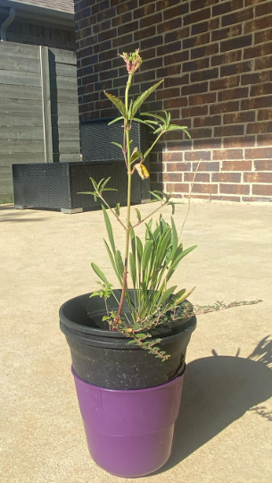
Look at this plant closely. What do you notice? It looks green and pleasant. Why? Because it has water, good soil, sunlight, and Keren takes care of it by watering it regularly.
Now, what do you think will happen if we break a branch off this plant? The plant will still be alive, but the branch will wither and die. In the same way, if we stay connected to Jesus (abide in Christ), we will grow and live strong. But if we are separated from Him, like the broken branch, we can’t grow and we lose our life.
Also, if you look at trees in the fall, you might see no leaves at all. But the tree is still alive. After some time, new leaves grow, and the tree becomes full and beautiful again. That’s just like our life in Christ, even if we lose our “leaves” (joy, strength, or peace) for a time, as long as we stay connected to Him, we will grow again and bear fruit.

3. The Process of Fruitfulness: Pruning
John 15:2 – “Every branch that bears fruit He prunes, that it may bear more fruit.”
- Pruning = cutting away unnecessary growth.
- God uses trials, discipline, and correction to remove what hinders fruit.
- Painful, but purposeful.
Cross-reference: Hebrews 12:11 – discipline yields the peaceful fruit of righteousness.
Reflection Questions:
- What “pruning” might God be doing in my life right now?
- Am I resisting or welcoming His pruning?

4. The Warning: Fruitlessness Leads to Judgment
John 15:6 – “If anyone does not abide in Me, he is cast out as a branch and is withered.”
- A fruitless believer is like a dead branch: withered, dried, and cast away.
- This is a sober warning — without Christ, there is no fruit, no life.
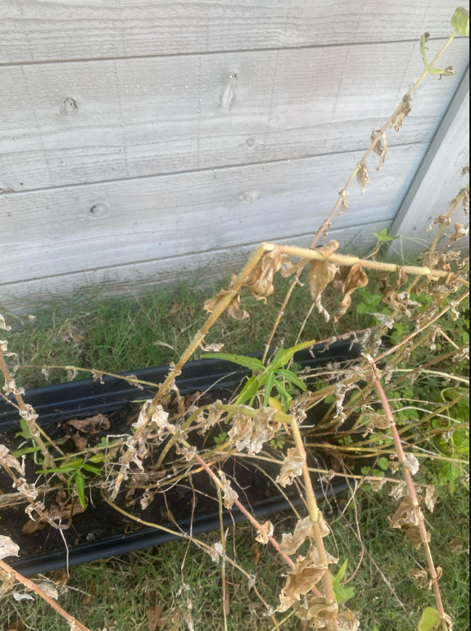
Reflection Questions:
- Am I truly abiding in Christ, or just appearing connected?
- What happens to a life that pretends to be fruitful but is not?

5. The Blessings of Fruitfulness
In John 15:8, Jesus says, “This is to my Father’s glory, that you bear much fruit, showing yourselves to be my disciples.” This verse speaks to the purpose and evidence of a life connected to Christ. Jesus teaches that when we live lives marked by spiritual fruit—such as love, patience, kindness, and good works—we bring glory to God. Our fruitfulness is not just for our benefit; it reflects God’s nature and a testimony to the world of His transforming power. The phrase “bear much fruit” implies abundance, not minimal or occasional impact. Jesus is calling His followers to a life that overflows with the results of being rooted in Him. And this fruitfulness serves as proof that we are truly His disciples. It’s not merely about claiming belief, but about living a life that visibly shows His influence. Ultimately, a fruitful life is one that both honors God and demonstrates the authenticity of our relationship with Jesus.

When we abide, blessings overflow:
- Answered Prayer (v.7)
- God is Glorified (v.8)
- Living in His Love (v.9–10)
- Fullness of Joy (v.11)
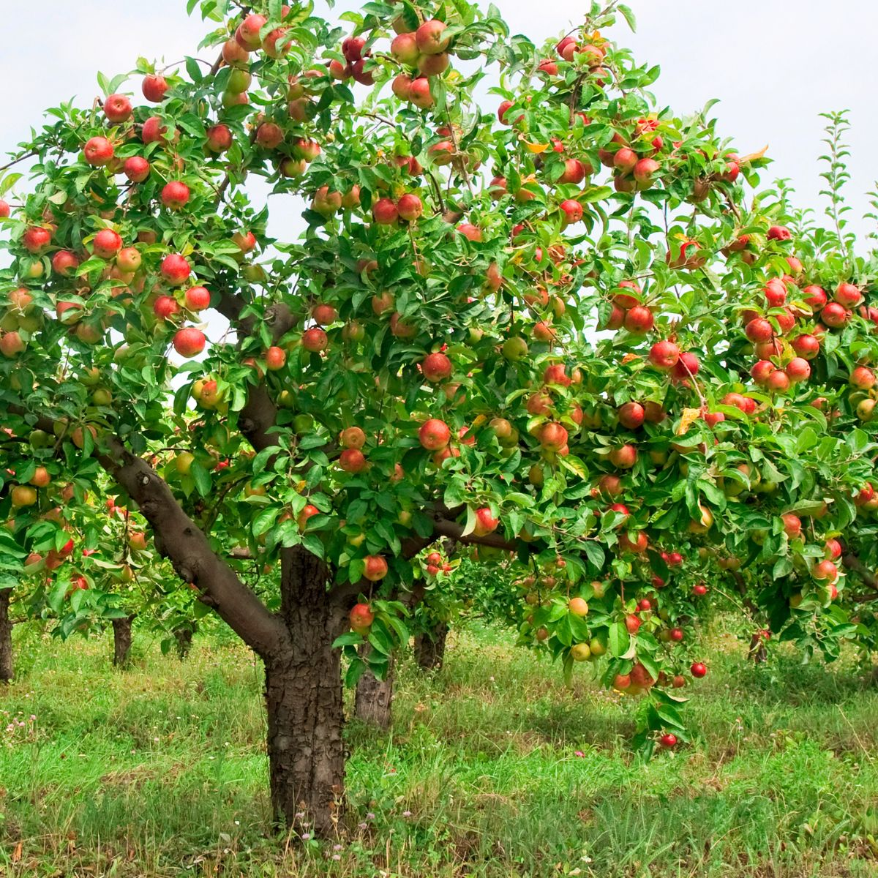
Reflection Questions:
- Do my prayers reflect God’s will or my own desires?
- How does fruitfulness bring glory to God in my daily life?
- Is my life marked by joy that comes from abiding in Christ?
6. Practical Steps to Live a Fruitful Life
- Begin each day with prayer and the Word.
- Obey God quickly, without delay.
- Confess sins daily to stay in fellowship (1 John 1:9).
- Stay connected to the church body (Hebrews 10:25).
- Depending on the Holy Spirit (Galatians 5:16)

Reflection Questions:
- Which of these steps is strongest in my life?
- Which one needs more attention and practice?

Conclusion & Call to Action
So, how can a believer do everything for God? By being fruitful.
And how do we become fruitful? By abiding in Christ.
Without Him, nothing.
With Him, everything.

Call: Today, let us commit to abide in Christ daily — so that we may bear much fruit, glorify the Father, and truly do everything for God.

Closing Prayer of Surrender:
“Lord, prune us, cleanse us, and help us remain in You, the True Vine. Make us fruitful disciples, for Your glory.”

Fruitful Life Fruitless Life
Fruitful Life (Abiding in Christ) | Fruitless Life (Apart from Christ)
Connected to the Vine (John 15:5) | Disconnected from the Vine (John 15:6)
Bears much fruit | Withers and dries up
Glorifies the Father (v.8) | Brings no glory to God
Lives in His love (v.9–10) | Lives in emptiness and self-effort
Receives answered prayer (v.7) | Lacks power in prayer
Experiences fullness of joy (v.11) | Experiences frustration and emptiness
Pruned for greater growth (v.2) | Cut off and cast away (v.6)
Lasting impact (v.16) | Temporary, fading results

