

AGENDA FOR THE SUMMER TERM 2023
(GUIDANCE FOR CHAIRS OF GOVERNING BODIES)

OPENING PRAYER AND INTRODUCTION OF NEW GOVERNORS/VISITORS (IF APPLICABLE)

PART A: STANDING ITEMS

1. APOLOGIES FOR ABSENCE
“Apologies for absence received by the Clerk, Chair or other governors will be reported to the meeting. The Governing Body is asked to determine whether or not the apologies are accepted. Governors absent from full governing body meetings for more than six months without the consent of the Governing Body, are disqualified, in accordance with School Governance (Constitution) (England) Regulations 2007 (Schedule 6).”

2. MEMBERSHIP
“The Clerk will inform the Governing Body of any membership changes since the last meeting and of any changes which will occur before the next meeting. Arrangements should be made to fill any vacancies on the Governing Body.

All governors are required to sign a self-declaration form on appointment, re-appointment, election or re-election. These should be retained by the bodies responsible for governor election or appointment.”

3. DECLARATION OF INTEREST
“The Governing Body is reminded that governors and others who are entitled to attend meetings of the Governing Body or its committees should declare an interest, withdraw from the meeting and not vote in relation to matters where:

- there may be a conflict between their interests and those of the Governing Body;
- a fair hearing is required and there is reasonable doubt about their ability to act impartially; or
- they have a pecuniary interest.”

4. MINUTES OF THE PREVIOUS MEETING
“The Governing Body is requested to approve the draft Minutes of their previous meeting as a correct record. Two copies of the approved minutes should be signed by the Chair; one kept by the Clerk, the other passed to the Headteacher to be kept available for public display.”

5. MATTERS ARISING FROM THE MINUTES NOT ELSEWHERE ON THE AGENDA
“Matters arising from the last meeting, which are not covered elsewhere on the agenda, may be raised here.”

6. REPORTS FROM COMMITTEES
“School Governance Regulations state that any governing body committee with delegated powers must report its action to the Governing Body. The following committee minutes are submitted, copies attached:

….. Committee
….. Committee.”

7. REPORTS FROM NOMINATED GOVERNORS
“The Governing Body to receive reports from nominated governors as appropriate. They may include:

(a) Link Governor (including training and development issues)
(b) SEN
(c) Safeguarding and Child Protection
(d) Others.”

8. CHAIR’S ACTION
“The Chair is asked to report any action taken on behalf of the Governing Body since the last meeting.”

9. HEADTEACHER'S REPORT
(a) Termly Report
“The Governing body is asked to receive the report. This is an opportunity for the Headteacher to update the report and for the Governing Body to ask questions and take any decisions required from them by the Headteacher, as part of their accountability and critical friend role.

(b) Educational Visits
The Governing Body is asked to approve those educational visits that require their approval.”

PART A: DIOCESAN ORIGINATED ITEMS

10. TRAINING UNDERTAKEN BY GOVERNORS
“The Catholic Education Service offer Induction Training for governors online. All governors of Catholic schools and academies will be able to complete the modules at http://www.formatio.org.uk/e-learning.

The Diocese of Lancaster encourages all governors to engage with the National training programme.

Please note that it is a diocesan requirement that all Foundation Governors are required to attend at least one diocesan training session in the four year term of office.”

11. FOUNDATION GOVERNOR APPOINTMENTS
“The Governing Body of a Voluntary Aided school is a legally constituted body under its Instrument of Government. It is essential that all Foundation Governors comply with the eligibility criteria specified in points (a) to (e) in the Foundation Governor Application Form.”

12. APPOINTMENTS FOR SENIOR POSTS Enclosure
“Governors are reminded that any appointments where there is genuine occupational requirement that they are filled by a practising Catholic it must involve diocesan advisory support from the initial meeting to discuss the appointment process.

These posts include Headteacher, Deputy Headteacher, Head of RE in a High School and Chaplain.”

13. ACADEMIES UPDATE – SUMMER 2023 – NEXT STEPS FOR GOVERNING BODIES
Enclosure
“The Academisation update : Growing our Family of Schools shares how we seek to realise the Bishop's vision of all his schools joining their MAT families no later than the end of academic year 2025/2026. Included are proposed conversion timetables and an updated FAQs document. Governors are reminded to:

1. Distribute all academy documents to stakeholders. Take the time to read all documentation carefully. Check that your school has returned all early due diligence documents to the Diocese, including the academy-ready assessment grid and the financial health information request.

2. All schools should organise a governor meeting to discuss the Academisation Plan no later than 30th June 2023. This may require an extraordinary meeting, or it may be discussed as part of the regular cycle of governor meetings.

3. Following the meeting, all schools should complete the Statement of Intent form (Appendix 8) and return to the Diocese no later than Friday 7th July.

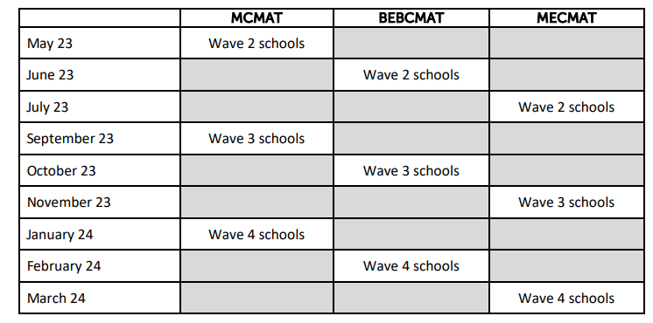
The Education Service will be holding an Academies Meeting for Headteachers and Chairs of Governors, in addition to ongoing bespoke advice as requested, where we can support schools in answering any questions they may have regarding the academisation process. These will be organised roughly according to the geographic clusters in the conversion schedules listed below ( dates and venues to follow).”

14. SCHOOL BUILDING MATTERS
“The Schools Buildings Surveyor would like to thank all who attended the recent successful Estate Conferences.”

15. SECTION 48 INSPECTIONS
“Inspection has now resumed within the Diocese and two inspections have been successfully completed this half-term. We will continue to gather feedback from our inspectors on the inspection process, which we feed into regional and national CSI inspection forums, and we welcome school feedback and questions as part of ongoing dialogue about the new framework.

All schools can access key inspection materials directly from the CSI website: click here.

Further training on the inspection process, which was originally designed for inspectors but is also useful CPD for school leaders and governors, can be accessed here: CSI training (click here).

Due to the new structure of inspections, the associated costs have changed and will be determined by size of school. We propose to charge these fees over a five-year period, at 20% of the presumed costs per year, with any rebates or further costs to be determined at time of inspection. This information was sent out in the previous termly briefing - if you are having difficult locating the information, please contact Heather Watts in the office on hew@lancasterrcdiocese.org.uk.”

PART A: LA ORIGINATED ITEMS

16. SCHOOL BUDGET 2023/24
“It is recommended that the Governing Body are updated on any early amendments to the 2023/24 budget and implications of these, where such have arisen, for school planning.”

17. POLICIES OF THE GOVERNING BODY
“It is recommended to the Governing Body that policies are reviewed on a regular basis.”

18. CONFIDENTIALITY
“The Governing Body is requested to identify any items on this agenda which it requires to be recorded in the minutes as confidential matters.”

19. DATE AND TIME OF NEXT MEETING
“The Governing Body is asked to note that its next meeting is scheduled to take place on ________________________________ 2023 at _________________ pm, and to the schedule of committee meetings for the remainder of the Summer Term.”

PART B - CONFIDENTIAL ITEMS
End of Draft Agenda

