
DIOCESAN AGENDA ITEMS FOR THE SUMMER TERM 2026

- Service Newsletter
The Sway newsletter is our half-termly update and contains information relating to schools, including governance, training dates, and important updates. Please share this with all governors.

2. Education Mass
The annual Education Mass will take place on Thursday 25th June at St. Peter's Cathedral, Lancaster at 6:30pm followed by a reception at Ashton Hall, Lancaster Town Hall. This is the principal celebration of the wonderful work of our schools, and the Bishop will be leading the Mass.

Everyone is welcome, including new governors and staff, they will be commissioned by the Bishop and thanks given to those retiring. A registration form/booking system link is
https://www.tickettailor.com/events/lancasterromancatholicdioceseeducationservice/2163378
This will be circulated to schools to register new staff or governors to be commissioned. Please ensure this is completed at the earliest possible opportunity.

- Model Appraisal and Employee Development Policy - The CES have now completed the consultation process for these policies. They will be circulated to schools and trusts, but the CES ask that they are download from the CES website for use in schools. (See attached including the response from Unions).

- Compliance with CBCEW and CES
Compliance with documents produced by the Catholic Bishops' Conference of England and Wales with the CES and noted in the minutes:

Religious Education Directory (RED) - Fully implemented in KS3 by September 2025, in Primary by September 2026 (with a diocese agreed scheme of work).
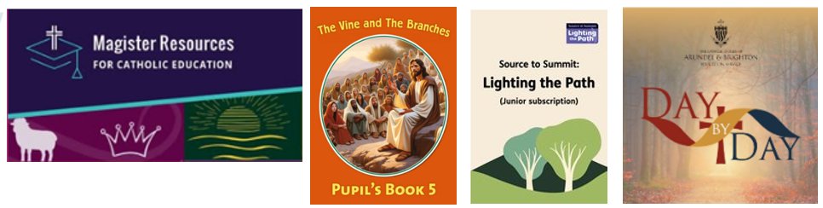
Prayer & Liturgy Directory - Fully implemented in all Key Stages by September 2025.

- Chair and Vice Chair elections
When considering electing the Chair and Vice Chair they should be Foundation Governors - unless agreed with the Education Service.

- Foundation Governor Terms of office
Please give adequate time to renew the terms of office for Foundation Governors, especially in the summer months. All governors renewing for September should be completed by July to enable paperwork to be issued in time for the new academic year.

- Admissions 2028
Compliance – the diocese are requesting that all schools update their policy. If it wasn’t done for 2027 it needs prioritising for 2028.

Consultation 1st October 2026 – 28th February 2027. Guidance to follow from Diocese/CES and consultation with 4 Local Authorities for 2027.

After the 6-week consultation period has closed and once the final Admissions Policy for 2028 has been finalised and agreed with the diocese (by the end of January 2027), then specifically minute that the proposed arrangements for 2028/2029 were determined in the Full Governing Body minutes.

Once 'determination' has taken place in the Spring Term Governing Body Meeting, please send a copy to the Diocese, Trust and Local Authority and post one on the School Website.

Please determine on or before 28th February 2027.

To comply with the DfE School Admissions Code, please make sure that the policy is with the Diocese, Trust, Local Authority and on the school website by 15th March 2027 at the very latest.

8. RE Moderation
Annual RE moderation will take place in three venues across the Diocese on Wednesday 24th June from 9:30 am to 3:00 pm at
- Rheged Centre, Redhills, Penrith;
- Jack McLaughlin Centre, Corpus Christi, Preston;
- St Cuthbert’s Academy, Blackpool.
Governors with responsibility for curriculum RE are very welcome to attend one of these. If so, please contact Jackie Broadley at jackie.broadley@lrcd.org.uk for catering purposes.

9. Annual Governors’ Conference
The Annual Governors’ Conference will take place on Saturday 28th November 2026 at University of Lancaster Chaplaincy Centre from 10:00am to 3:00pm.

