
AUCKLAND MĀORI & PASIFIKA TRADES TRAINING (MPTT) SCHOLARSHIP INFORMATION SHEET
2026
The Māori & Pasifika Trades Training (MPTT) Scholarship entitles you to: free tuition fees for this academic year (excludes short/block
courses). You will be assigned to an MPTT Navigator’ who will provide opportunities such as Work Readiness workshops & discussions
that will help prepare your transition into employment.
Eligibility criteria to apply for the MPTT Scholarship:

You must identify that you are of New Zealand Māori and/or, of South Pacific
descent
of the South Pacific regions i.e. Republic of
Fiji, The Kingdom of Tonga, Samoa, the Cook Islands, Solomon Islands, Vanuatu, Tuvalu, Nauru, Niue, Kiribati and atolls of Tokelau.
It is very important that you identify
as being of New Zealand Māori and/or of South Pacific descent when you apply for the
programme that you wish to study in.

If you do not identify as New Zealand Māori and/or of South Pacific descent on your
programme of study application, you will need to provide evidence to support your ethnicity when you complete this MPTT
Scholarship application
and

You must be a NZ Citizen or NZ Permanent Resident or regarded as a Domestic student or an Australian Citizen or Australian
Permanent Residence currently residing in New Zealand
and
You must be aged between 16-40 years of age at the start of your programme at Lifeskills Training + Education
You
are
enrolled
in
a
programme
at
Lifeskills
Training

+
Education
which
is
approved
for
Māori
&
Pasifika
Trades
Training
Scholarship funding.

All MPTT Scholarship recipients are required to
adhere
to the following terms and conditions of this Scholarship
All Scholarship applicants may be required to attend an interview unless otherwise advised. Applicants can bring a support
person/s with them to the interview.
Regular attendance to your classes throughout the duration of your course
Attend ALL “Work-Ready” preparation programme workshops.

Maintain regular contact with your MPTT Navigator services
Attendance and participation in Regional MPTTA events if and when required
Fully consent to MPTT staff informing the person I’ve nominated to act as my Recommended Sponsor and Navigator of my
academic progress when required.
To apply for the Lifeskills Training + Education MPTT Scholarship please
complete
the questions in the application form (page 2) and
attach the required supporting documents as noted below.

Auckland Māori & Pasifika Trades Training Scholarship Form
(
completed and signed
)
Copy of your CV

Your Recommended MPTT Support Person form.
Personal Statement to be completed by the applicant (outline detail why you should be
awarded the MPTT Scholarship which should include
POST
Māori and Pasifika Trades Training Scholarship
Lifeskills Training and Education
PO Box 53 166
Auckland Airport
Auckland 2150
Or
EMAIL
Josh.levi
@
lifeskills.nz
Or
IN-PERSON
Any of our Auckland Campuses:
Henderson Campus: 8 Te Pai Place, Henderson
Mangere Campus: 59 Tidal Road, Mangere
Papakura Campus: 15 Walters Road, Papakura
All documents must be returned (as per locations listed below)


2026: AUCKLAND MĀORI & PASIFIKA TRADES TRAINING (MPTT) SCHOLARSHIP APPLICATION FORM
Legal First Name: | Legal Surname:
Known as or preferred name(s): | Date of Birth: dd / mm / yyyy
Postal Address:
Suburb: | Town/City: Postal Code:
Ethnicity 1: | Ethnicity 2:
Iwi 1 (Maori): | Iwi 2 (Maori):
Village 1 (Pacific): | Village 2 (Pacific):
Home Phone: | Cell phone Number:
Work Phone: | Email Address:

AREA OF STUDY
Have you applied and been accepted into your programme of study at Lifeskills? (plse circle) No / In progress / Yes
Name of programme:
Programme Code (if known): | Expected Start Date:
Lifeskills Student ID Number: (if known)

MORE INFORMATION
Do you have a Drivers Licence (Plse circle), None, Learners, Restricted, Full
Do you have a CV? No / Yes (if Yes, please attach your CV to this application)
What is your shirt size? Do you have access to Internet at home? Yes / No
Do you have access to a device? No / Yes (if yes what type of device)
Would you continue to study at Lifeskills if this Scholarship was not available?
What Career would you like to get into?
Do you have any work experience in the field of study you have applied for?
Are there any concerns you have that could impact on your ability to successfully complete your programme of study? e.g. working, No / Yes (if yes please advise what these concerns are)

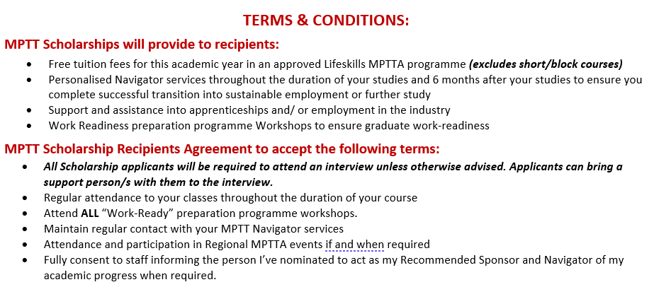

Signed: ………………………………………………………………….. Date: …………………………………………

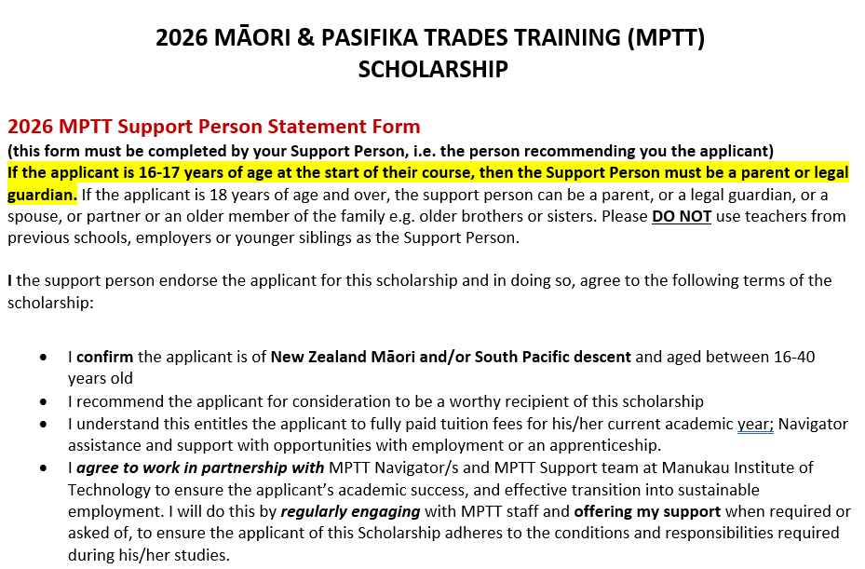

Full Name of Applicant applying for the MPTT Scholarship:

Full Name of Support Person:

Postal Address of Support Person:

Home Phone: | Cell phone Number:
Work Phone: | Email Address:
How do you (as the Support Person) know the Scholarship Applicant?

Signed: | Date:

