SETTING RISK ASSESSMENT

Name of setting: ENTER SCHOOL NAME - Wraparound Services Risk Assessment

Assessment conducted by: | Name: | Signature: | Date:

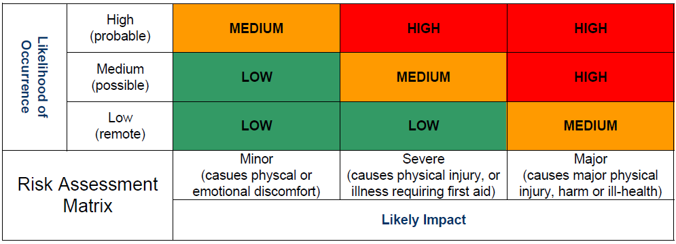
- The Risk Assessment Matrix is used to assess risks before and after control measures are applied. The objective is to remove all HIGH risks and to reduce all other risks to an acceptable level.

Area for concern | Risk rating prior to control  H/M/L | Risk Control Measures | Risk rating following action  H/M/L
Inadequate supervision of activities or activities not suitable for students. | M | - Supervision ratios are appropriate for the number of children and the activities (taking into account staff absenteeism / holidays / sickness)  - Where 1:1 support is required due to behavioural/additional needs, this is considered in supervision ratio | L
Use of knives and equipment | M | - Only staff are permitted to use (kept out of children’s reach in a locked sharp box) and equipment. Any defects will be reported to the school.  - Staff have been trained in the correct use of knives and equipment  - Equipment, such as knives and higher risk equipment, is counted out and back in at the end of each club | L
Allergies and intolerances to specific foods, resulting in potential for allergic reactions. | M | (  - Arrangements are in place for camp staff to receive adequate information from parents / school relating to the pupils attending the camp, i.e. pupil medical, dietary, behavioural or other special needs, i.e. allergies.  - Staff that handles food are trained in food allergies and food safety  - Food for children with food allergies/intolerances will be prepared before, and separately to other food to avoid cross contamination.  - Any changes to dietary requirements/allergens must be reported by parents to Orbito Head Office to update our medical records  - All allergies/dietary requirements are stored centrally on digital system, parents must fill in this information when creating an account. This information will be shown on the digital register for staff to view on site. | L
First Aid and Emergencies – risk of choking etc | L | - Qualified first aiders are in place at an appropriate ratio for paediatric first aiders for the age of children attending provision  - All members of camp staff have been trained to an appropriate level of first aid (taking into consideration staff absenteeism, holidays etc). Refresher training is provided.  - A suitable number of First Aid kits are provided in the rooms which are used  - There is a policy for the administration of medication and club staff are familiar with this.  - Parental consent is obtained prior to medication being administered to pupils  - Children are seated when eating and drinking at all times  - All building users advised re monitoring their own health, reporting of symptoms and self-isolating for contagious diseases. Users are advised to wear PPE where possible.  https://www.gov.uk/government/publications/covid-19-personal-protective-equipment-use-for- | L
Electrical hazards, giving rise to potential for fire, shock, burns etc | M | - Arrangements are in place for portable electrical appliances to be PAT tested on a regular basis  - There are sufficient numbers of electrical sockets in the rooms to avoid the use of extension leads wherever practical  - Staff visually inspect portable electrical items for evidence of cable damage / crushing, plug damage, etc. prior to use  - Fire extinguishers are provided within the room and staff trained in their use  - Cooking or toasting equipment is unplugged after use | L
Slips, trips and falls | L | - Staff carry out checks and a daily risk assessment of the room prior to use  - Children’s bags and other school items are stowed away and not left in gangways  - All spillages are cleaned up promptly  - There is a formal system for reporting health and safety defects  - Sufficient lighting is provided | L
Food safety and use of chemicals | M | - Staff responsible for preparing or handling foods have appropriate food safety knowledge / food hygiene training  - There are suitable arrangements in place for the storage of club food, including chilled / perishable foods  - Temperature records are maintained daily through use of a fridge thermometer  - Only food grade cleaning chemicals are used within the room by staff. Access to chemicals by children is restricted  - Staff trained in safe and correct use  - Waste is stored correctly and is regularly removed | L
Kitchen Hygiene | M | - All areas and surfaces of the kitchen will be cleaned before and after use and in between any food preparation session.  - Gluten free and other foods for children with allergies will be stored correctly and separately to ensure there is no cross contamination.  - If kitchen areas are to be used and food preparation is planned, HACCP plan in place. | L
Toilet Areas | L | - Children will have toilet breaks built into the timetabled session. Those who need to go in between these times will be supervised on the walk to the toilets by a member of staff. Children will be reminded of the handwashing procedure. | L
Safeguarding | L | - Behavioural issues will be dealt with by the staff onsite following our Fun Agreement. All incidents relating to behaviour will be logged electronically on an incident form and the Supervisor will communicate this with parents. Should a child persistently break the rules and/or cause a safeguard concern for themselves or anyone else on site. Their parent/guardian will be called to collect their child immediately  - The Designated Safeguarding Lead will be made aware of any Child attending that are on the Child Protection register. If a staff member has any concerns about a child’s welfare, they must inform the Designated Safeguard Lead immediately. | L
Fire Alarm | L | - Fire drill process will be explained to children at the start of the session. Should the firm alarm go off, children will line up and file out of their nearest fire exit door in their groups and walk calmly to the site-specific fire assembly point with their assigned bubble coach.  - Ensure all staff working in different spaces know their quickest fire exit | L
Injury from  lifting/handling | L | - Children not to move any heavy items, any equipment that is handled by children, staff will demonstrate correct way to lift safely. | L
Activity | L | - All rules will be explained to children within the activity/sport they are taking part in.  - Children will be in age groups for any physical contact sports to reduce the risk of injury and abilities will be considered in all activities. | L
Louise Noises | L | - ENTER SCHOOL NAME will be made aware of any contractors on site that may create louder noises.  - Other areas to be explored to use If noises become to loud | L
Impaired vision | L | - Activities will not go ahead outside if the weather effects vision as well as children will not be outside when dark.  - If lighting issues occur inside, we will seek to use another area, or ensure all blinds/curtains are open to let in light from outside. | L
Personal Safety/Public | M | - All visitors will be required to sign in at school reception.  - No one to be allowed on site without permission and staff seeing photo ID of the visitor.  - School/site to inform us if anyone is to be on site, contractors or teachers.  - Children kept away form any areas that may be used by other hirers/contractors. | L

