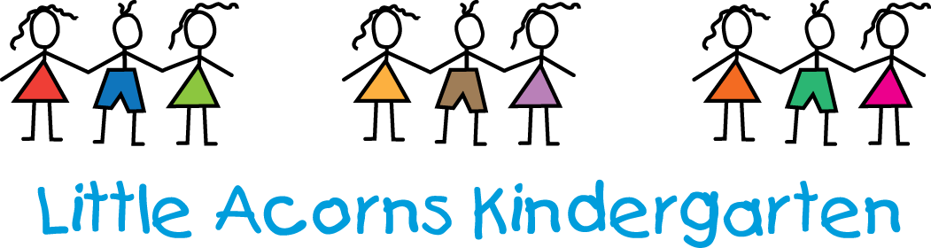

Tapestry Online Agreement Form

I give permission for Little Acorns Kindergarten to create an online Tapestry Learning Journey for ……………………………………………………………… (name of child).
The e-mail address/addresses I would like to link with the account so I have access to my child’s Learning Journey is/are ……………………………………………………………………………………………………………………………(provide your e-mail address).

Agreed guidelines for accessing and using Tapestry ‘Online Learning Journeys’

As a parent I will…
• Not publish any of my child’s observations, photographs or videos on any social media site. Understand that my child’s image may be used in another child’s profile if they are engaged in the same activity. This image will not be shared by the other parent (please see above point) • Keep the login details within my trusted family • Speak to a member of staff if I experience any difficulties accessing my child’s learning journey

I agree to the guidelines:

Print name: _____________________________

Name of child: _____________________________

Signature: _____________________________ Date: ___________________

