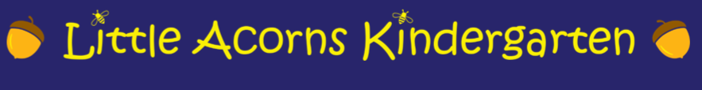

Safer Eating Policy
For Packed Lunches & Prepared Snacks

Purpose
This policy ensures a safe, inclusive, and healthy eating environment for all children, supporting their well-being, reducing risk of allergic reactions, and promoting good hygiene and nutrition habits.
All members of staff are paediatric first aid trained, ensuring a rapid and informed response to any medical emergency. During mealtimes, each table of children is closely supervised by a dedicated member of the team, who actively monitors eating habits and offers support as needed. This supervision, combined with trained awareness, helps maintain a safe and calm environment for all children during food-related activities.

Packed Lunches – Guidelines for Parents
Parents are kindly asked to follow these guidelines when preparing packed lunches:
- Allergen Awareness
  - Strictly no nuts or nut-based products (including peanut butter, cereal bars with nuts, etc.).
  - Please always check labels thoroughly
- Healthy Choices Encouraged
  - Include fruit, vegetables, whole grains, and a source of protein.
  - Limit sugary treats and drinks—water is preferred.
- Food Safety
  - Use an insulated lunch bag with an ice pack to keep food cool.
  - Ensure food is fresh, well-cooked, and stored hygienically at home before packing.
- No Sharing Rule
  - Children are not to share food with their peers to avoid allergen exposure.
To minimise the risk of choking, all food brought into the setting must be prepared with young children's safety in mind:
- Cut grapes, cherry tomatoes, and similar items lengthwise into quarters — never served whole.
- Slice sausages and hot dogs lengthwise, then into small pieces.
- Avoid hard, round foods like raw carrots
- Remove pits, stones, and hard skin from fruits.
- No popcorn or hard sweets.
- Sticky or chewy foods should be avoided.

Prepared Snacks – Provided by Preschool
Preschool staff offer snacks during the morning and afternoon sessions, prepared in accordance with the following principles:
- All snacks are nut-free, with allergen-safe alternatives provided as needed.
- All food prep follows strict hygiene procedures (handwashing, clean surfaces, separate utensils).
- Staff will maintain a record of known allergies and ensure supervision during snack time.

Hygiene & Supervision
- Staff and children will wash hands before and after eating.
- Tables are disinfected before and after meals or snacks.
- Each table will be closely supervised by a paediatric first aid trained staff member, ensuring swift response in case of choking, allergic reactions, or other emergencies.
- Meal and snack time is supervised to monitor food safety and encourage polite eating habits.

Communication with Families
We welcome conversations with parents about dietary needs, preferences, or cultural considerations. Regular reviews of this policy will keep our approach current and collaborative.

