Reason for today’s visit?

Pain Management Injections Eval and Treat

Pharmacy: ________________________
PCP: ________________________
Referring Physician: ________________________

PLEASE CIRCLE THE LOCAITON OF YOUR WORST PAIN TODAY
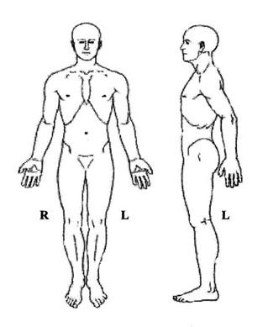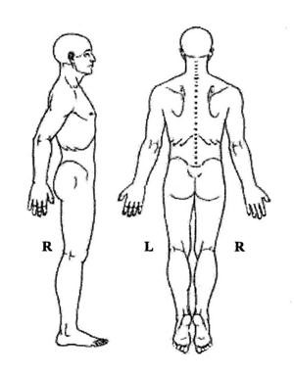

Rate your pain (0 is no pain, 10 is worst):
Please rate your pain by circling the number that best describes your pain at its WORST
0 1 2 3 4 5 6 7 8 9 10
Please rate your pain by circling the number that best describes your pain at its LEAST
0 1 2 3 4 5 6 7 8 9 10
Please rate your pain by circling the number that best describes your pain RIGHT NOW
0 1 2 3 4 5 6 7 8 9 10

3. Does your pain negatively affect any of these activities?

Enjoyment of life
General activity
Mood
Normal work
Recreational activities
Relationships with people
Sleep
Walking
Sitting
Standing

Other _______________________

Have you had any of the following?

Hospitalization
Emergency room visit
Primary care visit
Mental Health visit
Change In Marital Status
Death in the family
Changes in family structure
Changes in employment
Arrested by law
Operating under the influence
Procedures
New medication prescribed
Other _________________________

Please check any of the following you are CURRENTLY having (Please answer all of the following)

Gastrointestinal:
Nausea
Vomiting
Frequent Diarrhea
Constipation
Heartburn

Endocrine:

Increased Thirst
Heat Intolerance
Cold Intolerance

General:
Recent Fever or Chills
Weight Gain
Weight Loss
Night Sweats
Fatigue

Eyes:

Dry Eyes
Irritation
Vision Change

ENMT:

Difficulty Hearing
Ear pain
Frequent Nosebleeds
Nose/Sinus Problems
Sore Throat
Bleeding Gums
Snoring
Dry Mouth
Oral Abnormalities
Mouth ulcer
Teeth Abnormalities
Mouth Breathing

Cardiovascular:

Chest Pain on Exertion
Arm Pain in Exertion
Shortness of Breath when walking
Shortness of breath when lying down
Palpitations
Know Heart Murmur
Light-headed on standing

Respiratory:

Coughing
Wheezing
Shortness of Breath
Coughing up Blood
Sleep Apnea

Genitourinary:

Urinary loss of Control

Difficulty Urinating
Increased Urinary Frequency
Blood In Urine (Hematuria)

Incomplete Emptying

Integumentary/Skin:
Abnormal Mole
Yellow/Jaundice
Rash
Itching
Dry Skin
Growth/Lesions

Neurologic:

Loss of Consciousness
Weakness
Numbness
Seizures
Dizziness
Frequent of severe headaches
Migraines
Restless Legs
Loss of Bowel
Loss of Bladder

Psychiatric:

Depression
Sleep Disturbances
Restless Sleep
Feeling unsafe in a Relationship
Alcohol Abuse
Mood Swings
Suicidal Thoughts

Hematologic/Lymphatic:

Excessive Bleeding
Excessive Bruising

Musculoskeletal:
Severe Muscle Pain
Muscle Spasms
Muscle Weakness
Neck Pain
Mid-Back Pain
Low-Back Pain
Pain In Upper/Lower Extremities
Numbness In Upper/Lower Extremities
Tingling In Upper/Lower Extremities
Weakness In Upper/Lower Extremities

Medication Trials (previously taken meds)

Anti-inflammatories

Ibuprofen
Naproxen
Meloxicam
Celebrex
Other ________________

Muscle Relaxers

Cyclobenzaprine
Skelaxin
Methocarbamol
Tizanidine
Baclofen
Other _____________

Opioids

Duragesic/Fentanyl
Oxycontin
Roxicodone
Methadone
Percocet
Belbuca
Morphine
Hydrocodone
Dilaudid

Social History

Smoking status: Never Former Smoker Current every day smoker Current somedays smoker

1PPW 2 PPW ¼ PPD ½ PPD 1 PPD 2 PPD 3+ PPD

Tobacco years of use: _____________

Deal or serious difficulty hearing? Yes No Blind of serious difficulty seeing? Yes No

Difficulty concentrating, remembering or making decisions? Yes No

Difficulty walking or climbing stairs? Yes No

Difficulty dressing or bathing? Yes No

