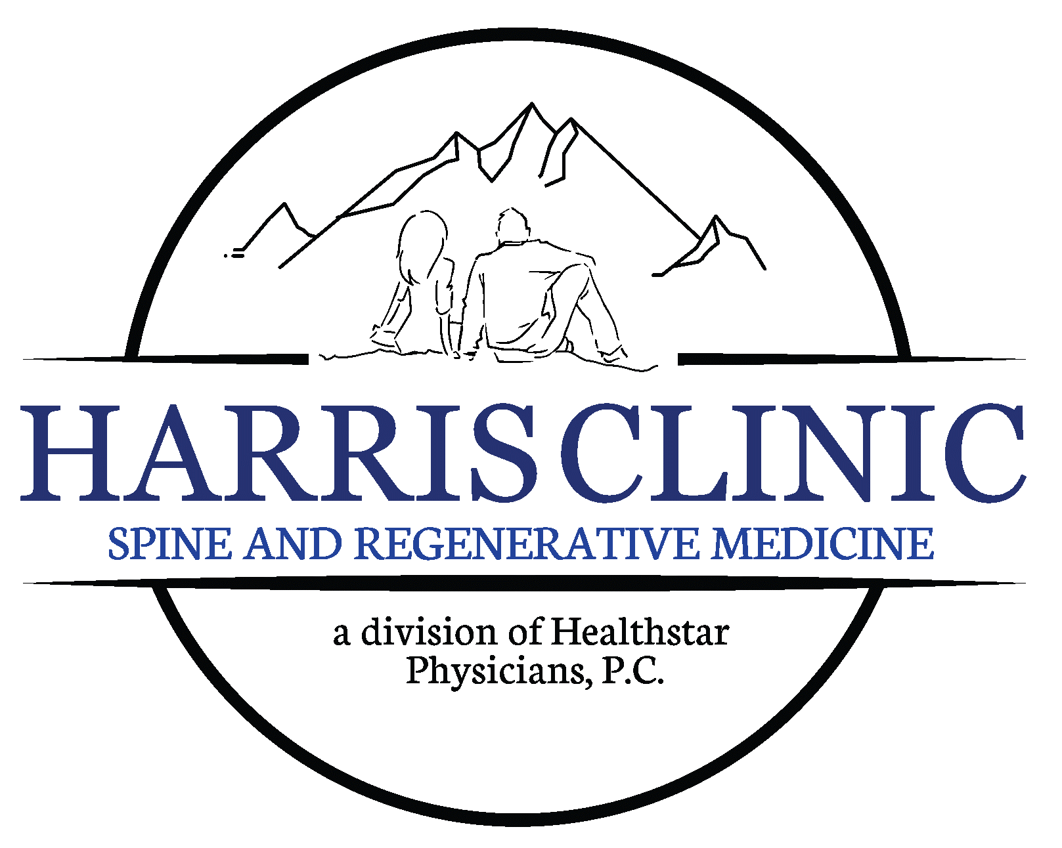

PROCEDURES THAT REQUIRE PREP
GI PREP INSTRUCTIONS
**All items listed in this prep are available over the counter without a script**

The day before your procedure:
- At 2:00 PM take 2 Senna (Sennakot) tablets followed by 8 oz. of water
- At 4:00 PM drink 1 bottle of Magnesium Citrate or take 2-3 400 mg Magnesium Oxide pills every 6 hours followed by 8 oz of water until bowel movement.

If no bowel movement, then please continue the following prep:
- At 6:00 PM mix a pitcher of MiraLAX (mix as directed on the label) (with Gatorade, Water, Kool-Aid, Juice) drink 4 glasses then take two magnesium 500 mg pills.

The day of your procedure:
- If your procedure is scheduled in the morning do not eat, only drink liquids. (Diabetics can eat a light breakfast)
- If your procedure is scheduled after lunch, then you may have a light breakfast. You may then only drink liquids up to 1 hour before procedure. (Diabetics can eat a light lunch)

**WE MAY REQUIRE THAT YOU HAVE A DRIVER FOR THIS PROCEDURE IF THAT IS NOT POSSIBLE CALL US BEFORE YOUR APPOINTMENT**
If you have any questions or concerns regarding the GI Prep, please call our office at 423.581.3939

