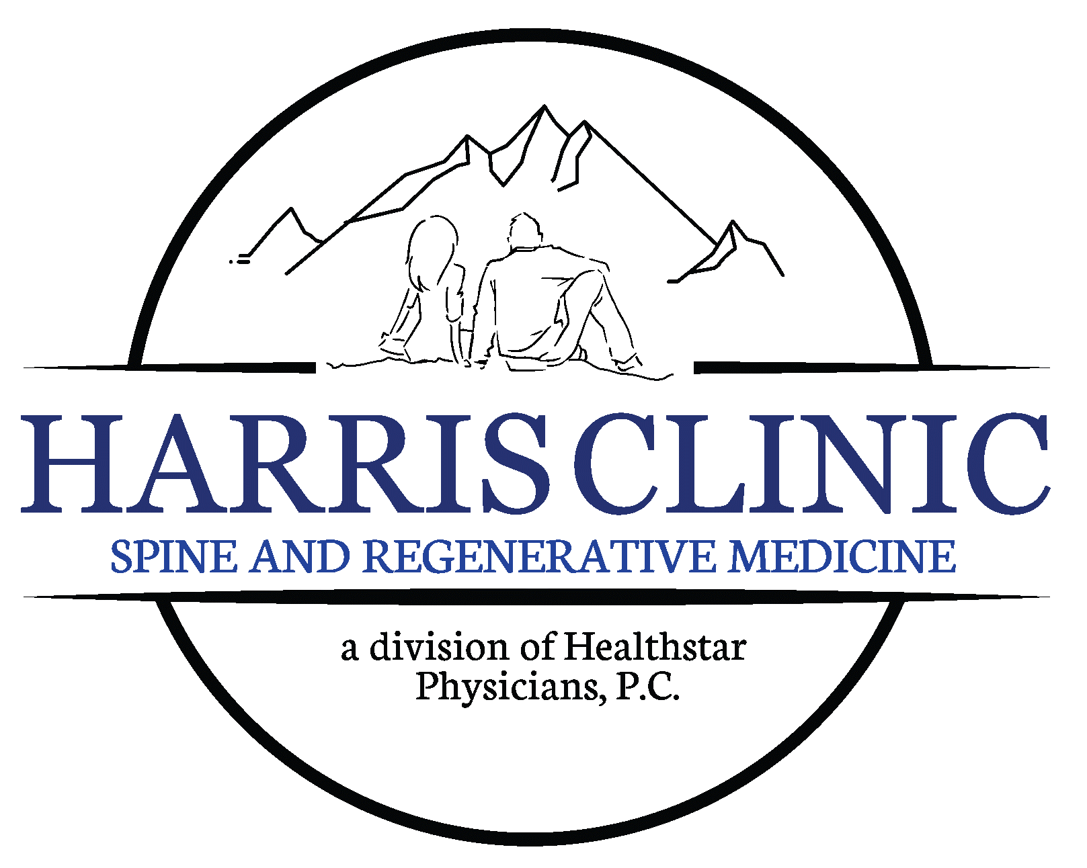
HARRIS CLINIC
On the Day of Your Procedure
Arrive at the clinic:
Arrive at your scheduled time. Please be aware that your arrival time is not your procedure time. On the day of your procedure please be prepared to be at our office for 1-3 hours. This is an outpatient procedure, and this time allows for check-in, procedure, and any post procedure recovery time.
- Bring with you:
  - Photo ID
  - Insurance card
  - List of current medications
  - Any pre-procedure forms provided by your doctor
- Consent Form:
Your doctor will review the procedure and risks with you and ask you to sign a consent form.
After Your Procedure:
- Follow-up Care:
  - Your doctor will provide specific instructions regarding post-procedure care, including:
    - Any activity restrictions
    - Medications to take
    - When to return for a follow-up appointment
Important Considerations:
- Medical Conditions:
Inform your doctor about any medical conditions you have, including allergies, diabetes, or bleeding disorders.

Pre-Procedure Instructions

Please read carefully and follow these instructions before your scheduled procedure. Failure to follow the pre-op instructions could result in you having to reschedule your procedure.

Important Contact Information:
- Clinic Phone Number: [423-581-3939]

Before Your Procedure:
- Medications:
  - Inform your doctor about all medications you are currently taking, including over-the-counter drugs, herbal supplements, and vitamins.
  - Follow your doctor's instructions regarding which medications to take or stop taking before your procedure.
- Diet:
  - If you are required to do a GI prep for your procedure, you may be asked to eat light prior to your procedure, depending on your doctor's instructions.
- Hygiene:
  - Shower the day before your procedure using antibacterial soap.
  - Do not apply lotions, powders, makeup, or deodorant: to the area where the procedure will be performed.
- Clothing:
  - Wear comfortable, loose-fitting clothing preferably that does not have zippers, buttons or any metal that may interfere with the x-ray picture. This allows for easy access to the procedure site.
- Transportation:
  - Arrange for someone to drive you to and from your procedure: if a driver is required.

Do you have any questions about your pre-procedure instructions? Please contact your doctor's office at:

(P): 423-581-3939
Harris Clinic
420 West Morris Blvd. Suite 130
Morristown, TN. 37813

Please note that these are general guidelines; your doctor may provide specific instructions based on your individual situation.

Remember to always consult with your healthcare provider regarding any questions or concerns you may have about your upcoming procedure.

