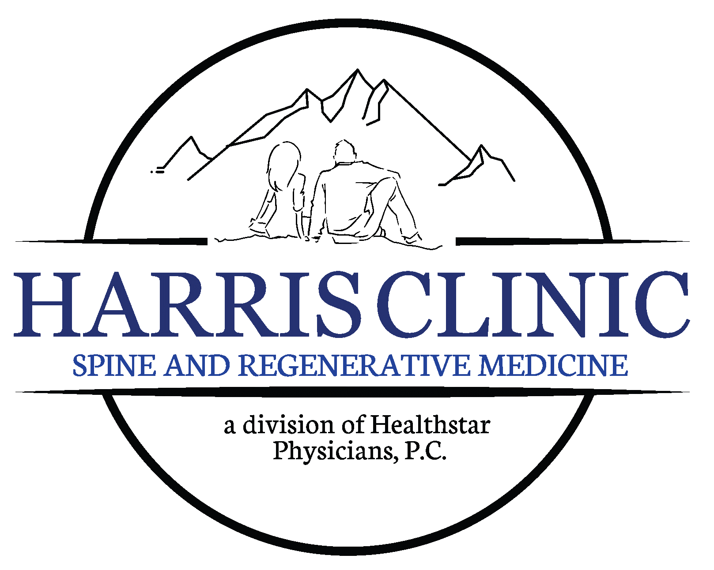

Light GI Prep Instructions
2 Days before procedure:
Take 2 - 400mg Magnesium Oxide pills and drink 1 glass of Miralax in the morning and 1 glass at lunch.

1 Day before procedure:
Drink 2 glasses of Miralax and take 1 – 400mg Magnesium Oxide pill.
If needed due to no or little bowel movement take 1-2 Magnesium Oxide pills in the afternoon.
*Miralax can be mixed with Gatorade, water, or juice*

**If you have any questions or concerns regarding the GI Prep, please call our office at 423-581-3939**

