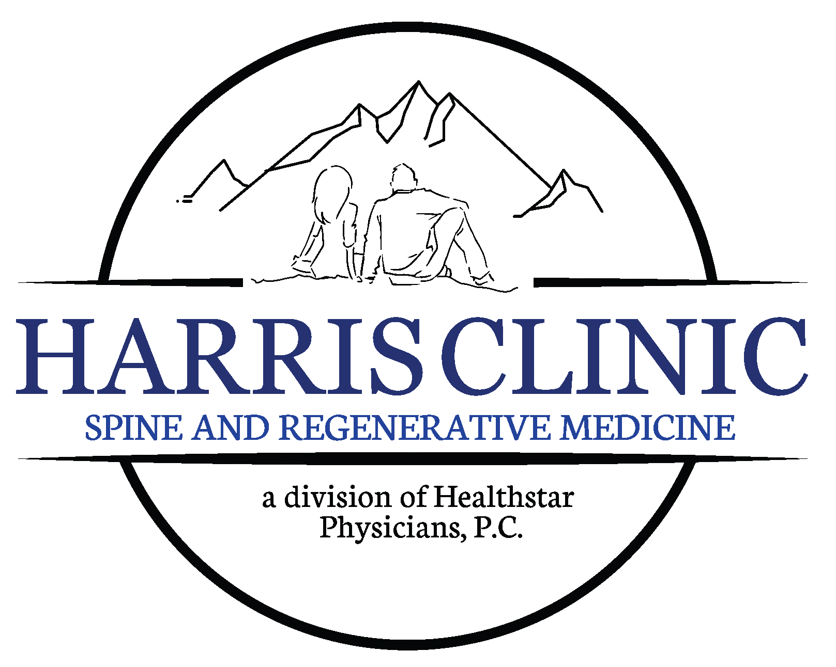
Dennis G Harris, MD
It is very important that you read these instructions carefully. Failure to follow the pre-op instructions could result in having to reschedule your procedure.
These medications must be stopped five (5) days prior to any injection. It is very important to get the approval of the physician who is prescribing these medications. There is a medical reason why you are on these medications and problems could possibly result if you stop without medical clearance.
- If you take Blood thinning agents such as Coumadin, Heparin, Plavix, Warfarin, Ticlid, Aspirin, or any other blood thinning medications. Anti-inflammatory agents (such as ibuprofen, Aleve, Goody or BC Powders, Advil, Naproxen, Motrin, Doans, Midol, Pamprin, Relafen, Mobic, Arthtec, or any other arthritis medications) or any other medications which thin your blood (Vitamin E, Cold medicines other that Tylenol Cold) notify the physician. These medications must be stopped prior to procedure to avoid complications. Tylenol is the only safe over the counter medication for pain prior to the injection.
- If you take the Flu, Pneumonia or Shingles vaccine you cannot have a steroid injection for 2 weeks, and, you should not take the Flu, Pneumonia or Shingles vaccine for 2 weeks after a steroid injection.
- Also, if you have had any recent signs of an infection (such as fever, cough, sore throat), please make sure you discuss this with the nurse. If you have been placed on antibiotics, you must wait until you have taken all of the antibiotic medication before the procedure can be done. Notify your doctor’s office with any medication changes.
- It is better if you can shower prior to the injection with an antibacterial soap such as Dial. This will help prevent the spread of bacteria that can cause infection.
- We recommend you eat lightly the day of the procedure unless otherwise instructed. Some injections require you not to eat or drink prior to the injection for a better image on the X-ray monitor. This will be explained when the injection is scheduled.
- No necklaces or earrings should be worn for injections in the neck or shoulder. Also if you have long hair you will need to pull it up off your neck. No jeans or belts with metal can be worn during the low back injections. It is easier to wear pants with a drawstring or elastic if you want to keep them on during the procedure.
- There is an estimated time it takes to complete each procedure; however patient response and human anatomy are not predictable factors. Everyone tolerates the injections differently. Please be patient with us if you have to wait a little longer than your appointment time. We are sorry for any inconvenience this may cause.
- We recommend that you bring a driver to your injection for the first time until you know how the procedure will affect you. If you have a Sacroiliac Injection (SI Joint), Radio Frequency Lesioning, Bilateral Carpal tunnel or Selective Nerve Root you will need to bring a driver every time.

MEDICATIONS THAT MUST BE STOPPED FIVE (5) DAYS PRIOR TO A PROCEDURE:
ASPIRIN EXAMPLES:
Anacin Arthropan A.S.A. Enseals Ascriptin A/D
BC Powders Bayer Aspirin Bufferin Cama
Cobunox Diflunisal (Dolobid) Disalcid Easprin
Ecotrin Empirin Excedrin Pamprin
Goody Powders Midol Standback Trilsate

ANTICOAGULANTS EXAMPLES:
Anisindione (Miradon) Dalteparin Danaparoid (Orgaran) Dicumarol
Warfarin (Coumadin) Plavix Pletal Cilostazol
Pradaxa Efficient Aggrenox Aspirin
Ranolazine (Ranexa) Plaquenil

Eliquis (48 hours) Xarelto (48 hours)

MEDICATIONS THAT MUST BE STOPPED ONE (1) DAY PRIOR TO A PROCEDURE:
ARTHRITIS/PAIN MED EXAMPLES:
Diclofenac (Cataflam, Volataren) Etodolac (Lodine) Fenoprofen (Nalfon)
Flubiprofen (Ansaid) Ibuprofen (Motrin, Advil, Nuprin) Indomethacin (Indocin)
Ketoprofen (Orudis) Ketorlac (Toradol) Meclofenamate (Melcomen)
Mefenamic Acid (Ponstel) Nabumetone (Relafen) Oxaprozin (Daypro)
Piroxicam (Feldene) Sulindac (Clinoril) Tolmetin (Tolectin)
Mobic (Meloxicam) Vimovo Vicoprofen
Zipsor Cobunox Naproxen (Anaprox, Naprosyn, Aleve)

This list contains the most common medications that are blood thinning agents. You may be taking a medication that is NOT on this list that you may need to stop. If you have any questions concerning what medications to stop, please feel free to call our office at 423-581-3939.

Also you will need to exercise caution with any over-the -counter pain relief or cold medications with the exception of Tylenol. It is the patient’s responsibility to read the labels on any over-the -counter medications.

Before stopping any of these medications, be sure to consult the physician who ordered them. Some, such as Coumadin (Warfarin), are ordered to prevent or treat serious conditions. The amount of time you may need to be off the medication may vary depending on the medication and the reason for which you are taking it. If you are taking these medications, you may need a MEDICAL CLEARENCE before stopping. DO NOT STOP WITHOUT CLEARENCE FROM THE PRESCRIBING DOCTOR.

