1st go to Blue Pole and follow instruction for NEELE VAT
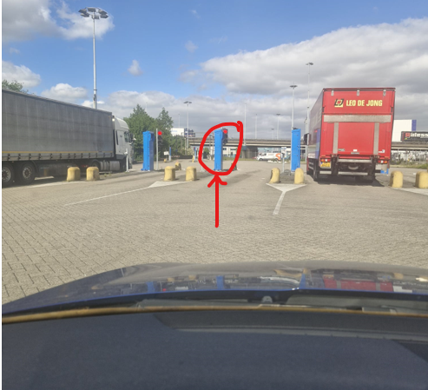
Address & Entry Address
Neele-Vat CITY TERMINAL
Albert Plesmanweg 231
3088 GC Rotterdam

INSTRUCTION ON POLE (PEDDESTOOL)
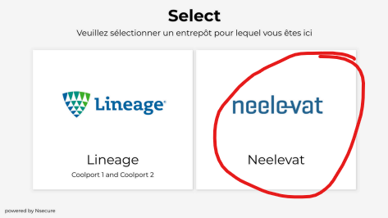
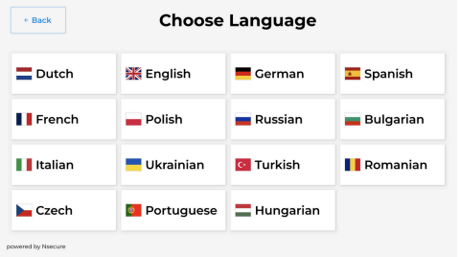

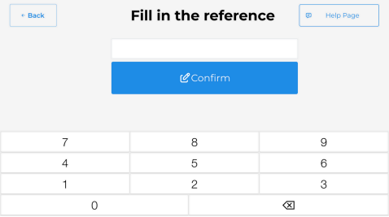
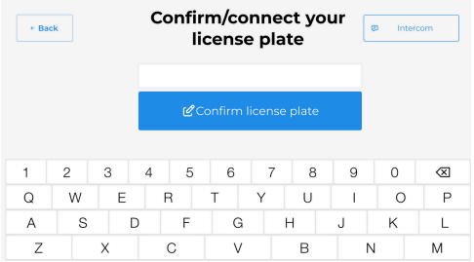
1st fill in LICENSE PLATE 2nd fill in REFERENCE

3rd scan PASSPORT
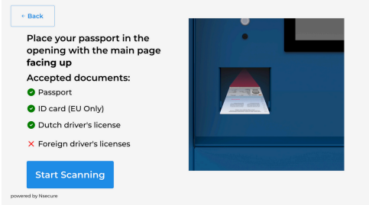

ALL OK = TICKET WITH QR-CODE

GO TO 2ND GATE AND SCAN TICKET TO ENTER
