1. | Visit the Blue Shield website: www.blueshieldca.com  Navigate to Find a Doctor  You should be on the Find Doctors & Services page.  Enter your City, State, or Zip Code  Addresses outside of California will be directed to the ‘find out-of-state care’ search link. | 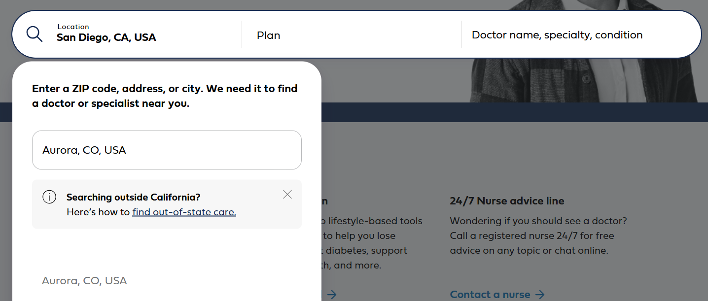
2. | To find Doctors and Specialists, select ‘Find Care’  You will be informed that you are leaving the blueshieldca.com website, as you will be redirected to the BlueCard nationwide provider search.  Select Continue | 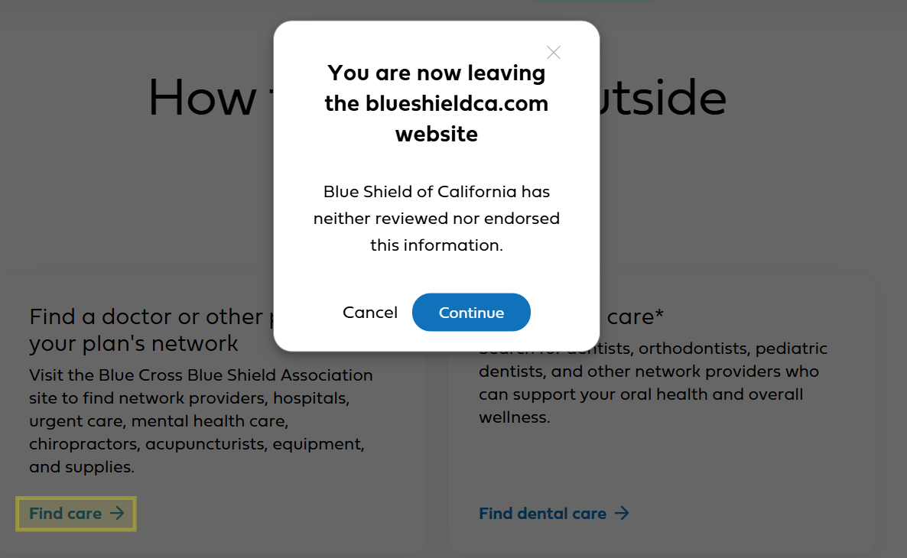
3. | Click on ‘Choose a location and plan’  Enter your search area. You can search by Address, City or Zip Code  Select ‘Yes, this is correct’ to confirm your search | 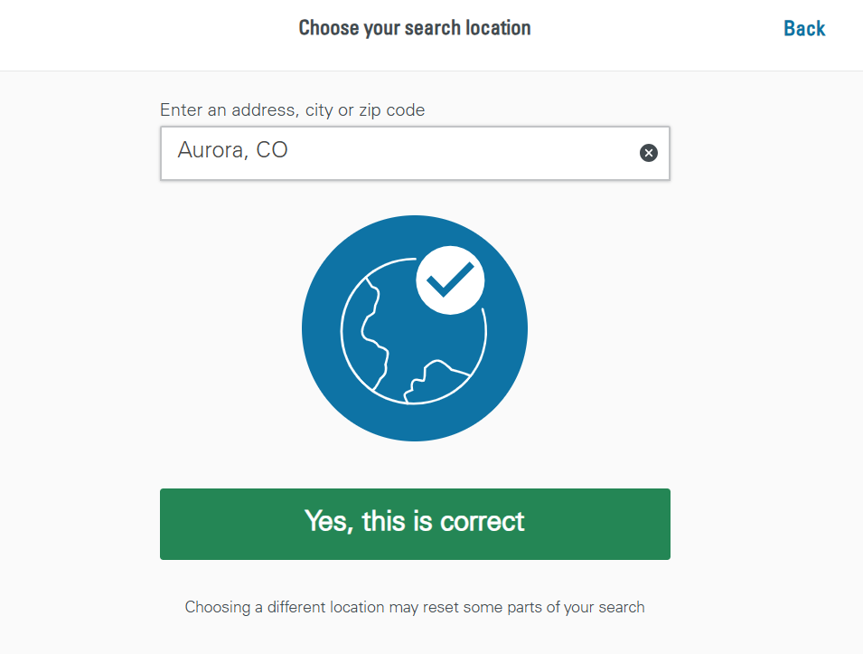
4. | Enter one of the following prefixes, depending on your plan selection: | 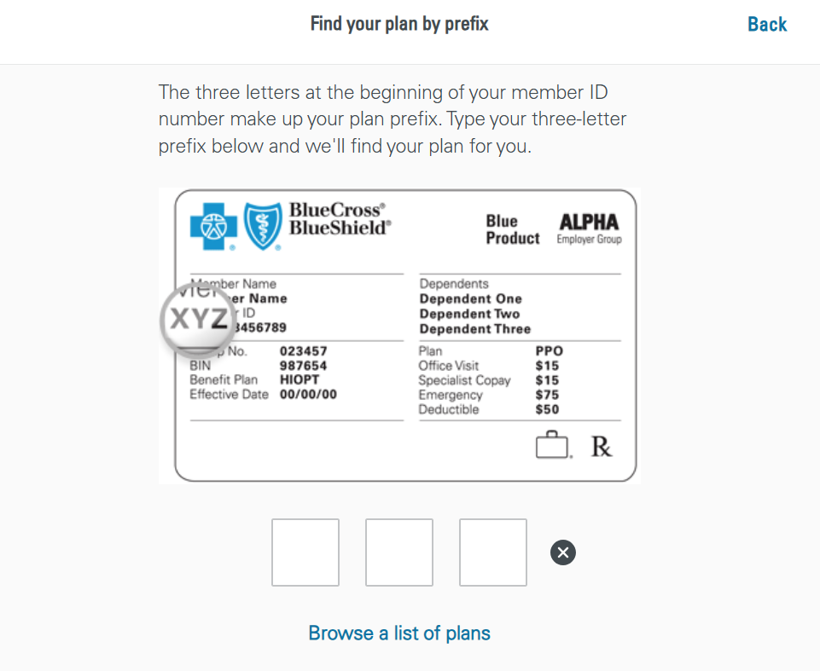
  Plan Name | Prefix
  Full PPO Plan | MNI
  HPN Base | MHI
  HPN Performance | MHI
5. | You can search for providers by Name, Specialty, Places by Name, or Places by Type | 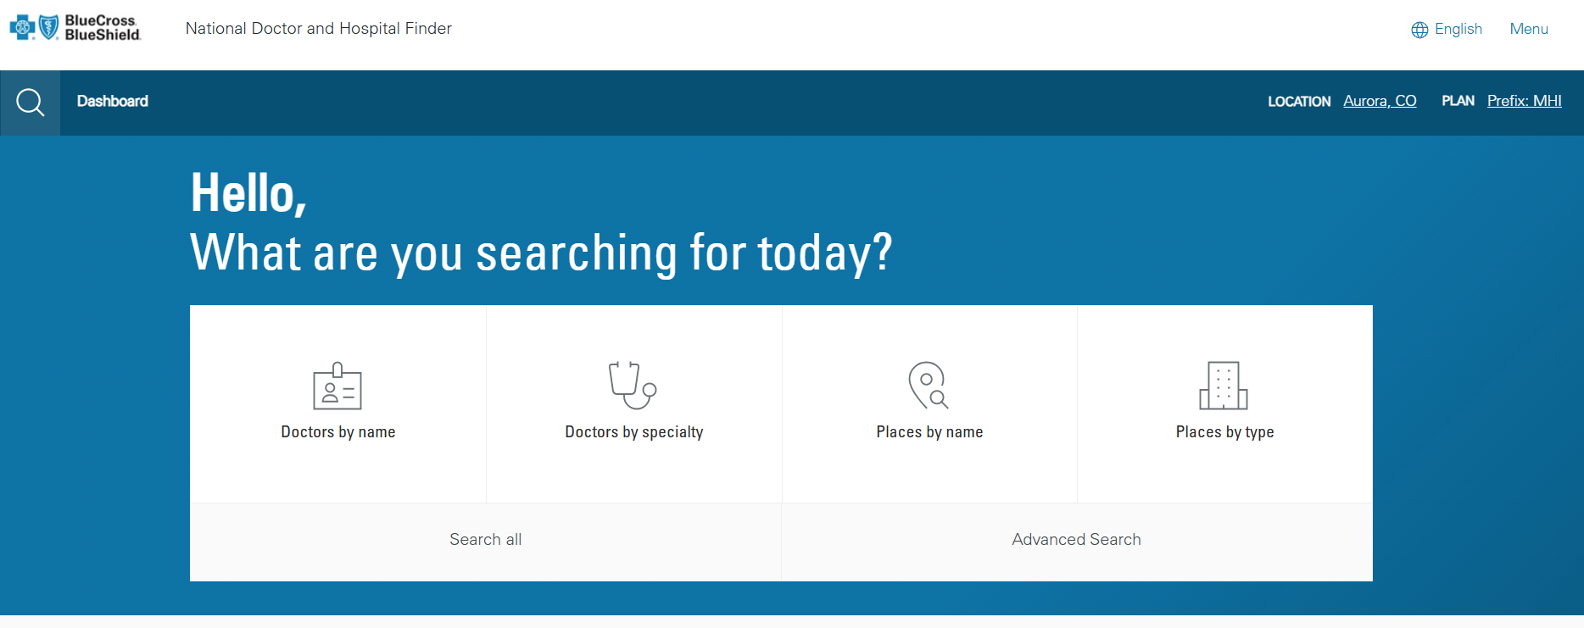
6. | The search results field is interactive, and will populate options as you type | 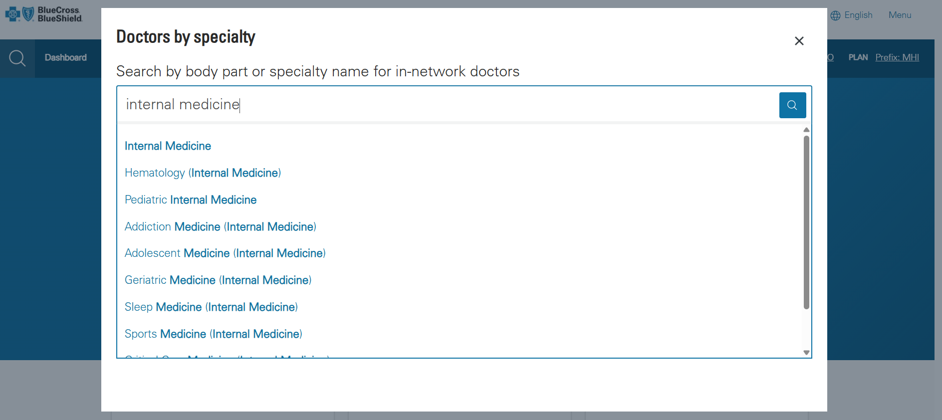
7. | Select a provider or specialty  Once an option is selected, you will be directed to the search results, with the following details for each provider:  - Address  - Specialties  - Areas of Expertise  - Gender  - Office hours and contact information  - Languages spoken  - Board Certification | 