Sports Terms I

Study the definitions and examples of the following idioms and complete the exercise below.

Up to Par – to be at an average or standard performance usually at work or in school. It can also be used to speak of one’s health. It comes from the game of golf. A set number of strokes (hitting the ball) to get it in the hole is given for each hole. For example, it should take 4 hits for Hole #9 to get the ball in the hole. If you do, you are par, or we say par for the course for all 18 holes. If you get the ball in at 3 strokes, you are below par. If you get the ball in at 5 strokes, you are above par. We often use this in the negative.
- Bob hasn’t been performing up to par for quite a while now. Maybe we should consider letting him go. (Fire him)
- I haven’t been feeling up to par lately. Maybe I should go to the doctor.
A Game Plan – a strategy or an agenda
- O.K. This is the game plan. First, we will meet with the marketing department at 9:00. After that, our department will meet at 11:00 to make a final decision.

Right off the bat – immediately; this term comes from baseball. The batter makes contact with the ball and the ball flies off the bat.
- We had problems right off the bat. Nothing went right from the very beginning.

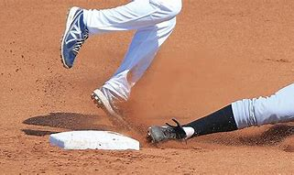
To touch base – to contact or connect with someone; usually by email or phone; this term comes from baseball. When a batter is running, he must touch the base.

- Let’s touch base next week. I’ll call YOU.

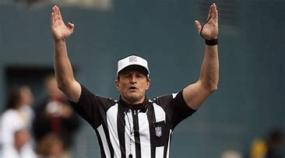
Take a rain check – to get a ticket or invitation for another time; this term comes from baseball; when a game is canceled due to rain or bad weather, the ballpark gives a free ticket for a future game.
- I would love to go to dinner with you tomorrow night, but I have plans. Can I take a rain check?
Hard to call – difficult to make a correct decision or difficult to determine; this can come from any sport where the umpire or referee has to make a decision;
- I don’t know if we’ll get the Ford contract or not. It’s hard to call.

To call the shots – to make the decisions in a department, company, or even at home; this term comes from the game of pool when a player says which pocket they will put the ball in.
- She’s not the boss, but she seems to be the one calling the shots around here. She acts like she’s the boss.

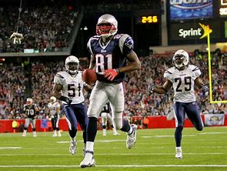
Take the ball and run with it – to take control of something such as a plan or a problem and add your own ideas to make it successful; this term comes from American football when a player catches the ball and runs down the field to make a touchdown (goal).

- He’s amazing! We just hired him last week, but he’s taking the ball and running with it. It seems as if he’s worked here for years.

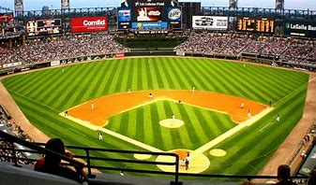
A ballpark figure – an approximate number having to do with money; an estimate; this term comes from baseball; the stadium is called a ballpark; a ballpark figure is a general number inside the stadium – not outside the stadium.

- This sounds expensive. Can you give a ballpark figure of how much it will cost?
To drop the ball – to neglect or forget to do something that was important; this term comes from baseball when a player drops the ball and misses the play.
- I completely forgot that the report was due today. I don’t have it done. I’m sorry. I totally dropped the ball.

Fill in the blanks with the correct idiom from the list. Be sure to use the appropriate tense if necessary.
Take the ball and run with it right off the bat a ballpark figure hard to call a game plan to drop the ball up to par
Take a rain check to touch base to call the shots

- What’s the agenda for today? What’s the __________________?
- Your proposal sounds very interesting. Do you have an idea how much it might cost? Can you give me a ____________ ___________?
- Nobody seems to be in charge. Who is ___________ _____ ___________ around here?
- I am not a micromanager. I will not control every decision you make and how you do things. I hope that you will _______ ______ _______ _____ _______ _______ _____. I want you to work independently.
- I’m sorry. I have to leave. I would like to talk with you more about this later. I’ll ________ ________ with you next week.
- Sometimes the weather is _______ ___ _______. You never know what it’s going to do: rain, snow, be warm, be cold. Who knows?
- John’s performance hasn’t been ______ ____ ______. His work is usually of a much higher quality. Is anything wrong?
- I liked her the minute I met her. I liked her _________ _____ _____ _______. I think she liked me immediately as well.
- I forgot to turn in my report to my team leader last week. It was a huge mistake. I really _________ _____ _______.
- Thank you so much for the invitation, but I can’t come on Tuesday. Could I ________ ___ _______ _______.
Answers:
- game plan 2. ballpark figure 3. calling the shots 4. take the ball and run with it 5. touch base 6. hard to call 7. up to par
8. right off the bat 9. dropped the ball 10. take a rain check

