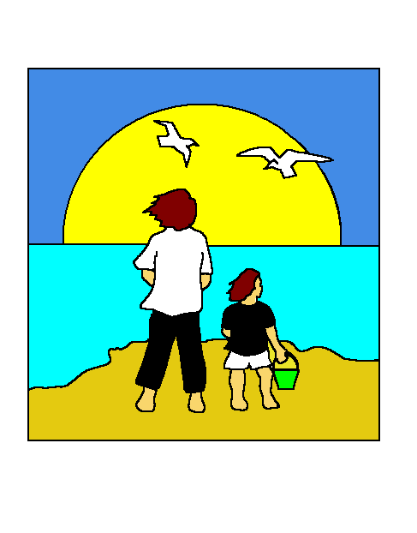
North Shore Pediatrics
www.northshorepeds.com
480 Maple Street, Suite 3A, Danvers, MA 01923
978-406-4234 Fax 978-921-2968

Authorization of Release of Information to Family Members/Guardians

Date __________________

I, ______________________________ give permission to ____________________________ to have access to my protected health information in the following manner:

_____Scheduling/ changing appointments

_____Talking to triage nurse regarding myself (or my child) _____________________

_____Access to ALL my medical records including labs, office visits, and discussions with my doctor, etc

_____I DO NOT give my parents/guardians permission to any of my medical records

Signature: ___________________________________

Patient Cell Phone Number: ____________________

