2024 Annual Sustainability Report

Executive Summary 1

Introduction 2

About the Report 3

2024 in Numbers 3

Message from the CEO 5

About Samskip 7

Sustainability at Samskip 16

From Ideas to Impact 17

Double Materiality Assessment 19

Our Sustainability Strategy 24

Sustainability Management System 27

General Policies 28

Sustainable Procurement 30

Compliance Overview 32

Our Planet 36

Our Environmental Pledge 37

Climate Change Action 37

Energy Efficiency 46

Air Pollution Prevention 46

Pushing New Boundaries 47

Our People 50

Our Social Pledge 51

People at Samskip 51

Our Value Chain 57

Our Responsible Business 62

Our Governance Pledge 62

Business Conduct 62

Concluding Remarks 65

Appendix 66

Abbreviations 66

Glossary 67

GRI Index Table 69

# Executive Summary

2024 was a pivotal year for Samskip as we navigated the complex journey of sustainability. We made significant progress, achieved important recognitions, and faced tough decisions that will shape our long-term impact.

**From Strategy to Action**

Sustainability is not a side project at Samskip, it's central to how we operate and grow. Our commitment took center stage again in 2024, with major milestones that reflect both ambition and action:

* **We kicked off construction of our hydrogen-powered SeaShuttles**, a major step toward zero-emission maritime transport.
* **We earned EcoVadis Platinum for Samskip Multimodal**, placing us in the top 1% of companies rated in our industry.
* **Our organization updated our Double Materiality Assessment** and stayed committed to CSRD alignment despite the EU's reporting delay.
* ‍**Our climate targets were officially validated by the Science Based Targets initiative (SBTi)**, confirming that our decarbonization goals are aligned with the latest climate science.
* **We held our first Sustainability Day**, uniting key stakeholders and celebrating the start of our SeaShuttles' construction.

**A hard trade-off for long-term impact**

2024 brought strategic challenges. To fund our investment in hydrogen vessels, we scaled back the use of biofuels. This led to a 51% increase in Scope 1 emissions, a difficult but deliberate trade-off. While this decision impacted our short-term results, it enables deeper, long-term emissions reductions once the hydrogen-powered vessels are operational in 2027.

We are committed to staying transparent, because sustainability is all about trust – especially when the impact is long-term, and not visible in the short-term. That’s why we’ve continued to improve how we track and share data. In 2024, our in-house carbon calculator was significantly enhanced for accuracy and ease of use, and we integrated it into our customer portal so our clients can monitor and understand their emissions better.

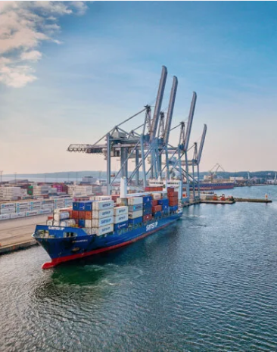

**Looking Ahead**

Our sustainability journey is far from over. We remain focused on:

* Completing CSRD alignment by 2026
* Launching the first two hydrogen-powered SeaShuttles in 2027
* A 50% total emission reduction by 2030
* Reducing total emissions to reach net-zero by 2040

At Samskip, we believe in progress, not perfection. This report reflects both our achievements and our learning curve. We hope it informs, inspires, and encourages continued collaboration toward a more sustainable logistics industry.

# Introduction

## About the Report

## (ESRS-1, GRI-1)

**Welcome to Samskip’s 2024 Sustainability Report! To us, Sustainability is more than a corporate commitment, it is central to how we operate, grow, and shape the future of logistics. We are proud to present this year’s report as a transparent and comprehensive account of the actions we’ve taken, the lessons we’ve learned, and the challenges we’ve faced.**

This past year has tested the resilience of global supply chains and redefined the meaning of responsible business. In a landscape marked by shifting political and business priorities, Samskip remains committed to long-term sustainability. Our strategy reflects this long-term view, from daily operations to bold investments that shape a low-carbon future.

Our approach is shaped by industry experts and diverse stakeholder input. Building on last year’s Double Materiality Assessment, we have refined our focus to where we can create the most value and impact environmentally, socially, and economically. Through partnerships, innovation, and the dedication of our people, we are taking sustainability from ambition to action.

We know the journey doesn’t end here. As we share both achievements and areas for improvement, our aim remains clear: **to empower our customers, colleagues, and partners to move forward together towards a sustainable future.**

GRI Standards Statement of Use  
Samskip B.V. has reported in reference to the GRI Standards for the period January to December 2024.

## 2024 in Numbers

|  |  |
| --- | --- |
| Annual Net Turnover | 802 million  Compared to 790 million in 2023 |
| Number of Offices in operating countries | 38 offices in 20 countries  Compared to 31 in 19 countries 2023 |
| Countries of Operations | 22  Compared to 20 in 2023 |
| Number of Employees | 1,727  Compared to 1,674 in 2023 |
| Number of Vessels (owned and chartered) | 22+  Compared to ~22 in 2023 |
| Number of Trucks and Trailers | 521+  Compared to ~460 in 2023 |
| Transported Container Units (TEUs) | 647,575  Compared to 617,876 in 2023 |
| Shortsea Departures Per Week | 98+  Compared to 121+ in 202 3 |
| Rail Departures Per Week | 100+  Compared to 87+ per week in 2023 |
| Scope 1 CO₂e Emissions | 291,617 tons of CO₂e  Compared to 191,928 in 2020 |
| Scope 2 CO₂e Emissions | 6,607 tons of CO₂e  Compared to 19,915 in 2023 |
| Scope 3 CO₂e Emissions | 256.465 tons of CO₂e  Compared to 320.489 in 2023 |
| Energy Per Nautical Mile | 6.5 GJ/TEU |
| Change in Scope 1 CO₂e Emissions 2023 – 2024 | +51,48% |
| Change in Energy Use 2023 – 2024 | +22.51%  Compared to –2.03% in 2023 |
| Change in the Share of Renewable Energy | -15%  Compared to +3% 2023 |
| Share of Renewable Energy | 5%  Compared to 24% in 2023 |
| Share of Biofuels | 4.6%  Compared to 17% in 2023 |
| Full-Time Employees | 92%  Compared to 84% in 2023 |
| Number of Serious Incidents | 0  Compared to 0 in 2023 |
| Training Hours Per Employee | ~3 hours  Compared to1.49 in 2023 |
| Women in Workforce | 34%  Compared to 32% in 2023 |
| Women in Management Board | 40%  Compared to 20% in 2023 |

## Message from the CEO

**CEO letter – 2024 annual sustainability report**

*Dear reader,*

I’m pleased to welcome you to our 2024 Sustainability Report – an honest reflection on our sustainability journey and the world around us. In the pages ahead, we’ll share how we’ve navigated a shifting landscape while keeping sustainability at the core of what we do.

2024 was an eventful year and, at times, deeply challenging. Global tensions continued to rise, and the world became less stable and predictable – which could clearly be felt in international trade. In the face of conflicts and major supply chain disruptions, predicting what lies ahead felt impossible. In this climate, resilience and flexibility to adapt became more important than ever.

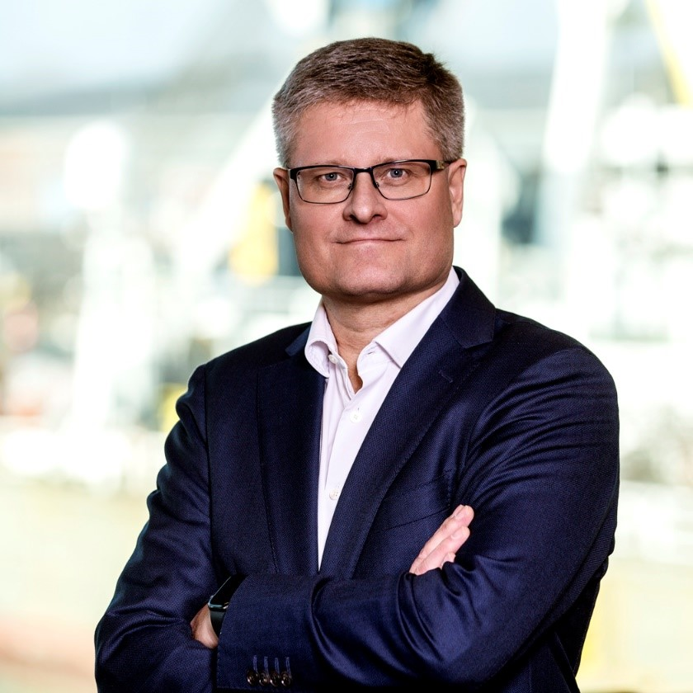

Sustainability suddenly had to compete with other topics on the agenda. As global priorities shifted, some companies and governments paused or even reversed their climate ambitions – but the reality of the situation is not going anywhere. For us at Samskip, sustainability remains non-negotiable. The urgency to combat climate change has only grown, and we remain fully committed to driving meaningful change.

Throughout 2024, we focused on providing our customers with an excellent and reliable service, and strengthening our network. We believe that sustainability is not separate from performance – it underpins our reliability and resilience, enabling us to serve our customers better today and tomorrow.

Financially, 2024 brought its own headwinds. Rates fell, costs rose, and we were faced with a business environment not working in our favour. Moments like these reveal character: Do we stick to our sustainability commitments when times are hard? And if we do, how?

Strategy is about making trade-offs, and these will be tough at times. When shaping our investment plans for 2024, we faced a dilemma: Should we continue using biofuels to cut emissions now, or invest in hydrogen technologies that promise larger reductions in the future, even if it means scaling back our current biofuel use?

We chose the latter, prioritizing long-term impact over short-term gains. It wasn’t an easy decision because after reaching significant biofuel levels in 2023, reducing our usage meant accepting a temporary rise in carbon emissions. Yet, we believe this is the right path, one that will enable us to deliver the lowest possible carbon footprint in the years ahead. We’re investing today to build a cleaner, more sustainable tomorrow.

This long-term vision is embodied in our investment in the Samskip SeaShuttles, our two hydrogen-powered container vessels. With these ships, Samskip is not only securing a sustainable future for itself, but they contribute to the sustainable progress of our customers, the green hydrogen economy, and society in general.

Milestones like these are a team effort, built on a culture that promotes and celebrates sustainability. Our first Sustainability Day in early 2024 brought together so many relevant stakeholders, from policymakers to financiers, suppliers, ports and cargo owners, and of course many of our valued colleagues, all there to witness the *steelcutting* ceremony of our SeaShuttles, which marked the official start of the construction phase. A powerful moment that brought us together and proved that the sustainable future of shipping is no longer a vision – it’s becoming a reality.

Of course, none of this is possible without our People. They are the hearts, minds, and hands of Samskip. While our environmental footprint is critical, we must also ensure we uphold social sustainability: a just, safe, and inclusive workplace where talent can thrive. I am proud of our diverse, international team, and how we balance strict safety and conduct standards with a culture that allows space for joy, collaboration, and personal growth.

To our colleagues, business partners, clients and friends, and all other readers:

I hope this report offers you insight and inspiration. But more than that, I hope it moves you to act. We cannot allow sustainability to slip down the agenda. At Samskip, our door is always open to those who want to work together for a better future — because *together* it must be.

Sincerely,

Kari-Pekka Laaksonen

CEO, Samskip

## About Samskip

**Our Industry** (ESRS-2; GRI-2; SDG-8,16,17)

**Within the vast and complex web of global supply chains, freight transport holds a weighty responsibility: Shipping the world’s goods that keep our economies running. With added pressure to reduce its environmental footprint, the industry is facing enormous decarbonization challenges.**

Freight transport has long been, and still is, heavily reliant on fossil fuels. The global freight transport market (including warehouses and ports) was responsible for 11% of global greenhouse gas (GHG) emissions in 2021 [1].

With the demand for global freight transportation projected to double between 2019 and 2050, there are huge challenges for decarbonizing the industry. [2]

These aren’t just numbers. They serve as an urgent call for action for an industry standing at the crossroads of economic necessity and environmental responsibility.

Different modes of transport – air, road, maritime, and rail – have varying environmental impacts, with road being the largest contributor to CO₂e emissions, and rail the most environmentally friendly.

Road: This type of transport remains the largest emitter of CO₂ emissions. Trucking vehicles accounted for nearly 65% of freight transport emissions1. The extensive reliance on diesel-powered trucks, combined with the growing demand for road freight transportation, has led to a significant rise in emissions in the industry

Maritime (including inland waterways): Water transport accounted for approximately 21% of the transport sector's emissions in 2022.[3] While maritime shipping is still largely dependent on fossil fuels, it is still considered more energy efficient than freight trucking, and is one of the few industries that is regulated globally through the International Maritime Organization (IMO). [4]

 Rail: Trains are generally considered to be one of the more environmentally friendly modes of transportation. Freight trains make up only 1% of global transport emissions.[5]

Note: Samskip does not directly partake in freight air transportation.

Transport and logistics companies have to prioritize emission reduction across all modes. Through the electrification of vehicles, use of low-carbon fuels, and improved operational efficiencies. When it comes to zero-emission trucks, crucial for decarbonizing road freight, this still requires significant public investment and policy support.[6]

**One thing is clear**: to make a real impact, we need collaboration throughout the whole industry. Through international cooperation on policy, innovation, and regulatory frameworks, we can create lasting change, particularly given the global nature of freight transport. This collaboration must include efforts to harmonize emission standards, accelerate innovation in zero-emission vehicles and fuels, and address infrastructure gaps and global supply chain inefficiencies.

**The Multimodal Network: More Sustainable, Resilient Logistics**

**Our multimodal network is what sets us apart. Seamlessly combining sea, road, rail, and river transport to deliver efficient, resilient, and cost-effective logistics solutions, all while reducing GHG emissions and prioritizing sustainability.**

We optimize each journey by leveraging our extensive transport network and strategically shifting cargo away from road transport, the highest emitter per ton-kilometer, onto more sustainable alternatives, like rail, barges, and vessels. This approach enhances energy efficiency and significantly lowers the carbon footprint of every shipment by up to 80%, compared to road-only transport.

Samskip is continuously improving and strengthening its unique multimodal network, for example by expanding our rail services at the Duisburg terminal, which improves connections between Northern and Southern Europe, and offers a reliable alternative to road transport. Or through our collaboration with the Matrans Rotterdam Terminal, which is set to become a key multimodal hub, connecting our sea-going vessels, trains, and inland barges.

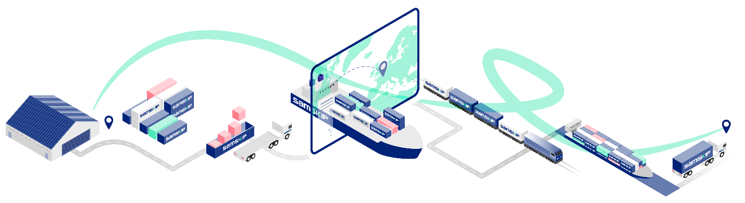

Innovative tools like our Carbon Footprint Calculator provide visibility into the environmental impact of different transport routes, allowing our customers to compare multimodal options against conventional road transport. By making emissions reductions visible and showcasing the CO₂ saving benefits of our multimodal network, our customers can make transparent and informed decisions.

The multimodal approach is the foundation of our work, the way we move goods across the world, shaping a smarter, environmentally conscious, and more responsible logistics industry. This year we continued to push the boundaries further, significantly avoiding emissions by ~60-80% on key routes.

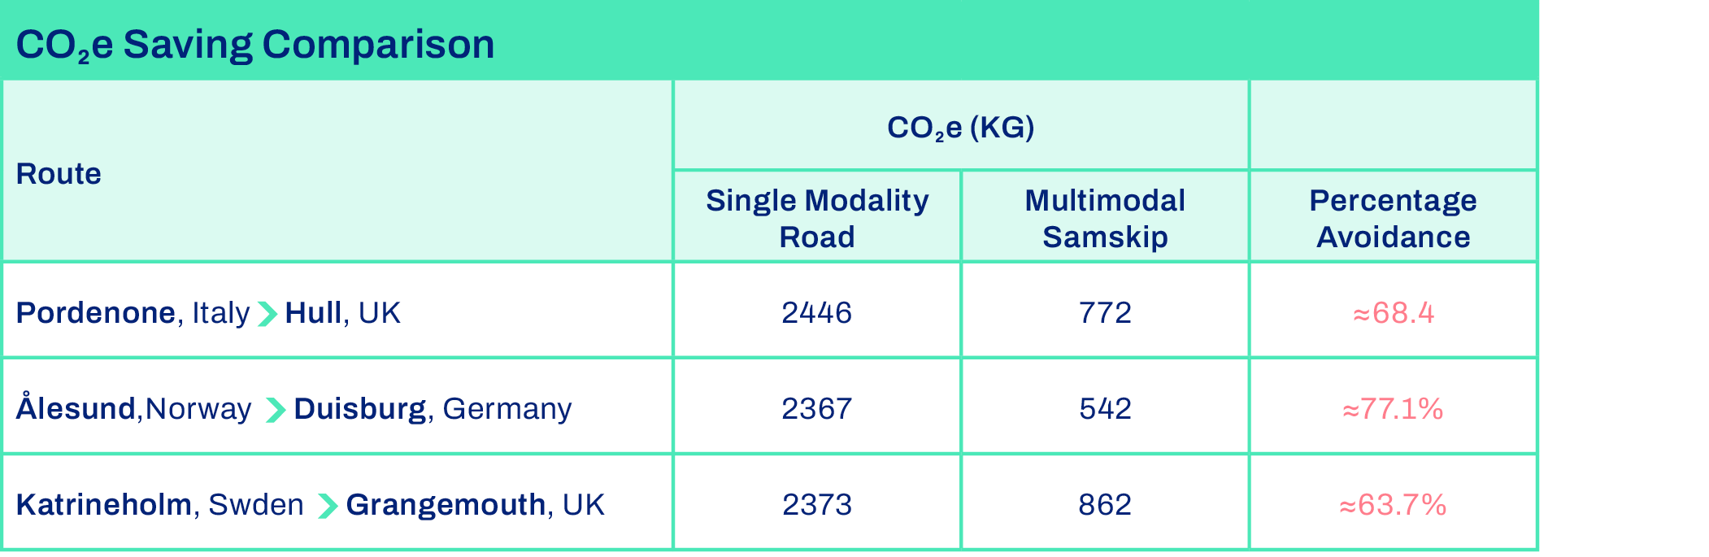

By combining rail, sea, and road transport on our routes from Venice to Raunds, we cut **1,487 kg of CO₂ emissions per container.** Similarly, on our route from Weert to Northampton, we cut another **347 kg of CO emissions per container.** This is a clear win for both efficiency and the environment.

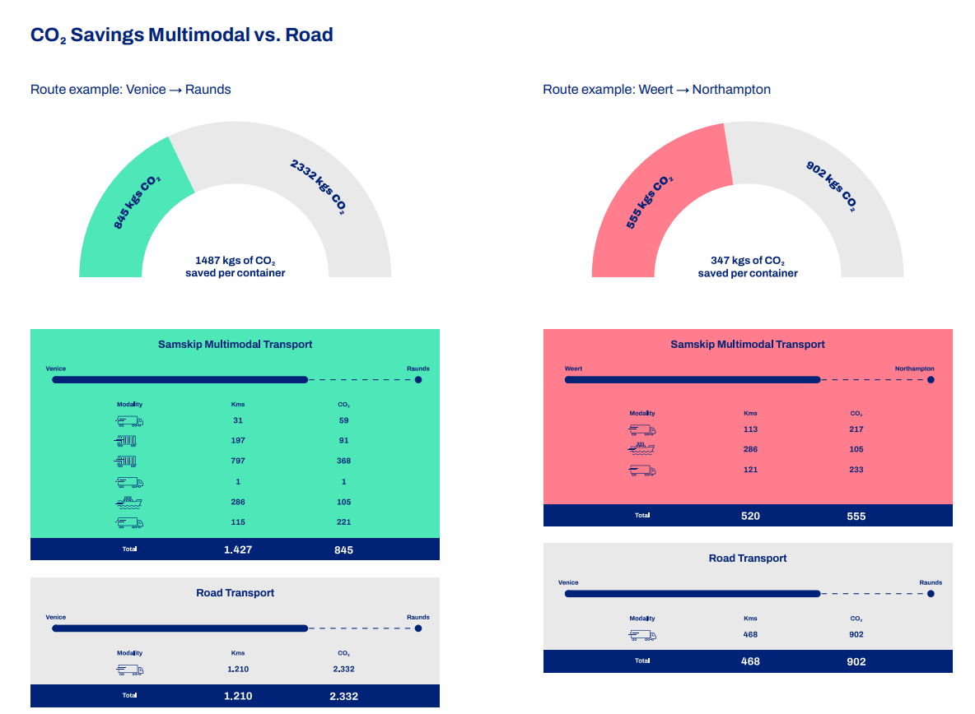

**Our Corporate Strategy**

**Launched in 2020, our Corporate Strategy is grounded in our values, vision, and mission, and structured around five strategic pillars, with Sustainability at the center.**

For each pillar, we have set clear targets and KPIs. Our targets are not just numbers; they are milestones that inspire us to continuously strive for meaningful impact.

At the heart of our strategy is our vision: **Making Green Logistics Easy**.

In the middle of the framework stands the Sustainability pillar, which plays a central role in our strategy. This means sustainability is not a separate goal; it is our aim to embed it into the center of our company.

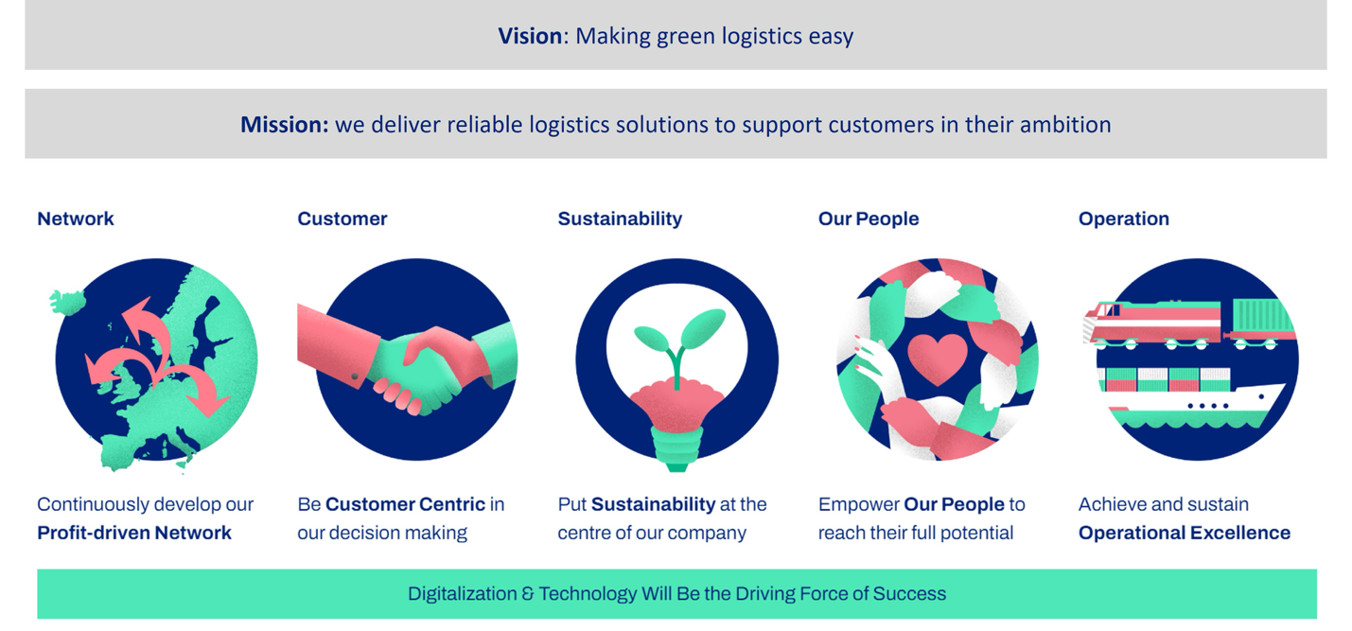

Through this strategy, our focus is on strengthening our network, being customer centric in decision-making, empowering our people to reach their full potential, reaching and maintaining operational excellence, and to put sustainability at the heart of everything we do.

Our recent corporate strategy was launched in 2020, marking a defining moment when Samskip made a firm commitment to sustainability. This then led to the development of our Sustainability Strategy later in 2020, a focused plan aimed at building a better, more sustainable Samskip. Since then, we have invested significant time, effort, and resources into turning this commitment into action, further shaping the future of Samskip.

**Industry Memberships**

**At Samskip, we believe that collaboration across our industry is key in driving sustainability forward by setting standards and sharing lessons learned.**

Working together accelerates the development of sustainable technologies and the establishment of industry-wide standards that benefit us all. By learning from each other's successes and setbacks, we can refine our own sustainability strategies and avoid duplicating efforts. In the end, many of us have the same goals and by developing a collective approach, we are strengthening the industry's resilience to tackle future challenges.

|  |  |  |
| --- | --- | --- |
| **Association** | | **Description** |
|  | Royal Association of Dutch Shipowners (KVNR) | The KVNR promotes and protects the common interests of Dutch shipping companies on a national, European, and global level. As a member, Samskip actively participates in committees and working groups regarding key regulatory and policy decisions on maritime matters. |
|  | UK Chamber of Shipping | The UK Chamber of Shipping is the trade association with the mission to create a greener shipping industry. Samskip is specifically involved in the decarbonization work, supporting the urgent need for the shipping industry to commit to net-zero by 2050. |
|  | International Union for Rail Transport (UIRR) | The International Union for Road-Rail Combined Transport promotes intermodal freight and works with EU institutions to advance sustainable long-distance transport. |
| Smart Freight Centre | Smart Freight Centre (SFC) | Smart Freight Centre is an international non-profit organization focused on reducing the emission impacts of global freight transportation. |

**Corporate Governance** (ESRS-2; GRI-2)

**Our Sustainability Manager reports directly to our Director of Business Development, who reports to our CEO. Our Sustainability Manager decides on day-to-day sustainability issues, and our Management Board makes high-impact decisions that affect the company at scale.**

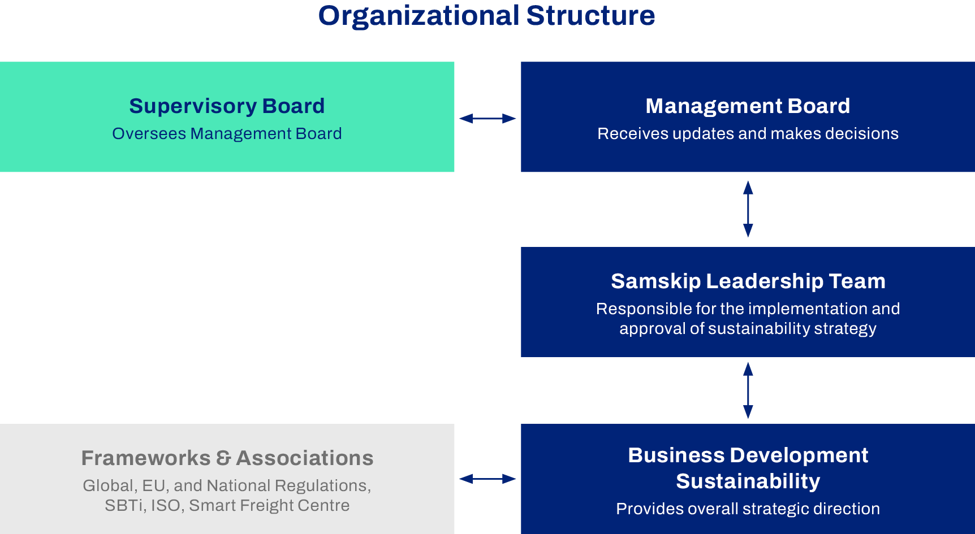

The company has two boards: the Supervisory Board and the Management Board.

The **Supervisory Board**, which includes members of both Icelandic and Dutch nationality, supervises the Management Board, and is elected by the company's shareholders. There is a supervisory board member dedicated to sustainability topics, and the board is regularly informed by the sustainability team on updates and pressing issues.

The **Management Board** is responsible for the daily management of the company and holds the highest decision-making power. It is composed of C-level executives, responsible for developing, approving, and updating the corporate strategy, mission and vision statements, policies, and sustainability-related goals. The Management Board oversees organizational due diligence through the financial, legal, operational, quality, and sustainability departments.

The **Sustainability Team** supports both boards and provides detailed research and strategic developments to enhance Samskip’s environmental, social, and long-term business impact, identifying opportunities while minimizing risks. Our Sustainability Manager reports to the Director of Business Development, who then reports to the CEO, who also serves as Chairman of the Management Board.

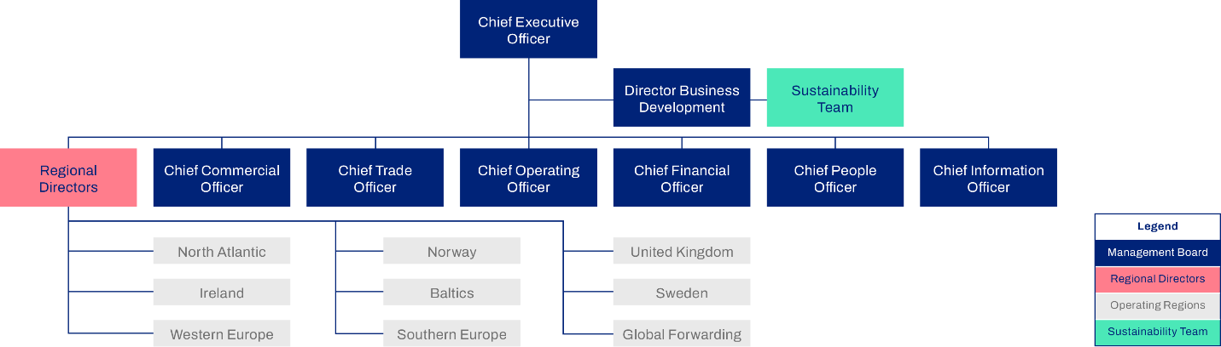

Samskip’s operations span multiple regions, with key activities based in Western Europe, the Iberian Peninsula, the United Kingdom and Ireland, Iceland, Norway, Sweden, the Baltic states, and through its Global Forwarding services. These diverse regions reflect the company’s broad logistical reach and strategic presence across Europe and beyond.

# Sustainability at Samskip

## From Ideas to Impact

**Unlocking Customer Impact: A Conversation With Samskip’s Chief Commercial Officer and Sustainability Manager**

Our Chief Commercial Officer (CCO) **Christina Sauter** and our Sustainability Manager **Laurens Dourleijn** sat down with Sustainability Analyst **Shadé Hightower t**o explore the connection between sustainability and business at Samskip. With their unique perspectives, one rooted in commercial strategy and the other in environmental leadership, they offered valuable insights into how sustainability is evolving within our operations, customer relationships, and long-term vision. Here’s what they had to say:

|  |  |
| --- | --- |
| 1. **Personal Perspective (Intro Questions)** | |
| **Shadé Hightower:** What excites you most about the work you do at Samskip? What’s your favorite part of your role? | **Christina Sauter:** “It's hard to say what excites me most because there are quite a few things I like about my time here. One of the first things that comes to mind is the fact that people feel deeply connected to the brand and are genuinely motivated to help shape it into a modern, sustainable, and efficient company. There’s a noticeable eagerness to drive change, whether it’s updating processes, improving systems, or rethinking the way we work. Something else that excites me is seeing real progress being made and this positive momentum that continues to transform Samskip.” |
| **Shadé Hightower:** What have you been most proud of this past year? | **Christina Sauter:** “I’d say the way our teams reacted under pressure and turned a operational incident into an opportunity. We didn’t just fix the problem but we made structural changes that improved how we operate. It showed me how much potential we have when we align quickly and work across functions.” |
| **2) Customer conversations** | |
| **Shadé Hightower:** How have your conversations with clients changed over the years? | **Christina Sauter:** “It varies widely. Larger multinational companies are leading the way, often including sustainability as a key factor in their logistics decisions. Working with some of our largest customers, we’ve had joint discussions about how to decarbonize specific lanes. In contrast, medium-sized companies may not have the same urgency or resources, but that’s where we step in with guidance, showing them how switching to multimodal transport or using biofuels can cut emissions without major cost increases.” |
| **Shadé Hightower:** Can you share an example where our sustainability initiatives have helped us win new business or strengthen partnerships? | **Christina Sauter:** “Definitely. One standout example is our **FlexFuel product**. We co-developed it with customers that share similar sustainability strategies, and it's now a concrete solution we can offer others. Even when certain customers aren’t ready to invest in reducing their emissions, they appreciate that we’re ready with scalable solutions for when the time comes. That proactive positioning gives us a real advantage.” |
| **3) Strategy and Implementation** | |
| **Shadé Hightower:** Do you see a strong alignment between our sustainability goals and commercial objectives? Where do they complement each other, and where do you still observe the need for alignment. | **Laurens Dourleijn:** “Sustainability isn’t just about doing the right thing, it’s a long-term business strategy. Climate change and shifting customer expectations will be the key forces reshaping logistics in the years ahead. Being prepared with innovative technologies like biofuels, hydrogen-powered vessels, and electrified trucks isn’t optional, it’s how we stay competitive.”  **Christina Sauter:** “I agree. Our entire business model is based on offering more sustainable alternatives to road transport. Multimodal logistics is inherently greener, and as we improve operational efficiency like seamless transitions between rail, sea, and road we make that model even more attractive to our customers.”  **Laurens Dourleijn:** “Having said that, not all customers are ready to pay more for sustainable options, especially in sectors where cost pressure is high. That’s why regulation plays a key role. Tools like the EU’s Emissions Trading System help level the playing field, making greener choices more viable across the board. We can’t rely solely on market demand – we need policy to drive change, too.” |
| **4) Looking Ahead** | |
| **Shadé Hightower**: What interests you most about the future of sustainability at Samskip? | **Christina Sauter:** There are quite a lot of interesting initiatives going on currently. I’m excited about our investments in our hydrogen-powered vessels and exploring electrifying short-haul routes. These projects aren’t just technical upgrades; they position Samskip as a pioneer in the field. We’re also watching how new regulations shift incentives in our favor. When trucking emissions face pricing and rail no longer receives subsidies, our solutions become even more competitive.  **Laurens Dourleijn:** For me, it’s the potential for every part of the company to contribute to sustainability projects. Whether you're in customer service, sales, or operations, you can play a role in pushing these initiatives forward. It creates a culture of shared ownership and pride. Each project adds up to more than the sum of its parts, and it's about building a company we're all proud to be part of. |
| **5) Final Thoughts** | |
| **Shadé Hightower**: If you could encourage our customers and partners to take one sustainability action, what would it be? | **Christina Sauter:** Let’s rethink speed. Many customers choose trucking because it’s slightly faster. But is shaving off a day or two really worth the environmental cost? If we can provide reliable, lower-emission alternatives even if they're a bit slower we hope customers will consider making that shift.  **Laurens Dourleijn:** Just start the conversation. There’s always something we can do, whether it’s switching to FlexFuel or optimizing your transport mix. The first step is reaching out and exploring the possibilities together. |

## Double Materiality Assessment

**Understanding the role of the DMA** (ESRS-1; GRI-3)

**After conducting our original Double Materiality Assessment (DMA) in 2023, we updated it in 2024 to improve the quality of the scoring. Ensuring we invest time and resources on the sustainability topics that matter most to our stakeholders and our business.**

The DMA was conducted in line with guidance from the European Financial Reporting Advisory Group (EFRAG), and as per the Corporate Sustainability Reporting Directive (CSRD). The DMA helped us identify the most important environmental, social, and governance (ESG) topics from two perspectives: Impact and Financial materiality.

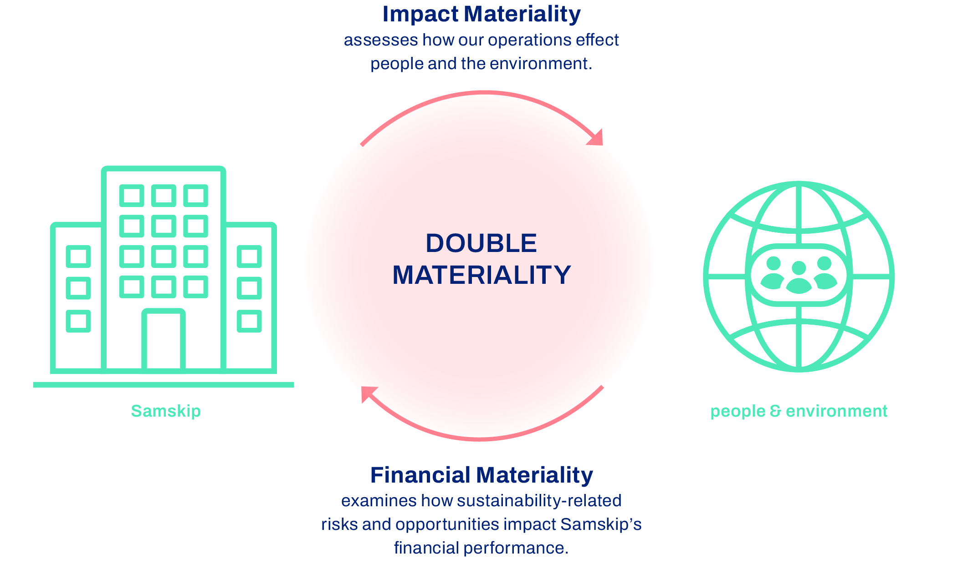

Analyzing both perspectives has strengthened our ability to make better strategic decisions, focus our efforts on the topics that really matter to us, and enhance transparency in our sustainability reporting (a key output being the report you’re reading right now).

Because of the DMA, we can channel our time and energy into the issues that most impact our customers, and the communities and environments we operate in. It has also helped us to identify risks to our business model and spot opportunities that can shape our long-term sustainability strategy. Additionally, the DMA is part of regulatory compliance under the CSRD and plays a key role in building stakeholder trust.

By conducting this systematic evaluation, we are being proactive, better positioning ourselves to navigate regulatory requirements, mitigate risks, and act on emerging opportunities.

**Methodology**

**To ensure a robust assessment, we followed a structured methodology aligned with EFRAG guidelines. We took three steps to identify our material topics.**

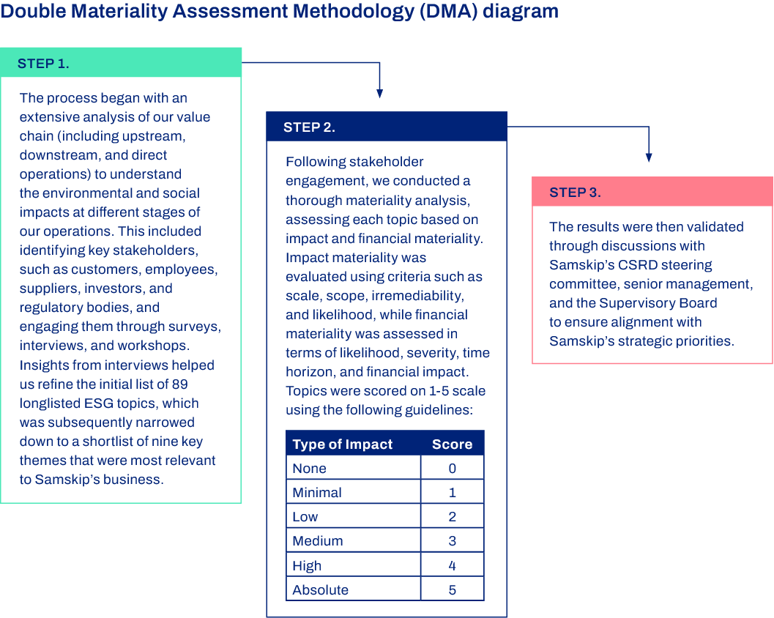

**Results**

**Through our DMA, we identified five key ESG topics that are material for Samskip.**

Environment

Responsible Team for overseeing Environmental Initiative: Operational Department and Sustainability Team

* Unsurprisingly, **climate change mitigation** emerged as a critical issue, with GHG emissions from our logistics operations presenting both regulatory risks and opportunities for decarbonization. At the same time, the transition to cleaner energy sources, including hydrogen and electric-powered transport solutions, is a key opportunity for Samskip to maintain a competitive edge, while reducing its carbon footprint.
* Additionally, **air pollution** from fuel combustion in our transport operations was recognized as a material environmental impact. Managing this requires ongoing efforts to improve energy efficiency and adopt cleaner technologies.

Read more about the actions we are already taking in the section ‘Our Planet’ of this report.

Social

Responsible Team for overseeing Social initiatives: People Department and the Procurement Team

* **Health and safety** emerged as a material topic, particularly in transport operations, where risks can be severe. Robust regulations and strict compliance continue to be essential in preventing accidents. **Fair wages, equal pay, and an inclusive work environment** represent a significant opportunity to enhance employee dignity and job satisfaction, which is something that we take seriously as an employer. We already emphasize work-life balance, flexible working hours, and healthy working conditions to prevent burnout and improve retention. On top of that, by investing in **training and skills development,** we know we’re investing in long-term employability, operational efficiency, and workforce engagement.
* We place strong importance on addressing **health and safety risks, work-life balance, and instances of violence and harassment** across our value chain. Effectively managing these issues will allow us to help maintain a safe and supportive work environment for these individuals.

Read more about the actions we are already taking in the section ‘Our People’ of this report.

Governance

Responsible Teams for overseeing Governance initiatives: People Department, the Legal team and Sustainability Team

* Responsible business practices, including **corporate culture** and **anti-corruption measures**, were judged essential for maintaining stakeholder confidence and regulatory compliance.

Read more about the actions we are already taking in the section ‘Our Responsible Business’ of this report.

Moving forward, we will define new targets for the DMA topics highlighted here and thus continue to strengthen our Sustainability Strategy.

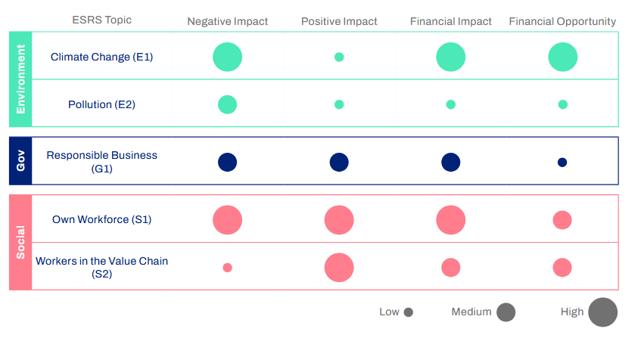If you would like to learn more about our DMA, read our report (Link report)

## Our Sustainability Strategy

**Putting Sustainability at the Center**

**Our Sustainability Strategy is an extension of our overarching Corporate Strategy, turning our commitment to put Sustainability at the center into an actionable plan, with a clear roadmap and well-defined targets.**

Our **Sustainability Strategy** is based on our initial materiality assessment and is currently undergoing an update based on the latest DMA. The Sustainability Strategy consists of **three main objectives**:

1. Decrease the carbon intensity of our activities

**Reduce GHG emissions across our operations**. Let’s face it, Samskip is a heavy emitter. Every day, we move trucks and vessels around the world, many of which still rely on fossil fuels. The combustion of these fuels releases significant amounts of greenhouse gases, accelerating climate change and causing other environmental impacts. That is why this not only an obvious priority, but an essential one.

1. Create and offer low-to-zero emission freight transport services to our customers

**Create and offer low-to-zero emission freight transport services to our customers**. As a logistics provider, Samskip is part of tens of thousands of supply chains all around the world, working with many different customers. While we recognize our own responsibility and impact, we can’t alone solve the decarbonization challenge. We need everyone involved in the entire value chain to collaborate to reduce emissions. Part of our job is to enable our customers to make better, more sustainable, transport choices - by offering them that option.

1. Build a company culture that promotes and celebrates sustainability

**Build a company culture that promotes and celebrates sustainability.** Ultimately, sustainability is about people. It’s about whether we truly believe in change, or stick to old habits. We are building a culture that genuinely values sustainability, where people are motivated to integrate sustainable thinking into their everyday roles.

For each of the three objectives, we have defined clear targets. For now, the targets are still primarily focused on Environmental impact, reflecting Samskip’s energy intensive activities. In the next strategy updates, we aim to include more Social and Governance targets, in line with our latest DMA (2024).

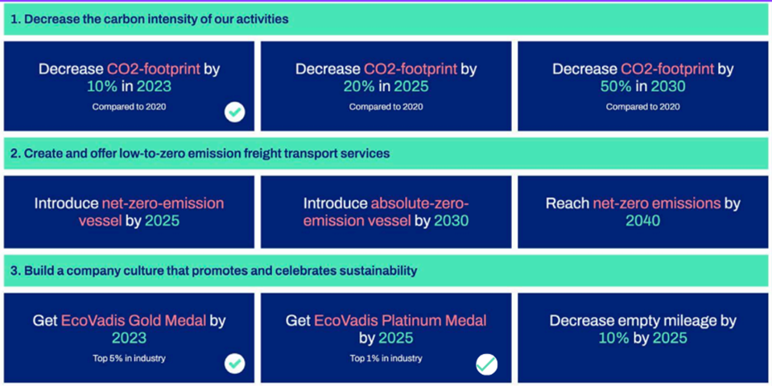

To formalize our ambition and ensure that targets are credible and of sufficient quality, we reached out to the Science-Based Targets initiative (SBTi), the leading authority in environmental target-setting. In 2024, after a thorough review, the SBTi officially validated our Near-Term (2030) and Net-Zero (2040) targets. This means that our targets are in line with what climate scientists say should be done to limit global surface warming to 1.5°C.

**Our Path to Net-Zero: A Three-Step Approach**

**Setting targets is the easy part-the real work begins now. Samskip has defined a three-step approach to lower its carbon footprint, with the goal to be net-zero in 2040**.

1. **We optimize our Multimodal Network to reduce energy use** – Did you know a truck uses over five times more energy per container than shortsea vessels, trains, or barges doing the same route? Yet, trucking remains the standard for the majority of European freight transport. There is a huge opportunity to save energy through a “modal shift” towards shortsea, rail, and barge. As we like to say: The most sustainable energy is the energy you do not use. There is a case for investing in alternative fuels but it is not sustainable to do so if you use them inefficiently. This is why a strong, efficient multimodal system is the foundation of our sustainability strategy.
2. **We decarbonize our Current Fleet with Biofuels, today** – We cannot afford to wait for the perfect technology to arrive. We must act now. Learning and adapting as we go. By using waste-based biofuels in our current vessels and trucks, we achieve up to an 89% reduction in CO₂e emissions per asset, without the need for significant investment in new assets or infrastructure. This is a powerful interim solution as we transition toward zero-emissions technologies.
3. **We invest in a Zero-Emission Fleet for tomorrow** – While we can make use of biofuels to create significant short-term impact, this is not our long-term strategy. Samskip is actively pioneering the development of cutting-edge technologies aimed at achieving zero-emission transport, for instance through electrification of trucks and using hydrogen for our vessels. Our literal flagship project is the hydrogen-powered SeaShuttles - the world’s first shortsea vessels capable of running on 100% green hydrogen.

**Targets & Achievements**

**We are proud to have successfully achieved a third of our Sustainability Targets, some even ahead of schedule.**

This includes significant emissions reductions and earning the prestigious EcoVadis Platinum medal (top 1% of all companies assessed). We're motivated to continue building on this momentum.

|  |  |  |  |
| --- | --- | --- | --- |
| **Target Reached** | **Decrease CO₂e-footprint by 10% by 2023** | **Get EcoVadis Gold Medal by 2024** | **Get EcoVadis Platinum by 2024 (fulfilled goal 1 year ahead of target year)** |
| **Actions to Reach Targets** | - Our vessels on **biofuel** reduced CO₂e emissions by an estimated 24% (against a confirmed 23,8% reduction in 2023).  - *Disclaimer: this target was reached in 2023 and therefore shows as completed. However, throughout 2024 we have seen an increase in energy and emissions as discussed earlier in the report, Unfortunately, we were not able to maintain this achievement.* | -Enhanced **reporting** on major data points.  -Introduced a detailed **KPI dashboard**.  -Developed a comprehensive **carbon footprinting** methodology. | -Updated policies and codes of conduct with **specific targets.**  -Expanded the **KPI dashboard.**  -Implemented **Science-Based targets** to meet 2040 Net-Zero target.  -Strengthened **data collection processes** for improved accuracy and traceability. |

## Sustainability Management System

**Managing Risks** (ESRS-2; GRI-2; SDGs-8, 13, 16)

**In 2020, Samskip developed its Sustainability Management System (SMS) as a key part of its strategy. Since then, we have continued to strengthen it, and are reviewed annually by EcoVadis.**

Both our general policies and SMS are integral parts of our Sustainability Strategy. Creating impact requires doing things the right way: this means conducting ourselves and our business in a way that upholds the highest sustainability standards, ensuring the well-being of our employees, and the communities connected to our operations.

We implemented our SMS based on methodology from EcoVadis, which is aligned with globally recognized guidelines and frameworks, such as ISO26000 and the UNGC principles.

The EcoVadis assessment reviews us on 4 main pillars: Environment, Labour and Human Rights, Ethics and Sustainable Procurement. Based on detailed feedback from EcoVadis, we continuously aim to improve our policies and data management across these 4 pillars.

Next year, we are taking it a step further by reviewing our SMS based on DMA results. This is to ensure we are managing risks and opportunities where it matters the most, and where we can have the greatest impact.

Lastly, our SMS has been independently evaluated and demonstrated to be effective, as evidenced by our ISO 14001 certification, which confirms that we meet international standards for effective environmental management.

|  |  |  |
| --- | --- | --- |
| Recognition | Detail | Description |
| ISO 14001 | Available for Samskip Multimodal BV  Rotterdam and Zwolle locations.    Expiration date: June 16, 2025 | ISO 14001 is an international standard for managing environmental sustainability. It requires the development and implementation of an appropriate environmental policy for the organization, with a focus on continuous improvement, preventing pollution, controlling environmental risks, and complying with applicable laws.  Note. As of 2025, our ISO certification has been renewed. |
| EcoVadis | Samskip Multimodal Score: 84 | EcoVadis provides a holistic sustainability ratings service for companies, covering a broad range of non-financial management systems, including environmental, human rights, business ethics, and sustainable procurement impacts. The certification helps companies improve their sustainability practices, build their reputation, and demonstrate their commitment to doing business responsibly. |
| EcoVadis | Samskip hf Score: | Note. Due to regional legal differences Samskip does the EcoVadis assessment for two of its major entities, both Samskip Multimodal and Samskip Hf. |

## General Policies (ESRS-G1; GRI-2, 205, 406; SDGs-5, 8, 10, 16)

**Our commitment to transparency means openly sharing the internal policies that form the basis of our ethics and accountability. On top of this, all our policies have targets, and we routinely evaluate progress against these.**

Our policies set guidelines and provide accountability across ESG topics, reflecting our core values and guiding our decision-making process. They ensure we uphold the highest standards of integrity, responsibility, and sustainability. By articulating these principles, we aim to foster trust among our stakeholders and demonstrate our ongoing commitment to conducting our operations ethically.

Environmental Policy (Environmental-related policies)

Our Environmental Policy outlines our commitment to **reducing emissions**, improving resource efficiency, and minimizing our overall **environmental impact**. Guided by international standards, we have set clear targets, including achieving net-zero emissions by 2040, increasing multimodal transport options to lower carbon footprint, and transitioning to **renewable energy** in our operations.

Scope: Employees of Samskip BV and all its entities

Key Targets:

* Achieve net-zero emissions by 2040
* Provide customers with CO₂e emission savings estimates to support informed decision-making
* Ensure 100% of the sales force is trained on sustainability, expanding their ability to effectively promote and support our sustainable services

Labour and Human Rights (Social-related policies)

The Labour & Human Rights Policy reflects our dedication to fostering a fair, safe, and engaging workplace for all employees. We prioritize **employee well-being** by offering social benefits, flexible working conditions, and circulate regular engagement surveys. **Health and safety** are paramount, with rigorous risk assessments, injury prevention strategies, and a commitment to mental well-being in place. We champion **employee growth** through career development programs, annual performance reviews, and internal mobility opportunities. Through these principles, we continue to build a workplace where everyone can thrive.

Scope: Employees of Samskip BV and all its entities

Key Targets:

* Aim for a participation rate of over 70% in quarterly employee satisfaction surveys
* Promote flexible working conditions (flexible hours and remote work options) to increase employee satisfaction
* Target an average employee turnover below 20%

Gift and Entertainment (Governance-related policies)

To further strengthen our ethical safeguards, we introduced a Gifts & Entertainment Policy in 2022. This policy provides clear guidance on financial prudence, outlining when gifts and gestures are appropriate, and introduces an approval process to mitigate potential risks when receiving gifts over 100 euros in value. It ensures **transparency** and **integrity** in all exchanges, preventing conflicts of interest while maintaining strong professional relationships. By upholding these principles, we safeguard our reputation, promote fair dealings, and foster a culture of trust, both within Samskip and with our partners.

Scope: Employees of Samskip BV and all its entities

Employee Code of Conduct

At Samskip, integrity and ethical business practices are at the core of everything we do. Our **Code of Conduct** serves as a guiding framework, reinforcing our commitment to responsible business operations across all levels of the organization. Covering key areas such as anti-bribery, corruption, and cybersecurity, it ensures that every employee upholds the highest ethical standards in their daily work. At Samskip, we believe that a strong ethical foundation ensures long-term success for our business.

## Sustainable Procurement

**Moving From Supply Chain to Value Chain** (ESRS-S2; GRI-414; SDG-8, 10)

**We recognize the impact of our value chain, which is why we have embedded sustainability considerations into supplier selection and evaluation processes. We aim to add value to our supply chain by collaborating closely with our suppliers on ESG topics.**

As a logistics company, we are part of countless global supply chains, as we move goods for our customers.

At the same time, Samskip itself has a value chain. This includes the procurement of assets and fuels that enable the logistic services we offer, as well as the aftercare and end-of-life processes of our vessels, trucks, and containers.

We also make use of subcontracted services from other transport and logistics related companies, like trucking services or vessel crewing. We take responsibility for the workers in those value chains, even though they are not directly employed at Samskip.

Our goal is to encourage and support our suppliers in adopting responsible and sustainable business practices. We achieve this through our **Sustainable Procurement Policy, Supplier Code of Conduct, CSR Survey, and Supplier Audits**.

Sustainable Procurement Policy

Our Sustainable Procurement Policy ensures that our purchasing decisions prioritize environmental, social, and ethical standards. This document acts as a managerial tool to direct our purchasing practices. It outlines a set of group-wide measures that are deployed across our geographical entities. It, therefore, acts as a coordinating tool for aligning internal sustainable procurement practices. By collaborating with suppliers who align with these values, we aim to reduce our environmental impact, uphold human rights, and promote ethical conduct across our supply chain. This document is managed by the Procurement Team and is revised annually.

Scope: Employees of Samskip BV and its entities

Targets:

* Evaluate our top suppliers (covering approximately 80% of our direct operation spend) through our supplier survey
* Establish a ranking of assessed suppliers according to their sustainability performance
* Conduct 3-5 on-site audits at selected Strategic and Preferred suppliers to monitor their quality, health and safety, and environmental processes.

*Note: Strategic suppliers are those that play a critical role in the success of an organization, often supporting key operations, innovation, or long-term goals. While preferred suppliers are trusted partners that meet our quality and performance standards and are regularly selected for procurement.*

Supplier Code of Conduct

As the business landscape evolves, so do our expectations for the companies we work with. In 2022, we updated our Supplier Code of Conduct to include a stronger emphasis on sustainability, covering environmental and social responsibility alongside business ethics.

Our Code sets clear standards for business integrity, labour practices, health and safety, and environmental management. It is aligned with global frameworks, including the UNGC, United Nations Guiding Principles on Business and Human Rights (UNGPs), and the International Labour Organization (ILO) Declaration on Fundamental Principles and Rights at Work.

To ensure compliance, we integrate the Code into new contracts and require suppliers to commit to these principles by signing the Code. All new suppliers that sign a contract with Samskip also sign our Supplier Code of Conduct.

Our Approach to Supplier Audits in 2023

To ensure our suppliers align with our commitment to sustainability and operational excellence, we apply strict evaluation criteria. As part of this supplier-checking process we assess:

* Business Strategy,
* Financial Profile,
* Sustainability,
* Quality
* Legal background,
* Cultural Fit.

Regular audits help us track adherence to key standards in business ethics, human rights, and environmental responsibility.

CSR Survey

Strengthening our partnerships requires ongoing collaboration and transparency. Our Corporate Social Responsibility (CSR) Questionnaire enables us to assess suppliers' ethical, social, and environmental performance.

## Compliance Overview

**Staying Compliant in a Changing Landscape**

**At Samskip, we welcome new regulatory requirements as a way to stay on track to achieve global climate goals, and as opportunities to innovate and lead in sustainable logistics. We want to do our part.**

The EU is actively pursuing its Green Deal or "Fit for 55" program goals, aiming to make Europe a global leader in the transition to a low carbon economy. And to meet the time-critical goals from the Paris Agreement.

Because of these climate goals, new rules have been created for business, to do with sustainability compliance and reporting. Keeping up with these changes can be challenging for organizations but they are essential if we want to achieve our global climate goals.

At Samskip, we have anticipated these changes and built a strong plan over the last few years to make sure we stay ahead and avoid any surprises. We don’t see compliance as a check-the-box exercise; we see it as an opportunity to improve and grow our sustainability strategy. To do our part.

Read more about the compliance projects we are working on below.

Road to CSRD

The **Corporate Sustainability Reporting Directive (CSRD)** is a new EU rule that requires companies like Samskip to report more clearly and consistently on their environmental and social impact. It sets a higher standard by using the **European Sustainability Reporting Standards (ESRS)**, created by [EFRAG](https://www.efrag.org/), and is aligned with global guidelines such as the [GRI Standards](https://www.globalreporting.org/), which Samskip followed in its sustainability reports prior to this one.

Under the CSRD, we must explain not only how sustainability issues affect our business, but also how our activities impact people and the planet. This information must be reviewed by independent auditors and published in a digital, easy-to-access format.

The journey towards CSRD compliance is going to be challenging for many companies needing to comply. Fortunately, Samskip has been preparing for this, and we have established a structure that will facilitate compliance.

**Omnibus disclaimer**: *Prior to publication of this document in 2025, the European Commission and Parliament adopted the Omnibus proposal, delaying the CSRD reporting requirements for Samskip. As we value the CSRD and ESRS as a framework and guidance to reaching our strategic sustainability targets, Samskip remains committed and will stick to the plan and voluntarily keep to the original timeline. Our first CSRD-aligned report will be published in 2026.*

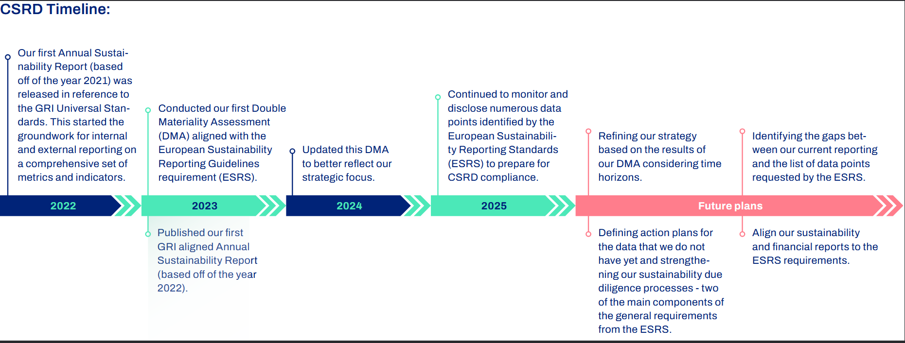

EU-Taxonomy

Which of your activities can be considered environmentally sustainable? It seems an easy question but without a clear definition, there is a lot of room for discussion and unclarity. The **EU Taxonomy** aims to solve exactly that.

By providing a classification system, it establishes clear criteria for defining environmentally sustainable economic activities. This framework helps us to identify and prioritize investments that contribute to a low-carbon economy.

We are currently developing a list of economic activities that are relevant for us and calculating how much of our company is “eligible” to be Taxonomy-aligned, meaning it has potential to become environmentally sustainable. Ultimately, we are aiming to increase the share of Taxonomy-aligned economic activities within the company. In the future, Samskip will report on our share of revenue, operational expenditures and capital expenditures that are either eligible or aligned with the EU Taxonomy.

EU Emission Trading System (ETS)

Samskip has been part of the **EU’s Emission Trading System (EU ETS)** since the beginning of 2024.

One of the EU’s main tools to drive carbon reduction is the EU ETS. It works by putting a price on carbon emissions for large emitters, such as heavy industrial companies. These companies are then required to buy Emission Allowances (EUAs) from the market or through EU-organized auctions, in order to be allowed to emit greenhouse gas emissions. In simple terms, it’s like a tax on carbon emissions.

The EU controls the supply of emission allowances, which essentially represents the amount of emissions allowed. As the number of EUAs decreases over time, emissions are reduced as well. At the same time, the increased cost of emitting CO₂ helps to close the price gap between fossil and alternative fuels.

While this system has been around for many years, the maritime sector was only added to the EU ETS in 2024. From this moment on, Samskip has been procuring emission allowances and investing in alternative fuels.

Fuel EU Maritime

Another tool in the EU’s toolbox from 2025 onwards is the **FuelEU Maritime (FEUM)**. Specifically designed to reduce maritime emissions, the FEUM does not just incentive carbon reduction like the EU ETS, it forces an increase of alternative fuels.

FEUM takes a slightly different approach to looking at emissions. Where EU ETS and other carbon calculations look at the emissions from the exhaust, the FEUM looks at the tank of a vessel and asks: *“What kind of fuels are it using, and how much CO₂ is in them?”*

This is referred to as the carbon intensity of fuels onboard. It is measured at grams of CO₂ per Megajoule. Why does this matter? Because it removes efficiency savings from the equation. The carbon intensity of the fuel used does not change whether you use it efficiently or not, and so, you cannot “save” your way out of FUEM maritime compliance by taking smarter routes or sailing slower. There is only one solution: to invest in alternative fuels.

The FUEM starts slow, with only 2% reduction required in 2025. But don’t sleep on it, in ten years it will be 14.5% and then increase exponentially to 80% in 2050.

Samskip is committed to its decarbonization roadmap and expects to over-comply with the FUEM from its introduction in 2025.

# Our Planet

## Our Environmental Pledge

**Since 2020, we have been steadfast in our commitment to environmental sustainability, embedding it at the core of our operations.**

As a leading multimodal freight transport company, we recognize the urgent need to reduce our environmental impact. We are actively developing strategies to minimize our negative environmental impact, while maximizing our contributions to global initiatives such as the Paris Agreement and the Sustainable Development Goals (SDGs).

Our goal is to inspire positive change in the logistics industry. We recognize that **Every Journey Counts**. By creating sustainable transport solutions, we are paving the way for a more sustainable future.

## Climate Change Action

## (ESRS-E1; GRI-302 and 305; SDG-13)

**Strategy: Navigating Towards Net-Zero by 2040**

**There’s no silver bullet when it comes to reducing emissions: it takes a combination of solutions, each playing a part. At Samskip, we have an ambitious roadmap with the goal to become carbon neutral by 2040.**

We are proactive in addressing climate change, setting ambitious targets, investing in transition strategies, and embracing industry innovations. From adopting biofuels in the short-term to developing the **world’s first green hydrogen-fueled vessels**, as we continue pushing the boundaries of innovation. But that doesn’t mean there are no compromises to be made. Every choice has its trade-offs. By bringing these actions together, we’re building a connected, realistic roadmap to 2040.

Due to years of commitment and continuous progress reporting, we have positioned ourselves as a leader in sustainable logistics. **We’re proud of the work we do with our customers and suppliers**:

* As a key partner in the European logistics chain, we help our customers navigate evolving regulations and stakeholder expectations, while ensuring stable and reliable services.
* To mitigate emissions across our value chain, we have adopted a comprehensive strategy, investing in fuel-efficient equipment, switching to alternative fuels, and collaborating with suppliers and other stakeholders to assess and address the impact of our operations.

**KPIs & Results**

We can only manage what we measure. That is why we’ve developed our own carbon calculator, using real fuel consumption data from across the entire Samskip Group. With each region and department owning its data, our global Sustainability Team is in charge of bringing it all together, for a complete picture of our emissions.

Looking at the numbers, our **total Scope 1 emissions went up in 2024** compared to the year before. Why? The biggest reason is a drop in the use of marine biofuels, which was replaced by traditional fuel. Biofuels have been our go-to solution to reduce emissions, but this year we chose to shift those resources to something bigger: our upcoming green hydrogen-powered vessels. It’s a trade-off: higher emissions now to invest in major CO₂ savings in the future. It was a difficult decision, but we believe it’s the right move for lasting impact. Next to that, Samskip has seen operational growth, with our vessel fleet growing both in number of vessels and their sizes. This led to an increase in vessel fuel use of 23% compared to 2023. Both the increase in fuel usage and the reduction in marine biofuels explain the increase in our Scope 1 emissions.

We also **witnessed an increase in our Scope 2 emissions**. Throughout 2024, we made significant improvements in the collection of Scope 2 data on a global level, which is reflected in a total increase of Scope 2 emissions. Samskip has an extensive network with different companies and many separate locations. By focusing on better data collection we have included more of these locations this year, which explains the increase in this emission scope. We did not find any structural drivers of this increase other than our increase in the number of sites included.

Scope 3 was not fully recalculated but based on last year’s figures corrected for business growth or decline. We included significant changes like the capital investments in the SeaShuttles and we updated the amount of procured road transport, which showed a decrease compared to last year.

Some recalculations were applied to Scope 3 emissions in base year 2022 and 2023 as well, to reflect consistency in data allocation. This resulted in a small difference from the values reported in last year’s sustainability report.

GHG emissions

|  |  |  |  |
| --- | --- | --- | --- |
| **tCO₂e** | **2022** | **2023** | **2024** |
| Scope 1 | 214.472 | 192.518 | 291.617 |
| Scope 2 | 18.620 | 19.915 | 6.607 |
| Scope 3 | 244.245 | 320.489 | 256.465 |

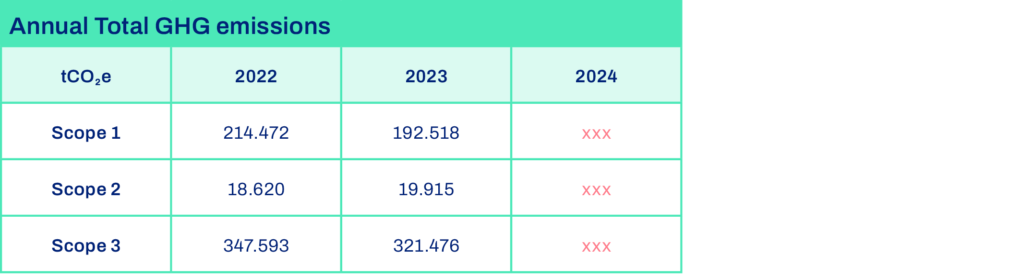

**Annual Energy Usage: 4.22 petajoules (PJ)**

**Total Volume of Biofuels: 4,592,368 liters**

**Our Approach to Emissions Calculation**

To measure our global emissions, Samskip has built an internal carbon calculator to guide the way and keep us on track. This system enables us to accurately calculate emissions and assess the effectiveness of our carbon reduction initiatives.

In 2023, we updated our methodology to align with the latest industry standards and began integrating it into our IT systems, including the **MySamskip Customer Portal**, enabling customers to get clear insights into their emissions. Our approach is fully aligned with the **ISO14083 carbon footprinting standards** and the **GLEC Framework**.

To further strengthen our commitment to transparency, Samskip introduced a customized emissions tracking tool in 2023. Built on the rigorous criteria of the SBTi Maritime Guidance and Net-Zero Standard, which are in line with the [Global Logistics Emissions Council (GLEC) Framework](https://www.smartfreightcentre.org/en/our-programs/global-logistics-emissions-council/) and [Greenhouse Gas (GHG) Protocol](https://ghgprotocol.org/). This tool provides a comprehensive view of emissions across our entire company. It allows us to monitor operational emissions and measure the environmental impact of transported shipments with greater accuracy.

By standardizing emissions tracking and enhancing visibility, we are not only improving our own sustainability performance but also empowering our customers. Regardless of the journey or transportation mode, this system offers valuable insights, helping customers understand the emissions associated with Samskip’s services and make informed, sustainable choices.

All of our carbon reporting is based on the **Scope 1, 2 and 3 methodology** of the Greenhouse Gas Protocol.

**Scope 1: Direct emissions from the combustion of fuels**

This includes all emissions from our owned and controlled assets using fuels. Throughout the last couple of years, Samskip has been working to reduce its Scope 1 carbon emissions through investments in more sustainable fuel alternatives. Scope 1 is calculated by taking all fuels bought by Samskip, and multiplying it with carbon emission factors per fuel type.

**Scope 2: Indirect emissions generated to produce electricity we use**

For all indirect emissions that come from the production of the electricity that we use. While the electricity that we use does not emit CO2, we are responsible for emissions from the production of the electricity that we use. Scope 2 includes data from electricity providers that power the Samskip offices. Previously, we included the electricity usage of our trains in Scope 2, but as Samskip is not buying this energy directly, we’ve decided to include this in Scope 3 from now on.

**Scope 3: Indirect emissions generated to produce goods and services we use**

These indirect emissions from upstream and downstream activities are the most difficult to calculate, and while we stay committed to enhancing data accuracy and transparency across our supply chain, we did not fully recalculate Scope 3 this year as not all categories are material in our total carbon inventory. Samskip estimated its indirect emissions in Scope 3, either through historical proxy data, or spend-based emission factors. Categories like Capital Goods were recalculated and there was a clear difference happening in 2024, also Upstream Transport was updated as it’s the most significant category.

|  |  |  |  |
| --- | --- | --- | --- |
| Scope 3 categories | Description | tCO₂e |  |
| Category 1 - Purchased Goods and Services | Emissions from the production of goods and services purchased by the company. | 769 | Proxy data – no full recalculation done |
| Category 2 - Capital Goods | Emissions from the production of capital goods that are purchased or acquired by the company. | 9.507 | New investments in steel for SeaShuttles and new trucks. |
| Category 3 - Fuel- and Energy-Related Activities | Emissions related to the production of fuels and energy purchased by the company, not already accounted for in Scope 1 or Scope 2. | 53.092 | Proxy data – no full recalculation done |
| Category 4 - Upstream Transportation and Distribution | Emissions from the transportation and distribution of products purchased by the company, occurring upstream in the value chain. – This is the transport we’re doing with subcontracted assets, by far the main source of our scope 3 emissions. | 192.582 | Used a mix of proxy and actual data. Updated the trucking procurement values. |
| Category 5 - Waste Generated in Operations | Emissions from the disposal and treatment of waste generated by the company’s operations. | 91 | Proxy data – no full recalculation done |
| Category 6 - Business Travel | Emissions from the transportation of employees for business-related activities. | 322 | Actual data from travel partner |
| Category 7 - Employee Commuting | Emissions from the transportation of employees between their homes and their workplaces. | 48 | Proxy data – no full recalculation done |
| Category 12 - End-of-Life Treatment of Sold Products | Emissions from the disposal and treatment of products sold by the company at the end of their life. | 54 | Proxy data – no full recalculation done |

**Science-Based Targets initiative (SBTi)**

**We keep our eyes on the future, and our future is one without emissions. By joining the Science Based Targets initiative (SBTi), Samskip became part of a global network of sustainability leaders committed to real, science-based climate action.**

After committing to SBTi in 2023, we developed targets for our operations, including our maritime activities. By end of 2024, we were finally ready: Samskip’s Near-Term and Long-Term targets were officially verified and published on the SBTi website.

The SBTi rigorously reviewed our data, methods, and assumptions, ultimately validating our goals for 2030 and 2040. This means our targets are not just ambitious, they’re aligned with what climate science says is needed to limit global warming to 1.5°C.

We based our targets on detailed internal data for Scope 1 and 2 emissions and performed a full Scope 3 screening. Since the maritime sector is an energy-intense sector, the SBTi developed a special Maritime Guidance, which we followed closely. This helped us to construct an additional target for our vessels, alongside our overall targets.

Our near-term (2030) Science-Based Target is to reach at least **42% CO2 reduction**, which in our strategic targets we rounded up to 50%. Our long-term (2040) target is to **reach Net-Zero emissions**, which means we reduce as much CO2as we can and offset what’s absolutely unavoidable.

As we are including our Scope 3 emissions (indirect emissions from purchased goods and services), we are dependent on our many suppliers. Reaching zero emissions across all these suppliers, alongside our own operations, is incredibly complex, but we are committed: We’re targeting a **90% reduction by 2040**.

Since we can’t eliminate every emission across our value chain, the final 10% will be neutralized through high-quality offset projects (e.g., investing in carbon sinks such as forests). Until we reach this 90% reduction, we do not participate in carbon offsetting initiatives but rather invest in our own decarbonization.

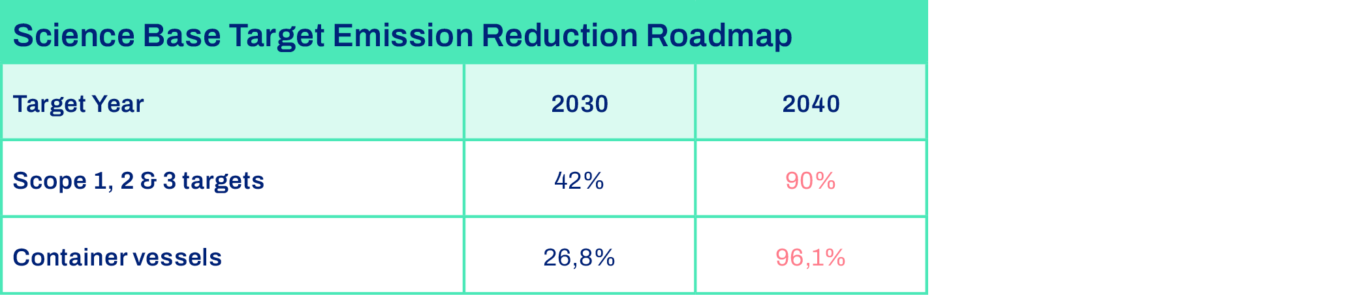

**Actions**

**Our approach towards Net-Zero emission is built on our Multimodal Network, the standard for energy efficient transport. On top of that, we’re investing heavily in short-term and long-term decarbonization solutions, such as switching to alternative fuels, electrifying our rail network, and the launch of our hydrogen-powered SeaShuttles. Beyond decarbonization, we also take action to prevent and reduce air pollution.**

Did you know that Europe is still dominated by road-only transport, even though trucks use about 5 times more energy per container than alternatives via rail and water? By making the switch of transport mode, we can easily reduce carbon emissions by up to 80%.

As our CEO is fond of saying: *The greenest form of energy is the energy we can save.*

That’s why we focus on reducing energy consumption, through investing in our extensive multimodal system that includes sea-going vessels, river barges, trains, and trucks. Optimizing this network is a must for sustainability. Adding more alternative fuels into an inefficient system would be wasting valuable energy.

Alternative Fuels

With the multimodal network in place, the next step is to target individual assets and begin introducing transitioning fuels. We've started moving away from carbon-intensive traditional fuels back in 2017, when we invested in two Liquefied Natural Gas (LNG) vessels, a bold and innovative decision at the time. As we learned more about alternative fuels, we moved towards marine biofuels as an intermediate solution.

In 2021, Samskip was among the first shipping companies to use 100% biofuels in one of its vessels. When trials succeeded, we increased this to five vessels. This helped reduce our vessel fleet’s CO₂e emissions by an estimated 24%, and about 89% per vessel. All our biofuels were, and still are, International Sustainable Carbon Certification (ISCC certified), with production chains audited on sustainability, deforestation, and competition with food production.

But biofuels are not our end game. They are a transition tool to create impact today. To achieve our Net-Zero target, we must go further. That’s why Samskip is investing in zero-emission technologies, such as our **hydrogen-powered Samskip SeaShuttles**. These groundbreaking ships will be the world’s first hydrogen short-sea vessels, and are set to embark on their first journey in 2027, marking a significant milestone in maritime decarbonization, and Samskip’s sustainability journey.

|  |  |  |
| --- | --- | --- |
| **LNG** | **Biofuels** | **Hydrogen** |
| **2023**: 2 out of 21 vessels run on LNG  **2024**: 2 out of 21 vessels run on LNG  **Strategy**: Continue use of LNG vessels. | **2023**: 5/41 (Peak of biofuel usage)  **2024**: Samskip blended biofuels throughout its whole vessel fleet to ensure operational efficiency and compliance with all environmental regulations.  **Strategy**: Biofuels is an intermediate solution creating carbon reductions today. However, it’s a transitional tool, that will be phased-down in the long term as we move towards zero-emission power sources. | **2024**: Hydrogen vessels under construction  **2027**: 2/21 Hydrogen container ships  **Strategy**: Pioneer, test, and further develop. Potentially increase the number of hydrogen vessels. |

Rail Electrification Efficiency

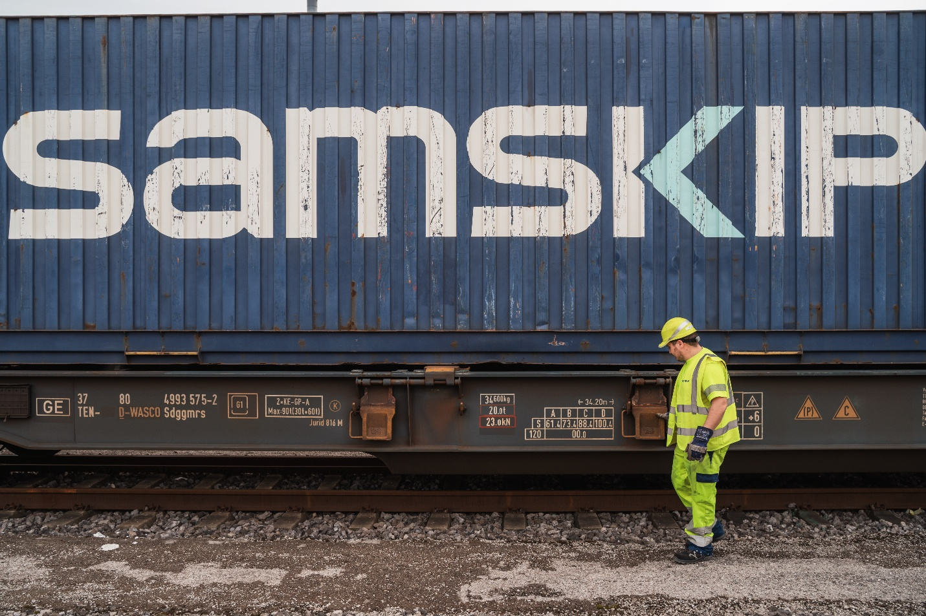

Our robust rail network is one of the cornerstones of our Multimodal Network. With the rail network being almost fully electrified (with the exception of some very short repositioning of locomotives within rail stations), opting for train transport is the easiest way to bring emissions close to zero.

In most cases, a container moved by train replaces a journey that would have otherwise been made by truck, helping to significantly cut down on GHG emissions. For many routes, it’s one of the most effective ways to get close to zero-emission logistics.

In 2023, we expanded our rail network by adding 4 new routes to our Duisburg terminal, connecting it to Padborg (Denmark), Macon (France), and Padua and Verona (Italy). Duisburg remains a key hub for Samskip's north-south services between Germany, Sweden, and Italy, as well as connecting Denmark, Lubeck, Poland, and our shortsea connections in Rotterdam and Amsterdam. These new routes address the growing driver shortages in Europe's road haulage sector, offering reliable, efficient, and sustainable rail services along major European corridors.

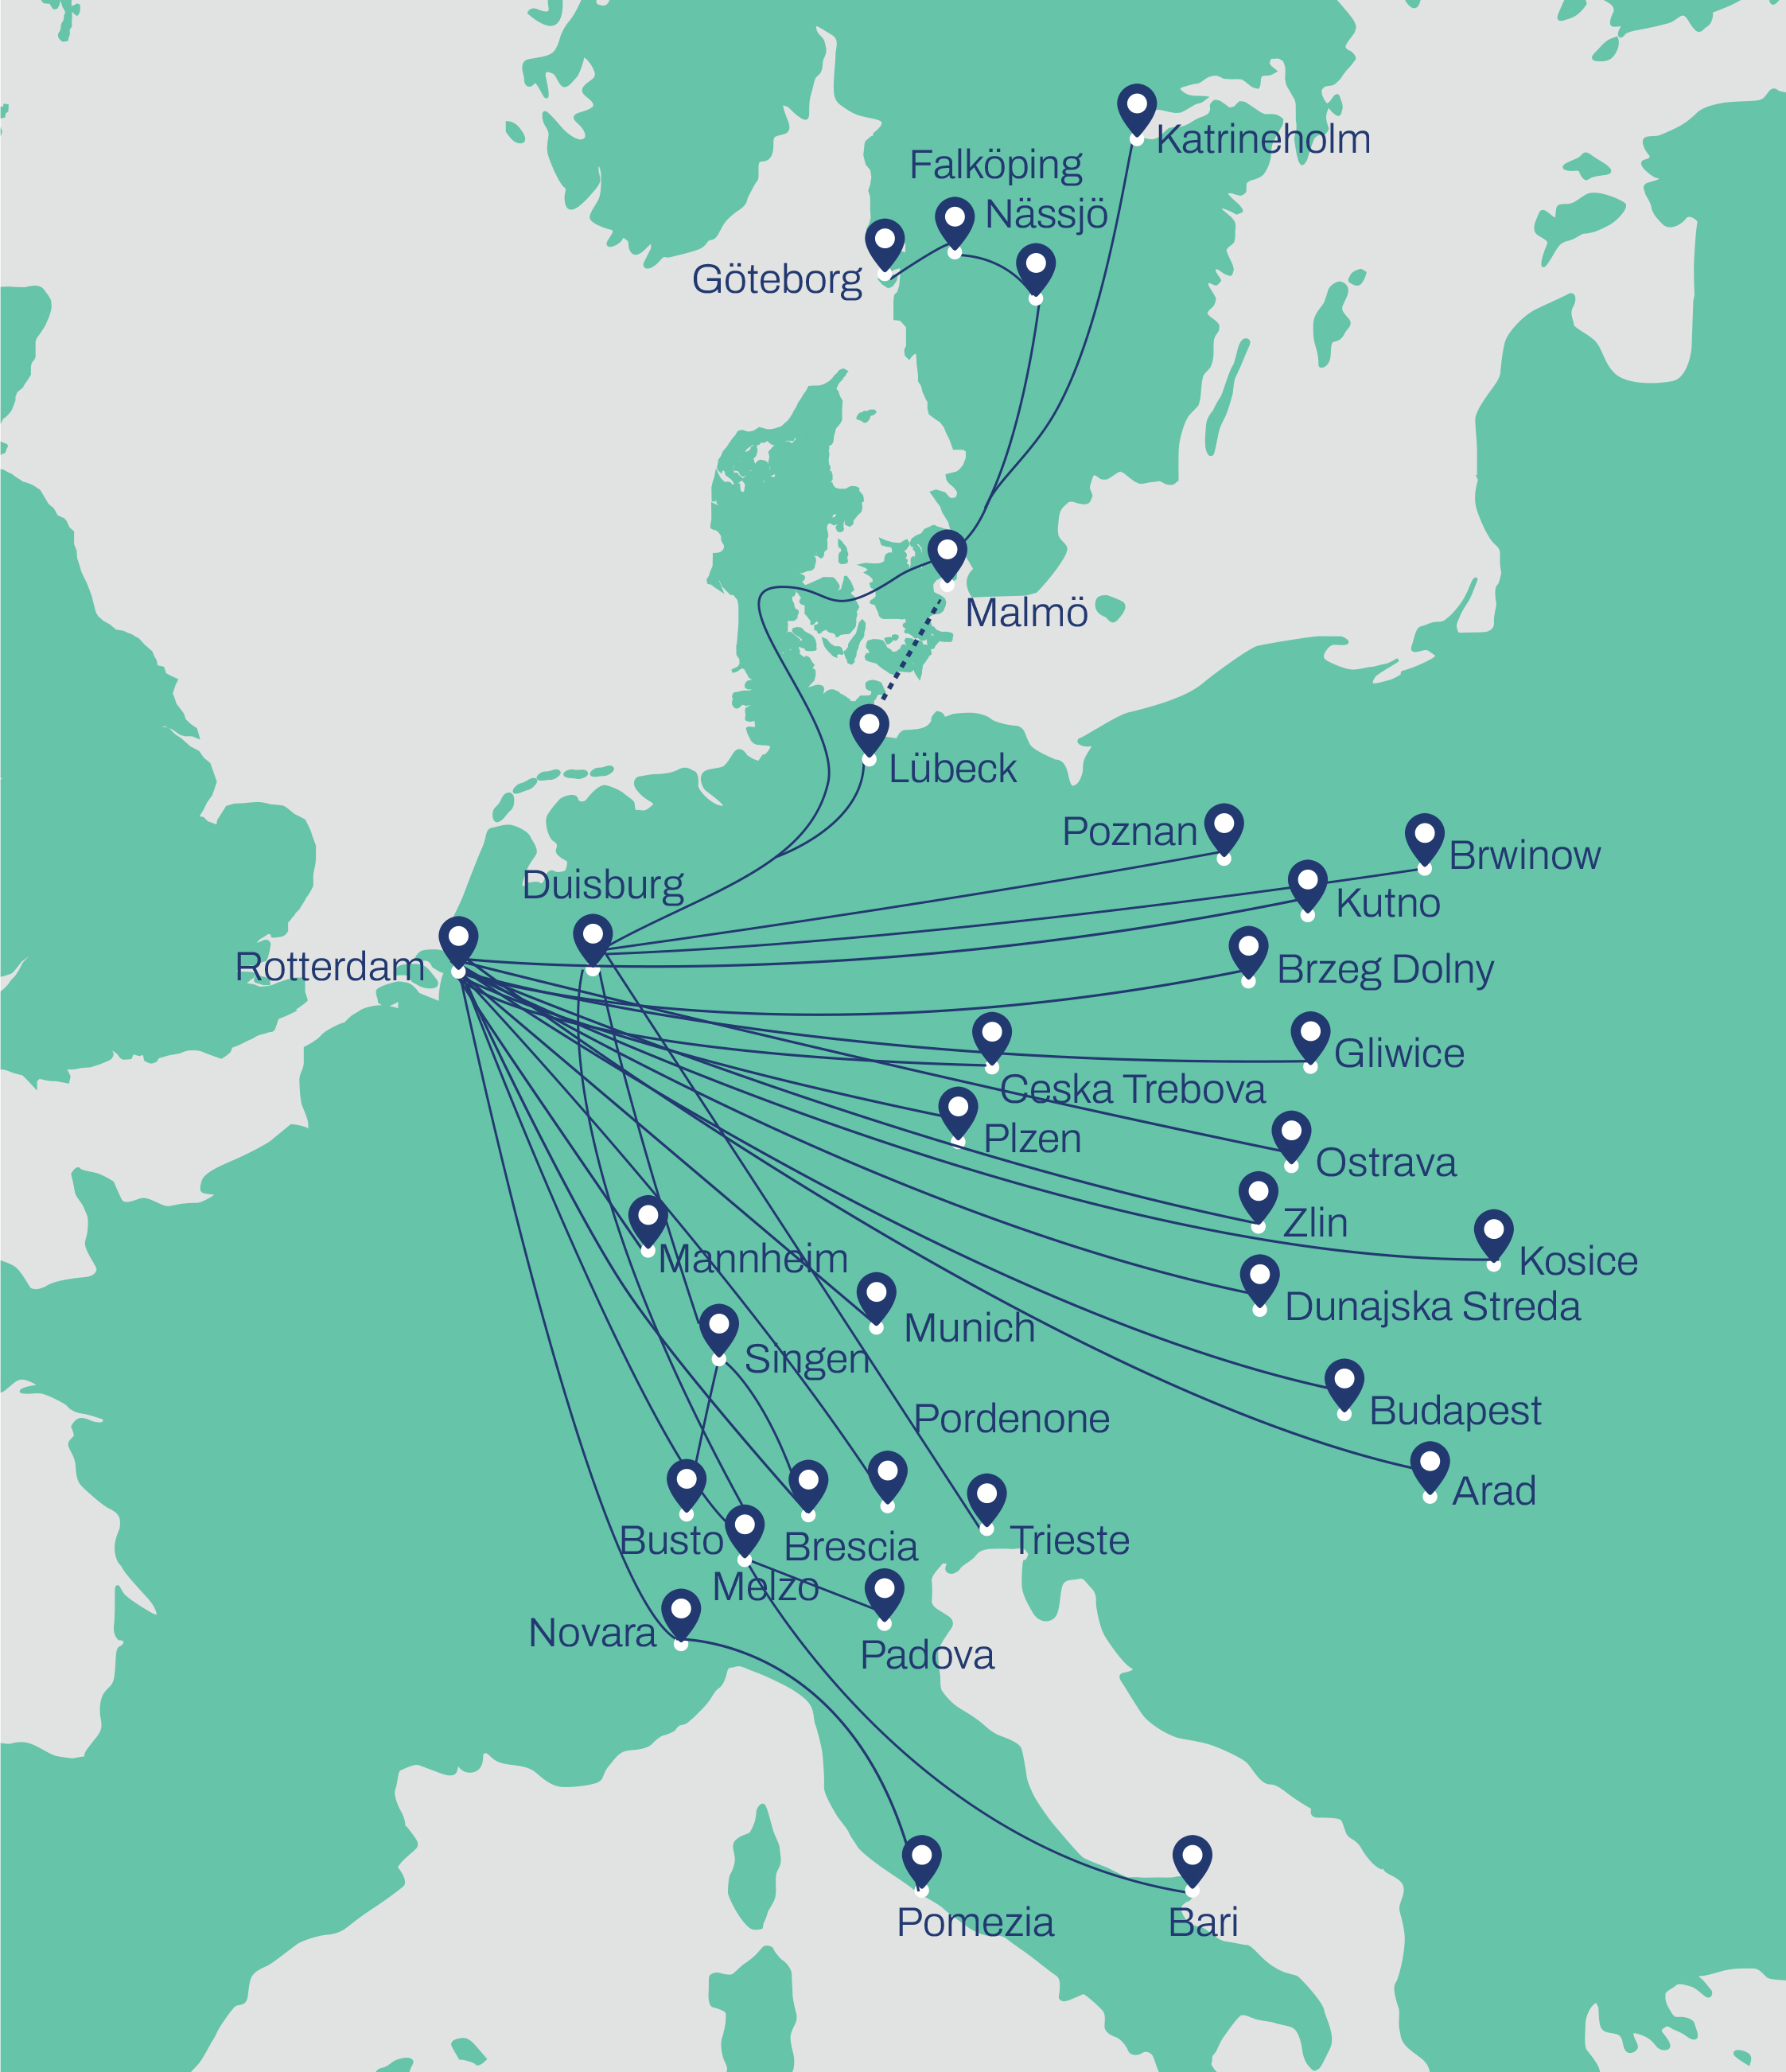

Green Shore Power initiative

In July 2023, Rotterdam Shortsea Terminals (RST) and Samskip launched the Green Shore Power initiative, aiming to drastically cut CO₂ emissions from docked vessels by providing a clean, innovative onshore power supply.

Previously, vessels relied on fossil fuels to generate electricity while docked. With the implementation of green shore-power, the shipping industry can reduce CO₂ emissions by up to 5 megatons annually, accounting for 3.7% of global shipping emissions.

This initiative not only reinforced Samskip’s position as a leader in the industry, but also prepared us for the FuelEU Maritime regulation, which will require shore-power connections by 2030.

We firmly believe that collaborative action is essential to address the urgent challenge of global climate change. We take pride in being early adopters of initiatives like this, positioning ourselves ahead of the industry.

For more information: [RST and Samskip join forces to launch first shore power green initiative](https://rstshortsea.nl/rst-and-samskip-join-forces-to-launch-first-shore-power-green-initiative/)

## Energy Efficiency

## (ESRS-E1; GRI-305; SDG-12,13)

In 2024, the total energy consumption across our vessels, trucks, barges, trains, offices, and warehouses was (4.22 petajoules), marking a 22.51% increase compared to 2023 data. In 2023, we had managed to reduced our energy consumption by 2.03%, from 2022. The significant increase in energy usage is a result of the introduction of more and larger vessels into our fleet.

While Samskip is still largely dependent on fossil fuels, we use renewable biofuels in part of our vessel and truck fleets, alongside renewable electricity for a significant share of trains and in our offices. In 2024, 5% of our energy consumption came from renewable sources. This represents a 19% decrease when compared to our renewable energy share in 2023. While our renewable share has declined in the short term, we remain committed to learning from our setbacks so we can continue to improve in these areas in the future.

## Air Pollution Prevention

(ESRS-E2; GRI-305-306; SDG-3, 11, 15)

**Strategy**

**By switching to cleaner fuels, as well as complying with local environmental regulations, we achieve reductions in both GHG emissions and local air pollution. We take it a step further by using Exhaust Gas Cleaning Systems (EGCS).**

**Emissions vs. Local Pollution**

*Explain the difference between local pollution and GHG emissions (THIS CAN BE DELETED)*

It is important to distinguish the difference between emissions and pollutants, as the terms are often used interchangeably. While both emissions and pollutants can stem from the same transport operations, their impact is different. GHG emissions contribute to rising temperatures at a global level, which in turn affects regions and local communities in various ways. Air pollutants, such as sulfur oxides (SOₓ), nitrogen oxides (NOₓ) have a local impact, directly affecting the air quality and posing health risks to people in nearby areas.

Samskip recognizes its involvement and actively implements measures to reduce its contribution to operational pollution. We have installed pollution control technologies such as EGCS, and invest in sustainable infrastructure, including Shore Power Systems, to minimize our environmental impact.

Next to this, we proactively manage environmental risks through our robust Sustainability Management System.

**KPIs & Results**

Even though we are fully compliant with all global and local regulations, Samskip’s operations still contribute to local air pollution. Air pollution data is based on fuel data, based on the different fuel types Samskip uses in its vessels and trucks.

**Pollution related incidents: 0** 

**Vessels equipped with EGCS: 4 out of 22**

**Total pollution per modality:**

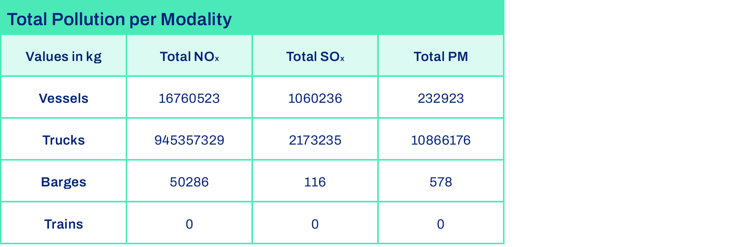

**Actions**

Exhaust Gas Cleaning Systems (EGCS)

The International Maritime Organization (IMO) regulates Sulphur Oxide (SOx) emissions from ships, offering two major compliance options: using fuels with limited sulphur content, or employing EGCS. As of January 1, 2020, the IMO placed a global sulphur cap on fuels, which caused a 77% drop in SOx emissions (SOURCE).

At the same time, EGCSs have proven to be effective in removing SOx and other harmful air emissions, like Particulate Matter (PM) and Polycyclic Aromatic Hydrocarbons (PAHs). Therefore, to reduce the emissions of harmful air pollutants, Samskip has equipped 4 ships in 2023 with EGCS, these ships are still in operation with this technology in 2024.

## Pushing New Boundaries

**SeaShuttle Steel-cutting Ceremony**

The “steel-cutting ceremony” in March 2023 marked the official construction start for Samskip’s next-generation zero-emission shortsea container vessels: the Samskip SeaShuttles. The vessel is still under construction in 2024 and is set to become the world’s first zero-emission shortsea container ships using green hydrogen as source of power.

Each 135-meter vessel will be equipped with a 3.2 MW hydrogen fuel cell, supplemented by (bio)fuel generators for backup power. When operating in zero-emission mode, the two SeaShuttle vessels are projected to reduce CO₂e emissions by approximately 25,000 tons annually. Additionally, they will achieve emission-free operations in ports by utilizing green shore power at their docking locations. Both vessels are scheduled for delivery in 2027.

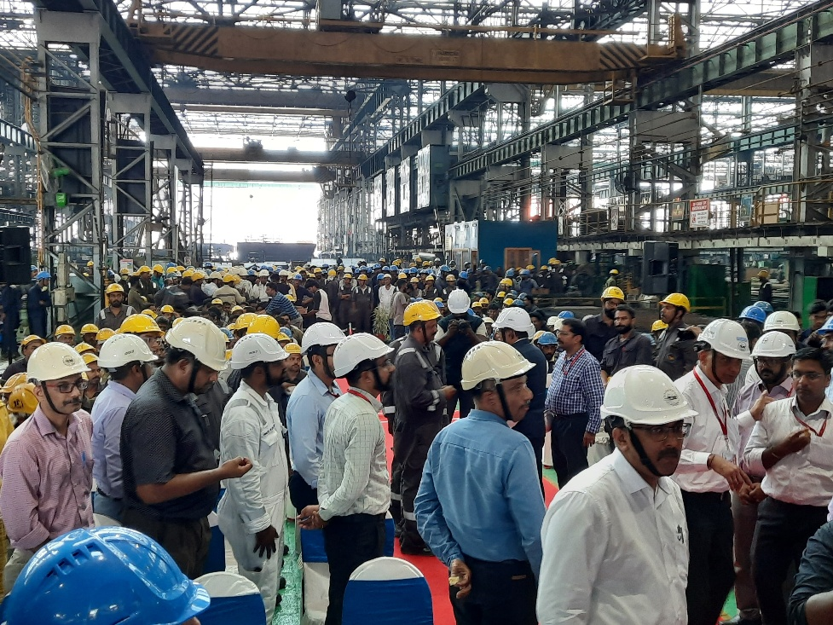

**Next Generation Terminals**

Samskip, in collaboration with **Matrans Rotterdam Terminal**, is launching a state-of-the-art terminal in Rotterdam. As a key multimodal hub in Samskip’s network, Rotterdam has long been integral to our operations. This new terminal represents a significant step forward in enhancing reliability, optimizing supply chain efficiency, and advancing sustainable transport solutions.

The terminal will serve as a central hub for both containerized and breakbulk transport, integrating sustainable initiatives such as vehicle electrification, shore power, and solar energy. By improving control over vessel, rail, and barge operations, Samskip aims to reduce bottlenecks, optimize modal shifts, and lower emissions. Digital innovations will further **enhance operational efficiency** by enabling real-time cargo prioritization and dynamic supply chain management.

Through this initiative, Samskip and Matrans reaffirm their shared vision of a greener, more resilient logistics network, ensuring faster, more reliable transit times with the lowest possible environmental impact.

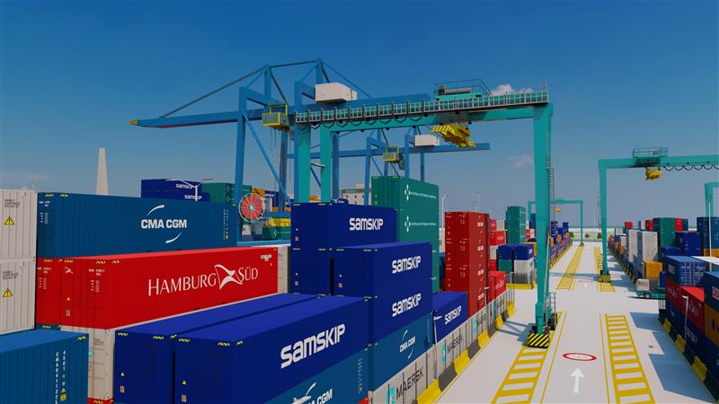

# Our People

## Our Social Pledge

**At Samskip, our people are the driving force behind our success. Their dedication, innovation, and commitment enable us to push boundaries and deliver exceptional service to our customers.**

## People at Samskip

(ESRS-S1-13; GRI:401-406; SDG-3, 5,8 and 10)

**Strategy**

**We believe that a sustainable business starts with a strong, supported workforce, built on two pillars: Safe & Supportive Working Conditions, and Equal Opportunities and Equal Treatment for All.**

That means creating workplaces where safety is second nature, fair pay is a given, and work-life balance is promoted. Next to that, we’re committed to building an inclusive workplace where everyone has the same opportunities, feels valued, and can grow through training and personal development.

From putting rigorous safety systems in place to introducing inclusive hiring and flexible work policies, we’re shaping a culture where everyone can grow, speak up, and belong. Because sustainability doesn’t just happen in operations, it begins with the people behind them.

Safe & Supportive Working Conditions Equal Opportunities and Treatment for All

|  |  |
| --- | --- |
| Health and Safety  No task is more important than protecting people. We prioritize a culture of safety that supports the physical and mental well-being of all employees and contractors. This commitment is embedded in our policies, systems, and daily operations to ensure a safe and compliant working environment across all locations.    Adequate Wage  We seek to ensure that employees are paid an equitable and just wage that reflects the value of their contributions, skills, and experience.  Across our entities we have embedded proper compensation into our company that states our team must be paid fairly and competitively for their hard work. This approach promotes financial well-being, fosters employee loyalty, and reflects our values of fairness and inclusion across all operations.  Work-life Balance  A balance between a professional and personal life is not a perk, it is a core part of respecting and retaining valuable workers. We understand that when employees have room to recharge, reconnect, and grow outside of work, they bring their best selves to the job. That’s why we design our working culture to fit real lives, not just job descriptions. Creating space for balance, flexibility, and fulfillment alongside performance. | Gender Equality and Equal Pay  Our diverse workplace is one of Samskip’s greatest strengths. A collective environment shaped by different cultures, perspectives, genders, and life experiences.  We believe inclusion goes beyond access. It means ensuring genuine equity and giving everyone a voice at every level. We are intentional in building a culture where no background becomes a boundary and every employee, regardless of gender, identity, or origin, has equal access to remunerations, representation and opportunity, respect, and recognition. Fairness is not left to chance.  Although there is still work ahead, we are united in building a future that ensures everyone’s right to social and economic inclusion is fully taken into account.  Training Skills and Development  Efficient and fulfilling career development is about finding your direction and having the tools to get there. We want to make sure that every employee feels valued, with their unique strengths, aspirations and areas of improvement. This provides a dual benefit: helping our employees grow personally while also bettering company operations and strategies. |

**KPIs and Results**

Safe & Supportive Working Conditions Equal Opportunities and Treatment for All

|  |  |
| --- | --- |
| Health and Safety   * ***7***Work-Related Incidents, including Non-Serious.   Work Life Balance   * **7.2** Employee Satisfaction Score (Out of 10)   *Note: Serious incidents include any incidents related to the transport of goods which results in fatal or serious injury to a person, or major property or environmental damage. This data point was derived from Nav-Tech, the inhouse ship managing company of Samskip. Therefore, non-serious injuries are that do not result in long-term harm or significant medical treatment.* | Gender Equality and Equal Pay   * Number of employees   + Total: **1,715**   + By gender: **F:34%, Male:65%** Unknown:1% age   + Region:   -UK and Ireland: 7%  -Iceland: 29%  -Western Europe & Iberia: 31%  -Norway & Sweden: 18%  -Baltics: 3%  -Global Forwarding:8%  -Others: 4%  Employee Age Ratio   * + <20 = <1%   + 21-30 = 23%   + 31-40 = 26%   + 41-50 =20%   + 51-60 = 19%   + >60 =8%   + Unknown = 2%   + **92% Full-Time Employees** * **0** DEI Incidents Reported   Training Skills and Development   * **3,913** Total Number of Hours Spent on Training & Development * Average ~**3** Hours of Training Per employee |
|  |  |

All demographic data is managed by our People department and stored centrally in our systems. For employee satisfaction, Samskip makes use of the MoodUp system, which sends quarterly surveys to all employees. Training data is taken from our company-wide Samskip Academy.

*Note: Total employee count represents all individuals directly employed by Samskip. The breakdown by gender and contract type includes employees across all entities, with the exception of truck drivers.*

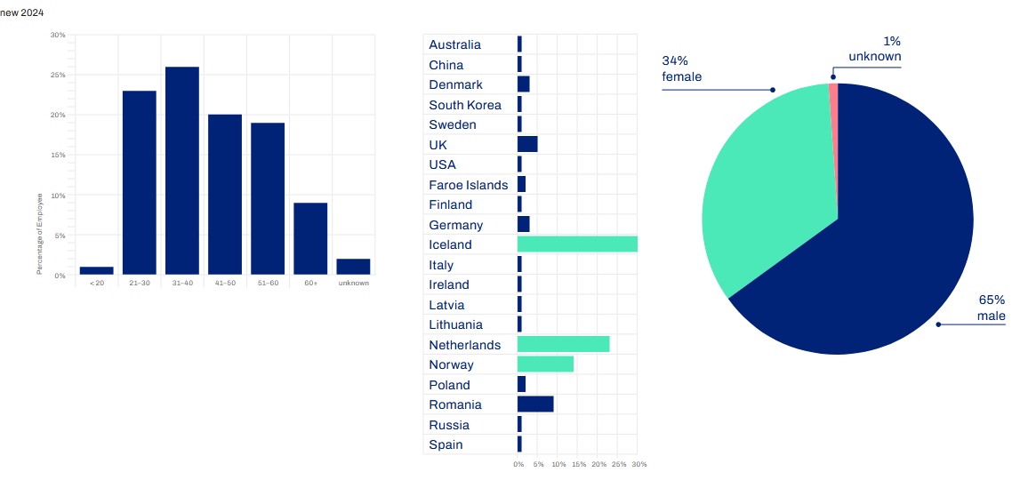

**Actions**

**Working Conditions**  **Equal Opportunities and Treatment for All**

|  |  |
| --- | --- |
| We Take Safety Serious  Workers' safety is integrated into our Code of Conduct and Vessel Safety Management System, providing formalized guidelines. Safety principles are actively communicated across teams and geographies to foster shared accountability. Policies and safety systems vary depending on the type of operation and operating region.  Training plays a critical role in maintaining a safe working environment. Operational employees undergo occupational safety briefings before starting work, in accordance with legal requirements. These briefings are repeated annually, with employees confirming their participation through signature in our health and safety journal. A dedicated health and safety coordinator oversees the delivery and documentation of this training process, ensuring compliance and consistency across all locations.  These trainings equip employees with the necessary skills and knowledge to work safely and efficiently. Equipping  employees to handle occupational risks, including hazardous substances, and making sure employees understand how to apply safe practices in their day-to-day work.  We provide our employees with appropriate safety equipment and resources as necessary; this includes adequate personal protective equipment (PPE) for specific job roles.  A Whistleblowing Procedure allows employees to report safety concerns confidentially and without fear of retaliation. Reports are reviewed promptly, with corrective actions implemented where needed.  Regular audits and inspections further ensure compliance with safety standards and drive ongoing enhancement of safety protocols. Samskip audits its warehouses and terminals throughout different regions on a wide range of topics, focusing largely on health and safety.  Wages That Reflect Worth  Samskip started developing a **company-wide compensation framework** designed to ensure employees are paid fairly and competitively. This is expected to roll out at the end of 2025.  Since 2020, for our Iceland operations, we have an accredited Equal Pay Management System that complies to the requirements of Icelandic Standard IST 85:2012. This certification confirms that employees have equal opportunity to use their skills in a job and be compensated accordingly, regardless of gender or any other non-relevant criteria.  Supporting Balance  We support flexible working arrangements, including hybrid schedules and adaptable start/end times.  Additionally, employees are encouraged to take full advantage of their annual leave, recognizing the importance of rest for sustained performance. Managers actively monitor leave usage and promote time-off planning to prevent burnout. | Diversity, Equity, and Inclusion  Discrimination and harassment have no place in our culture. This is strictly stated in our Code of Conduct which has zero-tolerance approach through clear protocols, because every single person deserves to feel safe, respected, and valued. For our Iceland operations, an additional anti-bullying committee provides extra support and resources to employees who may feel hesitant about reporting misconduct. Our Whistleblowing Procedure allows employees to report misconduct safely and confidentially across all locations.    Our hiring process is based on competency analyses aligned with job requirements, ensuring decisions are made purely on skills and experience. We apply **equal opportunity principles** to every stage of the employee lifecycle: recruitment, promotion, and professional development. Decisions are guided by competency-based evaluations, ensuring that merit and skill remain the only criteria for advancement.  Candidates are assessments rely on standardized interview forms and multi-reviewer panels to reduce unconscious bias. We explicitly remove factors such as gender identity, race, religion, age, or sexual orientation from influencing hiring decisions.  Training for a Better You  Through the **Samskip Academy** online platform, we offer a broad catalogue of training, in areas such as safety, conflict resolution, time management, and leadership. Our training formats offer fully virtual options to ensure accessibility across all locations and schedules.  Employees are supported through regular performance reviews and career management planning, where personal growth is aligned with organizational goals. These reviews are a space for open dialogue, identifying strengths, discussing satisfaction, and planning future development.  We encourage employees to actively reflect on their progress, set yearly goals, and engage in two-way conversations with managers. This process supports personal accountability while fostering a transparent, supportive environment that values feedback and growth. |

## At Samskip, we believe

## Our Value Chain

(ESRS-S2; GRI-403, 409 and 414; SDG-8 and 10)

**Strategies**

**Our values, principles, and standards apply not only to our direct employees but also to everyone working throughout our value chain. We believe that all individuals deserve the same rights and protections as our own team members.**

That’s why we are committed to conducting thorough due diligence across our value chain, ensuring that the same key social topics we prioritize internally are also upheld by our partners and suppliers. The workers within our value chain consist of truck drivers, vessel crew, rail providers, terminal and port operational workers, and many more indispensable people that keep our operations going. These workers are hired as sub-contractors or third-party employees and are an essential part of our daily operations.

Working Conditions  Equal Opportunities and Treatment for All

|  |  |
| --- | --- |
| Health and Safety  Our commitment to health and safety covers everyone in our value chain. Protecting and promoting fundamental human and labor rights such as providing safe and fair working conditions for all individuals is a core responsibility at Samskip. We recognize that ensuring safe working conditions for these workers is not only a matter of compliance, but a reflection of our values. Through collaboration, clear expectations, and shared systems, we work with partners to uphold high safety standards and respond to risks across all tiers of our operations.    Work Life Balance  While we do not directly manage all workplaces in our supply network, we influence conditions through our procurement practices, contractual standards, and ongoing engagement with partners. Our strategy centers on responsible sourcing and continuous supplier evaluation to ensure respect for workers' rights and well-being. Given the work-intensive nature of many roles within our value chain, it is especially important to address this topic, as workers in these positions may be at higher risk of overwork. | Measures Against Violence  At the end of 2024 we identified this subtopic as material through our DMA. As this is a new initiative we want to focus on, there are no strategies in place to assess progress in this area. We are currently working on measures to improve this area. |

**KPIs and Results**

Data regarding suppliers to Samskip’s multimodal operations is managed centrally by our Procurement Team. Additional data is provided by relevant operational regional departments, covering the full scope of our company.

Note: We are taking steps to better align with the material subtopics identified in our DMA. By 2025, we expect the data to more accurately reflect the key impacts, risks, and opportunities relevant to this area.

Working Conditions  Equal Opportunities and Treatment for All

|  |  |
| --- | --- |
| * Number of suppliers audited on ESG issues: 2 * # of suppliers that filled the CSR survey: 45 (80% supplier spend) * Average score CSR Survey: 48% (out of 100%) * Additional results:   + 67% have established ESG targets.   + 71% have investment plans for sustainable technologies.   + 91% have a Health & Safety policy in place. | At the end of 2024 we identified this subtopic as material through our DMA. As this is a new initiative we want to focus on, there are no KPIs in place to assess progress in this area. We are currently working on measures to improve this area. |

**Actions**

Safe & Supportive Working Conditions Equal Opportunities and Treatment for all

|  |  |
| --- | --- |
| Prioritizing Safety  Samskip maintains a robust safety management system that emphasizes risk prevention, ongoing crew training, and transparent incident reporting for both employees and subcontracted crew. Developed with Nav-Tech guidance manuals and emergency procedures, this system ensures a unified and effective approach to managing safety risks and responding to onboard incidents throughout our value chain.  Health and safety protocols are actively communicated with subcontracted partners and vessel crews. Safety expectations and standards are embedded into onboarding procedures, briefings, and operational processes.  All suppliers are contractually required to maintain safe working conditions under Samskip’s Supplier Code of Conduct. Compliance is monitored through audits and CSR surveys, ensuring that health and safety obligations are upheld across the supply chain. The survey further evaluates supplier performance on safety, ethical practices, and social impact. These assessments guide improvements and identify non-compliance within the value chain.  Work Wellbeing  Samskip will provide an anonymous whistleblowing platform that allows third-party and subcontracted workers to report concerns, including unethical treatment or unsafe working conditions, without fear of retaliation.  To further protect worker rights across the value chain, Samskip is developing a formal grievance mechanism accessible to all subcontracted and supply chain workers by 2025.  Samskip’s procurement policy embeds social responsibility into all purchasing decisions. This includes evaluating suppliers on labor standards, working conditions, and legal compliance. Expectations from Samskip are communicated in supplier onboarding and monitored through KPIs.  Samskip applies a structured, standardized process when selecting and onboarding suppliers to ensure alignment with ethical and legal standards. This includes:   * **Pre-qualification checks** on financial stability, labor compliance, and sustainability alignment. * **Category-specific criteria** to evaluate working conditions, health and safety practices, and human rights risks. * **Mandatory documentation** such as certifications (e.g. ISO, labor standards), insurance, and legal credentials. * **IT and operational integration** to ensure secure connectivity and compliance monitoring. * **Centralized approval tracking**, ensuring transparency and consistency across all supplier categories.   Procurement staff receive training on social and environmental standards. Samskip shares annual sustainability reports with suppliers, encourages sustainability certifications, and supports continuous improvement efforts through collaboration and performance feedback. | Measures Against Violence  At the end of 2024 we identified this subtopic as material through our DMA. As this is a new initiative we want to focus on, there are no Actions in place to assess progress in this area. We are currently working on measures to improve this area. |

# Our Responsible Business

## Our Governance Pledge

**Ethical and responsible business practices are fundamental to our long-term success. We are committed to fostering a culture of transparency, open communication, and accountability, ensuring that ethical conduct remains at the core of our operations.**

Our business relies on a vast network of suppliers and stakeholders across the value chain, making collaboration essential in upholding these principles. To extend our commitment beyond our own operations, we actively engage with our suppliers on business ethics, promoting responsible practices throughout our supply chain.

## Business Conduct

(ESRS-G1; GRI-205, 406, 418; SDG-5,8,9,10)

**Strategy**

|  |  |
| --- | --- |
| Ethical Business Conduct  Our approach to ethical business conduct is guided by a commitment to integrity, transparency, and compliance across all operations. We align our policies with international standards such as the UNGC and OECD Guidelines, embedding ethics into our decision-making processes, supply chain oversight, and stakeholder engagements. Our Code of Conduct and Supplier Code of Conduct set clear expectations for behavior  Data Security and Protection  In today's technology-driven world, data security measures are increasingly becoming more important. Given the significant volume of sensitive data we manage, staying ahead of data security risks is an essential part of responsible business operations and safeguarding stakeholder trust. | Corporate Culture  Samskip fosters a corporate culture which focuses on fostering transparency, accountability, and ethical behavior throughout our company. This culture is shaped and sustained by leadership behavior, clear communication, and shared values across our global operations.  We invest in initiatives that build understanding and connection. Terminal visits help new employees gain firsthand insight into the logistics chain, strengthening operational awareness, while activities like the Rotterdam Marathon foster a sense of community and teamwork across our organization. |

**KPIs and Results**

The data on whistleblowers is tracked through our whistleblowing procedure, which is managed by our People and Quality departments. All training hours are logged in our Samskip Academy, which also is managed by the People department. Unfortunately, not all training provided is tracked in the academy, we are working to update and improve this process over 2025. Our IT team oversees data breaches.

|  |  |
| --- | --- |
| Ethical Business Conduct   * # of whistleblower incidents: 0 * % of employees that took training on ethical business practice: 9% of workforce | Data Security and Protection   * Number of Data breaches or accounts compromised: 0 |

**Actions**

|  |  |
| --- | --- |
| Ethical Business Conduct  We conduct regular risk assessments and due diligence on ethical issues, particularly in relation to bribery, corruption, and human rights.  All employees are incentivized to complete mandatory compliance training, with periodic refreshers.  A whistleblower mechanism is in place to allow for anonymous reporting of concerns, and we actively monitor and respond to reports through defined internal procedures.  Data Security and Protection  We have a formal IT Data policy which governs the ethical, secure, and compliant use of all digital systems, networks, and equipment across the company. This includes strict controls around account access, data protection, remote work protocols, and responsible use of AI tools.  We protect data end-to-end through a robust Information Security Management System (ISMS) framework, designed in accordance with General Data Protection Regulation (GDPR) principles and the ISO 27001 international standard for security management. | Corporate Culture  We facilitate regular employee engagement surveys and feedback loops to gauge satisfaction and improve workplace dynamics.  We have an unwritten open-door policy to encourage a workplace where everyone feels comfortable asking questions.  Our leadership training and internal communication programs promote alignment on core values and expected behaviors.  Team-building activities help strengthen a sense of belonging and collaboration across teams. Such activities include cultural lunches, project celebration, and the Rotterdam marathon and Harbour run. |

# Concluding Remarks

**In 2024, Samskip moved from ambition to action.** We launched our hydrogen-powered SeaShuttles, we earned an EcoVadis Platinum rating for Samskip Multimodal and a Gold for Samskip hf, and our climate targets were validated by the Science Based Targets initiative. Together, these milestones lay a strong foundation for long-term impact.

We updated our Double Materiality Assessment to better reflect what matters most to our business and stakeholders. These insights help guide our strategy and ensure alignment with the CSRD. Even as regulatory timelines shift, we remain committed to transparency and continue reporting voluntarily under the GRI Universal Standards.

In line with our environmental goals, we made a strategic choice to temporarily reduce our use of biofuels and invest in hydrogen technology. While this led to a short-term rise in Scope 1 emissions, it supports deeper reductions in the future.

We also improved our internal systems. Our updated carbon calculator, now part of the customer portal, provides better visibility and supports shared responsibility for emissions across our value chain.

Sustainability is not only about carbon. It's about people, values, and governance. We continue to focus on employee engagement, inclusion, and safety, while strengthening the systems that support our commitments.

At Samskip, transparency, credibility, and collaboration guide our progress. We are working toward a more sustainable logistics sector, step by step, and in partnership with others.

Our team is always here to support your sustainability journey, wherever you may be along the way.

# Appendix

## Abbreviations

|  |  |
| --- | --- |
| **Abbreviated word** | **Meaning** |
| CO₂e | Carbon Dioxide Equivalent |
| CSRD | Corporate Sustainability Reporting Directive |
| DMA | Double Materiality Assessment |
| EFRAG  EGCS  ESG | European Financial Reporting Advisory Group  Exhaust Gas Cleaning Systems  Environmental, Social, and Governance |
| ESRS | European Sustainability Reporting Standards |
| ETS | Emissions Trading System |
| FEUM | FuelEU Maritime |
| GHG | Greenhouse Gas |
| GLEC | Global Logistics Emissions Council |
| GRI | Global Reporting Initiative |
| HVO100 | 100% Hydrotreated Vegetable Oil (biofuel) |
| IMO  ISCC | International Maritime Organization  International Sustainable Carbon Certification |
| ISO | International Organization for Standardization |
| KPI | Key Performance Indicator |
| LNG | Liquefied Natural Gas |
| PM  RST | Particulate Matter  Rotterdam Shortsea Terminals |
| SDG | Sustainable Development Goals (UN) |
| SBTi | Science-Based Targets initiative |
| SMS | Sustainability Management System |
| UNGC | United Nations Global Compact |
| UNGPs | United Nations Guiding Principles (on Business and Human Rights) |

## Glossary

|  |  |
| --- | --- |
| **Term** | **Definition** |
| **Biofuel** | Renewable fuel made from organic materials like plant oils or waste, used to reduce emissions in transport. |
| **Carbon Intensity** | The amount of CO₂e emitted per unit of energy or economic output. Lower carbon intensity means cleaner energy. |
| **Decarbonization** | The process of reducing carbon dioxide emissions, especially in energy and transport systems. |
| **Double Materiality** | A concept in sustainability reporting where a topic is material if it has significant impact on people/environment *and* on the company’s financial performance. |
| **Green Hydrogen** | Hydrogen produced using renewable energy, considered a clean alternative for fuel. |
| **Lifecycle Emissions** | Emissions calculated over the entire life of a product or process, from production to disposal. |
| **Material Topic** | A sustainability issue considered important enough to influence stakeholder decisions or company strategy. |
| **Modal Shift** | Moving freight from high-emission transport modes (e.g., trucks) to lower-emission ones (e.g., rail, sea). |
| **Multimodal Transport** | A logistics system that combines different modes (e.g., rail, sea, road) to optimize efficiency and reduce emissions. |
| **Net-Zero** | A state where a company removes as much carbon as it emits, typically through a mix of reductions and offsets. |
| **Renewable Energy** | Energy from natural sources that replenish, such as wind, solar, or hydropower. |
| **Scope 1, 2, 3 Emissions** | Categories of emissions: Scope 1 (direct emissions from fuel combustion), Scope 2 (indirect from procured electricity), Scope 3 (indirect from value chain). |
| **Sustainable Procurement** | Purchasing goods/services in a way that considers environmental and social impacts. |
| **Zero-Emission Fleet** | Vehicles or vessels that operate without releasing greenhouse gases during use, often powered by electricity or hydrogen. |

## GRI Index Table

|  |  |  |  |  |  |  |
| --- | --- | --- | --- | --- | --- | --- |
| GRI Standard | Disclosure Number & Title | Disclosure Description | Section in Report | Omission (if any) | ESRS Topic | Relevant SDG(s) |
| **GRI 1: Foundation 2021** | N/A | Statement of use: Report prepared in reference to the GRI Standards. | About the Report |  | ESRS 1: General Requirements |  |
| **GRI 2: General Disclosures 2021** | 2-1 to 2-30 | General disclosures: structure, governance, stakeholders, and policies. | About Samskip; Governance Pledge; Sustainability Management System |  | ESRS 2: General Disclosures | SDG 8, 16, 17 |
| **GRI 3: Material Topics 2021** | 3-3 | Management of material topic: Climate Change Action | Double Materiality Assessment; Climate Change Action |  | ESRS E1: Climate Change | SDG 13 |
| **GRI 3: Material Topics 2021** | 3-3 | Management of material topic: Working Conditions (Own Workforce) | Double Materiality Assessment; Working Conditions (Own Workforce) |  | ESRS S1-13 to S1-15 | SDG 8 |
| **GRI 3: Material Topics 2021** | 3-3 | Management of material topic: Equal Treatment and DEI | Double Materiality Assessment; Equal Treatment |  | ESRS S1-18 to S1-19 | SDG 5, 10 |
| **GRI 3: Material Topics 2021** | 3-3 | Management of material topic: Working Conditions (Value Chain) | Double Materiality Assessment; Working Conditions (Value Chain) |  | ESRS S2: Workers in the Value Chain | SDG 8, 10 |
| **GRI 3: Material Topics 2021** | 3-3 | Management of material topic: Responsible Business Practises | Double Materiality Assessment; Business Ethics & Anti-Corruption |  | ESRS G1 | SDG 16 |
| **GRI 3: Material Topics 2021** | 3-3 | Management of material topic: Air Pollution | Double Materiality Assessment; Air Pollution |  | ESRS E2: Pollution | SDG 3, 11, 12 |
| **GRI 302: Energy 2016** | 302-1, 302-3, 302-4 | Energy consumption, intensity, and efficiency improvements. | Energy Efficiency; Climate Change Action | Energy sold is not applicable to Samskip’s operations and therefore is not included. | ESRS E1: Climate Change | SDG 7, 12, 13 |
| **GRI 305: Emissions 2016** | 305-1 to 305-5 | GHG emissions Scope 1, 2, 3 and emission reductions. | Climate Change Action | The breakdown of gases and consolidation approach are not separately disclosed. Emission factors are embedded in our carbon calculator but not listed explicitly. Scope 2 is calculated on location-based approach only due to no complete data from suppliers. Scope 3 was assessed but not fully recalculated, more work is needed to improve data quality. | ESRS E1: Climate Change | SDG 13 |
| **GRI 401: Employment 2016** | 401-2 | Benefits provided to full-time employees. | Our People; Compensation Framework | Country-specific variations are not included in this report. | ESRS S1-13, S1-14 | SDG 8 |
| **GRI 403: Occupational Health and Safety 2018** | 403-1 to 403-9 | Workplace health and safety structure and performance. | Our People; Value Chain | While Samskip reports safety policies, training, and incident data, a detailed breakdown by employment type or operational region is not included. | ESRS S1-13 to S1-15 | SDG 3, 8 |
| **GRI 405: Diversity and Equal Opportunity 2016** | 405-1, 405-2 | Diversity metrics and equal remuneration. | DEI Metrics; Equal Pay Certification | Data on remuneration is not disclosed disclosed due to confidentiality. | ESRS S1-18 to S1-19 | SDG 5, 10 |
| **GRI 406: Non-discrimination 2016** | 406-1 | Incidents of discrimination and actions taken. | Whistleblower Policy; Code of Conduct |  | ESRS S1 & G1-6 | SDG 5, 10, 16 |
| **GRI 414: Supplier Social Assessment 2016** | 414-1, 414-2 | Screening and monitoring supplier labor practices. | Sustainable Procurement; Supplier Code of Conduct | No specification of the percentage of new suppliers added in the (ongoing) supplier survey is 2024. | ESRS S2: Workers in the Value Chain | SDG 8, 10 |
| **GRI 205: Anti-Corruption 2016** | 205-2, 205-3 | Anti-corruption training and incident disclosure. | Responsible Business; Code of Conduct | No breakdown of training coverage by region or function is available. Also no information on follow-ups of outcomes is provided. This will be improved over the next year. | ESRS G1-1 to G1-3 | SDG 16 |
| **GRI 418: Customer Privacy 2016** | 418-1 | Data privacy breaches and protection measures. | Data Security and Protection |  | ESRS G1-5 | SDG 9, 16 |
| **GRI 305: Emissions 2016** | 305-7 | Other air emissions (NOx, SOx, PM). | Air Pollution Prevention | Calculation method is available internally but not disclosed in this report. | ESRS E2: Pollution | SDG 3, 11, 12 |

1. 1MIT Climate Portal. (2023, February 3). *Freight transportation*. Massachusetts Institute of Technology. <https://climate.mit.edu/explainers/freight-transportation>
2. **POLIS Network.** (2024). *Facts and figures: Transforming freight transport*. Retrieved from <https://www.polisnetwork.eu/wp-content/uploads/2024/05/Facts-and-figures-TransformingFreightTransport.pdf>
3. **Statistics Netherlands.** (n.d.). *How much greenhouse gas does the transport sector emit?* CBS. <https://www.cbs.nl/en-gb/dossier/greenhouse-gas-emissions/how-much-greenhouse-gas-does-the-transport-sector-emit->
4. **Ancheta, A.** (2024, July 2). International Maritime Organization (IMO): Definition and purpose. Investopedia. https://www.investopedia.com/terms/i/international-maritime-organization.asp

   **Statista**. (2024). *Distribution of carbon dioxide emissions produced by the transportation sector worldwide in 2022, by sub sector*. <https://www.statista.com/statistics/1185535/transport-carbon-dioxide-emissions-breakdown/>
5. **Statista**. (2024). *Distribution of carbon dioxide emissions produced by the transportation sector worldwide in 2022, by sub sector*. <https://www.statista.com/statistics/1185535/transport-carbon-dioxide-emissions-breakdown/>
6. **Statista**. (2025). *Transportation emissions worldwide*. Statista. Retrieved [Insert retrieval date], from <https://www.statista.com/topics/7476/transportation-emissions-worldwide/#topicOverview>