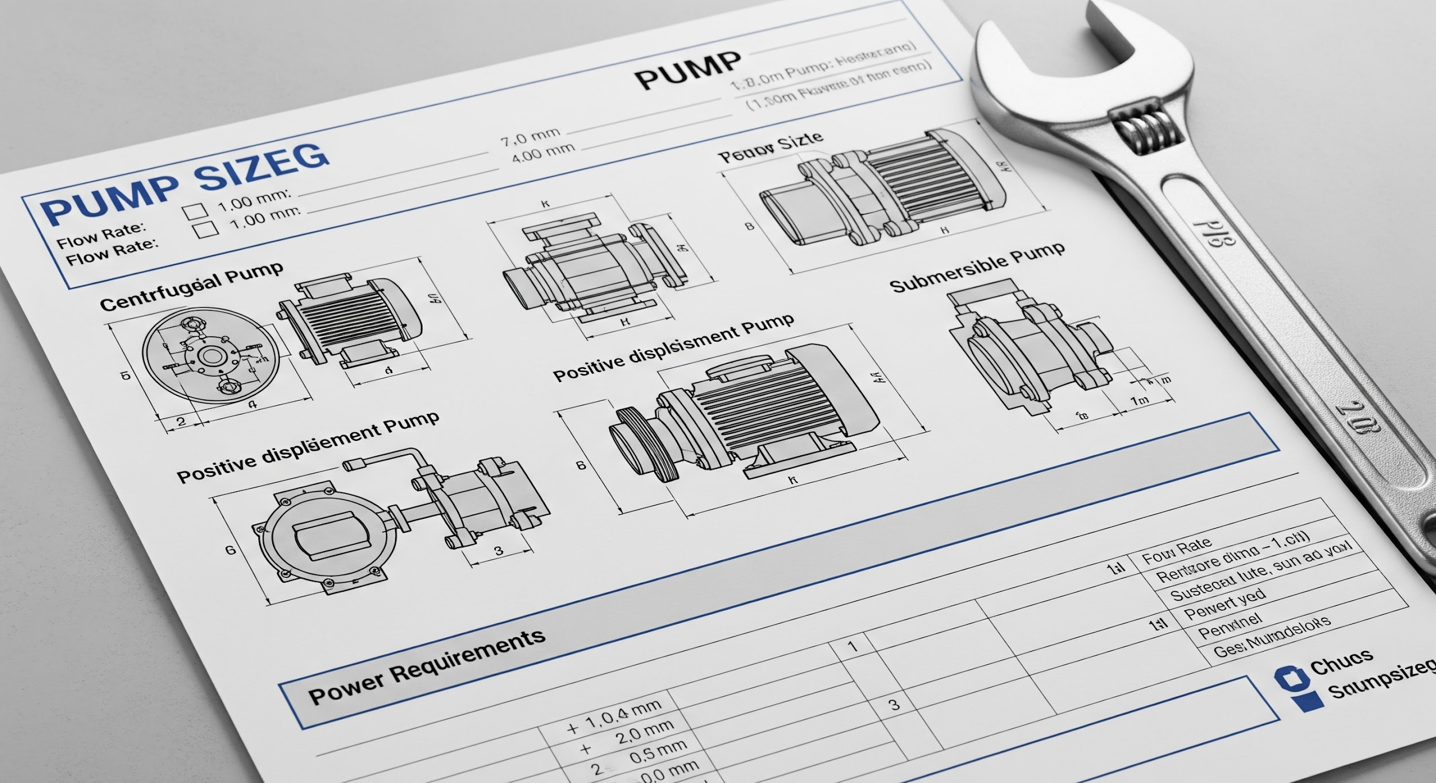

Pump Sizing & Selection Enquiry Form

This form is designed to capture all necessary information for accurate pump sizing and selection. Please complete all relevant fields to ensure the best possible solution for your project.

# Section 1: General Enquiry Details

| Field | Input |
| --- | --- |
| **Enquiry Type** | [New Project, Replacement, Upgrade, Maintenance, Other] |
| **Date** [DD/MM/YYYY] |  |
| **Site Reference / Project Name** |  |
| **Company Name** |  |
| **Contact Person** |  |
| **Email Address** |  |
| **Phone Number** |  |

# Section 2: Fluid Properties

**Fluid Name:** [Free Text]

**Fluid Type:**

* Liquid
* Slurry
* Viscous Fluid

**Temperature Range (Min/Max):**

**Specific Gravity (SG):**

**Viscosity (cP or cSt):**

**Vapor Pressure (kPa or PSI):**

**Solids Content (if applicable):**

**Corrosive/Abrasive Nature:**

* Corrosive
* Abrasive
* Both
* Neither

**Chemical Composition (if known):**

# Section 3: System Requirements

**Required Flow Rate:**

* [e.g., m³/hr, GPM, L/s]

**Required Discharge Pressure:**

* [e.g., bar, PSI, kPa]

**Suction Conditions:**

* **Suction Pressure:** [e.g., bar, PSI, kPa]
* **Static Suction Head:** [e.g., meters, feet]
* **NPSHa (if known):** [e.g., meters, feet]

**Elevation Differences:**

* **Suction Tank Level (relative to pump):** [e.g., meters, feet]
* **Discharge Point Level (relative to pump):** [e.g., meters, feet]

**Pipework Details:**

* **Suction Pipe Diameter:** [e.g., mm, inches]
* **Discharge Pipe Diameter:** [e.g., mm, inches]
* **Pipe Material:**
* **Total Equivalent Length (Suction):** [e.g., meters, feet]
* **Total Equivalent Length (Discharge):** [e.g., meters, feet]

# Section 4: Pump & Motor Selection

**Preferred Pump Type:**

* [Centrifugal, Positive Displacement (Gear, Lobe, Screw, Diaphragm), Submersible, Multistage, Other]

**Seal Type:**

* [Mechanical Seal, Gland Packing, Mag Drive, Other]

**Power Source:**

* [Electric Motor, Diesel Engine, Air Motor, Other]

**Voltage & Frequency (if Electric):** [e.g., 400V/50Hz, 480V/60Hz]

**Desired Material of Construction (MOC):** [e.g., Cast Iron, Stainless Steel 316, Duplex]

**Explosion Proof Requirement:**

* Yes
* No
* Not Sure

**Specific Standards/Certifications:** [e.g., ATEX, API, ISO]

# Section 5: Environment & Control

**Environment Type:**

* Indoor
* Outdoor
* Hazardous Area (Specify Class/Division/Zone below)

**Hazardous Area Classification:**

**Ambient Temperature Range (Min/Max):** [e.g., -10°C to 45°C]

**Control Options:**

* Manual Start/Stop
* Variable Frequency Drive (VFD)
* Pressure Control
* Level Control
* Flow Control
* Remote Operation
* PLC Integration

**Desired Features/Notes:**

# Section 6: Additional Information

**Budget (Optional):** [e.g., £, $, €]

**Timeline for Project Completion:**

**Any existing equipment details or limitations:**

**Any other information relevant to pump sizing and selection:**