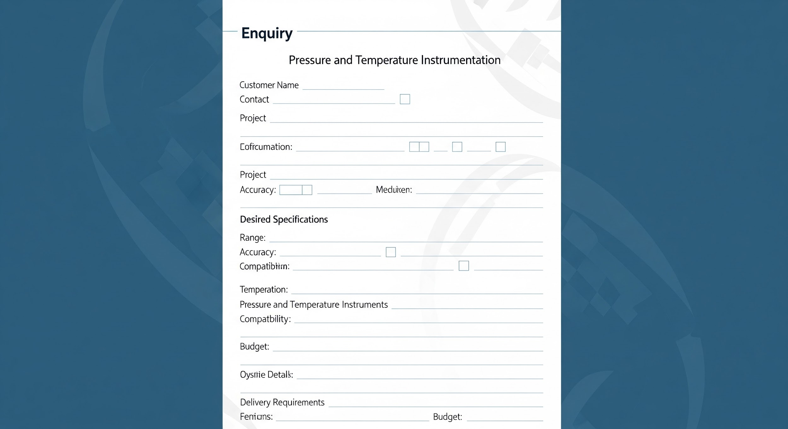

Pressure & Temperature Instrumentation Enquiry Form

This form is designed to gather comprehensive information for pressure and temperature instrumentation enquiries. Please fill out all relevant sections to ensure accurate and timely processing of your request.

# Project Details

* **Project Name/Reference:**
* **Company Name:**
* **Contact Person:**
* **Email Address:**
* **Phone Number:**
* **Enquiry Date:**

# Instrument Type

* **Pressure Instrumentation:**

Pressure Transmitter

Pressure Gauge

Differential Pressure Transmitter

Pressure Switch

Pressure Sensor

Other (please specify below)

* **Temperature Instrumentation:**

Temperature Transmitter

RTD (Resistance Temperature Detector)

Thermocouple

Temperature Gauge

Temperature Switch

Thermowell

Other (please specify below)

* **Other Instrument Type:**

# Process Characteristics

* **Process Medium:**
* **Process Temperature Range:**
* **Process Pressure Range:**
* **Units of Measurement for Temperature:** Celsius, Fahrenheit, Kelvin
* **Units of Measurement for Pressure:** psi, bar, kPa, MPa, mmHg, inH2O
* **Corrosive/Abrasive Medium:** Yes/No
* **Hazardous Area Classification (if applicable):**

# Sensor Details

* **Sensor Type (for Temperature):** RTD (PT100, PT1000), Thermocouple (Type J, K, T, E, N, R, S, B, C), Thermistor
* **Sensor Type (for Pressure):** Piezoresistive, Capacitive, Strain Gauge, Thin Film, Ceramic
* **Connection Size:**
* **Connection Type:** NPT, BSP, Flanged, Sanitary Clamp
* **Material of Wetted Parts:**

# Output Signals & Power Supply

* **Output Signal:** 4-20mA, 0-10V, HART, Modbus RTU, Profibus PA, Foundation Fieldbus
* **Power Supply:** 24V DC, 120V AC, 230V AC

# Mounting Options

Direct Mount

Panel Mount

Wall Mount

Pipe Mount

Flush Mount

Other (please specify below)

# Certifications & Approvals

ATEX

IECEx

SIL (Safety Integrity Level)

NACE MR0175

CE Marking

CSA

UL

Other (please specify below)

# Additional Notes & Requirements

* **Delivery Requirements:**
* **Required Quantity:**
* **Target Price (if applicable):**

# Review and Submission

Please ensure all necessary information is provided. Once complete, you may submit this form for review.