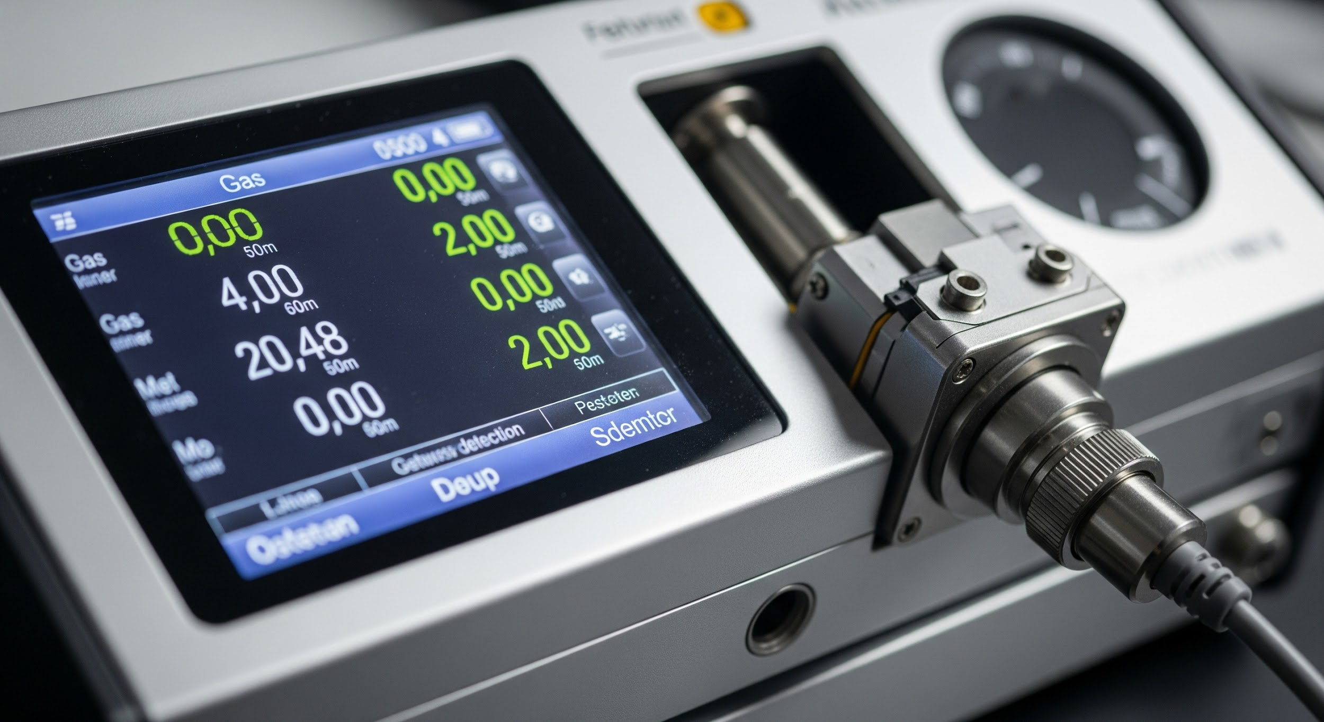

Gas Analyser & Detection Enquiry Form

This form is designed to gather essential information for your gas analyser and detection needs, ensuring we can provide you with the most accurate and suitable solution. Please fill out the sections below.

**1. Contact Details**

* Name:
* Company Name:
* Email Address:
* Phone Number:
* Project Name or Reference (if applicable):

**2. Application Overview**

* What is the application or system? (e.g., Biogas upgrading skid, Landfill flare, CHP plant, Laboratory, Confined space)
* Primary Purpose:  
   Process Gas Measurement  
   Safety / Personal Protection  
   Environmental Compliance  
   Flue Gas / Stack Emissions  
   Air Quality Monitoring  
   Other: ____________
* Installation Location:  
   Fixed installation  
   Portable unit  
   Confined or hard-to-reach area  
   ATEX / Hazardous Area  
   Cleanroom or Food Grade Area

**3. Gases to be Measured**

Tick all that apply:

CH₄ (Methane)  
 CO₂ (Carbon Dioxide)  
 O₂ (Oxygen)  
 H₂S (Hydrogen Sulphide)  
 NH₃ (Ammonia)  
 CO (Carbon Monoxide)  
 VOCs / Hydrocarbons  
 NOx / SOx  
 H₂ (Hydrogen)  
 Other: ____________

**4. Measurement Requirements**

* Required Measurement Range(s):
* Accuracy / Resolution (if known):
* Response Time Requirement (e.g., T90 < 15s):
* Sampling Type:
* Is sample gas hot, wet, or dirty?  
   Yes  
   No  
  If yes, please describe:

**5. Output & Integration**

* Signal Output Required:  
   4–20 mA  
   Modbus RTU / TCP  
   Relay (digital)  
   0–10 V  
   Wireless (LoRa, ZigBee)  
   Other: ____________
* Integration Requirement:  
   Standalone  
   To be integrated into site SCADA / PLC  
   Requires data logging  
   Requires alarm output or shutdown trigger

**6. Installation Environment**

* Ambient Temperature Range:
* IP Rating / Ingress Protection Required:
* Hazardous Area Classification (e.g., ATEX Zone 1, Zone 2):
* Mounting Preference:

**7. Preferred Brand / Compatibility (if any)**

e.g. Dräger, Oldham, Simtronics, Emerson, Michell Instruments, ABB, Testo, Honeywell

**8. Attachments (Optional)**

Upload a P&ID, datasheet, gas study, or image of current installation.

**9. Additional Notes or Requirements**