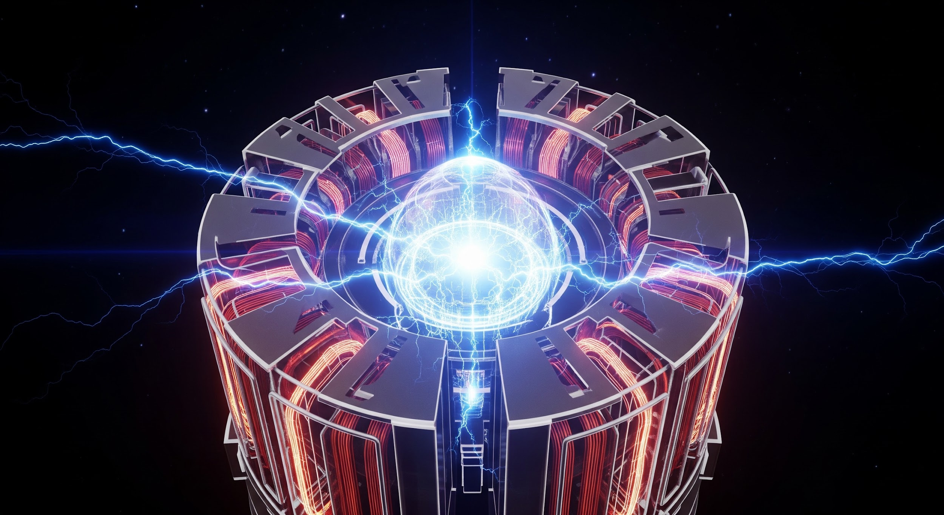

Electric Motor Specification & Selection Enquiry Form

This form is designed to gather essential information for specifying and selecting the appropriate electric motor for your application. Please provide as much detail as possible to ensure an accurate recommendation.

## Section 1: Contact Information

| Field | Input |
| --- | --- |
| Name |  |
| Company Name |  |
| Email Address |  |
| Phone Number |  |
| Project / Asset Reference |  |

## Section 2: Application & Duty Information

| Field | Input |
| --- | --- |
| Application Description (e.g. fan, pump, conveyor) |  |
| Load Type | Constant torque  Variable torque  High inertia  Cyclic  Unknown |
| Duty Cycle | S1  S2  S3  S4  Intermittent  Continuous |
| Mounting Arrangement | B3 Foot  B5 Flange  B14 Face  B35  Combination  Custom |
| Ambient Temperature (°C) |  |
| Altitude (m) |  |

## Section 3: Electrical Specifications

| Field | Input |
| --- | --- |
| Power Rating (kW) |  |
| Rated Voltage (V) |  |
| Rated Frequency (Hz) |  |
| Number of Phases | Single  Three Phase |
| Full Load Current (A) |  |
| Motor Speed (RPM or No. of Poles) |  |
| Motor Starting Method | DOL  Star-Delta  Soft Start  VFD |
| Efficiency Class | IE1  IE2  IE3  IE4  Unknown |

## Section 4: Mechanical Design

| Field | Input |
| --- | --- |
| Enclosure Type | TEFC  IP55  IP65  Open Drip Proof  Flameproof  ATEX |
| Frame Size (IEC/NEMA) |  |
| Shaft Dimensions (if known) |  |
| Gearbox Required? | Yes  No  Specify Type & Ratio |
| Cooling Method | IC411  IC416  IC06  IC71W  Custom |

## Section 5: Compliance & Environmental Requirements

| Field | Input |
| --- | --- |
| Required Certifications | ATEX  IECEx  CE  UKCA  UL  CSA  Marine  Energy Efficiency |
| Noise Level Limit (dB) |  |
| Site Conditions (e.g. dusty, offshore, high humidity) |  |

## Section 6: Accessories & Notes

| Field | Input |
| --- | --- |
| Accessories Required | PTCs  RTDs  Brake  Encoder  Force Vent  Terminal Box  Anti-condensation Heater  Custom Paint  Cable Glands |
| Preferred Manufacturer/Model |  |
| Additional Notes / Comments |  |