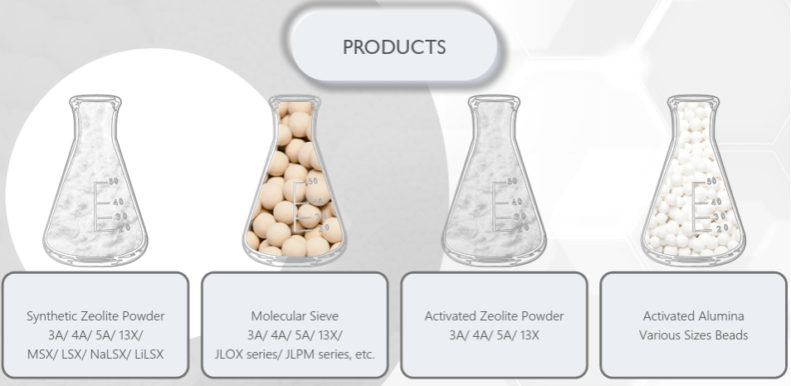

**Master the core technology of the whole industrial chain of molecular sieve production:**

* Possess the core technology of complete chain of molecular sieve, from raw powder synthesis, ion exchange modification, to molecular sieve forming.
* Crystal type (LTA, FAU, CHA, MFI, HEU, etc.), skeleton silicon-aluminum ratio (2-∞), crystal size (D50=0.510μm), cation type (Na+, K+, Ca2+, Li+, Ag+, Ba2+, etc.), and pH are all controllable.
* Products can be customized and developed according to customer needs to meet the individual needs of different customers and different systems.

**APPLICATIONS**

| Industry | Applications | Recommended Product |
| --- | --- | --- |
| Oxygen Generation | PSA  VPSA  Medical Oxygen | JLOX-500  JLOX-103A/200A  JLOX-101A/501A |
| Natural Gas | Dehydration  Desulfurization  Remove CO2 | 3A/4A  4A/13X  13X |
| Petrochemical | Cracked Gas Dehydration  Oxygenates remove only  Catalyst Protection | 3A  13X  13X, 4A |
| Glass | Insulation Glass | 3A |
| Packaging | Desiccant Bag | 4A |
| Coating, Adhesive, Sealant | Redriderant Dehydration | 3A, 4A |
| Petroleum Refineries | Removal of Moisture | JLH-03-B |
| Hydrogen Generation | Hydrogen Purification | JLWN5, JLOX-200A |
| Industrial Gas | Air Pre-Purification (PPU)  Air Dehydration | 13X, JLOX-300, JLPM |
| Alcohol and Solvent | Ethanol Dehydration  Alcohol and Solvent Dehydration | 3A  3A, 4A |

**LATEST PRODUCTS**