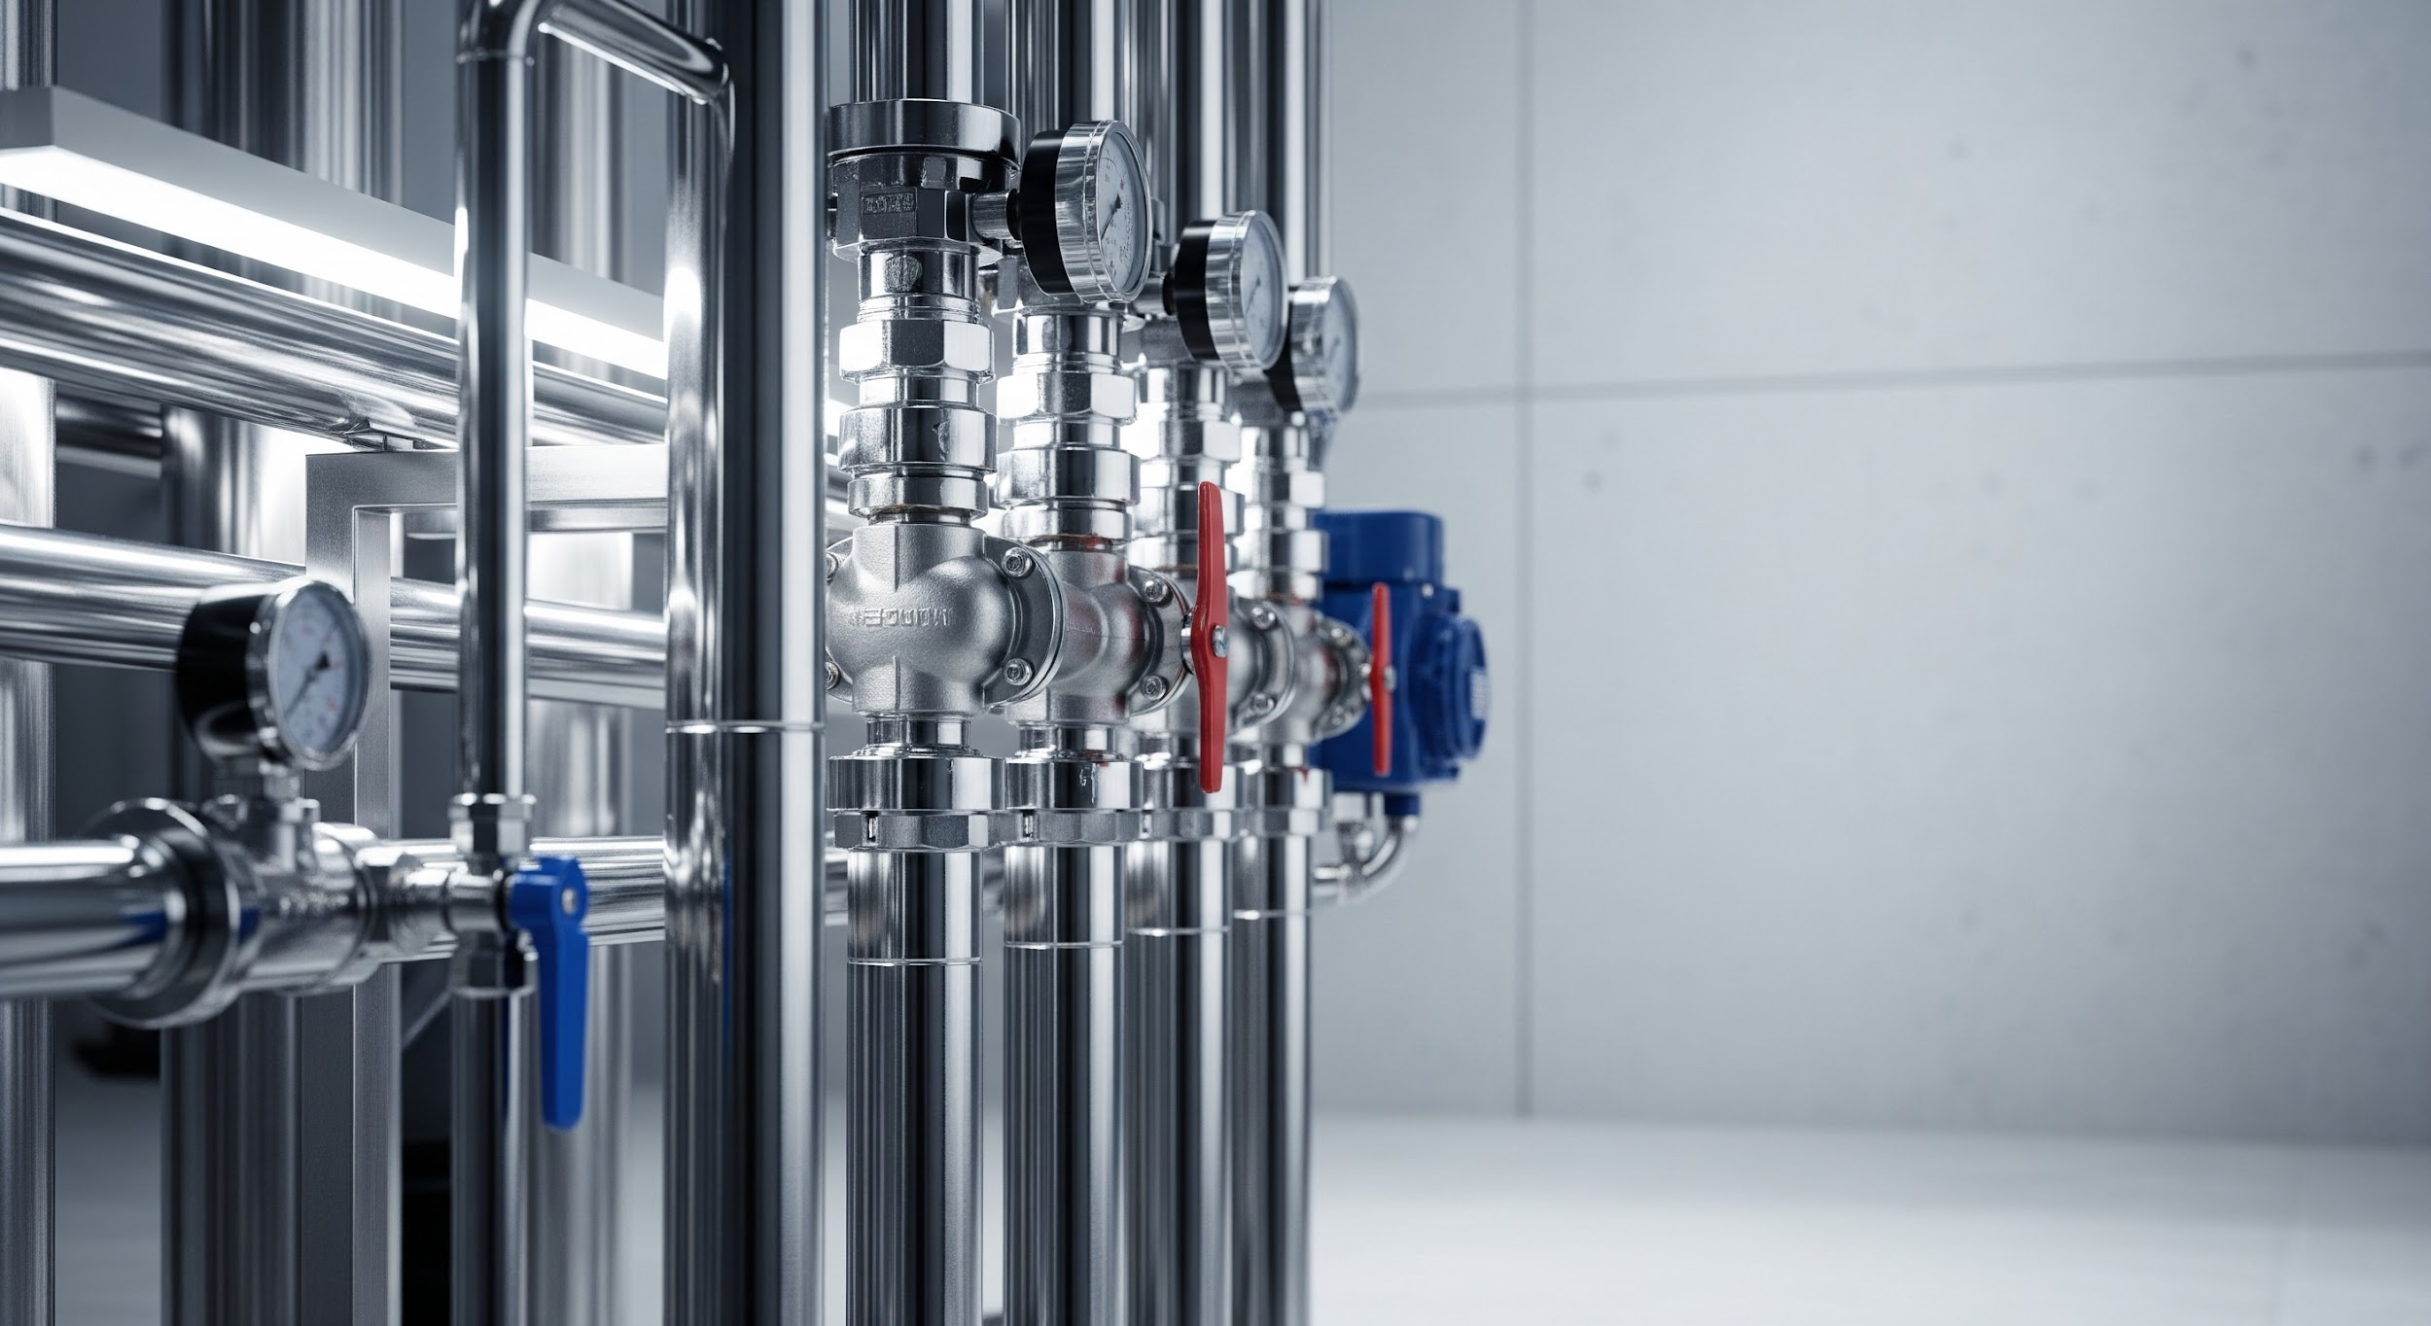

Filtration System Enquiry Form

Please complete this form with as much detail as possible to help us provide an accurate quotation for your filtration requirements.

**Section 1: Contact Information**

* **Name:** _______________________________________
* **Company Name:** _______________________________________
* **Email Address:** _______________________________________
* **Phone Number:** _______________________________________
* **Project Reference or Asset Tag:** _______________________________________

**Section 2: Application & Media Information**

* **Type of Application:**

Gas FiltrationLiquid

Filtration

HVAC

Sterile

Process Protection

Other:

* **Media to be Filtered:** _______________________________________ (e.g., air, oil mist, biogas, water)
* **Contaminant Type:** _______________________________________ (e.g., dust, bacteria, oil, moisture)
* **Known Contaminants:**
  + Dust
  + Oil Mist
  + Water
  + Biologicals
  + Siloxanes
  + Other: _______________________________________

**Section 3: Performance Requirements**

* **Micron Rating Required:** _______________________________________ (e.g., 0.1 µm, 10 µm)
* **Flow Rate:** _______________________________________ (e.g., 500 Nm³/h, 10 m³/h, 250 L/min)
* **Operating Pressure:** _______________________________________ (e.g., 6 barg)
* **Operating Temperature Range (°C):** _______________________________________
* **Initial Pressure Drop Limit:** _______________________________________
* **Operation Type:**

Continuous

Batch

Intermittent

High Pressure

Vacuum

**Section 4: Filter & Housing Design**

* **Filter Type:**
  + Cartridge
  + Bag
  + Coalescing
  + Activated Carbon
  + Panel
  + Self-Cleaning
  + Other: _______________________________________
* **Housing Material:**
  + Stainless Steel
  + Carbon Steel
  + Aluminium
  + Plastic
  + Disposable
  + Other: _______________________________________
* **Housing Connection Size & Type:** _______________________________________ (e.g., 2" BSP, DN100 flange)

**Section 5: Environment & Certification**

* **Installation Environment:**
  + Indoor
  + Outdoor
  + Hazardous Area (Conditional Logic: If selected, ask for specific zone/class details)
  + Corrosive
  + Weather-Exposed
* **Certification Required:**
  + ATEX
  + FDA
  + WRAS
  + CE
  + ISO 16890
  + Other: _______________________________________

**Section 6: Accessories & Notes**

* **Accessories Required:**
  + Pressure Gauge
  + Auto Drain
  + Sampling Port
  + Mounting Skid
  + Spare Filters
* **Preferred Brand / Model:** _______________________________________
* **Additional Notes / Constraints:**