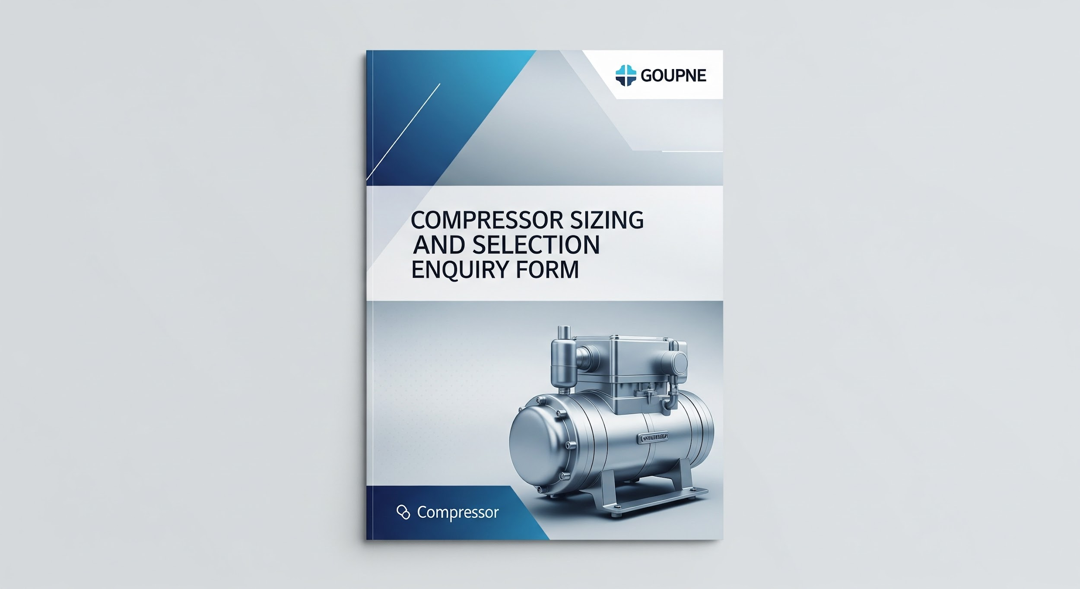

Compressor Sizing & Selection Enquiry Form

This form is designed to collect comprehensive information for accurate compressor sizing and selection. Please complete all relevant sections.

**1. Enquiry Details**

* **Enquiry Type:**  
  New Application

Replacement

Upgrade

Overhaul/Repair

Other

* **Date:**
* **Site Reference/Project Name:**
* **Urgency:**  
  Urgent (within 1 week)

Standard (2-4 weeks)

Planning (1-3 months)

Long-term (3+ months)

**2. Gas Characteristics**

Please tick all applicable gas characteristics.

| Characteristic | Selection |
| --- | --- |
| Air |  |
| Nitrogen |  |
| Oxygen |  |
| Natural Gas |  |
| Other (please specify) |  |
| **Conditions** |  |
| Inlet Pressure (min/norm/max) | Barg  PSI |
| Outlet Pressure (min/norm/max) | Barg  PSI |
| Inlet Temperature (min/norm/max) | °C  °F |
| Outlet Temperature (min/norm/max) | °C  °F |
| Dew Point | °C  °F |
| Flow Rate (min/norm/max) | Nm³/hr (or other unit, please specify) |
| Specific Gravity |  |
| Corrosive Gases Present | Yes  No |
| Explosive Gases Present | Yes  No |
| Purity Requirements |  |

**3. Compressor Type Preference**

Please tick all preferred compressor types.

* Reciprocating
* Rotary Screw
* Centrifugal
* Scroll
* Vane
* Oil-Free
* Oil-Lubricated
* Don't Know / Recommend

**4. Site Conditions**

* **Ambient Temperature Range:** °C/°F
* **Altitude:** meters
* **Humidity:** %
* **Indoor/Outdoor Installation:**  
  Indoor

Outdoor

Both

* **Space Limitations:**  
  (e.g., dimensions, height restrictions)
* **Noise Restrictions:**  
  Yes

No  
If yes, specify maximum dB(A):

**5. Drive Details**

| Detail | Selection/Input |
| --- | --- |
| **Power Supply** | 400V 3ph 50Hz  480V 3ph 60Hz  Other (specify) |
| **Motor Type** | IE3  IE4  IE5  DC  Hydraulic  Other (specify) |
| **Starting Method** | Direct On Line (DOL)  Star-Delta  Soft Starter  VSD/VFD  Other (specify) |
| **Desired Motor Power** | kW (if known) |
| **Duty Cycle** | (e.g., continuous, intermittent, hours/day) |

**6. Mounting Type**

* **Mounting Type:**  
  Skid Mounted

Baseplate Mounted

Containerized

Trailer Mounted

Other

* **Foundation Requirements:**

**7. Control Type**

* **Control Type:**  
  Fixed Speed

Variable Speed Drive (VSD)

Load/Unload

Start/Stop

Other

* **Remote Monitoring/Control:**  
  Yes

No  
If yes, specify requirements:

* **Integration with Existing DCS/SCADA:**  
  Yes

No  
If yes, specify protocols:

**8. Ancillary Equipment Requirements**

Please tick all required ancillary equipment.

* Air Receiver
* Air Dryer (Refrigerant)
* Air Dryer (Desiccant)
* Filters (specify type/grade)
* Condensate Management System
* Aftercooler
* Silencer
* Heat Recovery System
* Ventilation System
* Piping and Ducting
* Other (please specify): [Free text field]

**9. Overhaul/Repair Specifics (if applicable)**

Please tick all applicable reasons for overhaul.

* Scheduled Maintenance
* Component Failure
* Performance Degradation
* Age of Equipment
* Regulatory Compliance
* Other (please specify):
* **Current Compressor Make & Model:**
* **Hours Run:**
* **Last Service Date:**

**10. Additional Information / Special Requirements**

* [any additional notes, budget considerations, certifications, or specific standards to adhere to (e.g., ATEX, ASME)]