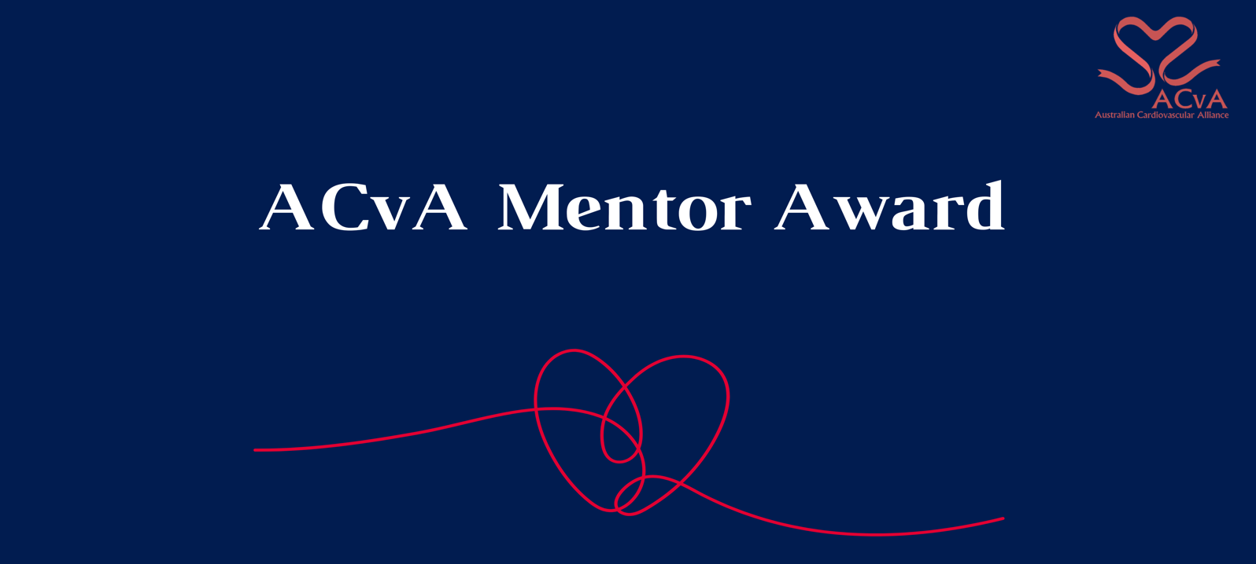
The ACvA Mentor award seeks to target individuals who during their careers demonstrate extraordinary leadership and practical help and guidance to:
- Support career development and progression in cardiovascular-related fields
- Advocate for the mentees in the cardiovascular sector
- Increase the participation, confidence and through this enhance the career sustainability of underrepresented groups in cardiovascular research.
Such commitment and extraordinary effort may be demonstrated by:
- the number and diversity of individuals mentored
- assisting mentees e.g. to present and publish their work, to find grants or other means to support their work, and to provide career guidance
- providing psychological support, encouragement, and essential strategies for life in academia and beyond
- continued interest in the individual’s professional advancement.

Eligibility criteria and conditions
- The nominee must have demonstrated leadership in mentoring as defined above.
- The nominee does NOT have to be an ACvA member.
- The nominee agrees to participate in promotional activities related to the ACvA Excellence in Cardiovascular Research should they be required.

Conditions
- By submitting this application, the nominee agrees to the use of any of the following for promotional purposes: profile picture, bio details, quotes from all sections of the application.
- The nominee agrees to participate in promotional activities related to the ACvA Excellence in Cardiovascular Research Awards should they be required.

How to nominate
- Self-nominations are NOT accepted
- The nomination should include a brief description of how the nominee has demonstrated their leadership.
- Testimonials from two mentees
- Testimonial from one peer

Nomination assessment
- The key criteria will be demonstrating that the nominee has demonstrated extraordinary leadership and practical help and guidance.
- The nominations will be provided to a review panel who select the award based on the above.

COMPLETE THE NOMINATION SUBMISSION FORM (NEXT PAGE)

Application Form

Terms and Conditions
For promotional purposes, do you give permission for your name to be displayed alongside any referee/mentee quotes? | □ Yes, I/my referees give permission to display our names together with any quotes  □ No, I/my referees would like to remain anonymous
By submitting this application the nominee agrees or permission has been granted by the nominee to use any of the following for promotional purposes: profile picture, bio details, quotes from all sections of the application. | □ Yes I agree
Please attach a profile picture as part of your application submission. | □ Yes I have attached a profile picture along with my application.

Please include a short professional bio (200 words max.)

Nominee Details
This award nomination is for: | Someone else
Title
First Name
Last Name
Current appointment
Current institution
Preferred contact number |  | Email
Please list relevant social media handles e.g. yours and your institution
Communication/publicity contact for you organisation | (Name + email)

Award details

Please include a brief history of the nominee’s involvement in mentoring (300 words max)

Referees
Mentee 1 details
Title
First Name
Last Name
Current appointment and institution
Preferred contact number |  | Email
How has the nominee’s mentorship affected your professional and personal development? (300 words max)

Mentee 2 details
Title
First Name
Last Name
Current appointment and institution
Preferred contact number |  | Email
How has the nominee’s mentorship affected your professional and personal development? (300 words max)
Peer details
Title
First Name
Last Name
Current appointment and institution
Preferred contact number |  | Email
Testimonial for nominee in relation to their history of mentorship (300 words max)

