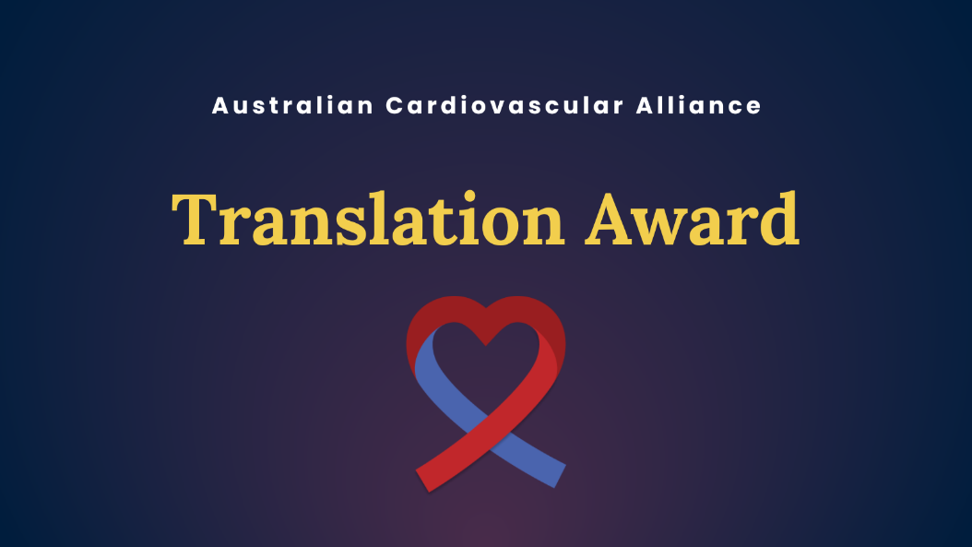

The ACvA Translation Award is for a research scientist or a team of researchers who have transformed a research idea or observation from the lab bench to interventions that improve the health of individuals and the community.

Translation may be, but is not limited to:
- the process of making discoveries in the research laboratory or in preclinical studies that will have an impact on human health and may lead to the development of studies in humans
- the process of applying discoveries generated during research in the laboratory, and in preclinical studies, to the development of trials and studies in humans and/or
- research aimed at but not limited to defining and/or adopting of new health policies/guidelines or health systems change.

Eligibility criteria and conditions
- The nominee can be any researcher or part of a team of researchers, irrespective of discipline or career stage but their work needs to have relevance to improving cardiovascular and stroke health outcomes, whether in the short, medium or long term.
- A clear journey from concept to implementation or along the translational pathway needs to be demonstrated for this award.
- The nominee does NOT have to be an ACvA member.

Conditions
- By submitting this application, the nominee agrees to the use of any of the following for promotional purposes: profile picture, bio details, quotes from all sections of the application.
- The nominee agrees to participate in promotional activities related to the ACvA Excellence in Cardiovascular Research Awards should they be required.

How to nominate
- The nomination can be made by anyone, including themselves.
- The nomination should include evidence of the translational pathway for the work. This could include validation by:
  - Clinicians
  - Hospital or LHD Executives
  - Clinical trialists
  - Experts in pre-clinical work
  - Funding bodies (eg NHFA, Stroke Foundation)
  - Industry
  - Government
  - Publication(s).
- At least one referee must be from an external organisation.

Nomination assessment
- The key criteria will be demonstrating the research journey from concept to implementation or along the translational pathway.
- The translation nominations will be provided to a review panel who select the award based on the above criteria.
COMPLETE THE NOMINATION SUBMISSION FORM (NEXT PAGE)

Application Form

Terms and Conditions
For promotional purposes, do you give permission for your name to be displayed alongside any referee/mentee quotes? | □ Yes, I/my referees give permission to display our names together with any quotes  □ No, I/my referees would like to remain anonymous
By submitting this application the nominee agrees or permission has been granted by the nominee to use any of the following for promotional purposes: profile picture, bio details, quotes from all sections of the application. | □ Yes I agree
Please attach a profile picture as part of your submission. | □ Yes I have attached a profile picture along with my application.

Please include a short professional bio (200 words max.)

Nominee Details
This award nomination is for (Please highlight one): | □ Someone else  □ My team  □ Myself
Title
First Name
Last Name
Current appointment
Current institution
Preferred contact number |  | Email
Please list relevant social media handles e.g. yours and your institution
Communication/publicity contact for you organisation | (Name + email)
If you are nominating as part of a team, please list all members and their organisations. | Please list members and their organisations.

Award details

What health problem(s) is your program of work aiming to solve? (200 words max in lay language) | Clearly define the specific health issue(s) your research addresses in lay language. Briefly explain the burden of the condition(s) and the gap in current knowledge, treatment, or practice that your work is targeting.
Describe the translational journey of your program of work so far. (350 words max in lay language) | Demonstrate that your work has moved beyond the theoretical or early research phase and is actively progressing toward patient or public health impact.
What long-term impact will your program of work have on human health? (200 words max in lay language) | Describe the expected future benefits of your work if successfully implemented in lay language.

Referees
Referee 1 details
Title
First Name
Last Name
Current appointment and institution
Preferred contact number |  | Email
Reference
[Briefly describe why this program of work is important, including its impact to the field and community] 300 words max.

External Referee details

Must not be from the same organisation as the nominee.
Title
First Name
Last Name
Current appointment and institution
Preferred contact number |  | Email
Reference
[Briefly describe why this program of work is important, including its impact to the field and community] 300 words max.

