

Namibia Desert Crossing

Weight limit: 85kg
Nearest airport: Windhoek
11 days/10 nights/8 days riding

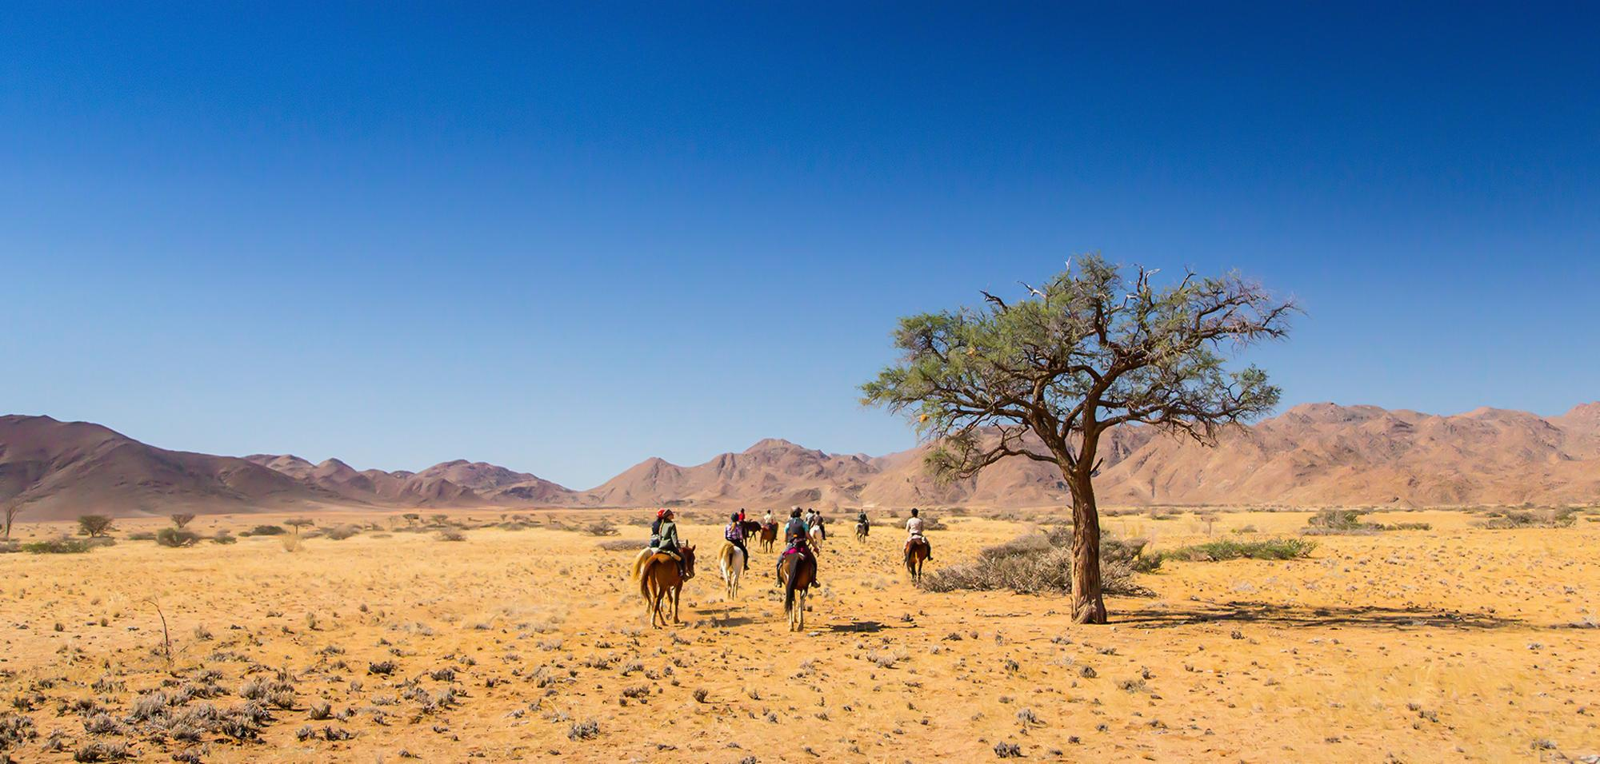

One of the most challenging trail rides in the world. Fast riding across 320 km taking in the wide open spaces of the Namib desert until you reach the Atlantic Ocean on the skeleton coast., Camp in tents or sleep under the stars, this is our most adventurous riding safari for experienced riders craving a real adventure.

The Riding

Expect to ride between 5-7 hours per day and at a good pace. You’ll ride through the highlands to deep river valleys where you may encounter elephant, rhino, oryx, springbok and other desert-adapted wildlife. Leaving the valleys behind you cross the open plains with the striking Brandberg (burning mountain) forming a dramatic backdrop. The endless plains allow for fast riding, imagine lining your horses up cavalry style and racing across the desert before you finish the trail with a final gallop on the beach. The terrain is very varied and you will ride at all places. Although fast, the horses are extremely responsive, enthusiastic and easy and comfortable to ride at speed.

Level of riding and fitness

This is the fastest trail we offer and is only suitable for intermediate or advanced riders with a good level of current fitness. You must be able to mount your horse from the ground unaided, and must feel completely at ease riding at all paces and over uneven terrain. It is important to be secure and balanced in the saddle and capable of riding up to 50kms a day. It’s all worth it when you arrive at camp for the night with a restaurant-quality meal waiting for you, cooked over the camp fire and an ice-cold drink. You’ll never sleep so well! On the trail you will be responsible for grooming, checking over and tacking up your own horse. Heavier riders can be taken by arrangement with a supplement (£850 in 2025) for an extra horse. Additional horses are required for riders weighing over 85kg in riding gear.

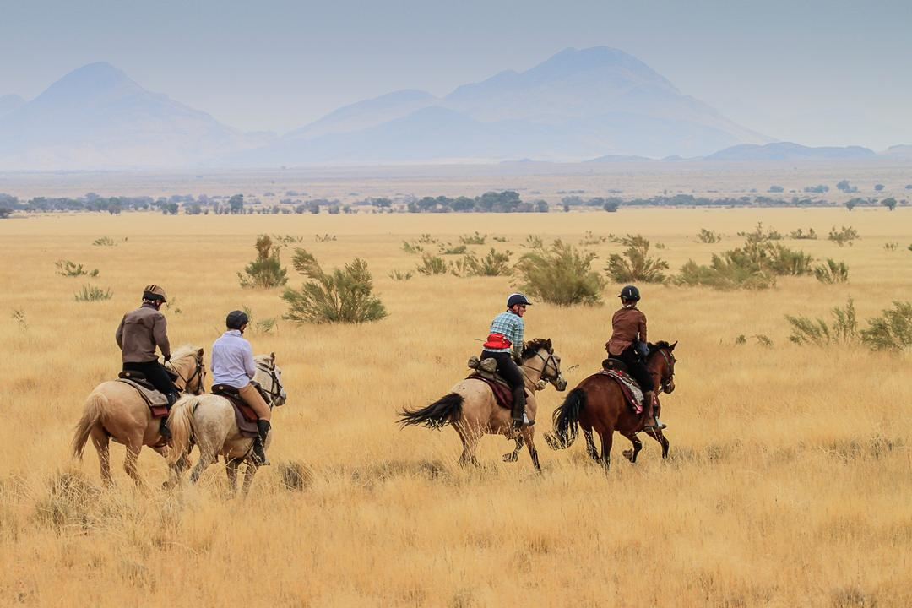
Guides & Groups sizes

The guides are a professional and dedicated team who love what they do, and it shows! You will feel like part of the family by the time you leave. Rides are usually guided by Andrew Gillies along with back up guides, all are knowledgeable, attentive and experienced. They have crossed the Namib desert many times so you’ll be in safe hands and are excellent horsemen and women.

Group size: 5-11

Horses & Tack

Horses at this destination are a real mix and include Arab, Haflinger, Lippizzaner, Trakehner, and even the famous wild horses of the Namib desert. They range in height from 14.2-16hh, are fast, fit and sure footed. Raised on rough terrain, all of them make kind and reliable companions for the trail. These horses live free as a herd in the bush when they are not on safari, each horse generally working no more than six safaris each season. This keeps them interested in the job and in good form, both mentally and physically. The horses are mainly ridden in skirted endurance saddles, mostly in snaffle bridles and on a long rein. They are well-schooled, responsive and experienced in the desert.

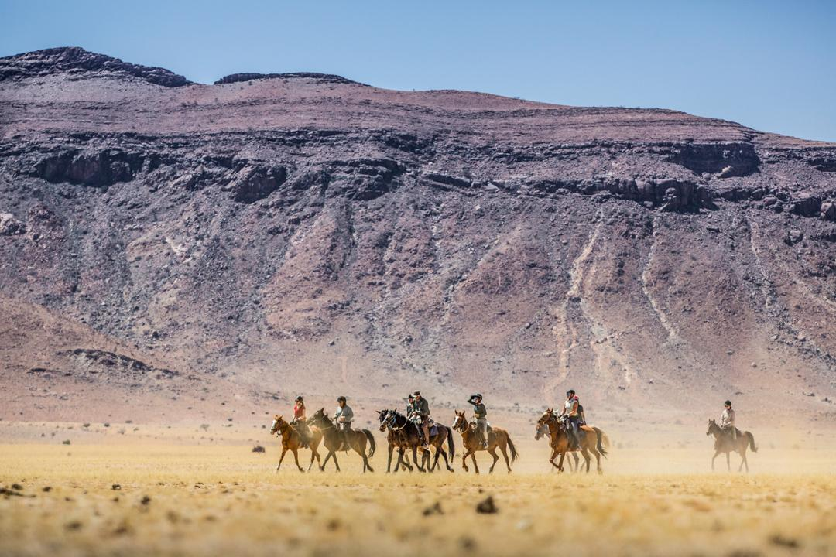

Accommodation and Dining

On the first and last night of the ride you’ll stay in luxury lodges, usually with swimming pools. If you do not want to share, you can request a single room at the beginning or end of the trail subject to availability and a supplementary charge.
Most guests choose to sleep out under the glorious canopy of desert stars during the ride - a very special experience. Large dome tents can be provided if required but why not enjoy the spectacular view of the milky way!.

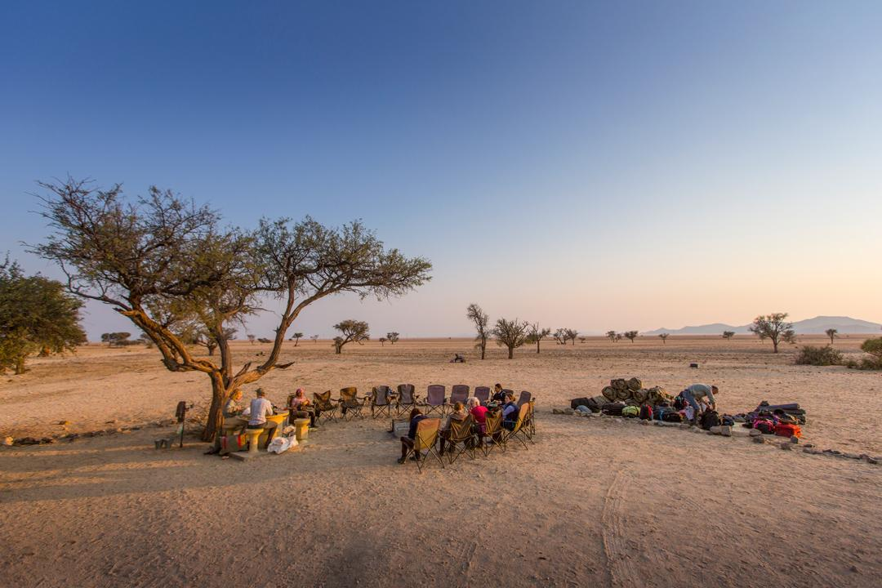
Camp beds are supplied with a bedroll consisting of a canvas bag containing an insulating mattress, down duvet and pillow. You are welcome to add a fleece liner if you feel you might get cold but extra blankets are available on request. Hot ‘bucket showers’ are available at all camps. Overnight camps are usually pitched at sunset followed by a typical Namibian meal cooked over an open fire.
Breakfast is usually porridge or cereal, eggs, coffee or tea and a hot dish. At lunch you’ll meet up with the supply trucks and either a hot lunch is served or sandwiches/wraps are enjoyed under a shady tree. Dinner is a delight of typical Namibian fare; wild game, free-range beef or karoo mutton served as braai (grilled over an open fire) or potjie (pot casserole) with vegetables and a dessert.
The menu is suitable for vegetarians but it is important to inform us of dietary requirements when booking – we will endeavour to accommodate your needs but please keep in mind that you will be in extremely remote areas making it difficult to cater to some complex dietary issues. Tea, coffee and juice are always available in camp with a fully stocked bar available in the evenings.

Itinerary

Day 1:
You will be met at Windhoek International Airport and transferred to one of the lodges where you’ll meet the rest of your riding group for dinner and attend a group briefing on what to expect on your trip.

Day 2:
After breakfast, you’ll depart for the Sossusvlei area (around a 5 hour drive) via the Spreetshoogte Pass which gives the first glimpse of the seemingly endless Namib Desert below. Arriving at the first campsite with a spectacular view over the Namib Sand Sea you will meet the horses and crew for lunch. This afternoon’s excursion is to the clay pan of Sossusvlei in the soft light of twilight. You are welcome to attempt to climb the towering dunes for a spectacularly panoramic view. Return to camp for a traditional Namibian meal cooked over an open fire.

Day 3:
The start of your riding adventure takes you to a wide grassy valley flanked on one side by the distant Namib Sand Sea. Lunch is at the surprising desert oasis before you continue on to reach that evening's campsite where you’ll enter the foothills of the rugged Namib Naukluft Mountains. The nearby water trough attracts numerous Mountain Zebra, Kudu and Oryx during the night.

Day 4:
Riding along a long ramp-like dune in the morning enjoying the unspoiled wilderness and striking scenery. In the afternoon the pace quickens as the valley opens into a riverbed before a gentle climb up to our campsite on a hill with a view. Dinner is served in an old farm dam converted into a unique dining room.

Day 5:
Today you’ll cross some red dunes before a rugged descent into the Gaub Canyon for lunch. Climbing out of the canyon after lunch you’ll ride across the wide plains to a cave with a spectacular view of the ephemeral Kuiseb River in the distance.

Day 6:
Today you’ll negotiate the terraces leading down to the rugged Kuiseb river – with a technical descent into the riverbed. It is this river which forms a dramatic end to the Namib Sand Sea, flowing just often enough to prevent the dunes from crossing the river. The tracks of Mountain Zebra criss-cross the steep sides of the canyon down to the water which is preserved by the high, narrow walls of the canyon. Tonight our camp is amongst a grove of trees on the plain above the Kuiseb.

Day 7:
Smooth terrain on today's ride allows for some fast-paced riding towards the water point at Ganab where Mountain Zebra, Oryx, Ostrich, Springbok, and if you are lucky, some desert-adapted warthogs come to drink. Here the wide grassy plains are scarred by several watercourses, some only distinguishable by the long lines of trees which mark their course, sometimes giving shelter to desert-adapted giraffe.

Day 8:
Another day which allows for fast-paced riding past the water point of Hotsas and across the Tinkas and Tumas plains which become more and more stark as you approach the coast. When approaching Marble Mountain, Ostriches and Mountain Zebra often run alongside the horses, making for an unforgettable ride. From now on life-giving evening fog can be expected, producing 5 times as much precipitation than rainfall in this extremely arid area.

Day 9:
You’ll ride through the hyper aridity of true desertscapes where you encounter the dinosaur-like plants such as the gnarled Welwitschia Mirablis. Strange shapes form and disappear in mirages and the fascinating survival devices of desert-adapted creatures astound; this is a land of great antiquity and also tremendous solitude. Passing the spectacular Moon Valley on our descent to a wonderfully sheltered campsite in the Swakop River.

Day 10:
The last ride down to the Swakop river and over to the coastal dunes and then, at last, the Atlantic Ocean. Your first glimpse of a town in days! The last stretch of riding is along the soft white beach sand of Swakopmund. Tonight’s accommodation is a comfortable guest house while the horses enjoy their well-deserved rest in a large sandy paddock with a wonderful view of the sea. After sundowners, enjoy your last memorable meal together, reminiscing over an adventure unlikely to be forgotten.

Day 11:
It’s time to say a fond farewell at breakfast as the transfer to Windhoek (4 hour commute) leaves in time for departure flights from Windhoek International Airport after 15:00.

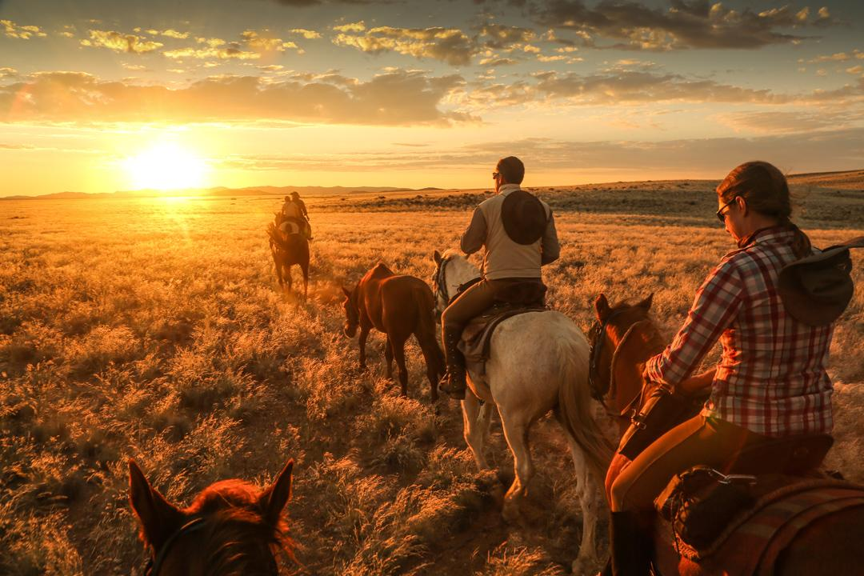

Price includes

- ​2 nights lodge accommodation
- 8 nights camping accommodation
- 8 days of riding
- Breakfasts
- Lunches
- Dinners
- All drinks while on the ride
- Return transfers from/to Windhoek airport at set times
- Local transfers during the ride
- Luggage transportation

Not included

- Flights
- Travel insurance
- Drinks in lodges (first and last nights)
- Additional transfers (for example if flights are delayed)

Flights & Airport transfers

Do not book flights until you have received the Booking confirmation email from saddletravel.com.

Please plan your flights to/from as follows:

On the first day of your holiday your flight should arrive at Windhoek by 6pm
On the last day of your holiday your flight should depart Windhoek after 3pm

What to bring

We recommend wearing your riding boots when travelling and carrying one set of riding clothing and your helmet in your hand luggage, so should your luggage not make it to the destination you’ll still be able to ride.

- Lightweight riding hat
- A wide-brimmed sun hat with strap or baseball cap
- Lightweight riding boots
- Comfortable shoes for camp
- Sunglasses on a string
- Bandana/buff to help protect from sun and dust
- Comfortable clothes to ride in including jodhpurs/long trousers and chaps, long sleeved cotton shirts, jersey or long sleeved fleece, sleeveless vest with pockets
- Lightweight waterproof/windbreaker jacket. Layering is key as temperatures fluctuate during the day
- Warm clothes for evenings including a woolly hat, socks and gloves
- Shorts, t-shirts, sarong, flip-flops or comfortable clothes to wear around camp and showers
- Sunblock, lip balm
- Towel
- Mosquito repellent.
- Plasters to protect areas of skin that might chafe
- Antihistamine and antiseptic cream
- Head torch
- Camera and spare batteries
- Although you’ll be provided with a warm down-filled bedroll, you may want to add your own fleece or silk lining if you get cold
- Soft luggage, well labeled and split in 2 bags if over 15 kgs

Climate

The best time to visit Namibia is from April to September when the days are sunny and warm (25 Celsius) with cool, even cold evenings. At other times the desert is too hot to make riding practical during the day. Temperatures begin to climb mid to late September with the rainy season beginning in November, peaking in January and ending in March/April.
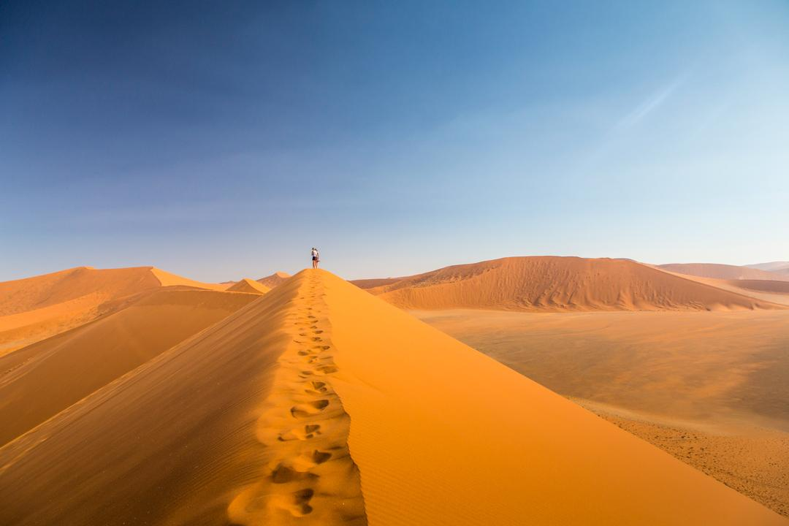
Health

For health and vaccine recommendations, please consult your healthcare provider at least 8 weeks before your trip. Country specific information can also be found at National Travel Health Network and Centre website: https://travelhealthpro.org.uk/countries.

Travel documents

For entry requirements to Namibia for UK citizens, please visit the Foreign Travel Advice website:
https://www.gov.uk/foreign-travel-advice/namibia/entry-requirements

For any other nationalities, please contact your local embassy to check entry requirements.
Having the correct travel documents is entirely your responsibility.

Currency & Tipping

The currency is Namibia dollars, equal to and linked to South African Rand and can be used interchangeably. There is a bureau de change at the Airport, and both Visa and MasterCard can be used in most places in cities and larger towns. There will be occasions when money is needed i.e. for drinks in Swakopmund. Money is best changed at the airport as there are not many opportunities while on the trail.

Tipping is at your discretion. If you do decide to tip it is best given to the guide. They can then arrange distribution amongst all camp staff, as there are many behind the scenes staff.

Cancellation policy

Payment & Cancellation Terms saddletravel.com

Holidays are confirmed with 20% non-refundable deposit. The full balance is due 56 days before the start date. If you cancel your booking less than 56 days before the start date of your trail we are entitled to receive full payment, less refunds as follows:

42 days or more before booking date - 50%
30 days or more - 30%
less than 30 days - nil
Book with confidence – Covid Guarantee:
If the ride operator is closed or you are unable to travel due to lockdown:
1/ The deposit is reissued as a rebooking voucher to rebook anytime.
2/ Any balance payment will be refunded to you in full within 1 week of departure date.

Insurance
All saddletravel.com customers are required to take out appropriate travel insurance that covers horse riding and holiday cancellation. Proof of insurance details will be required during the booking process.

Contact details
+44 1497 888 228 WhatsApp
trails@saddletravel.com

saddletravel.com
The Coach House
Clyro Court
Clyro
Hereford
HR3 5LE
Wales

CN: 05411320

https://saddletravel.com

