
Silver Route Trail

Weight limit: 110kg
Nearest airport: Leon, Mexico
8 days / 7 nights / 6 days riding

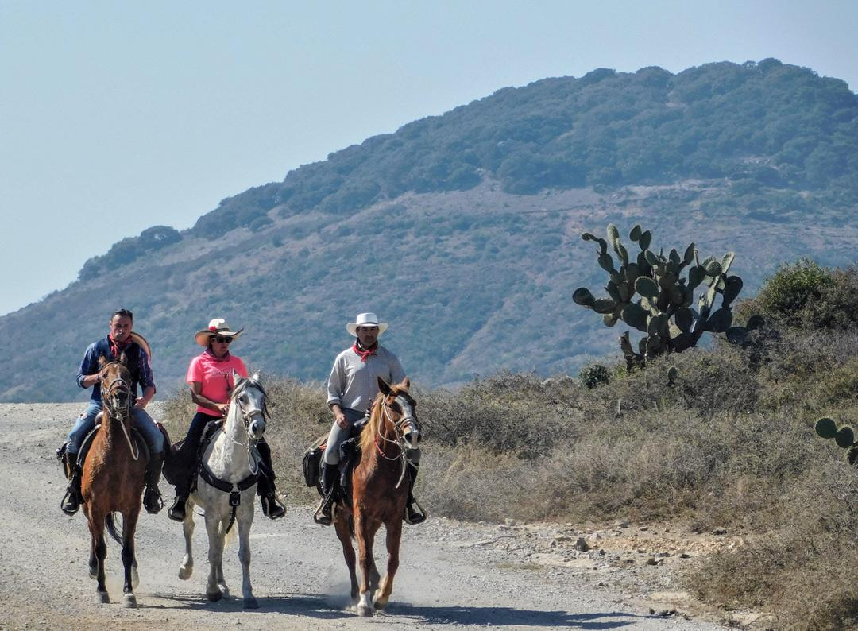

Travel between two UNESCO World Heritage Sites on the ancient silver route in Mexico. Encounter an unseen, forgotten Mexico; colonial cities, majestic shrines, and traditional rural communities, all while following the old Camino Real de Tierra Adentro, a 2.500 long trade route used to transport silver. Take in the beautiful natural landscapes of oak forests, mountains passes and wildlife-filled floodplains and discover 500 years of history, through cobbled streets little changed in centuries and an indigienous culture rarely glimpsed by outsiders.

The Riding

You’ll be riding over a variety of terrain during the course of the week. Starting with some steep mountain passes before descending into peaceful wooded valleys of pine forests, filled with birdsong. As the week progresses, you’ll be able to pick up the pace on sandy desert tracks before reaching the undulating terrain of the wetlands and floodplains created by the overflowing Laja river. While riding in the mountains the pace is mainly walk and some trot but once you reach the more gentle terrain there are opportunities for long canters and depending on the wishes of the group some fast gallops are also possible. Each day you’ll spend between 5-7 hours riding and will cover between 25-35 km.

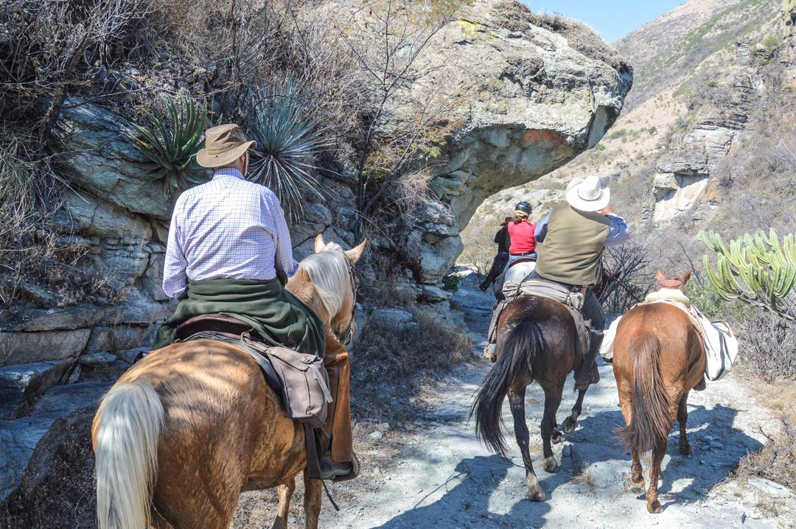

Level of riding and fitness

You’ll need to be a confident rider secure in walk, trot and canter, and with a reasonable level of fitness to enable you to spend most of the day in the saddle. There are some narrow, steep paths to navigate so you should be comfortable with this. The minimum age for this ride is 14 years old, riders aged 14-18 must be accompanied by an adult and a signed letter of consent from the parent/guardian needs to be provided before they can take part in the ride.

Guides & Groups sizes

You’ll be guided by Angel, a highly experienced tour operator and guide who has created this trail with a focus on an authentic, equestrian and cultural experience. Angel has built a network of friends and contacts across the trail route so you will receive a warm welcome when passing through the remote villages and hamlets dotted along the trail.
The group size is 4-12.

Horses & Tack

You’ll be riding Quarter horses or Mexican Criollo horses. All the horses at this destination are fit, responsive and willing, ranging from 15hh - 16.2hh. The horses are extremely fit and are able to cover the long distances with ease. You can tack up your horse each day if you like or this can be done for you by one of the guides. The tack used on the trail is either Mexican or Western although 2 English saddles can be used if requested.

Accommodation and Dining

Your first night's accommodation is at a typical Mexican working ranch, located about 30 minutes from the airport and surrounded by farms, working fields, and mesquite trees. There is a spacious terrace with bbq, garden with sun loungers and plenty of space to relax after your journey. The ranch features simple and rustic décor with wooden furniture and warm colors. Your accommodation is in luxury tents. Once out on the trail five nights are spent in 4 and 5 star hotels and one night in a mountain retreat. Hotels have en suite bathrooms, Wifi available and some have swimming pools and spa facilities. The mountain retreat is set among the majestic forests and mountains of this region. The retreat has original and simple decoration, with 7 comfortable rooms, with 3 shared bathrooms. The terrace features a fireplace and a BBQ and incredible views across the mountains and valleys.
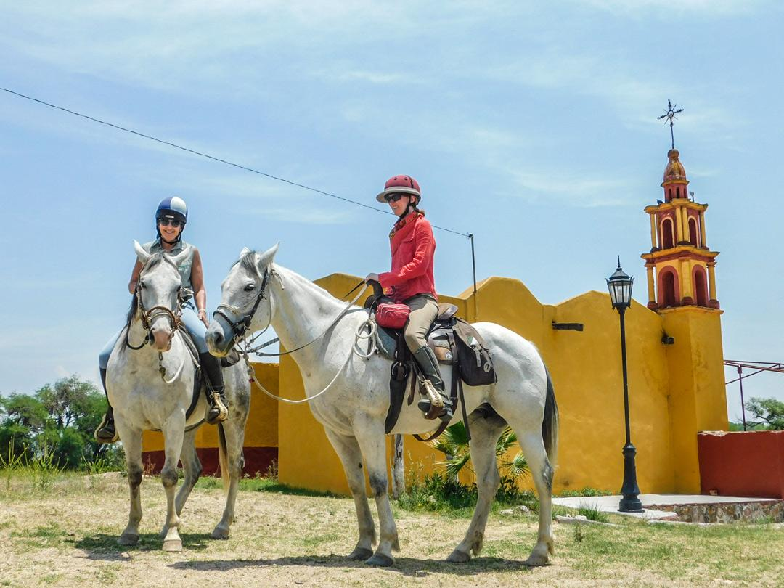

Meals are based on regional Mexican food and include: beef, pork, chicken, eggs, fruit, vegetables, cereals, rice, milk, coffee, natural fruit juices and purified bottled water. During the trail most of the food is prepared by the rural communities you visit, and in many cases traditional, prehispanic, ancestral recipes are used so the flavors and textures are unique and can be very different from what many may think of as classic Mexican food. Lunch is eaten at picturesque spots on the trail and set up with tables, chairs and a canopy. The food could be a tasty hot stew, peppers stuffed with cheese and quesadillas alongside a generous helping of beer and wine. After these meals you’ll usually take a siesta on the grass, where you can doze in the sun before continuing in the afternoon. Dinners are generally taken either in local restaurants or at the hotels where you stay overnight.

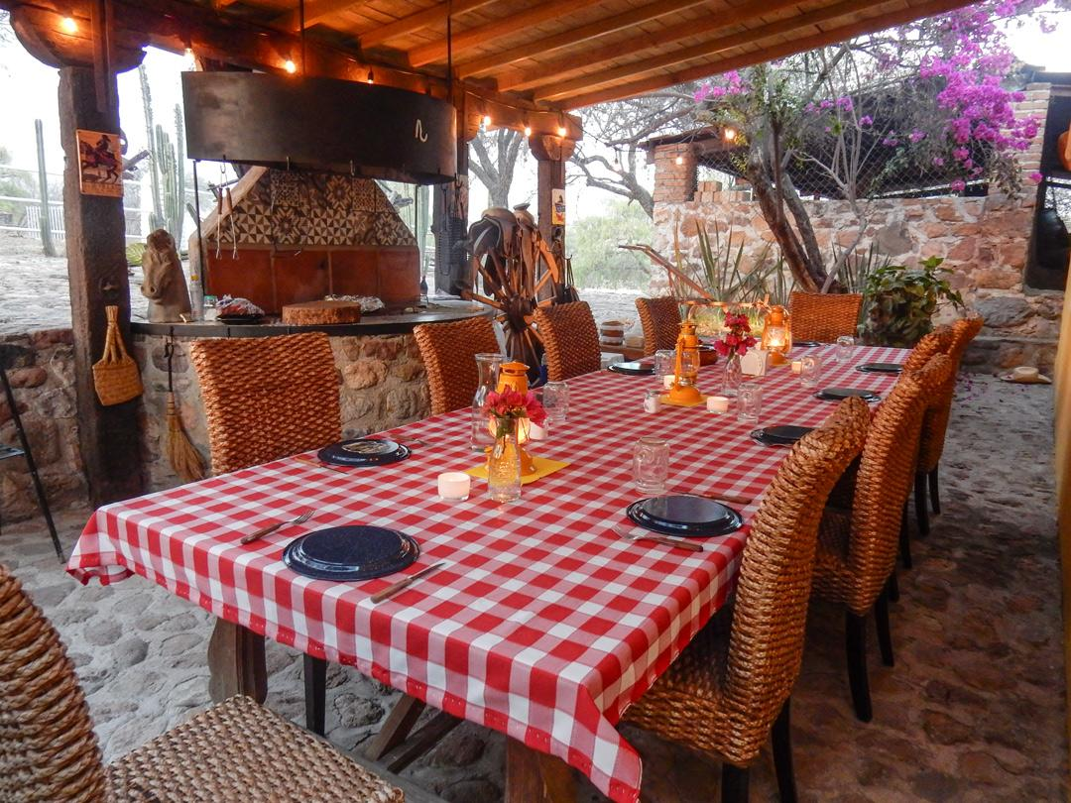

Itinerary

Day 1
You will be met at 17:00 at the meeting point in Guanajuato city (airport transfers available), and from there will transfer to your first nights accommodation at Rancho Colomitos, a traditional Mexican ranch. You’ll be greeted with a delicious welcome cocktail on the terrace and can meet your guides and get to know all the details of the trail before enjoying a welcome dinner barbecue, accompanied by soft Mexican music and the light of the terrace campfire. Your accommodation tonight is in luxury tents at the ranch.

Day 2 Colomitos – Guanajuato City
After a delicious breakfast at the ranch, you’ll meet the horses and start the trail, riding through rural communities, until reaching the foothills of the Montecillo mountains, where you’ll start to ascend towards the old Cardones hacienda. You can spot several ancient ruins of mines and haciendas nestled in the mountains from the time of the Spanish. You will cross the Cardo River and you can swim in its deliciously clear water which comes straight from the mountains above.
Continue riding up the mountains until reaching the ancient remains of the Cardones Hacienda and its Lienzo Charro (Mexican Horse Arena) at Peñafiel. Your horse will remain there for the night, and you will be transferred to the hotel located in the heart of Guanajuato’s historic centre. Guanajuato is a colonial city with beautiful indigenous and hispanic buildings, considered the most beautiful colonial city in Mexico. Dinner and overnight at the hotel.

Day 3 Guanajuato – Santa Rosa
After a delicious breakfast, you’ll be transferred back to the horses and will ride towards the village of Santa Rosa, located in the heart of the central highlands. At 2,850 meters high, this is a beautiful day on the old royal road, used 500 years ago during the Spanish colonial times to transport minerals, mainly gold and silver. You’ll pass by old gold and silver mines, as well as the beautiful rural communities Peñafiel, Monte San Nicolas, Peregrina and Santa Rosa.

In the afternoon, you can enjoy a delicious cocktail and tequila tasting at the mountain retreat terrace. Dinner is typical Mexican cuisine cooked by the chefs. Overnight at the mountain retreat.

Day 4 Santa Rosa – Dolores Hidalgo
After breakfast in the mountain retreat, you’ll saddle up and head out into the central highlands. This is the most bio-diversified area of the state, full of big mountains, with oak, pine and arbutus forests. You will be followed during the journey by bird sounds, and surrounded by majestic and changing natural environments, with amazing views from the area with spectacular mountains on one side and the semi-desert on the other. You may spot coyote, puma and raccoon footprints on the path of this wildlife-filled region. Dinner and overnight in the historical city of Dolores Hidalgo.

Day 5 Dolores Hidalgo
Today you’ll visit one of the most important historical cities of Mexico on horseback. Known as the "Cradle of Mexican Independence". The town took up arms against the colonial regime and the Spanish crown back in 1810. You will have a brief tour on horseback of the historic centre, visiting some of the most emblematic buildings from the war for independence of Mexico.

In the evening you can visit the Wine Museum, enter a real Mexican cantina or just walk around and look at the great variety of local handicrafts. Dinner will be in a typical Mexican restaurant, within a historic house dating from the eighteenth century. Overnight at a hotel in the town.

Day 6 Dolores Hidalgo – Atotonilco
In the morning after enjoying a delicious breakfast, accompanied by a typical Mexican coffee named ‘café de la olla’ you will continue your journey on horseback to the town of Atotonilco, passing through the Cactus Valley. A picnic lunch will be served, in the picturesque town on the outskirts of the old chapel of Barron community. In the afternoon you will visit Atotonilco where you can see the imposing walls from the eighteenth century church. This invaluable architectural treasure is known as the Sistine Chapel of Mexico and is illustrated with murals and easel paintings, altars and sculptures. This majestic shrine is declared by UNESCO as a world heritage site.

Day 7 Atotonilco – San Miguel de Allende
In the morning, after enjoying a pleasant breakfast served by the pool, you will prepare to head off on the trail towards San Miguel de Allende. You’ll be riding along the old roads, used 200 years ago during the War of Independence and the Mexican Revolution. Travelling through the Mexican landscape, you’ll pass ancient Indian chapels left by indigenous groups along the shore of the Laja River, as a testimony of their beliefs. Today's unique landscapes combine semi-desert, with wetlands as you head towards the cosmopolitan San Miguel de Allende, another UNESCO World Heritage Site. Dinner and overnight in San Miguel de Allende.

Day 8 Departure
Today you can explore the town of San Miguel de Allende on foot, known for its rich traditions and festivals, San Miguel is a town full of magic and mysticism which preserves ancient traditions. It’s UNESCO status was awarded because of its cultural and architectural contribution to Mexican Baroque style and its importance in the struggle for Independence of Mexico towards Spain. Transfer back to the airport if required.

Flights & Airport transfers

Do not book flights until you have received the Booking confirmation email from saddletravel.com.

Please plan your flights to/from as follows:
We strongly recommend arriving in Mexico 24 hours prior to the start of the ride to allow for any flight delays. Meet your hosts at the meeting point (Guanajuato city) at 5pm on Day 1 of the trail. Please arrange departure flights for after 2pm on the last day of the trail.

Airport Transfers
Private transfers from Leon Airport to Guanajuato city are approximately $85 each way per group (between 1-4 people). Alternatively a taxi from the airport costs around $50-60.

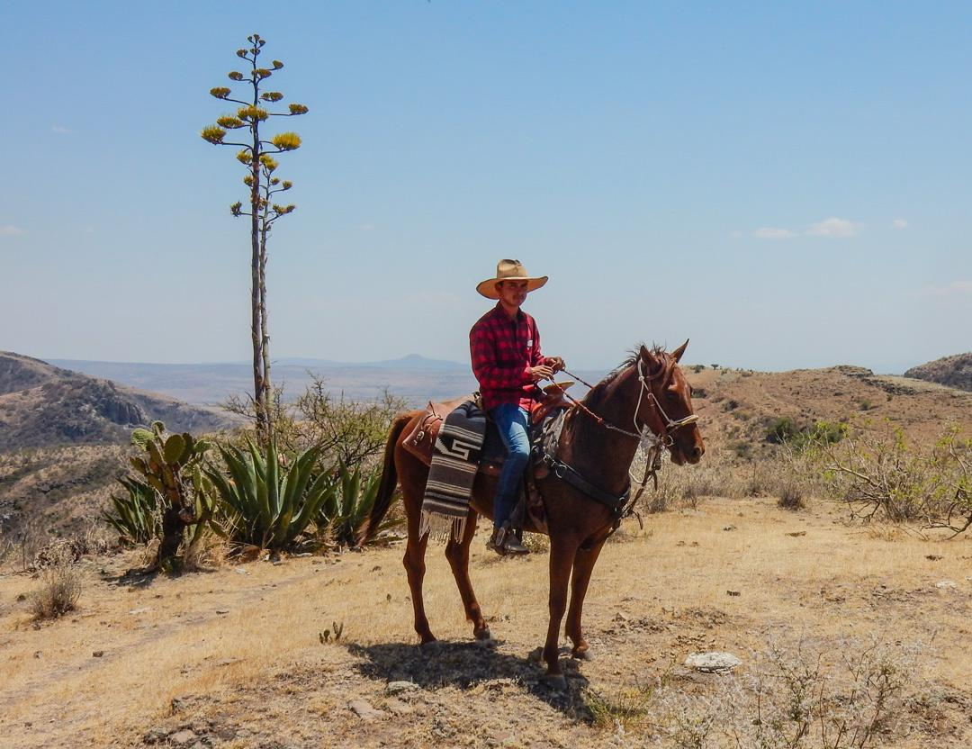

What to bring

We recommend wearing your riding boots when travelling and carrying one set of riding clothing and your helmet in your hand luggage, so should your luggage not make it to the destination you’ll still be able to ride. You will be provided with the following items: saddlebags, picnic mat, water bottle and bandana.

Please use the packing list as a guideline, bearing in mind the time of year you are riding.
- Riding hat/sunhat or cap
- Sunglasses
- Sun block
- Comfortable riding boots
- Comfortable shoes for after riding
- Light summer shirts
- Long-sleeved shirt
- Jodhpurs/leggins/trousers comfortable to ride in
- Waterproof jacket in case of rain
- Light jacket for warm weather
- Sweater
- Leggings or chaps
- Gloves
- Reusable water bottle
- Camera

Climate

January to March is cooler than the rest of the year with temperatures between 17 to 23°C during the day. April to June is drier and hot (between 25 to 40°C) and from June to September expect more humidity and a temperate climate between 17 to 25°C. July to September is when rain is most likely, usually in the evenings. October to December is considered winter, rain is unlikely and temperatures are between 17 to 23°C.

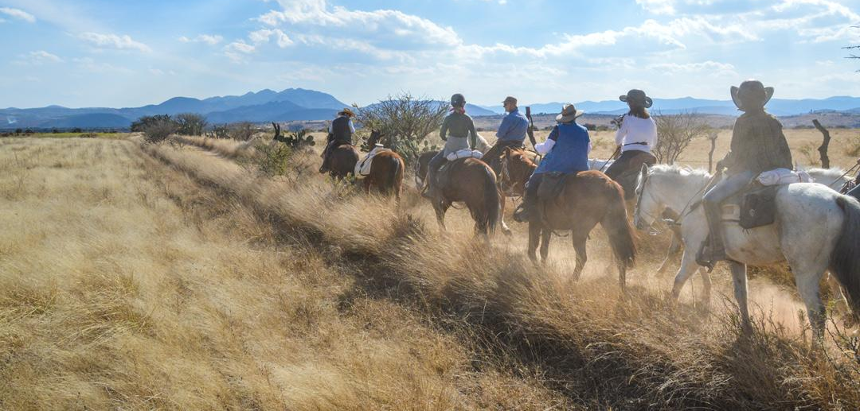

Health

For health and vaccine recommendations, please consult your healthcare provider at least 8 weeks before your trip.

Country specific information can also be found at the National Travel Health Network and Centre website: https://travelhealthpro.org.uk/countries.

Travel documents

For entry requirements to Mexico for UK citizens, please visit the Foreign Travel Advice website:
https://www.gov.uk/foreign-travel-advice/mexico/entry-requirements

For any other nationalities, please contact your local embassy to check entry requirements.

Having the correct travel documents is entirely your responsibility.

Currency & Tipping

The currency of Mexico is the Mexican Peso although US dollars are widely accepted along with credit and debit cards. You can exchange money in banks or in casas de cambio in towns and cities. The dollar sign is used to refer to pesos in Mexico; prices in US dollars are usually marked US$ or USD.

We recommend tipping about US$5-10/day but this is not at all compulsory. Tips are best given to your host who will arrange distribution amongst all the staff. During the rest of your stay in Mexico tipping is the norm, except in taxis.

Riding Declaration

“I am confident and in control at trot and canter out in the open and over uneven ground. I’m able to mount and dismount unaided and have a good level of current riding fitness. I do not suffer from any illness or disability that could prejudice my safety or that of others.”

Cancellation policy

Payment & Cancellation Terms saddletravel.com
Holidays are confirmed with a 20% non-refundable deposit. The full balance is due 56 days before the start date.

If you cancel your booking less than 56 days before the start date of your trail we are entitled to receive full payment, less refunds as follows:

42 days or more before booking date - 50%
30 days or more - 30%
less than 30 days - nil
Book with confidence – Covid Guarantee:
If the ride operator is closed or you are unable to travel due to lockdown:
1/ The deposit is reissued as a rebooking voucher to rebook anytime.
2/ Any balance payment will be refunded to you in full within 1 week of departure date.

Insurance
All saddletravel.com customers are required to take out appropriate travel insurance that covers horse riding and holiday cancellation. Proof of insurance details will be required during the booking process.

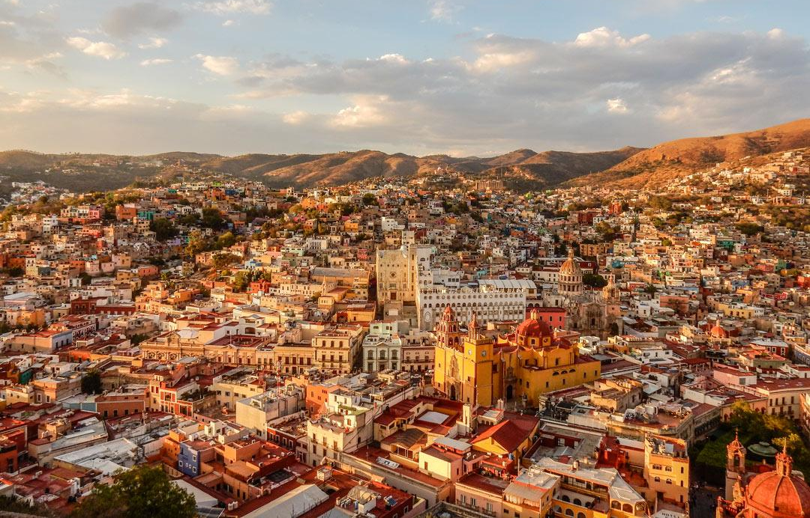

Contact details
+44 1497 888 228 WhatsApp
trails@saddletravel.com

saddletravel.com
The Coach House
Clyro Court
Clyro
Hereford
HR3 5LE
Wales

CN: 05411320

https://saddletravel.com

