Music and Cultural Identity in Central Europe

Ondřej Galuška, Ph.D.
oglalumpu@gmail.com

Course Description:

Music is recognized as a central part of culture. What deserves greater attention, however, is how closely music is tied to politics, history, economy and cultural identity. This interdisciplinary course will use the example of music to discuss more general issues in culture studies, aesthetics, sociology and other disciplines. Themes covered will include the National Revival, modernism and the First Republic, music during and after WWII, Czech underground and the Velvet Revolution, DIY culture and Samizdat (unofficial) editions, capitalism and the culture industry, and others. Although most attention will be paid to the Czech Republic and its historical predecessors, Polish, Austrian, Hungarian and other cultural identities will also be studied. The classes will consist of interpreting short excerpts from various texts on music, discussion, listening to musical samples, and field trips. Students will be introduced to major Czech and Central European classical composers as well as popular and alternative/underground music groups. No prior musical education is required. Guest lecturers will also be invited to the course, such as contemporary composers Miloš Orson Štědroň and Lukáš Sommer. The subject of music provides a unique insight into Central European society, culture and history from the 18th century to the present day.

Course Objectives/Learning Outcomes:

The course uses the engaging and entertaining subject of music to provide insights into Czech and Central European history and culture. It also aims to incite creative thinking about culture and reach a more informed perception of music and the arts. Students will present on music and on theoretical texts but they will also become familiar with a wide variety of musical practices and theoretical approaches, allowing them to write and present reflections on music and the arts.

Course Requirements:

Readings for each class are specified in the course outline.
All texts will be available either in the Course Reader or provided by the instructor.
Each student shall give two short presentations (10-15 min.). One presentation will be a.) on music of their own choice with a commentary stating the reason for the choice, highlighting interesting features of the music etc. or b.) on a piece of Czech music provided by the instructor. The second presentation will be on one of the texts from the syllabus. The presentation should be 10-15 minutes long and contain a summary of the text and some questions for discussion. Students will choose the topics for this presentation and the dates for their music presentation at the beginning of the course.
Two papers (mid-term and final): 2-3 page essays (600-900 words), MLA style. Full references of the quotations (from primary and/or secondary texts) shall be provided at the end in the Works Cited section.

Grading Policy:

20 % presentations.

20 % in-class performance. In-class activity includes responding to questions given by the professor, participation in discussions and team-work activities.

40% mid-term and final papers (2-3 pages) MLA format. These are research papers on a topic of the student’s choice related to the course readings. The project is evaluated according to the following criteria: knowledge of the subject demonstrated by quoting relevant authors. Best grade is given only to original papers, providing student’s own commentary, while using secondary sources as well. The work should have resonance with materials covered in class: apply the terminology offered.

20 % final test. The final test will consist of five open-ended questions on the texts and topics covered in class.

Mandatory Completion Policy
Note that all mandatory assignments and exams must be completed to the best of your ability in order for your final grade to be issued. Failure to complete a mandatory assignment or exam may result in a failing grade.

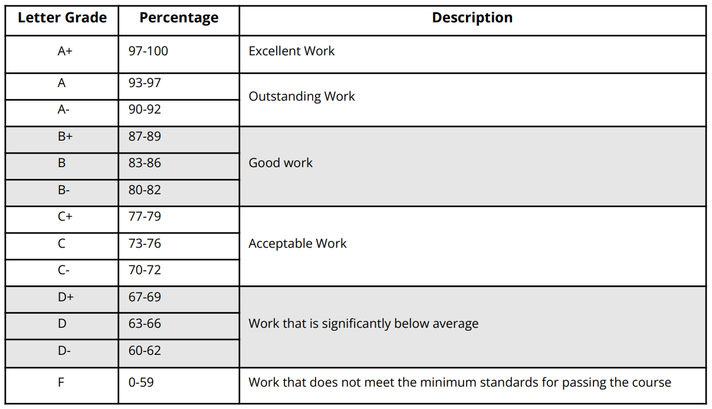
AEP Academic Integrity Policy
Plagiarism and other forms of academic dishonesty are not tolerated. The use of Artificial Intelligence (AI) for the development of knowledge and learning is encouraged at many stages of the learning process. While we value technology for educational purposes, we also value originality and the retainment of knowledge, and thus using AI for assignments and examinations, even if rephrased, is strictly prohibited and considered an academic integrity violation, unless the instructor explicitly allows for it in the context of evaluated work

AEP Non-Discrimination/Harassment Policy
The AEP program in Prague promotes a diverse learning environment where the dignity, worth, and differences of each individual are valued and respected. Discrimination and harassment, whether based on a person's race, gender, sexual orientation, color, religion, national origin, age, disability, or other legally protected characteristics, are repugnant and completely inconsistent with our objectives. Retaliation against individuals for raising good faith claims of harassment and/or discrimination is prohibited.

AEP Diversity Policy
AEP is committed to fostering an inclusive and welcoming community that values diversity in all its forms. We believe that one of the most meaningful lessons of studying abroad is learning to navigate and appreciate differences with curiosity and an open mind. While engaging across differences can sometimes be challenging or uncomfortable, these moments are essential for growth and learning. We recognize that every member of our community, even with the best intentions, may occasionally make missteps. Our commitment is to provide a supportive environment where respectful and honest dialogue helps us learn from these experiences, ensuring that every student has the opportunity to thrive and broaden their perspective.

Weekly Schedule

Week 1
1. Introduction: Cultural identity, history and music
2. Music, society and identity: Czech music in an international context
Required readings:
David Byrne, How Music Works (excerpt)
Simon Frith, “Music and Identity”

Week 2
1. Composing a Nation: Smetana and the National Revival
The idea of “Czechness” in music
2. Music as Social Life
Required readings:
Michael Beckerman, “In Search of Czechness in Music”
Thomas Turino, Music as Social Life (excerpt)

Week 3
1. The story of the national anthem. Anthems, revolutionary songs and “mass songs”
2. FIELD TRIP: Czech Museum of Music
Required readings:
Rosa Newmarch: The Music of the Czecho-Slovak Race

Week 4
1. Cultural Exchange; Antonín Dvořák in America
2. Janáček the European; music and the Czech language
Required reading:
J. E. Vacha, “Dvořák in America”
David Byrne, How Music Works (excerpt, part 2)
Milan Kundera: Testaments betrayed (excerpt)
Miloš Štědroň: “Direct discourse and speech melody in Janáček’s operas” (excerpt)

Week 5
1. Martinů: Jazz meets modernism; Silence, noise, musical sound; Quarter-tone compositions (A. Hába) and other extensions of the field of musical expression
2. Field Trip: Antonín Dvořák Museum - Villa America
Required reading:
Jennifer Judkins, “Silence, Sound, Noise, and Music”
John Cage, Silence (excerpt)

Week 6
1. Women in Czech music; From Vítězslava Kaprálová to Lenka Nota
2. Music from Concentration Camps; WWII and its effect on music; Modern classical (atonal) music in Central Europe: Schoenberg and the Second Viennese School, Ligeti, Penderecki etc.
Required readings:
Susan McClary, Feminine Endings (excerpt)
Theodore Adorno: The Philosophy of New Music (excerpt)
Jascha Nemtsov, Beate Schröder-Nauenburg and Dean Bell: „Music in the Inferno of the Nazi Terror: Jewish Composers in the “Third Reich””

Week 7
1. Transgressive music as a political force; Czech underground rock scene, DG 307, The Plastic People of the Universe, etc.
2. Official music during communism. Pop, rock, celebrity culture
Required readings:
František Stárek Čuňas: “In the Beginning Were Hells Devils”
Václav Havel: “The Trial”
Pavel Klusák: Gott, A Czechoslovak Story (excerpt)

Week 8
1. Playing for a Revolution; the Velvet Revolution and music; the political economy of music; Czech folk (singer-songwriter) scene, Karel Kryl, Jaromír Nohavica, etc.
2. FIELD TRIP: a recording studio / a concert hall
Required readings:
Toni Mitchell: “Mixing Pop and Politics: Rock Music in Czechoslovakia before and after the Velvet Revolution”
Optional: Jacques Attali, Noise: The Political Economy of Music (excerpt)

Week 9
1. Classical Composers Make it Big in Hollywood; Miloš Forman’s Amadeus
2. Contemporary Czech Opera and Modern Approaches to National Identity (Smolka, Štědroň, Acher, Nota)
Required readings:
Simon P. Keefe: “Beyond Fact and Fiction, Scholarly and Popular: Peter Shaffer and Miloš Forman's “Amadeus” at 25”
François Juillen, There Is No Such Thing as Cultural Identity (excerpt)

Week 10
1. Show-business: mass culture and capital; contemporary popular music
2. Pirates and Hackers - electronic music, musical software, remix, appropriation; Czech electronic music, hip hop, plunderphonics, remakes and sampling etc.
Required reading:
Theodor Adorno, The Culture Industry (excerpt)
Chris Cutler, “Plunderphonics”

Week 11
1. The Future of Music; Sound Design
2. Music and Emotion; Performance Art
Required readings:
Philip Ball, “Artificial Music: The Computers that Create Melodies”
Optional: Simon Emmerson, “‘Losing Touch?’: The Human Performer and Electronics”
Andrew Kania, “Music and the Emotions” (Stanford Encyclopedia of Philosophy)

Week 12
1. Guest Lecturer / Minority Culture goes Mainstream
2. Influence of Non-Western Musics
Required readings:
Alexandra L. Woodruff: “Hip, Hot, and Proud to be Roma”
Zuzana Jurková: “Rompop, and so on…
John Blacking, “Let All the World Hear All the World’s Music”

Week 13
1. Music and Culture, review
2. Final test
Required readings:
Leo Treitler, “History and Music”

