Applied Machine Learning for Economists

Achim Ahrens
achim.ahrens@cerge-ei.cz

Course Description:
Many problems in economics and the social sciences are prediction problems: identifying individuals at risk of unemployment, forecasting election outcomes, or predicting policy take-up. Methods from machine learning (ML) and artificial intelligence (AI) have revolutionized how prediction algorithms are designed and implemented.

This course introduces students to modern ML/AI methods with a strong emphasis on intuition, practical use, and critical evaluation, rather than mathematical derivations. Students will learn how to frame prediction problems, choose appropriate models, evaluate predictive performance, and interpret results. Advanced methods such as deep learning are introduced conceptually, focusing on when and why they are used rather than on technical implementation.

Course Prerequisites:
- Introductory statistics (regression, probability basics)
- Familiarity with basic principles of programming (from self-study or courses) OR strong interest in learning a statistical programming language

Course Objectives/Learning Outcomes:
By the end of the course, students will be able to:

- Distinguish prediction from causal inference
- Frame real-world problems as prediction tasks
- Learn the basics of programming using R
- Apply and compare basic machine learning models in R
- Understand overfitting, model complexity, and validation
- Interpret and critically assess model performance
- Explain, at a high level, how modern methods such as random forests and neural networks work
- Communicate results clearly to a non-technical audience
Assessment:

- Midterm Test (Week 8): 30%
Conceptual questions, interpretation
- Take-home Assignments (3 total): 30%
Guided assignments; focus on interpretation and model comparison. Students may work together, but every student is asked to submit their own homework.
- Final Prediction Project (Group-based): 40%
  - Code assessment: 10%
  - Short presentation: 10%
  - Short report (max. 3 pages): 20%

Grading Policy:

Mandatory Completion Policy
Note that all mandatory assignments and exams must be completed to the best of your ability in order for your final grade to be issued. Failure to complete a mandatory assignment or exam may result in a failing grade.

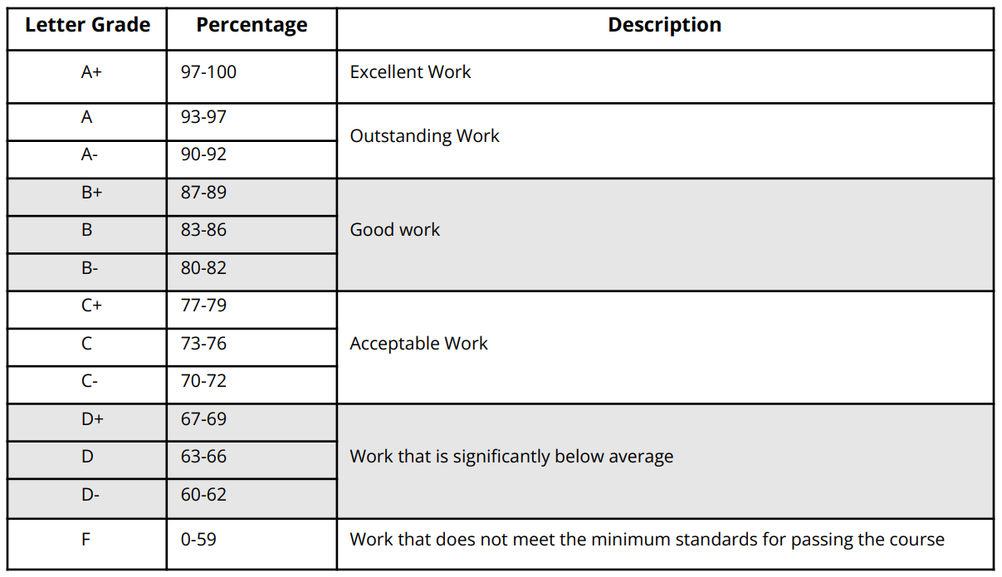
AEP Academic Integrity Policy
Plagiarism and other forms of academic dishonesty are not tolerated. The use of Artificial Intelligence (AI) for the development of knowledge and learning is encouraged at many stages of the learning process. While we value technology for educational purposes, we also value originality and the retainment of knowledge, and thus using AI for assignments and examinations, even if rephrased, is strictly prohibited and considered an academic integrity violation, unless the instructor explicitly allows for it in the context of evaluated work

AEP Non-Discrimination/Harassment Policy
The AEP program in Prague promotes a diverse learning environment where the dignity, worth, and differences of each individual are valued and respected. Discrimination and harassment, whether based on a person's race, gender, sexual orientation, color, religion, national origin, age, disability, or other legally protected characteristics, are repugnant and completely inconsistent with our objectives. Retaliation against individuals for raising good faith claims of harassment and/or discrimination is prohibited.

AEP Diversity Policy
AEP is committed to fostering an inclusive and welcoming community that values diversity in all its forms. We believe that one of the most meaningful lessons of studying abroad is learning to navigate and appreciate differences with curiosity and an open mind. While engaging across differences can sometimes be challenging or uncomfortable, these moments are essential for growth and learning. We recognize that every member of our community, even with the best intentions, may occasionally make missteps. Our commitment is to provide a supportive environment where respectful and honest dialogue helps us learn from these experiences, ensuring that every student has the opportunity to thrive and broaden their perspective.

Weekly Schedule
Week 1 – What Is Machine Learning? Prediction vs Explanation
Lecture
- Prediction vs causal inference
- Examples from economics and social science
- What ML can and cannot do
- Course overview and final project introduction
Tutorial
- Introduction to R and RStudio
- Loading data, basic plots, simple summaries
Reading
- ISLR, Chapter 1 (selected sections)
Week 2 – Linear Regression as a Prediction Tool
Lecture
- Linear regression revisited
- Prediction error vs goodness-of-fit
- Train vs test data
- Mean squared error
Tutorial
- Running regressions in R
- Making predictions
- Visualizing prediction error
Reading
- ISLR, Chapters 2–3 (selected sections)
Week 3 – Classification and Logistic Regression
Assignment 1 due
Lecture
- Binary outcomes and classification problems
- Logistic regression intuitively
- Confusion matrix, accuracy, ROC curves
Tutorial
- Logistic regression in R
- Visual comparison of classifiers
Reading
- ISLR, Chapter 4 (selected sections)
Week 4 – Overfitting and Model Evaluation
Assignment 2 due
Lecture
- Overfitting and underfitting
- Bias–variance tradeoff (conceptual)
- Cross-validation
Tutorial
- Cross-validation in practice
- Comparing models using test error
Reading
- ISLR, Chapter 5 (selected sections)
Week 5 – Model Selection and Regularization
Assignment 3 due
Lecture
- Too many variables
- Idea of shrinkage
- Ridge and lasso (no mathematical derivations)
Tutorial
- Regularized regression in R
- Interpreting coefficient paths
Reading
- ISLR, Chapter 6 (intuition)
Week 6 – Regression and Decision Trees
Lecture
- Tree-based thinking
- Interpretability vs accuracy
- Overfitting in trees
Tutorial
- Building and visualizing trees
- Comparing trees to regression
Reading
- ISLR, Chapter 8.1
Week 7 – Random Forests and Ensemble Ideas
Assignment 4 due
Lecture
- Why combining models improves prediction
- Random forests intuitively
- Variable importance
Tutorial
- Running random forests in R
- Interpreting model outputs
Reading
- ISLR, Chapter 8.2
Week 8 – Midterm Test and Project Launch
Midterm Test (90 minutes)
After the test
- Introduction to the final prediction project
- Evaluation criteria and expectations
Week 9 – Neural Networks and Deep Learning
Lecture
- What is a neural network?
- Neurons, layers, and learning (visual explanation)
- Why deep learning works well for images and text
- Strengths and limitations
Tutorial
- Using a pre-built neural network model
- Comparing results to simpler models
Reading (optional)
- ISLR, Chapter 10 (conceptual)
- Ananthaswamy, Why Machines Learn (selected chapter)
Week 10 – Text as Data
Lecture
- Turning text into data
- Bag-of-words idea
- Simple text prediction examples
Reading
- Instructor notes
Week 11 – Fairness and AI
Lecture
- Fairness and bias in prediction
- Transparency and accountability
Tutorial
- Open coding session, Q&A
Week 12 – Final Project Presentations
Group presentations & discussions

Readings:
The primary textbook is:

James, G., Witten, D., Hastie, T., Tibshirani, R. (2023). An Introduction to Statistical Learning with Applications in R (ISLR). Freely available at: https://www.statlearning.com/

Complementary reading:

Ananthaswamy, Anil (2025). Why Machines Learn. Penguin Books.

Wickham, H., Çetinkaya-Rundel, M., & Grolemund, G. (2023). R for data science: import, tidy, transform, visualize, and model data. O'Reilly Media, Inc. Freely available at: https://r4ds.hadley.nz/

