Philipsburg, February 27, 2026

Consumer Price Index Increased in the Fourth Quarter of 2025

Philipsburg Sint Maarten – The Consumer Price Index (CPI) increased in the fourth quarter of 2025 to 115.28, which represented an increase of 0.16% when compared to the previous quarter. Additionally, when comparing consumer prices in the fourth quarter of 2025 to the fourth quarter of 2024 the results show a notable increase of 0.42%.

The total average CPI for 2025 is 114.90. The inflation for 2025 is 0.92% indicating that overall price movements remained relatively stable throughout the year.

Period 2025 | 2024 Index | 2025 Index | Inflation
Quarter 1 | 113.31 | 115.02 | 1.51%
Quarter 2 | 113.49 | 114.23 | 0.65%
Quarter 3 | 113.82 | 115.09 | 1.12%
Quarter 4 | 114.79 | 115.28 | 0.42%
Annual Average | 113.85 | 114.90 | 0.92%

Quarterly Overview (Q4 2025-Q3 2025)
When comparing Q4 2025 to Q3 2025, the Consumer Price Index (CPI) shows that three of the four major expenditure categories increased during the quarter. These four categories carry the greatest weight in calculating the overall CPI and therefore have the largest impact on quarterly inflation trends. Overall, quarterly inflation remained low, driven by a decline in housing-related costs
- Housing, Water, Electricity, Gas, and Other Fuels recorded a decrease of 2.32% in Q4 compared to Q3. This decline was mainly due to a 6.69% drop in Actual rentals paid by tenants. In addition, Electricity, gas and other fuels decreased by 0.97%, largely driven by a 1.13% reduction in electricity prices.
- Transport increased by 2.75% during the quarter. This was primarily influenced by a 6.50% rise in Transport services, mainly due to an 8.97% increase in Passenger transport by air. The subcategory Purchase of vehicles also rose by 2.10%, driven by higher prices for Bicycles (+4.56%) and Motorcars (+2.12%).
- Miscellaneous goods and services rose by 0.38%. This increase was mainly attributed to Personal care (+0.67%), particularly higher prices for Other appliances, articles and products for personal care (+0.89%).
- Food and non-alcoholic beverages increased by 0.87%. This growth was largely driven by Non-alcoholic beverages (+1.10%), especially Coffee, tea and cocoa, which rose by 3.75%.

Annual Trends – Q4 2025 vs Q4 2024

Overall, the CPI for Q4 2025 increased slightly by 0.42% compared to Q4 2024. This modest rise was largely influenced by contrasting movements within the four main expenditure categories. Inflation remained below 1% year-on-year, reflecting stable price developments across most categories.
The largest category, Housing, water, electricity, gas, and other fuels, recorded a notable decrease of 2.07%, which helped keep overall inflation low. Meanwhile, the smallest of the four major categories, Food and non-alcoholic beverages, increased by 2.31%, partially offsetting the decline in housing-related costs.

Three of the four most influential expenditure categories recorded price increases compared to Q4 2024.
- Housing, water, electricity, gas, and other fuels decreased by 2.07%, mainly due to lower prices for Electricity, gas and other fuels (-7.50%) and Actual rentals for housing (-2.69%).
- Transport increased slightly by 0.84%, driven by higher costs for Operation of personal transport equipment (including fuel) (+1.77%) and Purchase of vehicles (+0.52%).
- Miscellaneous goods and services declined by 0.25%, primarily due to a drop in Financial services n.e.c. (-4.69). These include fees and charges for services from banks, post offices, money changers, brokers, tax consultants and similar financial institutions.
- Food and non-alcoholic beverages rose by 2.31%, influenced by higher prices for Food products n.e.c. (+12.16%) and Sugar, jam, honey, chocolate and confectionery (+8.30%). Food products n.e.c. include miscellaneous food items such as sugar cane, baking powders, broths, soup bases, instant desserts and nutritional or fortified foods

Major CPI Categories – Weight, Quarterly, and Year-on-Year Changes
Category | Weight (%)
  Q4 2025 vs Q3 2025
  Q4 2025 vs Q4 2024
Housing, Water and Energy | 36.1% | -2.32% | -2.07%
Transport | 14.6% | +2.75% | +0.84%
Miscellaneous Goods and Services | 13.4% | +0.38% | -0.25%
Food and Non-Alcoholic Beverages | 7.2% | +0.87% | +2.31%
*The above-mentioned categories are the variables that have the largest influence on price
For further information or clarification, please contact the Department of Statistics at statinfo@sintmaartengov.org.

Contact Information
For additional information, or to enquire about the methods and/ or data quality of this release, contact us on (+1) 721-542-0349 / (+1) 721-542-0640 or at statinfo@sintmaartengov.org / marlon.ricardo@sintmaartengov.org

Table 1. | Consumer Price Index figures, quarterly percentage changes, and inflation rates for the 12 major expenditure categories for 2025 quarter 4
Expenditure Category |  | 2018  WEIGHTS | INDEX | INDEX | INDEX | Quarter-to-Quarter | Year-on-Year
 |  | 2018  WEIGHTS | 2024 | 2025 | 2025 | % Change | % Change
 |  | 2018  WEIGHTS | Quarter 4 | Quarter 3 | Quarter 4 | Q3 2025 to Q4 2025 | Q4 2024 to Q4 2025
Food and non-alcoholic beverages |  | 7.2% | 121.76 | 123.50 | 124.58 | 0.87% | 2.31%
Alcoholic beverages, tobacco, and narcotics |  | 0.4% | 110.89 | 109.25 | 109.25 | -0.50% | -1.47%
Clothing and footwear |  | 4.8% | 122.35 | 124.26 | 128.14 | 3.13% | 4.74%
Housing, water, electricity, gas, and other fuels |  | 36.1% | 111.58 | 111.86 | 109.27 | -2.32% | -2.07%
Furnishings, household equipment and routine household maintenance |  | 6.5% | 114.75 | 117.29 | 118.93 | 1.40% | 3.64%
Health |  | 1.9% | 111.28 | 115.37 | 115.69 | 0.27% | 3.96%
Transport |  | 14.6% | 123.24 | 120.95 | 124.27 | 2.75% | 0.84%
Communication |  | 6.0% | 116.68 | 117.35 | 116.78 | -0.49% | 0.09%
Recreation and culture |  | 4.6% | 111.56 | 110.73 | 112.94 | 2.00% | 1.24%
Education |  | 2.6% | 108.96 | 111.83 | 111.83 | 0.00% | 2.64%
Restaurants and hotels |  | 2.0% | 126.35 | 130.84 | 138.08 | 5.53% | 9.28%
Miscellaneous goods and services |  | 13.4% | 108.22 | 107.54 | 107.95 | 0.38% | -0.25%
TOTAL CPI |  | 100% | 114.79 | 113.82 | 115.28 | 0.16% | 0.42%
Base Year 2018 = 100

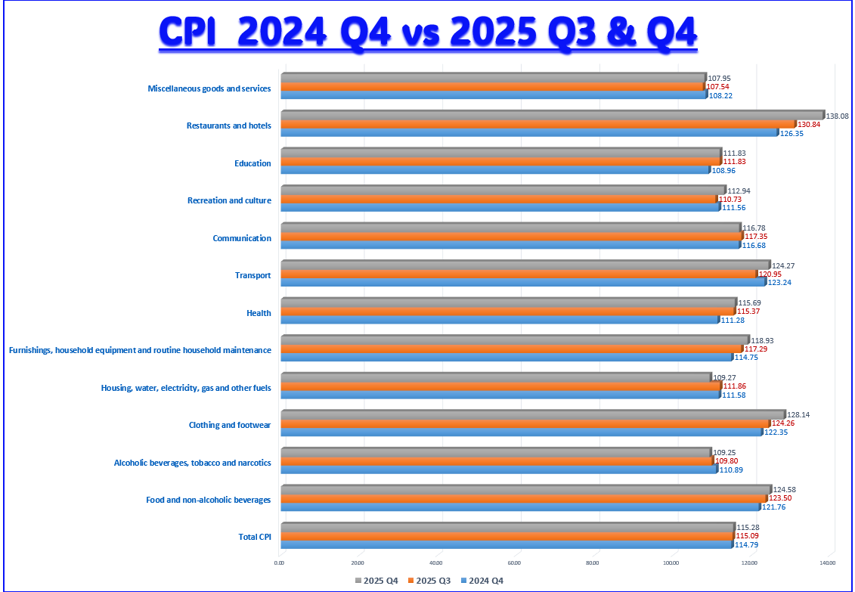

Appendix

- ‘Food products n.e.c.’ - are considered as sugar cane consumed for extracting juice or as a snack; prepared baking powders and yeasts, broth, stocks, bouillon cubes, soup bases, agar-agar, instant dessert preparations; and nutritional supplements and fortified food products.

- ‘Other services relating to the dwelling n.e.c.’ - are considered as co-proprietor charges for caretaking, gardening, stairwell cleaning, heating, and lighting, maintenance of lifts and refuse disposal chutes, pool cleaning, etc. in multi-occupied buildings; road and sidewalk cleaning and chimney sweeping; measuring background radiation and content of harmful substances in dwellings; landscaping and cleaning of grounds surrounding the dwelling; snow removal. Excludes: household services, such as window cleaning, disinfecting, fumigation, and pest extermination.

- ‘Other services relating to the dwelling n.e.c.’ - are considered as co-proprietor charges for caretaking, gardening, stairwell cleaning, heating, and lighting, maintenance of lifts and refuse disposal chutes, pool cleaning, etc. in multi-occupied buildings; road and sidewalk cleaning and chimney sweeping; measuring background radiation and content of harmful substances in dwellings; landscaping and cleaning of grounds surrounding the dwelling; snow removal. Excludes: household services, such as window cleaning, disinfecting, fumigation, and pest extermination.

- Purchases of spare parts – are considered as accessories or lubricants made by households with the intention of undertaking the maintenance, repair, or intervention themselves. If households pay an enterprise to carry out the maintenance, repair or fitting, the total value of the service, including the costs of the materials used.

- Personal care – are considered as Hairdressing salons and personal grooming establishments (S); Electric appliances for personal care (SD); and Other appliances, articles, and products for personal care (ND).

- Personal effects n.e.c – Not elsewhere classified are considered as jewelry, clocks, watches, travel goods and other carriers, and articles for babies.

- Social protection – Covers nonmedical assistance and support services provided to persons who are elderly, disabled, having occupational injuries and diseases, survivors, unemployed, destitute, homeless, low-income earners, indigenous people, immigrants, refugees, alcohol and substance abusers, and so on. It also covers assistance and support services provided to families and children.

